Date : 03-09-2021

Session : Bootstrap.

Task given : Read documentation of bootstrap and try to implement responsive designs.

Understand [glance-design-dashboard-bootstrap-responsive-web-template/](https://w3layouts.com/template/glance-design-dashboard-bootstrap-responsive-web-template/)

Schedule :

|  |  |
| --- | --- |
| 09.30 – 11.15 | Meeting |
| 11.15 – 12.00 | Reading bootstrap doc. |
| 12.00 – 1.30 | Ppt implementation, implementing grid system |
| 2.30 – 4.00 | Implement form, card, table, responsive image. |
| 4.00 – 6.15 | Meeting |
| 6.15 – 6.40 | Understanding  https://w3layouts.com/template/glance-design-dashboard-bootstrap-responsive-web-template/ |
| 6.40 – 7.00 | Git updated, PMS update, report creation. |

OUTPUT :

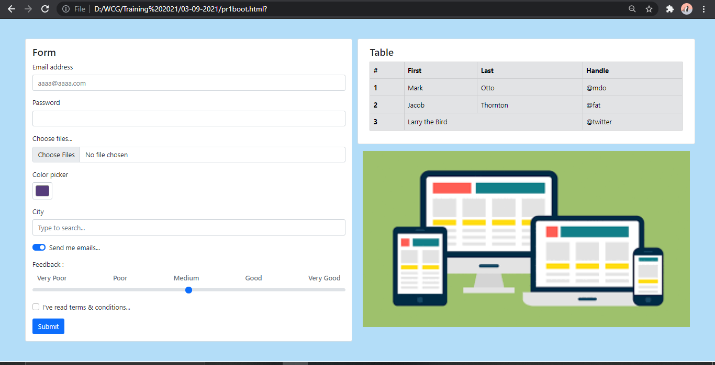

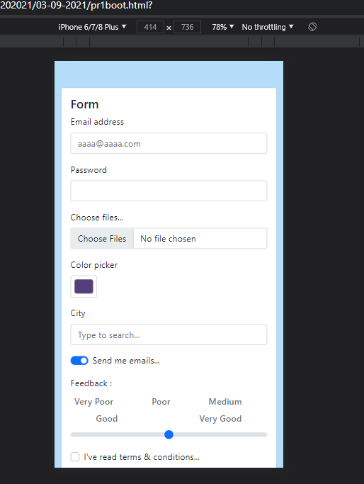

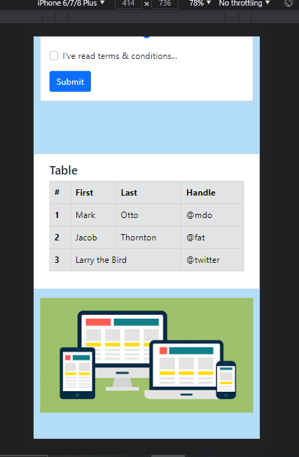

Practice

