Date : 05-08-2021

Session : Introduction to basic html tags.

Task given : Create a basic html website using tags with home page, about and contact page.

My Task : Screenshot includes home.html, css file and the out put. I have used basic css properties and made a static home page.

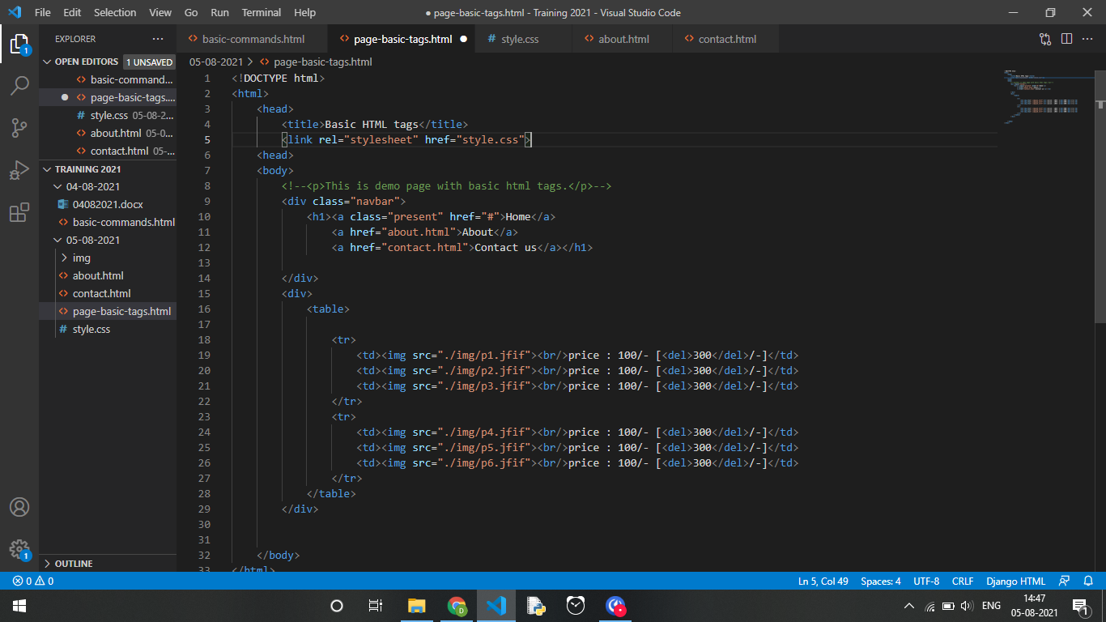

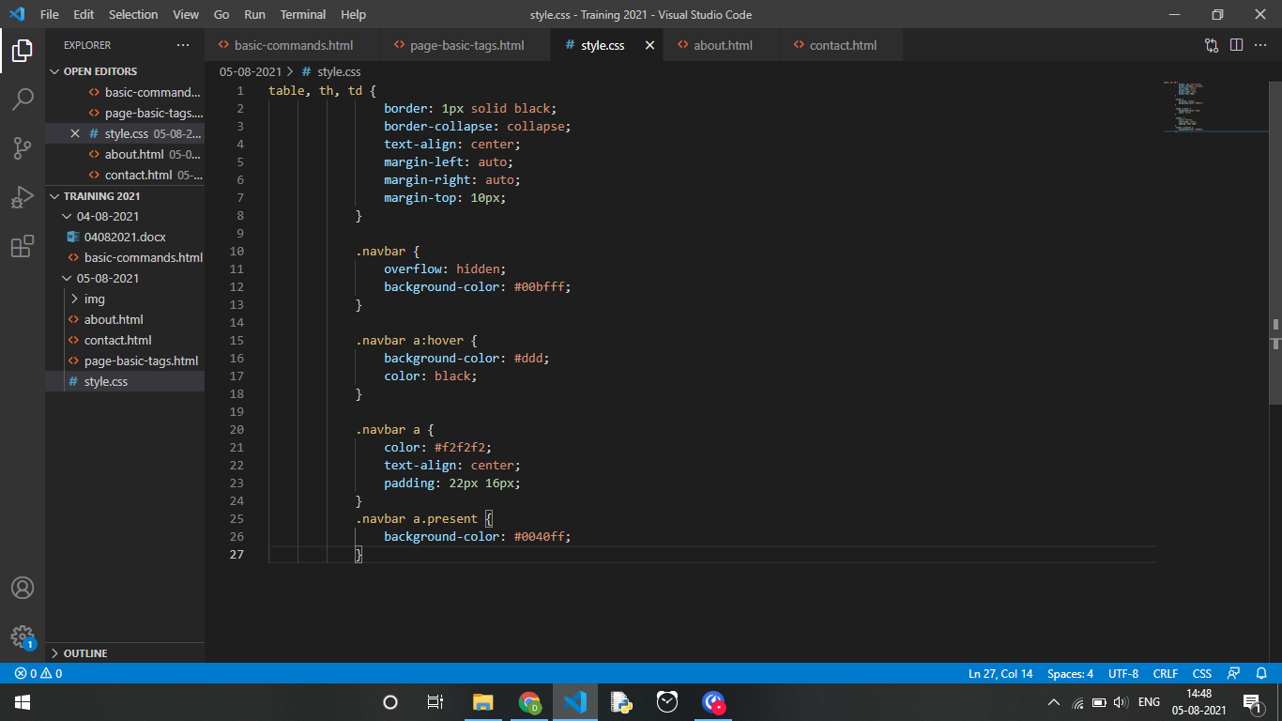

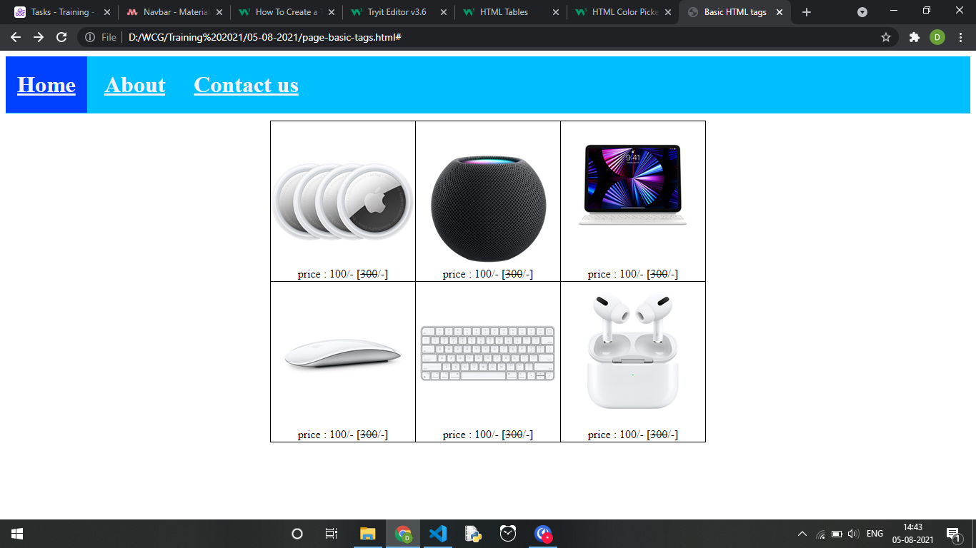

Date : 06-08-2021

About and Contact page was made and linked with navbar.

