Date : 07-09-2021

Session : Node JS routing and modules.

Task given : Implement and read http module, export programs, routing programs.

Schedule :

|  |  |
| --- | --- |
| 09.30 – 10.45 | Meeting |
| 10.45 – 1.30 | Http module and export programs |
| 2.30 – 5.00 | EJS engine, render dynamic data from JSON object |
| 5.15 – 6.00 | Meeting |
| 6.00 – 6.40 | Understanding route in url module |
| 6.40 – 7.00 | Git updated, PMS update, report creation. |

OUTPUT :

http module

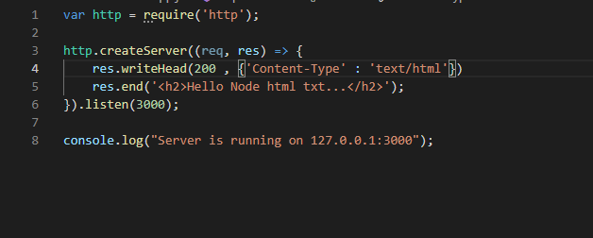

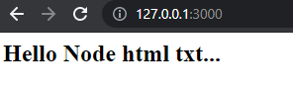

Export module



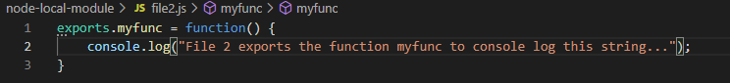

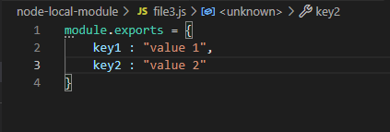

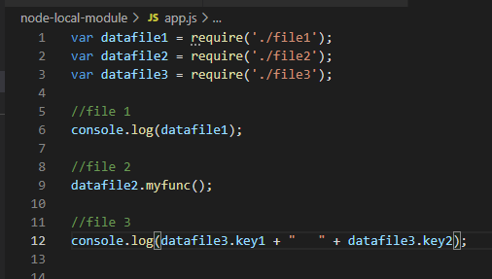

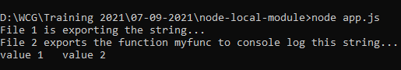

EJS program

