Date : 20-08-2021

Session : Basic of jQuery.

Task given : refer ppt, search websites, learn jquery, perform basic practicals.

Schedule :

|  |  |
| --- | --- |
| 9.30 – 11.30 | Meeting |
| 11.30 – 01.00 | Refering the PPT, Revision |
| 01.00 – 01.40 | addClass , css, fadeout |
| 2.40 – 4.30 | Fadetoggle, slideup, slidedown, slidetoggle, animate and others. |
| 4.30 – 6.30 | Websites visiting, viewing pagesource  For ex.  https://aamaadmiparty.org/  http://www.nypizza.co.in/  https://www.elala.in/  https://www.medplusmart.com/  https://www.suratsmartcity.com/ |
| 6.30 – 7.00 | Git updated, PMS update, report creation. |

Output :

Pr1 – addClass

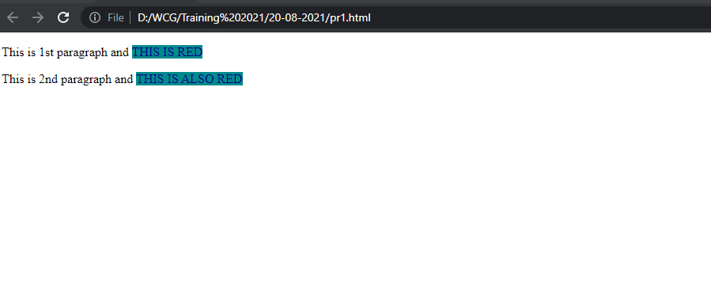

Pr2 – css

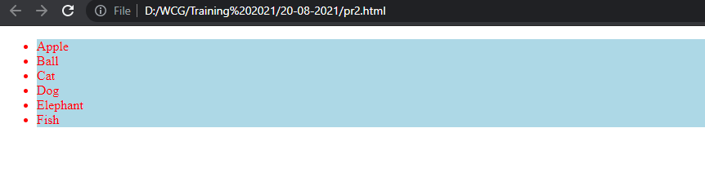

Pr3 – fadeout

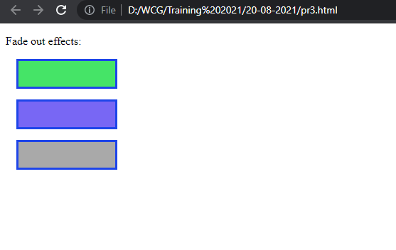

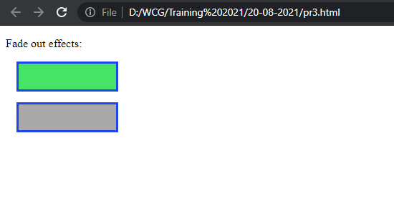

Pr4 – fadeToggle

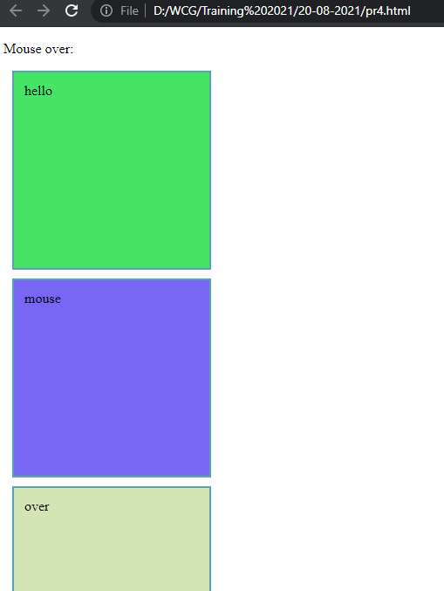

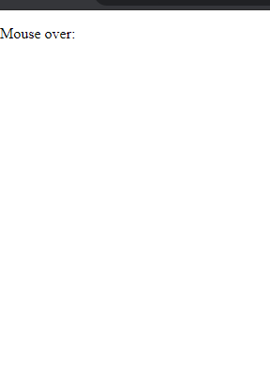

Pr5 – slideup

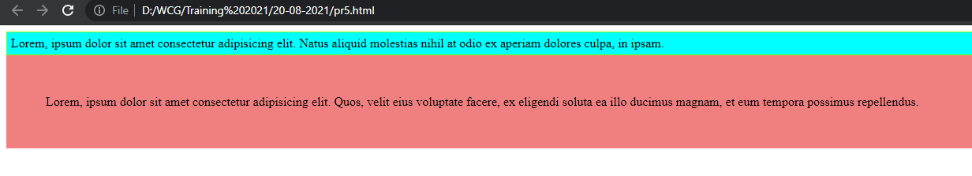

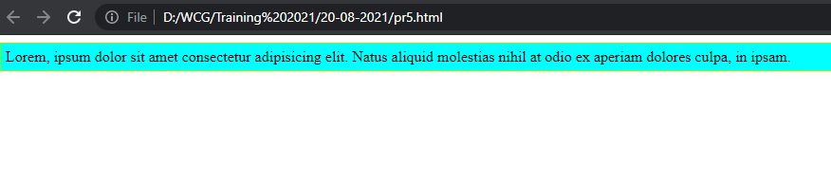

Pr6 – slidedown

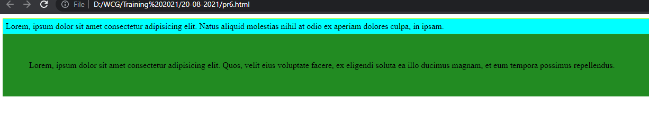

Pr7 – slidetoggle

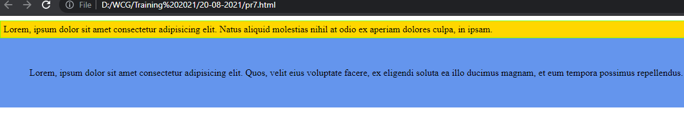

Pr8 - animate and others.

