Date : 21-08-2021

Session : Basic of jQuery – plug in .

Task given : create demo of plugin, pr1 – validate and datatable plugin in one page., pr 2 form validation.

Schedule :

|  |  |
| --- | --- |
| 9.30 – 11.00 | Meeting 1 |
| 11.00 – 01.15 | Meeting 2 |
| 2.15 – 3.00 | Demo of plugin |
| 3.00 – 4.15 | Pr 1 - validate and datatable plugin in one page |
| 4.15 – 5.30 | Pr 2 - form validation. |
| 5.30 – 6.30 | Study of extra plug in |
| 6.30 – 7.00 | Git updated, PMS update, report creation. |

Output :

Pr 1 - validate and datatable plugin in one page

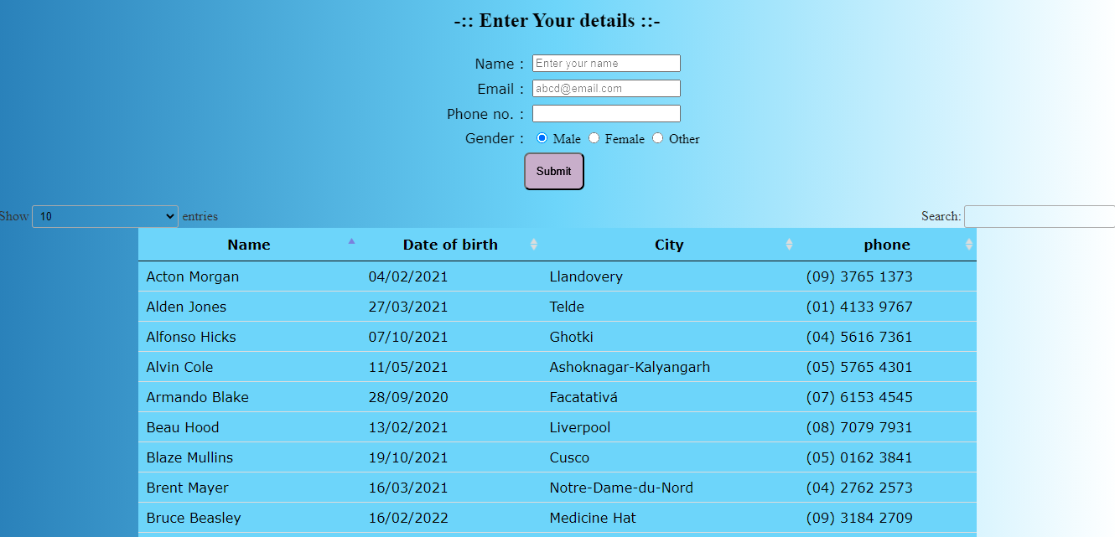

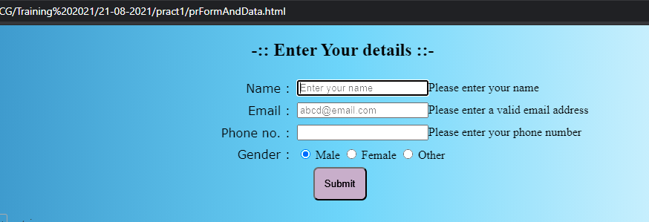

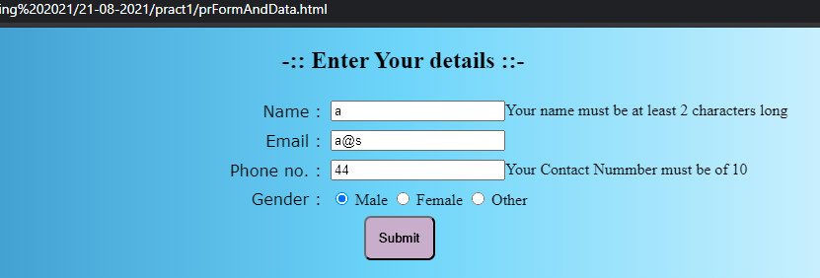

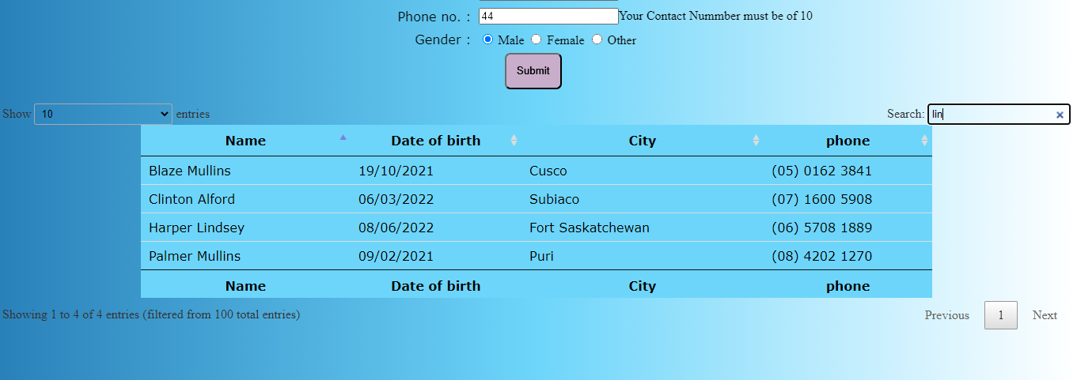

Pr 2 - form validation.

