Date : 23-08-2021

Session : Basic of jQuery – plug in .

Task given : Pr 3 – slider plug in, Pr 4 – chosen plugin, ckeditor, lightbox, navbar with snazzy plugin.

Schedule :

|  |  |
| --- | --- |
| 10.00 – 11.00 | Meeting |
| 11.00 – 11.45 | Slider plug in |
| 11.45 – 1.00 | Chosen plug in |
| 1.00 – 2.00 | Ckeditor and lightbox |
| 3.00 – 4.30 | Navbar with snazzy |
| 4.30 – 5.30 | Study of murri plug in |
| 5.30 – 7.00 | Meeting |
| 7.00 – 7.30 | Git updated, PMS update, report creation. |

Output :

Pr 3 – slider plug in

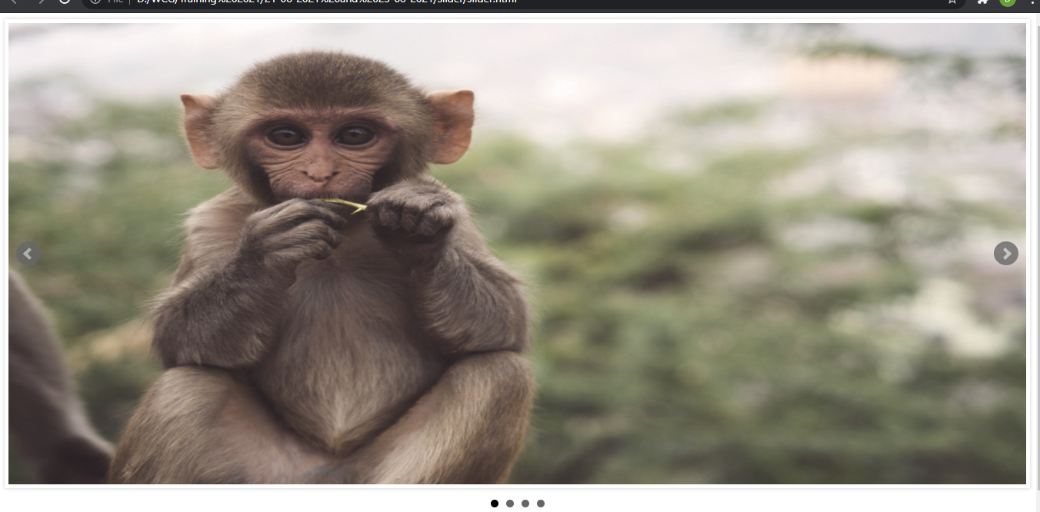

,

Pr 4 – chosen plugin

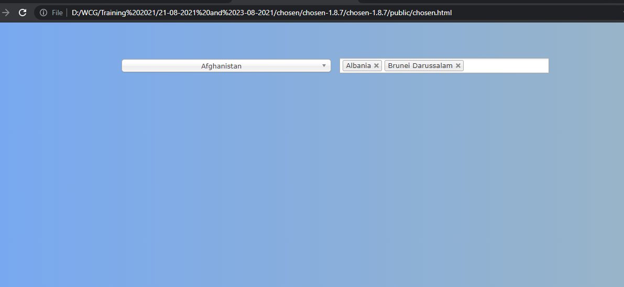

Ckeditor

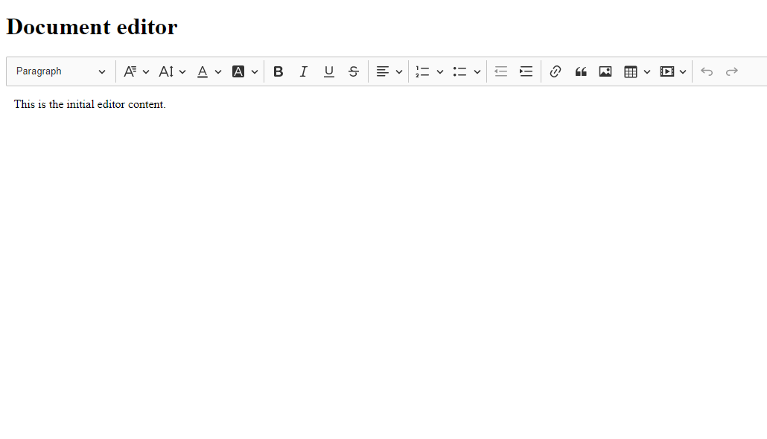

Lightbox

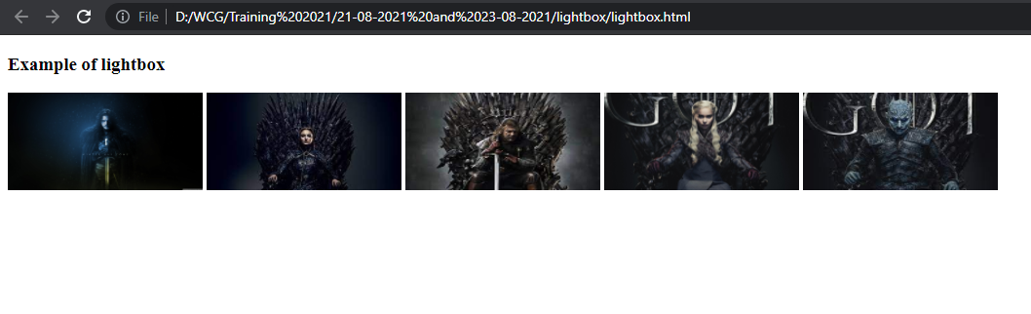

navbar with snazzy plugin

