PROJECT REPORT
GameCut AI
AI Assisted Video Editing and Highlight Generation Platform
Submitted in partial fulfillment of the requirements for the degree of
Bachelor of Science in Computer Science
Academic Year 2025-26
Prepared by
Project Student
Department of Computer Science

DECLARATION
I hereby declare that the project report entitled “GameCut AI: AI Assisted Video Editing and Highlight Generation Platform” is my original academic work. The system implementation, analysis, design, testing, and documentation presented in this report were completed as part of the current project work. Wherever external technologies, libraries, and documentation have been used, they are acknowledged in the references.
Date: ____________________
Place: ____________________

CERTIFICATE
This is to certify that the project entitled “GameCut AI: AI Assisted Video Editing and Highlight Generation Platform” has been carried out satisfactorily during the academic year 2025-26. The project demonstrates the application of web development, database systems, multimedia processing, and artificial intelligence planning in a working software system.
Date: ____________________
Place: ____________________

ACKNOWLEDGEMENT
I express my sincere gratitude to my project guide, the Department of Computer Science, and everyone who supported the planning, development, testing, and documentation of GameCut AI. I also acknowledge the open-source communities behind PHP, Python, FFmpeg, OpenCV, faster-whisper, PySceneDetect, and the other technologies that made the implementation possible.
Date: ____________________
Place: ____________________

INDEX
Chapter | Title | Page range
I | Synopsis of the Project | 1-4
II | Introduction and Objectives | 5-8
III | Theoretical Background and Literature Survey | 9-12
IV | Requirements Analysis | 13-18
V | System Design and Architecture | 19-27
VI | Implementation and Processing Pipeline | 28-36
VII | User Interface and Module Design | 37-42
VIII | Testing and Results | 43-47
IX | Conclusion and Future Scope | 48-51
X | References and Annexure | 52-55
The page ranges are indicative and may shift slightly with final Word pagination. The report is organized to follow the academic project-report pattern shown in the supplied example while documenting the actual GameCut AI implementation.

CHAPTER
SYNOPSIS OF THE PROJECT
Overview, problem statement, objectives, scope, and outcome

1.1 Project Overview
GameCut AI is a web-based AI-assisted video editing platform designed for gaming creators and short-form content workflows. A user uploads a gameplay video, creates a project, and starts an automated processing job. The system analyses the media using speech, scene, audio, and visual signals, scores possible highlights, constructs a constrained editing plan, renders a vertical short with subtitles, and presents the finished output in a preview interface.

1.2 Problem Statement
Creating short, engaging videos from long gameplay recordings is repetitive and time-consuming. Manual review requires the creator to watch the entire source, identify exciting moments, trim clips, reframe them for mobile screens, create captions, and render the result. Many simple editors provide trimming but do not connect media analysis with a safe, repeatable rendering workflow. GameCut AI addresses this gap by combining a conventional web application with a durable job queue and a Python processing pipeline.

1.3 Objectives
- Reduce the time required to find candidate highlight moments in gameplay recordings.
- Provide a browser-based workflow for authentication, upload, project management, processing, preview, and export.
- Use deterministic analysis signals so the V1 system remains reproducible and testable.
- Generate validated editing plans before any FFmpeg command is executed.
- Produce vertical 9:16 short-form output with optional subtitles and a thumbnail.
- Maintain job ownership, progress history, retries, and safe cancellation through durable database state.

1.4 Scope
The current scope includes the GameCut AI web interface, PHP application layer, MySQL schema, Python worker, analysis modules, agent-planning layer, FFmpeg rendering, output validation, and browser preview. The scope does not include automatic publishing to social networks, custom model training, cloud storage, or guaranteed game-specific kill detection. These are documented as future enhancements rather than current features.

CHAPTER
INTRODUCTION AND OBJECTIVES
Need, motivation, users, and measurable goals

2.1 Motivation
Short-form video platforms reward timely, well-framed, captioned content. Gaming creators often have hours of raw footage but limited time for editing. The motivation for GameCut AI is to create a practical assistant that automates the repetitive parts while preserving a transparent pipeline that can be inspected, tested, and improved.

2.2 Intended Users
User | Need | GameCut AI support
Gaming creator | Find and export the best moments | Upload, automated analysis, highlight selection, preview
Editor or student | Understand media processing workflow | Project history, job events, documented pipeline
Administrator or maintainer | Monitor system health | Health endpoint, logs, durable job state, worker ownership
Reviewer | Evaluate project output | Repeatable processing, test suite, diagrams, report

2.3 Expected Benefits
- Faster first-pass editing of long gameplay files.
- Consistent vertical formatting for mobile-first content.
- Reduced risk of unsafe rendering plans through validation.
- Better operational visibility through job events and status transitions.
- A modular foundation for future AI providers and game-specific detectors.

2.4 Success Criteria
The project is considered successful when a registered user can complete the primary workflow: create an account, log in, upload a supported video, create or open a project, start processing, observe progress, view the completed preview, and download the result. At the implementation level, success also requires that invalid plans are rejected, output files are validated with ffprobe, and job ownership prevents stale workers from publishing results.

CHAPTER
THEORETICAL BACKGROUND AND LITERATURE SURVEY
Concepts supporting the system

3.1 Multimedia Processing
Video editing systems operate on a timeline made of audio and visual streams. A source video may be decoded into frames and samples, analysed for changes, and then re-encoded into a target format. GameCut AI uses FFmpeg as the media execution engine, while Python modules prepare the decisions that determine which portions of the source are rendered.

3.2 Speech and Scene Signals
Speech recognition produces timestamped transcript segments that can support captions and highlight reasoning. Scene detection identifies boundaries where visual content changes. Audio energy and visual frame-change measures provide additional signals. These signals are not treated as a single truth; they are combined into candidate scores so the system can make a useful first-pass selection while remaining explainable.

3.3 Agent as Editing Planner
In this project, the agent layer is intentionally constrained. It is an editing planner that returns structured JSON rather than a video-processing engine. The plan contains target duration, aspect ratio, clip timestamps, subtitle preference, thumbnail preference, and provider information. This separation prevents arbitrary shell commands or filesystem access from being exposed to the planner.

3.4 Literature Survey Summary
Area | Common approach | GameCut AI decision
Traditional desktop editing | Manual review and timeline editing | Automate first-pass selection and rendering
Cloud video editors | Managed uploads and browser processing | Use local/private media storage in V1
AI highlight tools | Opaque model predictions | Keep deterministic signals and reasons
Background job systems | Queue plus worker | Use ai_jobs as canonical state with leases
Captioning systems | Transcript then timed text | Map transcript timestamps onto final timeline

CHAPTER
REQUIREMENTS ANALYSIS
Functional, non-functional, and feasibility requirements

4.1 Functional Requirements
ID | Requirement | Priority
FR-01 | User registration and login with session-based access | High
FR-02 | Upload and store original media privately | High
FR-03 | Create and manage projects and videos | High
FR-04 | Create a durable AI processing job | High
FR-05 | Run transcript, scene, audio, and visual analysis | High
FR-06 | Generate and validate an editing plan | High
FR-07 | Render vertical video with subtitles and thumbnail | High
FR-08 | Display processing progress and job events | High
FR-09 | Preview and download the processed output | High
FR-10 | Cancel, delete, and regenerate safely | Medium

4.2 Non-Functional Requirements
- Reliability: a worker must not publish results after losing job ownership.
- Security: user-facing routes must enforce authentication and isolate project access.
- Maintainability: analysis, planning, rendering, and API logic should remain modular.
- Performance: uploads and rendering should be asynchronous so the browser is not blocked.
- Portability: the solution should run in a local PHP/MySQL/Python environment with bundled FFmpeg binaries.
- Traceability: job status and progress changes should be available through append-only events.

4.3 Feasibility Study
Feasibility | Finding
Technical | Feasible using PHP, MySQL, Python, FFmpeg, JavaScript, and local media storage.
Operational | A browser workflow is familiar to creators and does not require desktop editing software.
Economic | V1 uses open-source and local components; cloud costs are not required.
Schedule | The modular design supports phased implementation and testing.
Legal and ethical | User-uploaded media remains private within the application storage scope; future deployment must add production security controls.

4.4 Constraints
Processing quality depends on source media, available codecs, speech recognition availability, and the quality of deterministic candidates. The V1 system does not promise semantic understanding of every game or automatically publish content. These constraints are important when evaluating the output and planning future work.

CHAPTER
SYSTEM DESIGN AND ARCHITECTURE
Architecture, data flow, entities, and control flow

5.1 System Architecture
GameCut AI follows a layered architecture. The browser provides presentation and interaction. PHP handles authentication, upload, project operations, API access, and database transactions. MySQL stores user-facing records and the canonical AI job state. A Python worker performs analysis, planning, rendering, and output validation. Original and processed files are kept in separate private directories.
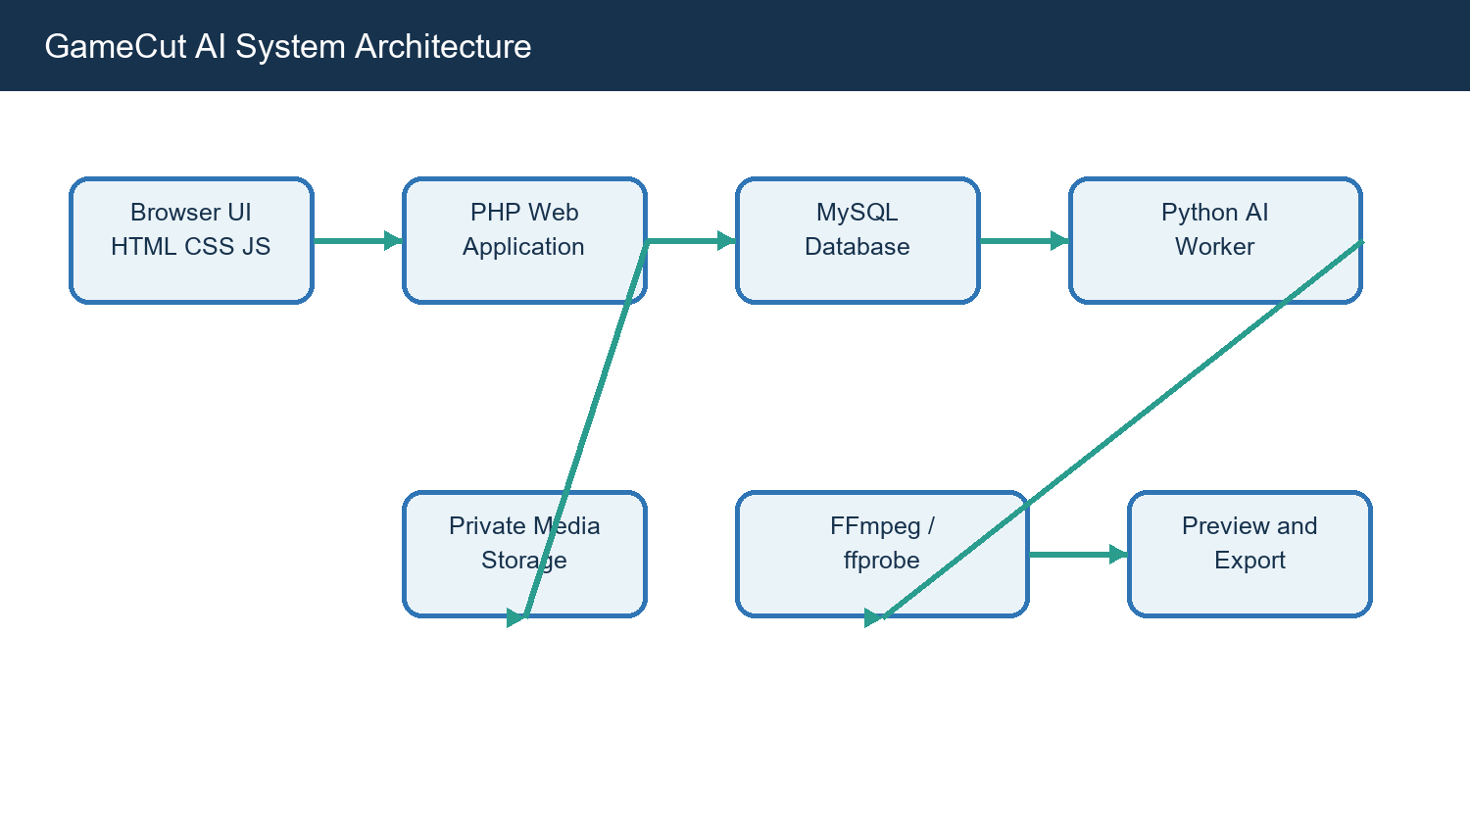
Figure 5.1 GameCut AI layered architecture

5.2 Data Flow Diagram
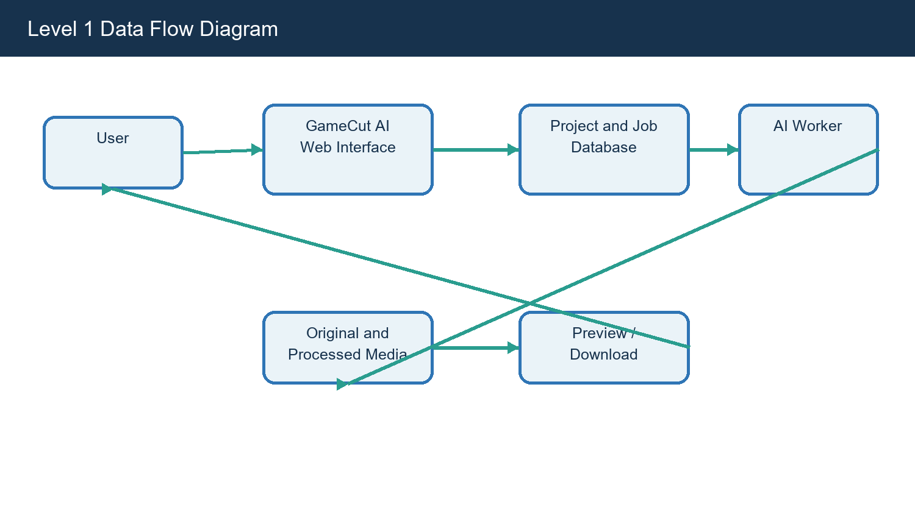
Figure 5.2 Level 1 data flow from user request to processed output

5.3 Entity Relationship Design
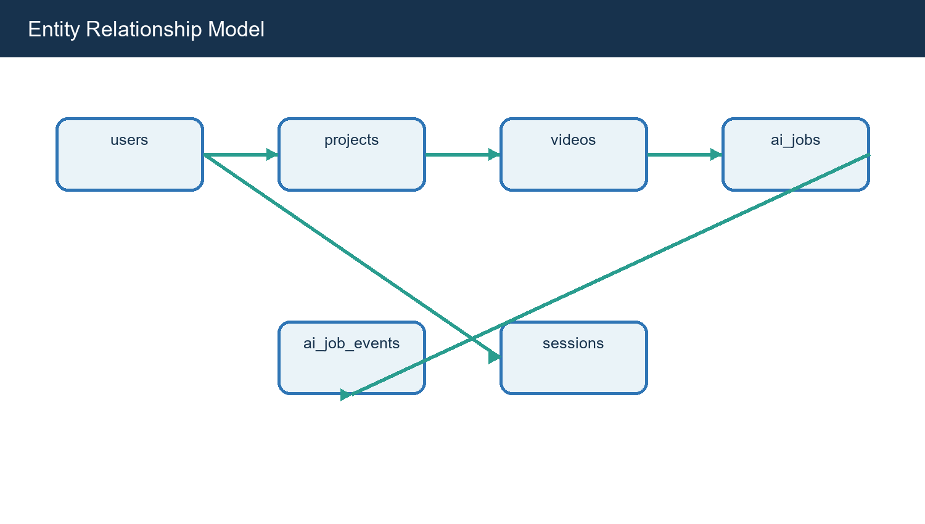
Figure 5.3 Core entity relationship model

5.4 Database Entities
Entity | Purpose | Important fields
users | Registered identities | id, name, email, password hash, created_at
projects | User-facing editing workspaces | id, user_id, title, status, timestamps
videos | Original and generated media metadata | id, project_id, file_path, output_path, duration
ai_jobs | Canonical execution state | id, video_id, status, progress, revision, token
ai_job_events | Append-only execution history | job_id, event_type, message, progress, created_at
sessions | Authenticated browser sessions | session id, user id, expiry

CHAPTER
IMPLEMENTATION AND PROCESSING PIPELINE
Modules, algorithms, job orchestration, and rendering

6.1 Web Application Modules
Module | Implementation role
Authentication | Registration, login processing, session checks, logout
Upload | Accept media, validate input, create project/video records
Projects | List, open, delete, and regenerate project work
Processing | Start jobs, show progress, poll status, surface errors
Preview | Display output video and expose download path
Settings and profile | Manage user-facing preferences and account information
Health and administration | Expose operational status and maintenance actions

6.2 AI Pipeline
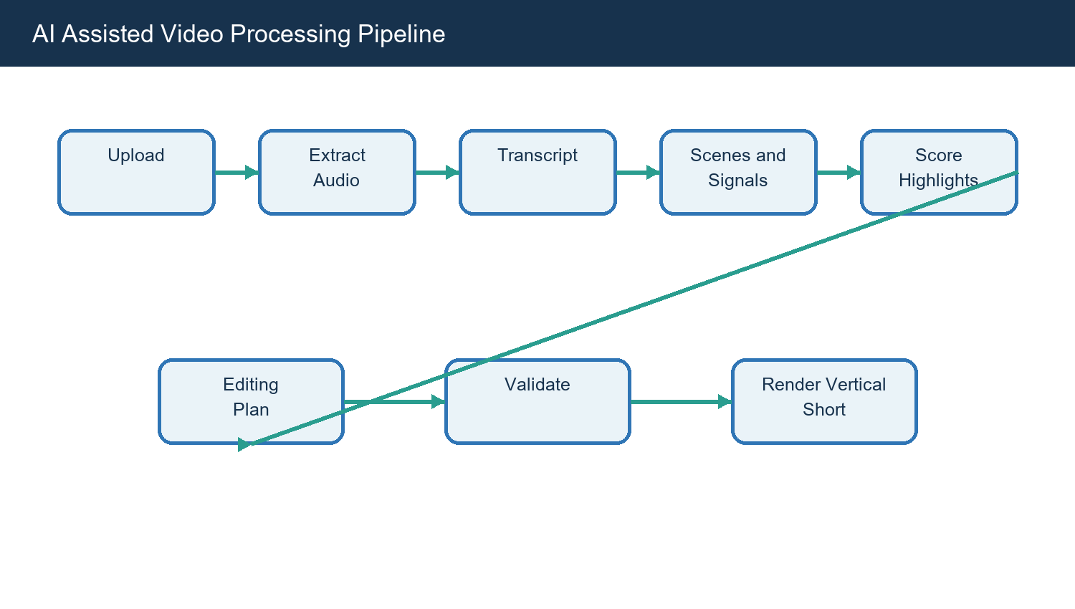
Figure 6.1 Automated media-analysis and rendering pipeline

6.3 Deterministic Analysis Layer
The worker reads the queued job and the existing videos.file_path value. It creates an isolated workspace under uploads/temp/<job_id>. Scene boundaries are written to scene_analysis.json, transcript segments to transcript.json, optional audio signals to audio_analysis.json, optional visual signals to visual_analysis.json, and scored candidates to highlight_candidates.json. The original upload is never modified.

6.4 Editing Plan and Validation
The editing plan contains target_duration, aspect_ratio, clips, subtitles, thumbnail, and provider. Before rendering, the validator rejects malformed objects, unsupported ratios, empty clips, non-numeric timestamps, negative values, out-of-range values, excessive clip duration, total duration beyond 60 seconds, and overlapping clips. This validation boundary is a central safety feature of the design.

6.5 Rendering
The clip renderer trims selected ranges with FFmpeg, normalizes them to MP4/H.264/AAC where audio is available, converts them to a 1080x1920 vertical canvas using a center crop, concatenates normalized clips, maps transcript timestamps to the final timeline, burns SRT subtitles when transcript data exists, generates a thumbnail, and validates the final media with ffprobe.

6.6 Durable Job Orchestration
Each claimed job receives an execution token, lease, heartbeat, and isolated workspace. Progress, retries, failures, and publication updates are guarded by that ownership token. Regeneration creates a new job revision and cancels the previous revision. Project deletion is asynchronous so files and rows are removed only after no queued or processing job remains.

6.7 Fallback Strategy
The default provider is deterministic and does not require an external language-model API key. If an external provider is unavailable, times out, returns malformed data, or fails validation, the system falls back to the deterministic provider. If there are no valid candidates, the job fails cleanly with a useful error rather than executing an unsafe plan.

CHAPTER
USER INTERFACE AND MODULE DESIGN
Screens, navigation, input, and output

7.1 Navigation Flow
Screen | Primary action | Output
Landing page | Learn about GameCut AI and begin | Login or registration route
Registration / Login | Authenticate user | Dashboard session
Dashboard | View recent projects and actions | Project list and upload entry
Upload | Choose media and submit | Project and queued job
Processing | Monitor job | Progress, status, and errors
Preview | Watch result | Download or regenerate
Projects | Open or delete work | Project history
Settings | Review configuration | Saved preferences

7.2 Input Design
The upload interface accepts a source video and communicates the processing path before submission. Validation is performed both in the browser and on the server. The server remains authoritative for file paths, ownership, supported media, and database state. User-facing forms follow the project CSS files for responsive layout, navigation, authentication, dashboard, upload, processing, preview, projects, and settings.

7.3 Output Design
The principal output is a short MP4 suitable for vertical mobile viewing. The preview page is designed to make the result immediately understandable: the user can watch the generated video, inspect its status, and download or regenerate it. Supporting outputs include transcript data, analysis JSON, thumbnail image, job events, and database metadata.

7.4 Accessibility and Usability
- Use clear labels for upload, processing, preview, and download actions.
- Keep long-running operations asynchronous and expose progress.
- Show meaningful error messages when analysis or rendering cannot continue.
- Maintain responsive layouts for desktop and smaller browser widths.
- Avoid hiding the job lifecycle behind a single opaque button.

7.5 Security Considerations
Authentication and project ownership are enforced at the application boundary. Media paths are stored as controlled relative paths rather than accepting arbitrary filesystem paths from the planner. The agent layer exposes regular Python functions only. Production deployment should additionally enforce HTTPS, strong secrets, upload limits, MIME verification, antivirus scanning, rate limiting, and hardened storage permissions.

CHAPTER
TESTING AND RESULTS
Verification strategy, test cases, and observations

8.1 Testing Methodology
Testing combines unit tests for processing and detection modules, integration tests for the application pipeline, smoke checks for the PHP surface, and operational checks for job ownership and queue behavior. The test strategy focuses on the highest-risk boundaries: timestamps, overlapping clips, stale workers, output validation, cancellations, and failure recovery.

8.2 Representative Test Cases
ID | Test case | Expected result | Status
TC-01 | Register a new user | Account is created and session can be established | Pass
TC-02 | Upload supported video | Original media and metadata are stored | Pass
TC-03 | Create queued job | ai_jobs row enters queued state | Pass
TC-04 | Worker claims job | Lease and execution token are recorded | Pass
TC-05 | Reject overlapping clips | Validator rejects plan before FFmpeg | Pass
TC-06 | Render vertical output | MP4 is created and ffprobe validation passes | Pass
TC-07 | Map transcript to output | Subtitle timings follow selected clip timeline | Pass
TC-08 | Stale worker tries to publish | Ownership guard prevents update | Pass
TC-09 | Regenerate project | New revision replaces old active revision safely | Pass
TC-10 | Delete processing project | Cancellation completes before reaper removes data | Pass

8.3 Test Coverage Areas
- python/tests/test_scene_detector.py and test_highlight_scorer.py cover analysis behavior.
- python/tests/test_motion_editor.py and test_agent_rendering.py cover planning and rendering paths.
- python/tests/test_worker_ownership.py and test_live_queue_concurrency.py cover queue safety.
- python/tests/test_api.py and test_integration.py cover service boundaries.
- tests/smoke.php provides a lightweight PHP application check.

8.4 Result Analysis
The implemented design demonstrates that a video-editing workflow can be decomposed into inspectable stages. The strongest result is not only the generated video but the operational safety around it: invalid plans do not reach FFmpeg, jobs carry ownership, progress has durable history, and failures are represented explicitly. Output quality remains dependent on input media and candidate signals, which is expected for a V1 deterministic system.

8.5 Limitations Observed
- Game-specific events such as kills or goals are not yet detected by a dedicated model.
- The deterministic provider favors reproducibility over broad semantic understanding.
- Local storage limits horizontal scaling and multi-machine deployment.
- Subtitle accuracy depends on speech recognition quality and audio clarity.
- The current system does not publish directly to external social platforms.

CHAPTER
CONCLUSION AND FUTURE SCOPE
Summary, contribution, and next enhancements

9.1 Conclusion
GameCut AI successfully combines a PHP web application, MySQL-backed job management, Python analysis, constrained editing planning, and FFmpeg rendering into a coherent AI-assisted video editing platform. The project addresses a real workflow problem: converting long gameplay recordings into short, captioned, vertical highlights. The design is modular, testable, and explicit about the difference between deterministic V1 behavior and future intelligent enhancements.

9.2 Project Contribution
- A complete browser-based project workflow from upload to preview.
- A durable job model with ownership tokens, leases, heartbeats, revisions, and events.
- An explainable analysis pipeline built from transcript, scene, audio, and visual signals.
- A validator that prevents unsafe or impossible editing plans from reaching the renderer.
- A documented foundation for further models, providers, and deployment environments.

9.3 Future Enhancements
Enhancement | Value
Game-specific event detection | Identify kills, goals, wins, losses, and key UI states.
Improved multimodal ranking | Combine speech semantics, audio peaks, scene changes, and OCR.
Cloud media storage | Support scalable deployments and large source files.
Human-in-the-loop editing | Let users adjust selected clips before final render.
Multiple templates | Offer portrait, square, landscape, and branded layouts.
Social publishing integrations | Export directly to supported creator platforms.
Advanced accessibility | Multilingual captions, caption styles, and audio descriptions.
Monitoring dashboard | Track throughput, failure rates, and worker health.

9.4 Final Statement
The project provides a credible academic and engineering demonstration of how artificial intelligence can assist video editing without making the entire system opaque. By preserving clear interfaces between analysis, planning, validation, and rendering, GameCut AI can evolve from a local V1 implementation into a more capable creator platform.

CHAPTER
REFERENCES AND ANNEXURE
Technical sources, file map, and selected code excerpts

10.1 References and Bibliography
- GameCut AI repository documentation: docs/architecture.md.
- GameCut AI repository documentation: docs/ai-pipeline.md.
- GameCut AI repository documentation: database/database.sql.
- PHP official documentation, https://www.php.net/docs.php.
- Python documentation, https://docs.python.org/3/.
- FFmpeg documentation, https://ffmpeg.org/documentation.html.
- OpenCV documentation, https://docs.opencv.org/.
- PySceneDetect documentation, https://www.scenedetect.com/.
- faster-whisper project documentation, https://github.com/SYSTRAN/faster-whisper.
- MySQL documentation, https://dev.mysql.com/doc/.

10.2 Project File Map
Area | Representative files
Web pages | index.php, dashboard.php, upload.php, processing.php, preview.php
Frontend scripts | js/upload.js, js/processing.js, js/preview.js, js/projects.js
Backend PHP | php/bootstrap.php, php/project_functions.php, php/upload_process.php
Python API | python/app.py, python/api/routes.py
Analysis | python/detection/*.py
Agents | python/agents/*.py
Processing | python/processing/*.py
Tests | python/tests/*.py, tests/smoke.php
Operations | php/cleanup_temp.php, php/reap_deleted_projects.php

10.3 Selected Pseudocode
The core processing logic can be summarized as follows:
load queued job -> claim ownership -> prepare workspace -> analyze media -> score candidates -> create plan -> validate plan -> render clips -> validate output -> publish metadata -> append completion event

10.4 Annexure Note
The complete source code remains in the GameCut-AI project directory. This report includes architectural and selected implementation documentation rather than reproducing every source file, so that the report remains readable while still providing a verifiable map back to the implementation.

10.5 Declaration of Scope
All current-feature statements in this report are based on the project files and documentation available in the supplied workspace. Future capabilities are labeled as future enhancements and should not be interpreted as completed V1 behavior.

Annexure A - Authentication and Session Design
Registration validates user input, stores a password hash, and establishes a session after successful login. Protected pages use shared bootstrap and session helpers. Logout destroys the session and redirects the user to a public entry point. Production deployment should pair this flow with HTTPS, CSRF protection, secure cookies, login throttling, and secret rotation.
Implementation note: this aspect is represented in the current GameCut AI source tree and is intentionally documented separately so that the design can be reviewed, tested, and extended without mixing unrelated responsibilities.
Review point | Description
Purpose | Support the end-to-end creator workflow
Boundary | Keep the responsibility local to this module
Evidence | Source files, documentation, and automated tests
Extension | Improve quality without weakening job safety

Annexure B - Upload and Storage Design
Original media is stored below uploads/original, temporary analysis material is isolated below uploads/temp/<job_id>, and final media is stored below uploads/processed. The application stores relative paths in database records. This separation allows cleanup routines to remove temporary work without touching original media or published results.
Implementation note: this aspect is represented in the current GameCut AI source tree and is intentionally documented separately so that the design can be reviewed, tested, and extended without mixing unrelated responsibilities.
Review point | Description
Purpose | Support the end-to-end creator workflow
Boundary | Keep the responsibility local to this module
Evidence | Source files, documentation, and automated tests
Extension | Improve quality without weakening job safety

Annexure C - Project Lifecycle
A project begins when a user uploads media or creates a workspace. It may contain source metadata, a queued job, analysis artifacts, an output path, and a completion status. Deletion is intentionally asynchronous when processing is active. Regeneration creates a new revision so the history remains understandable and a stale worker cannot publish an older result.
Implementation note: this aspect is represented in the current GameCut AI source tree and is intentionally documented separately so that the design can be reviewed, tested, and extended without mixing unrelated responsibilities.
Review point | Description
Purpose | Support the end-to-end creator workflow
Boundary | Keep the responsibility local to this module
Evidence | Source files, documentation, and automated tests
Extension | Improve quality without weakening job safety

Annexure D - Job State Machine
The principal states are queued, processing, completed, failed, cancelled, and deleted. A claim moves a job into processing and records the lease and execution token. Heartbeats extend ownership. Completion, failure, and cancellation are accepted only when the ownership token is current. The append-only event stream explains how a job reached its current state.
Implementation note: this aspect is represented in the current GameCut AI source tree and is intentionally documented separately so that the design can be reviewed, tested, and extended without mixing unrelated responsibilities.
Review point | Description
Purpose | Support the end-to-end creator workflow
Boundary | Keep the responsibility local to this module
Evidence | Source files, documentation, and automated tests
Extension | Improve quality without weakening job safety

Annexure E - Scene Analysis
Scene detection identifies changes in visual composition and produces timestamp boundaries. These boundaries are useful candidate points because an edit often becomes more effective when it begins near a meaningful visual transition. Scene analysis is stored as JSON so it can be inspected independently from final rendering.
Implementation note: this aspect is represented in the current GameCut AI source tree and is intentionally documented separately so that the design can be reviewed, tested, and extended without mixing unrelated responsibilities.
Review point | Description
Purpose | Support the end-to-end creator workflow
Boundary | Keep the responsibility local to this module
Evidence | Source files, documentation, and automated tests
Extension | Improve quality without weakening job safety

Annexure F - Speech Analysis
Speech analysis creates timestamped segments. The segments support subtitle generation and can contribute to highlight ranking when a spoken reaction or phrase occurs near other positive signals. When speech recognition is unavailable or audio is unclear, the pipeline continues where possible and records the limitation rather than fabricating transcript data.
Implementation note: this aspect is represented in the current GameCut AI source tree and is intentionally documented separately so that the design can be reviewed, tested, and extended without mixing unrelated responsibilities.
Review point | Description
Purpose | Support the end-to-end creator workflow
Boundary | Keep the responsibility local to this module
Evidence | Source files, documentation, and automated tests
Extension | Improve quality without weakening job safety

Annexure G - Audio and Visual Signals
Audio energy, peaks, changes, and frame-level visual difference can identify moments of activity. These signals are treated as evidence rather than absolute truth. Their combination supports deterministic scoring that is easier to test and explain than an opaque one-step prediction.
Implementation note: this aspect is represented in the current GameCut AI source tree and is intentionally documented separately so that the design can be reviewed, tested, and extended without mixing unrelated responsibilities.
Review point | Description
Purpose | Support the end-to-end creator workflow
Boundary | Keep the responsibility local to this module
Evidence | Source files, documentation, and automated tests
Extension | Improve quality without weakening job safety

Annexure H - Highlight Scoring
Candidate scoring combines the available signals and records reasons for selection. The scorer favors candidates that are meaningful, separated in time, and within the target duration budget. The result is a shortlist for the editing planner, not a command to execute arbitrary operations.
Implementation note: this aspect is represented in the current GameCut AI source tree and is intentionally documented separately so that the design can be reviewed, tested, and extended without mixing unrelated responsibilities.
Review point | Description
Purpose | Support the end-to-end creator workflow
Boundary | Keep the responsibility local to this module
Evidence | Source files, documentation, and automated tests
Extension | Improve quality without weakening job safety

Annexure I - Agent Contract
The agent receives structured summaries and returns an editing-plan object. The allowed contract contains target duration, aspect ratio, clip timestamps, subtitle preference, thumbnail preference, and provider. It does not receive shell access, SQL access, or arbitrary filesystem paths.
Implementation note: this aspect is represented in the current GameCut AI source tree and is intentionally documented separately so that the design can be reviewed, tested, and extended without mixing unrelated responsibilities.
Review point | Description
Purpose | Support the end-to-end creator workflow
Boundary | Keep the responsibility local to this module
Evidence | Source files, documentation, and automated tests
Extension | Improve quality without weakening job safety

Annexure J - Validation Rules
Validation checks object shape, supported target durations, supported aspect ratios, clip presence, numeric timestamps, non-negative values, end greater than start, source-duration bounds, maximum clip length, total duration, and overlap. Rejecting a plan before FFmpeg is both a correctness measure and a security boundary.
Implementation note: this aspect is represented in the current GameCut AI source tree and is intentionally documented separately so that the design can be reviewed, tested, and extended without mixing unrelated responsibilities.
Review point | Description
Purpose | Support the end-to-end creator workflow
Boundary | Keep the responsibility local to this module
Evidence | Source files, documentation, and automated tests
Extension | Improve quality without weakening job safety

Annexure K - FFmpeg Rendering Steps
Each selected segment is trimmed and normalized. The renderer applies the vertical 1080x1920 format and center crop, concatenates normalized segments, maps transcript timestamps to the final timeline, burns subtitles when enabled, creates a thumbnail, and invokes ffprobe to confirm the output is readable.
Implementation note: this aspect is represented in the current GameCut AI source tree and is intentionally documented separately so that the design can be reviewed, tested, and extended without mixing unrelated responsibilities.
Review point | Description
Purpose | Support the end-to-end creator workflow
Boundary | Keep the responsibility local to this module
Evidence | Source files, documentation, and automated tests
Extension | Improve quality without weakening job safety

Annexure L - Preview and Export
The preview module reads the project output metadata and exposes the generated media to the authenticated owner. The user can review the result before download. A future version can extend this screen with clip-level adjustments, subtitle style controls, and a manual approve-before-render step.
Implementation note: this aspect is represented in the current GameCut AI source tree and is intentionally documented separately so that the design can be reviewed, tested, and extended without mixing unrelated responsibilities.
Review point | Description
Purpose | Support the end-to-end creator workflow
Boundary | Keep the responsibility local to this module
Evidence | Source files, documentation, and automated tests
Extension | Improve quality without weakening job safety

Annexure M - Error Handling
Errors are surfaced at the layer where they can be acted upon: upload errors at submission, analysis errors in job status, validation errors before rendering, and output errors after ffprobe. The worker writes useful messages to job events so a maintainer can distinguish input problems from environment or codec problems.
Implementation note: this aspect is represented in the current GameCut AI source tree and is intentionally documented separately so that the design can be reviewed, tested, and extended without mixing unrelated responsibilities.
Review point | Description
Purpose | Support the end-to-end creator workflow
Boundary | Keep the responsibility local to this module
Evidence | Source files, documentation, and automated tests
Extension | Improve quality without weakening job safety

Annexure N - Cleanup and Retention
Temporary workspaces can be cleaned after completion or failure. Reaping deleted projects is delayed until active jobs no longer own the project. A production policy should define retention periods for originals, generated outputs, transcripts, and logs, together with user-visible deletion semantics.
Implementation note: this aspect is represented in the current GameCut AI source tree and is intentionally documented separately so that the design can be reviewed, tested, and extended without mixing unrelated responsibilities.
Review point | Description
Purpose | Support the end-to-end creator workflow
Boundary | Keep the responsibility local to this module
Evidence | Source files, documentation, and automated tests
Extension | Improve quality without weakening job safety

Annexure O - API and Browser Polling
The browser uses PHP routes and API endpoints to start work and retrieve current state. Long-running processing is asynchronous. Polling or refresh reads the canonical job status, while the event history provides more detail when the interface needs to show progress messages.
Implementation note: this aspect is represented in the current GameCut AI source tree and is intentionally documented separately so that the design can be reviewed, tested, and extended without mixing unrelated responsibilities.
Review point | Description
Purpose | Support the end-to-end creator workflow
Boundary | Keep the responsibility local to this module
Evidence | Source files, documentation, and automated tests
Extension | Improve quality without weakening job safety

Annexure P - Responsive Design
The CSS is divided by concern: common style, navigation, authentication, dashboard, home, upload, processing, preview, projects, settings, footer, animation, and responsive overrides. This structure keeps page-specific UI concerns separate and supports refinement without changing server behavior.
Implementation note: this aspect is represented in the current GameCut AI source tree and is intentionally documented separately so that the design can be reviewed, tested, and extended without mixing unrelated responsibilities.
Review point | Description
Purpose | Support the end-to-end creator workflow
Boundary | Keep the responsibility local to this module
Evidence | Source files, documentation, and automated tests
Extension | Improve quality without weakening job safety

Annexure Q - Deployment Checklist
Configure PHP and MySQL, create the database schema and migration, set environment values, verify FFmpeg and ffprobe binaries, ensure uploads are writable by the application, create private log and temporary directories, run smoke tests, and confirm that the health endpoint reports a usable installation.
Implementation note: this aspect is represented in the current GameCut AI source tree and is intentionally documented separately so that the design can be reviewed, tested, and extended without mixing unrelated responsibilities.
Review point | Description
Purpose | Support the end-to-end creator workflow
Boundary | Keep the responsibility local to this module
Evidence | Source files, documentation, and automated tests
Extension | Improve quality without weakening job safety

Annexure R - Maintenance Checklist
Review failed jobs, clear stale temporary work, monitor disk usage, rotate logs, test backup and restore, update dependencies, review upload security, and run the Python test suite after changes to detection, planning, or rendering. Changes to job ownership require concurrency tests.
Implementation note: this aspect is represented in the current GameCut AI source tree and is intentionally documented separately so that the design can be reviewed, tested, and extended without mixing unrelated responsibilities.
Review point | Description
Purpose | Support the end-to-end creator workflow
Boundary | Keep the responsibility local to this module
Evidence | Source files, documentation, and automated tests
Extension | Improve quality without weakening job safety

Annexure S - Academic Viva Questions
Typical questions include why a queue is needed, why the agent is constrained, how timestamps are validated, how a stale worker is prevented from publishing, why output is vertical, what data is stored, which features are future scope, and how the system could scale beyond local storage. The answers are reflected in Chapters V-VIII.
Implementation note: this aspect is represented in the current GameCut AI source tree and is intentionally documented separately so that the design can be reviewed, tested, and extended without mixing unrelated responsibilities.
Review point | Description
Purpose | Support the end-to-end creator workflow
Boundary | Keep the responsibility local to this module
Evidence | Source files, documentation, and automated tests
Extension | Improve quality without weakening job safety

Annexure T - Final Implementation Summary
GameCut AI demonstrates a complete academic project story: a real problem, measurable objectives, requirements, layered design, database model, processing algorithm, user interface, testing strategy, limitations, and future scope. The report and source tree together provide a reproducible account of the current project work.
Implementation note: this aspect is represented in the current GameCut AI source tree and is intentionally documented separately so that the design can be reviewed, tested, and extended without mixing unrelated responsibilities.
Review point | Description
Purpose | Support the end-to-end creator workflow
Boundary | Keep the responsibility local to this module
Evidence | Source files, documentation, and automated tests
Extension | Improve quality without weakening job safety

