Создаем базу данных

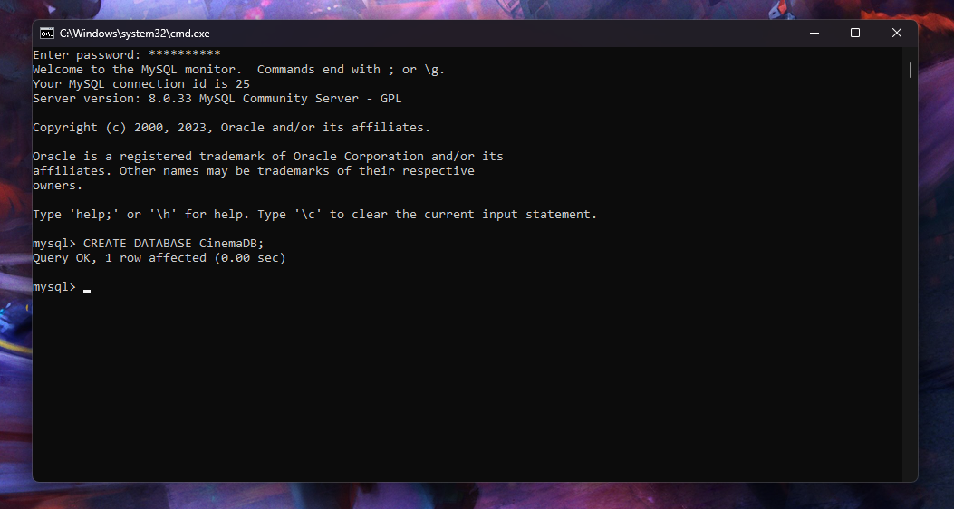

Выбираем БД

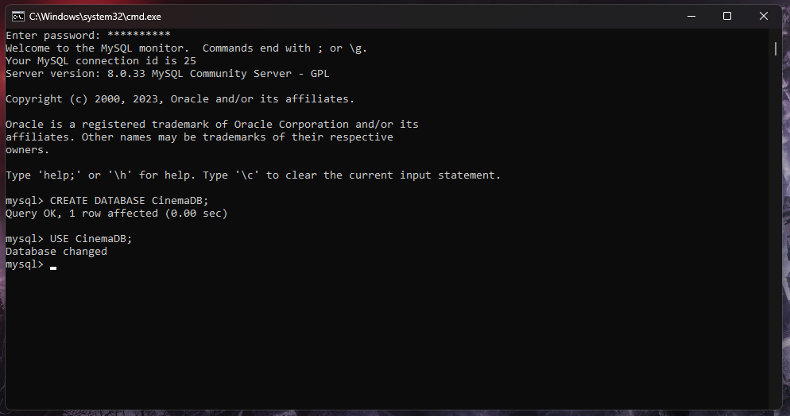

Скрипт создания таблиц:

CREATE TABLE users (

    UserID int PRIMARY KEY,

    FirstName varchar(100),

    LastName varchar(100),

    TelephoneNumber int,

    Email varchar(255),

    UserRole varchar(255)

);

CREATE TABLE films (

    FilmID int PRIMARY KEY,

    FilmName varchar(100),

    Genre varchar(100)

);

CREATE TABLE cinemas (

    CinemaID int PRIMARY KEY,

    CinemaName varchar(100),

    Seat int,

    RowNum int

);

CREATE TABLE sessions (

    SessionID int PRIMARY KEY,

    FilmID int,

    CinemaID int,

    ShowTime int,

    FOREIGN KEY (FilmID) REFERENCES films (FilmID),

    FOREIGN KEY (CinemaID) REFERENCES cinemas (CinemaID)

);

CREATE TABLE tickets (

    TicketID int PRIMARY KEY,

    SessionID int,

    UserID int,

    FOREIGN KEY (SessionID) REFERENCES sessions (SessionID),

    FOREIGN KEY (UserID) REFERENCES users (UserID)

);

CREATE TABLE comments (

    CommentID int PRIMARY KEY,

    UserID int,

    FilmID int,

    CommentBody varchar(800),

    CommentAuthor varchar(100),

    CommentAuthorRole varchar(100),

    FOREIGN KEY (UserID) REFERENCES users (UserID),

    FOREIGN KEY (FilmID) REFERENCES films (FilmID)

);

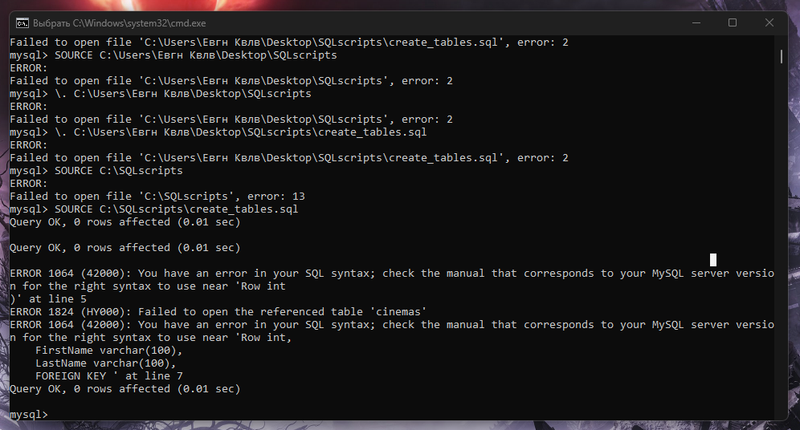

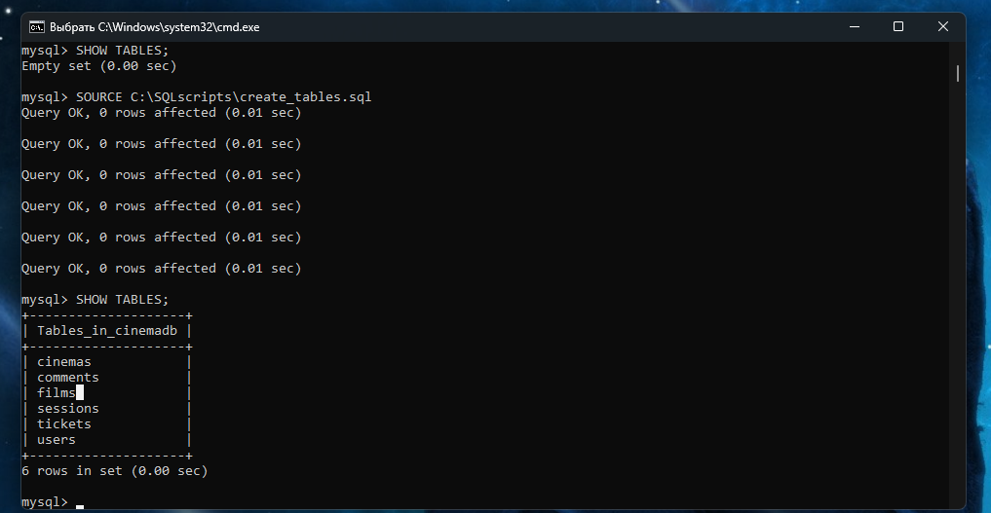

Тесовые значения:  
