ASSIGNMENT 4
Dipika Sharma
2021-04-25

Markdown Basics

Favorite Foods
- Veggie Burger
- Salad
- Pasta

Images
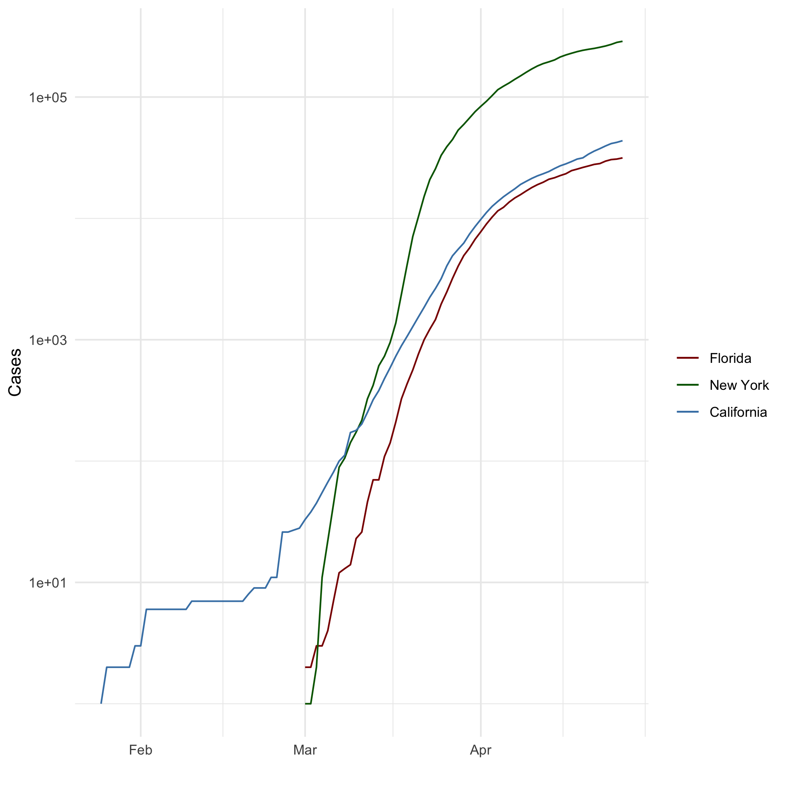
All Cases (Log Plot)

Add a Quote
“Arise, awake, and stop not till the goal is reached.”
— Swami Vivekananda

Add an Equation
- $a^{2}−b^{2}=(a−b)(a+b)$
- $E=mc^{2}$

Add a Footnote
R is a programming language.

Add Citations
- R for Everyone (Lander 2014)
- Discovering Statistics Using R (Field, Miles, and Field 2012)

Inline Code

NY Times COVID-19 Data
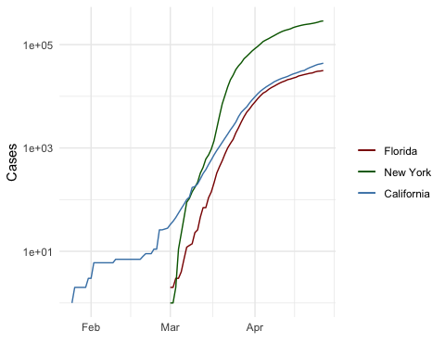

R4DS Height vs Earnings
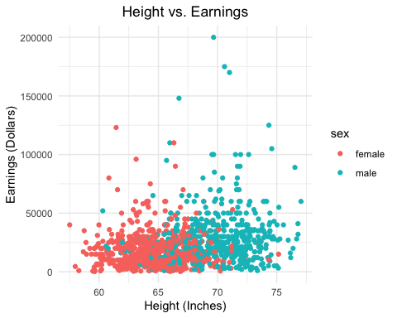

Tables

Knitr Table with Kable
One Ring to Rule Them All
name | race | in_fellowship | ring_bearer | age
Aragon | Men | TRUE | FALSE | 88
Bilbo | Hobbit | FALSE | TRUE | 129
Frodo | Hobbit | TRUE | TRUE | 51
Galadriel | Elf | FALSE | FALSE | 7000
Sam | Hobbit | TRUE | TRUE | 36
Gandalf | Maia | TRUE | TRUE | 2019

One Ring to Rule Them All
name | race | in_fellowship | ring_bearer | age
Aragon | Men | TRUE | FALSE | 88
Bilbo | Hobbit | FALSE | TRUE | 129
Frodo | Hobbit | TRUE | TRUE | 51
Galadriel | Elf | FALSE | FALSE | 7000
Sam | Hobbit | TRUE | TRUE | 36
Gandalf | Maia | TRUE | TRUE | 2019
Legolas | Elf | TRUE | FALSE | 2931
Sauron | Maia | FALSE | TRUE | 7052
Gollum | Hobbit | FALSE | TRUE | 589

Pandoc Table
Name Race In Fellowship? Is Ring Bearer? Age —— ——– —————– —————– —–: Aragon Men Yes No 88 Bilbo Hobbit No Yes 129 Frodo Hobbit Yes Yes 51 Sam Hobbit Yes Yes 36 Sauron Maia No Yes 7052

References
Field, A., J. Miles, and Z. Field. 2012. Discovering Statistics Using r. SAGE Publications. https://books.google.com/books?id=wd2K2zC3swIC.
Lander, J. P. 2014. R for Everyone: Advanced Analytics and Graphics. Addison-Wesley Data and Analytics Series. Addison-Wesley. https://books.google.com/books?id=3eBVAgAAQBAJ.

The R language is widely used among statisticians and data miners for developing statistical software and data analysis.

