Heat disspation is challenging electronic systems in：

1. Lifetime and Reliability: 1 Cesius rise in junction temp. Leads to 5% decline in lifetime, and it causes nearly 50% damage.
2. Power output: devices can‘t work at full power.
3. External energy cost: nearly 1.5 times total electricity consumption to cool down devices.

Current Semiconductor IC:

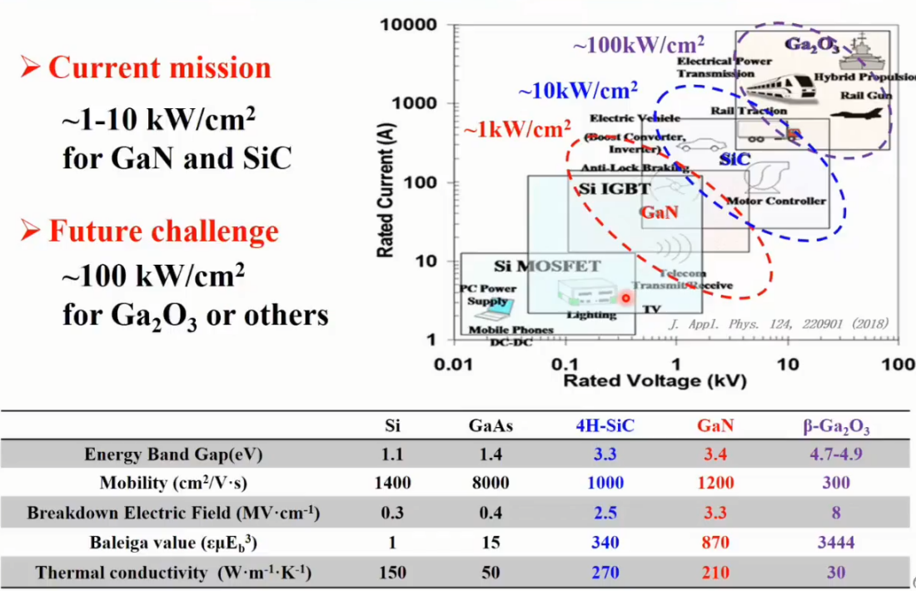

Typical cooling technologies

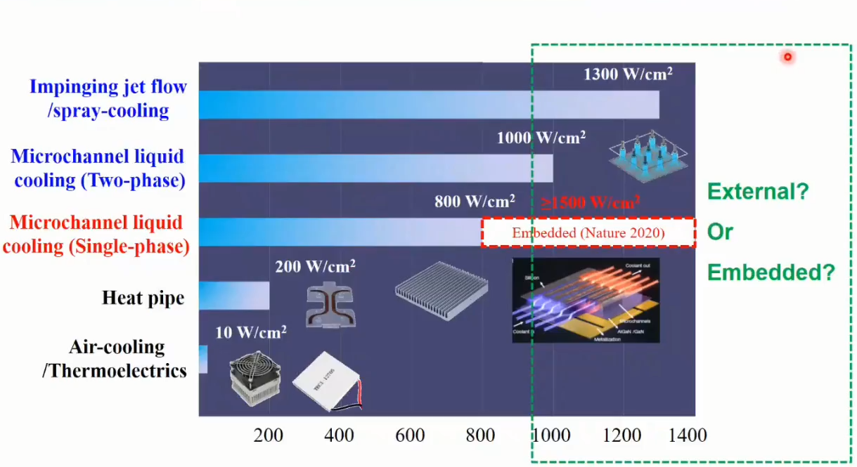

Je näher der Cooler zur Hitzequellen liegt, desto effizienter.

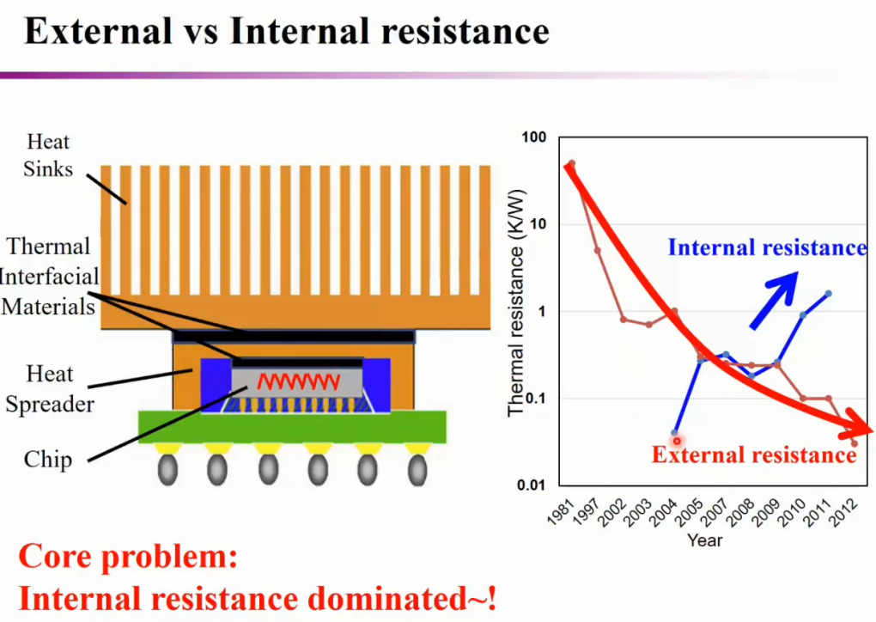

Nowadays dominates the internal resistance

Example of thermal resistance analyses of GaN IC

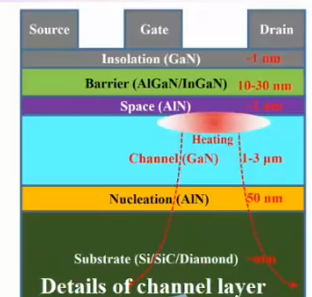

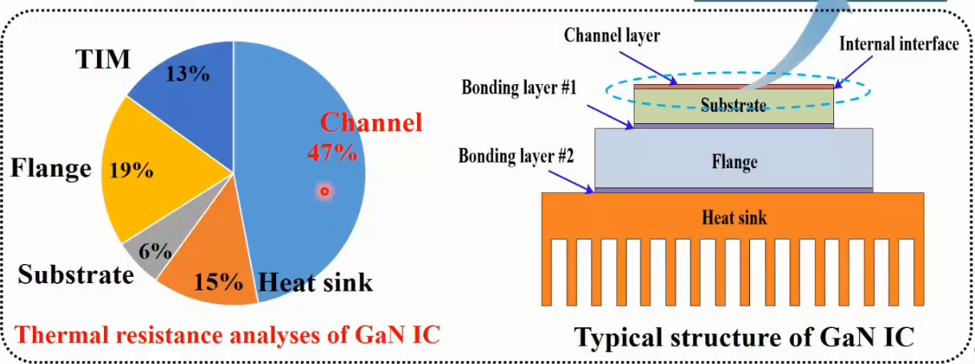

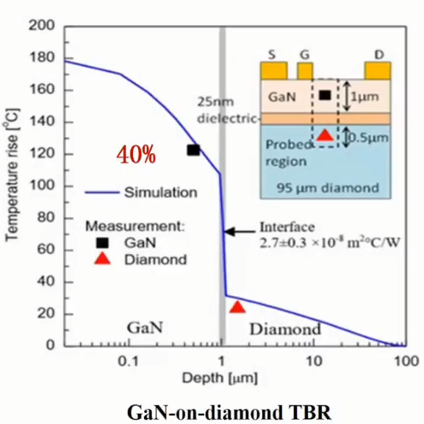

Theoretische Grundlagen von dem elastocalorischen Material