IMPLIMENTING A
NEURAL NETWORK MODEL
TO LEARN
TO PLAY CART-POLE

Introduction to Machine Learning

Machine learning is an application of artificial intelligence (AI) that provides systems the ability to automatically learn and improve from experience without being explicitly programmed. Machine learning focuses on the development of computer programs that can access data and use it learn for themselves.

The process of learning begins with observations or data, such as examples, direct experience, or instruction, in order to look for patterns in data and make better decisions in the future based on the examples that we provide. The primary aim is to allow the computers learn automatically without human intervention or assistance and adjust actions accordingly.

What are neural networks?

Artificial neural networks (ANNs) are computing systems vaguely inspired by the biological neural networks that constitute animal brains.Such systems "learn" (i.e. progressively improve performance on) tasks by considering examples, generally without task-specific programming.

An ANN is based on a collection of connected units or nodes called artificial neurons (a simplified version of biological neurons in an animal brain). Each connection (a simplified version of a synapse) between artificial neurons can transmit a signal from one to another. The artificial neuron that receives the signal can process it and then signal artificial neurons connected to it.

OpenAI Gym

Cart-PoleV1

About OpenAI

OpenAI is a non-profit artificial intelligence (AI) research company that aims to promote and develop friendly AI in such a way as to benefit humanity as a whole. The organization aims to "freely collaborate" with other institutions and researchers by making its patents and research open to the public.

Gym is a toolkit for developing and comparing reinforcement learning algorithms. The gym library is a collection of test problems — environments — that you can use to work out your reinforcement learning algorithms. These environments have a shared interface, allowing you to write general algorithms

Our own agent can be written using your existing numerical computation library, such as TensorFlow or Theano.

In the following project we shall be following the agent-environment loop as shown below:
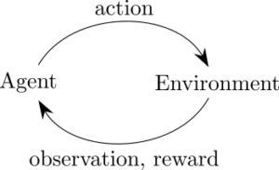

About CartPole:

A pole is attached by an un-actuated joint to a cart, which moves along a frictionless track. The system is controlled by applying a force of +1 or -1 to the cart. The pendulum starts upright, and the goal is to prevent it from falling over. A reward of +1 is provided for every timestep that the pole remains upright. The episode ends when the pole is more than 15 degrees from vertical, or the cart moves more than 2.4 units from the center.

This environment corresponds to the version of the cart-pole problem described by Barto, Sutton, and Anderson("Neuronlike Adaptive Elements That Can Solve Difficult Learning Control Problem", IEEE Transactions on Systems, Man, and Cybernetics, 1983).

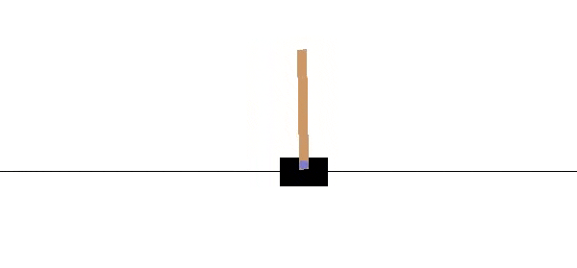

Key Terms and Functions

Activation Functions

They introduce non-linear properties to our Network.Their main purpose is to convert a input signal of a node in a A-NN to an output signal. That output signal now is used as a input in the next layer in the stack.

The activation functions used in the program are:

1)Softmax or Sigmoid or Logistic Activation Function

The main reason why we use sigmoid function is because it exists between (0 to Therefore, it is especially used for models where we have to predict the probability as an output.Since probability of anything exists only between the range of 0 and 1, sigmoid is the right choice.
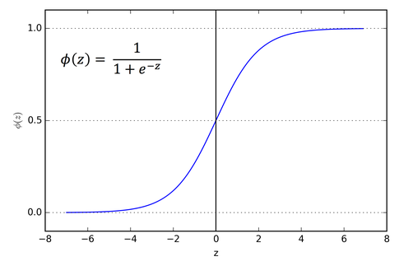

2)Rectified Linear Units(ReLU)

The Rectified Linear Unit is the most commonly used activation funciton in deep learning models.A rectified linear unit has output 0 if the input is less than 0, and raw output otherwise. That is, if the input is greater than 0, the output is equal to the input.

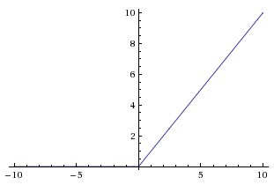

Loss Function:

Categorical Cross Entropy :

Cross-entropy loss, or log loss, measures the performance of a classification model whose output is a probability value between 0 and 1. Cross-entropy loss increases as the predicted probability diverges from the actual label. So predicting a probability of .012 when the actual observation label is 1 would be bad and result in a high loss value. A perfect model would have a log loss of 0.
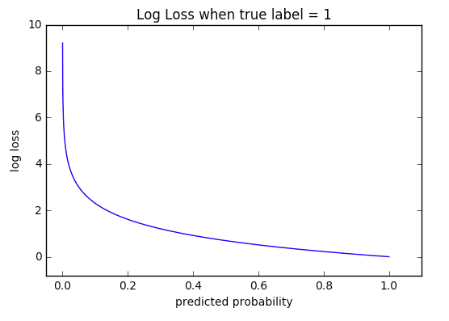
Adam Optimizer

(the name Adam is derived from adaptive moment estimation)
Adam is an optimization algorithm that can used instead of the classical stochastic gradient descent procedure to update network weights iterative based in training data.Adam is different to classical stochastic gradient descent.Stochastic gradient descent maintains a single learning rate (termed alpha) for all weight updates and the learning rate does not change during training.
A learning rate is maintained for each network weight (parameter) and separately adapted as learning unfolds.

