Ventura, Robert R. C335IT
2023-1-01666 October 14, 2025
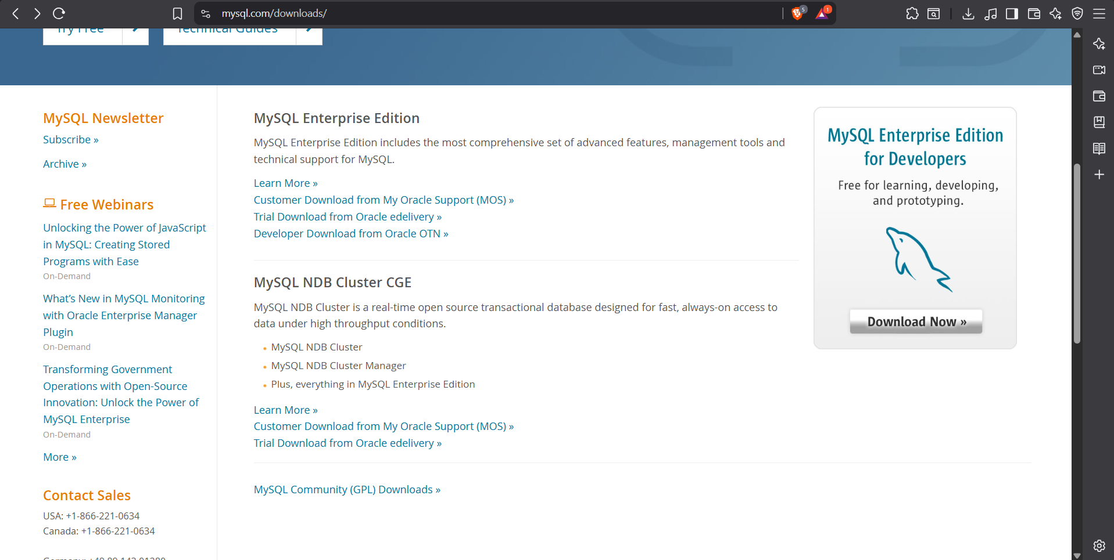
Visit https://www.mysql.com/downloads/ and click on MySQL Community (GPL) Downloads »
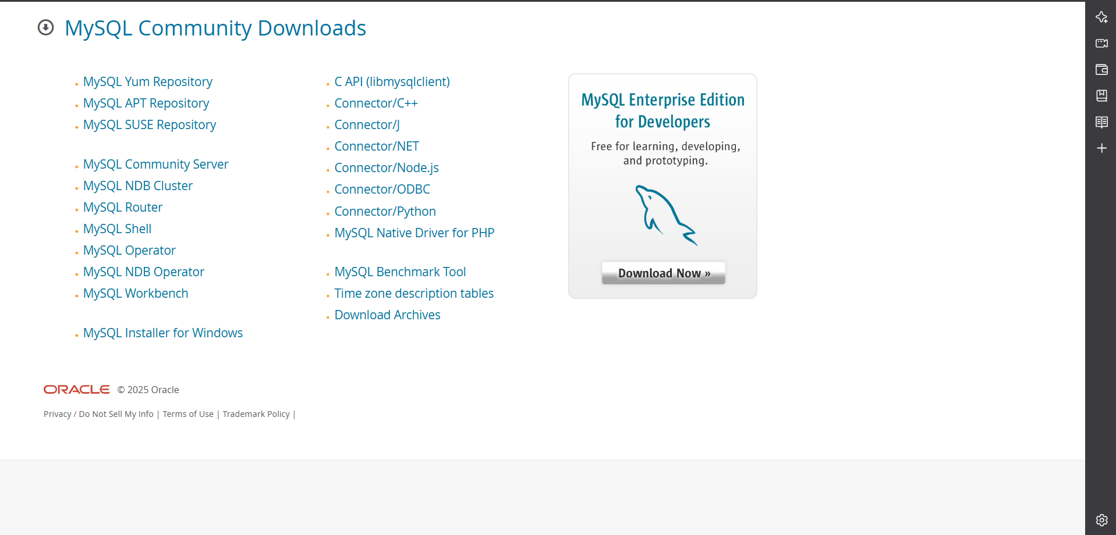
Click on MySQL Installer for Windows
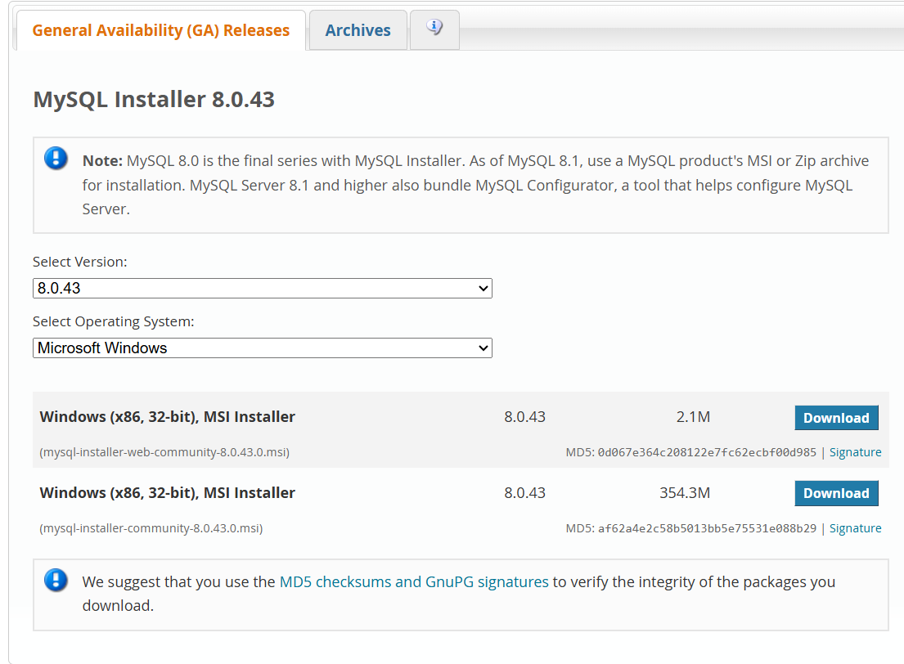
Click on the second one

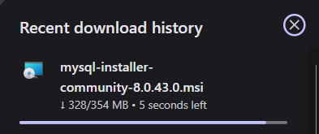
Wait for it to finish

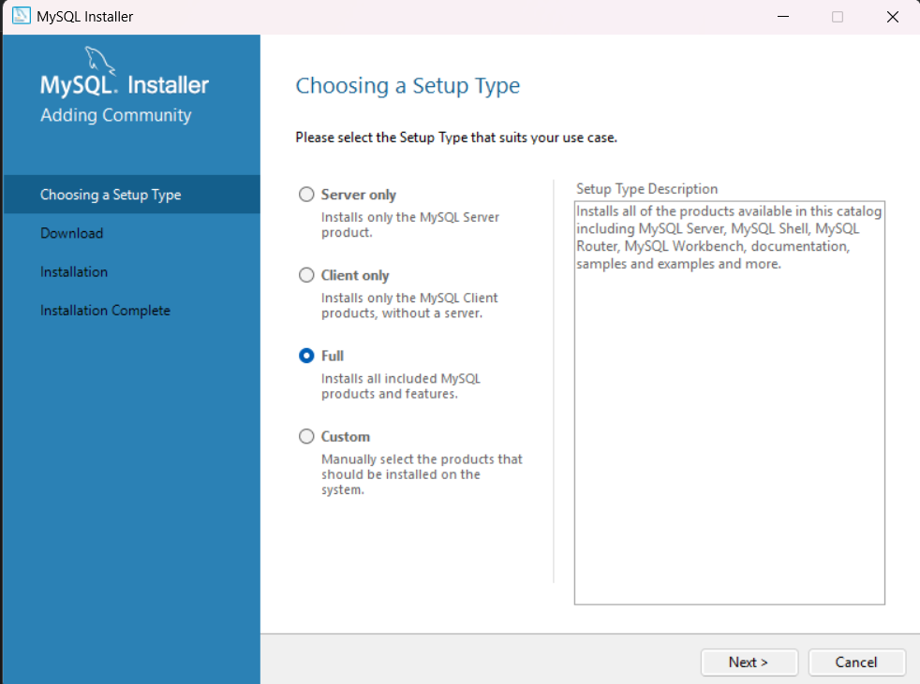

After setting it up, click on full and there you go.
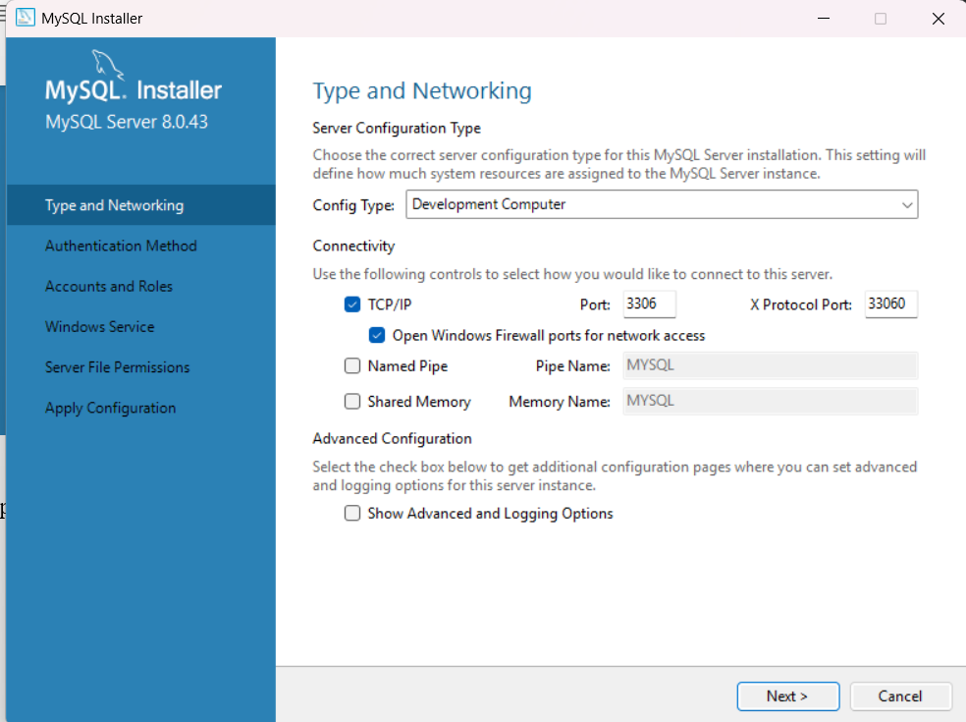

Configure.
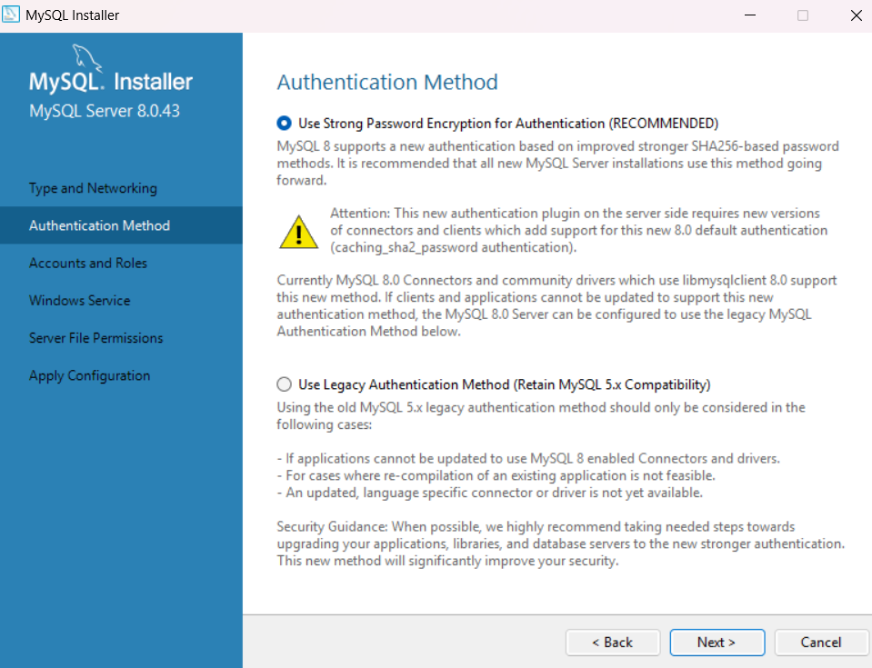

Choose the recommended

