Ventura, Robert R. C335IT
2023-1-01666 October 14, 2025

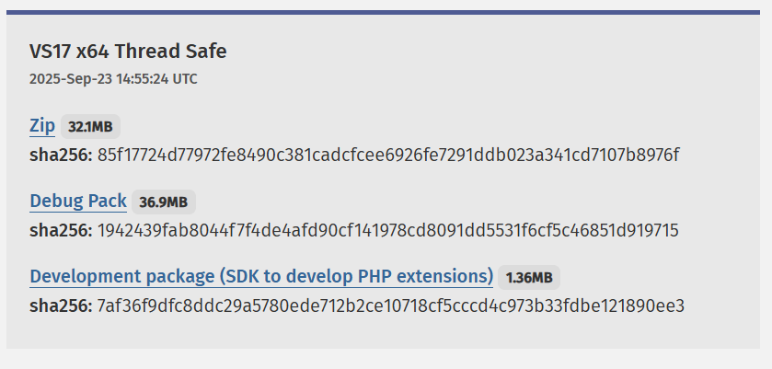
Go to https://www.php.net/downloads.php and click on Zip on the Thread Safe

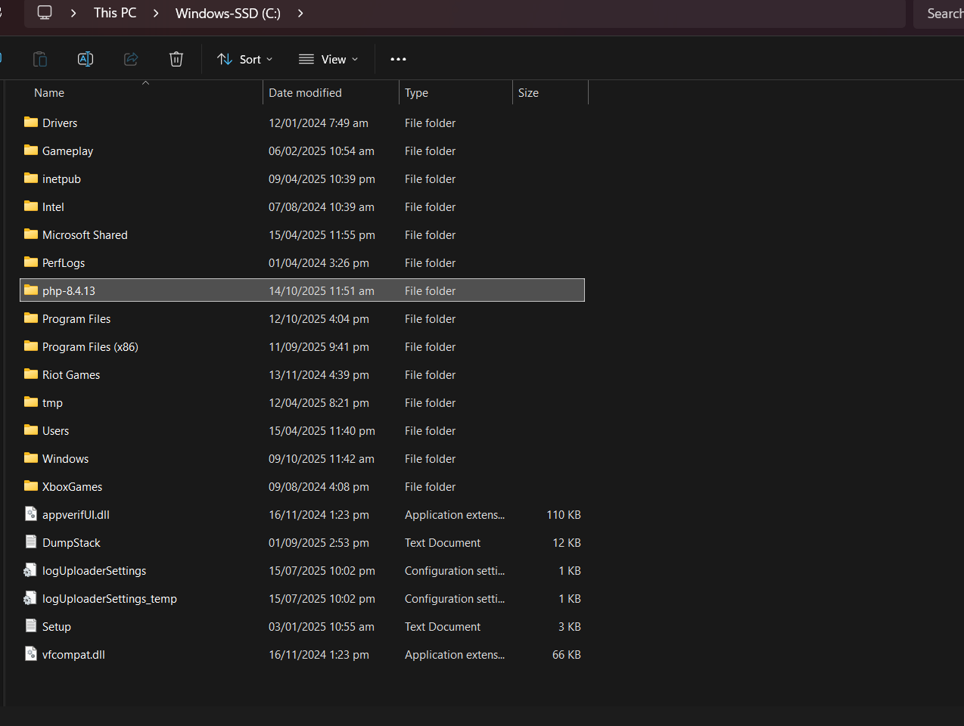
After downloading, extract the file and then rename the folder to it’s version, and paste it in the C drive of your device
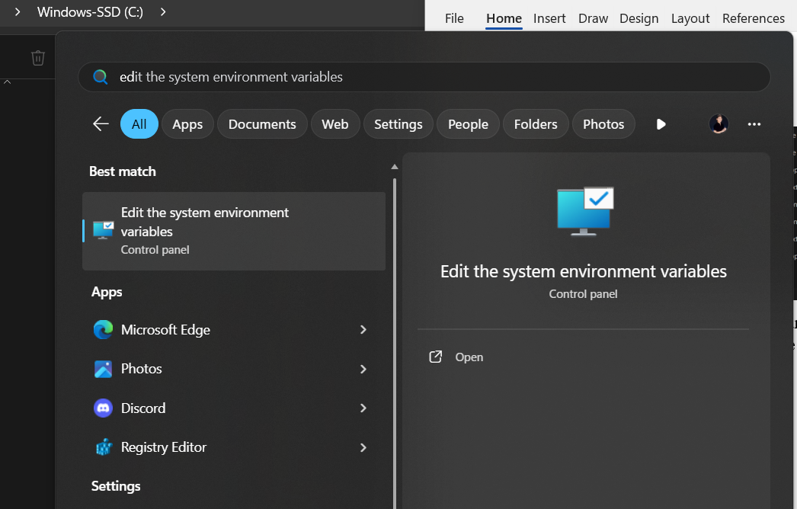
Open the Edit the system environment variables and edit that

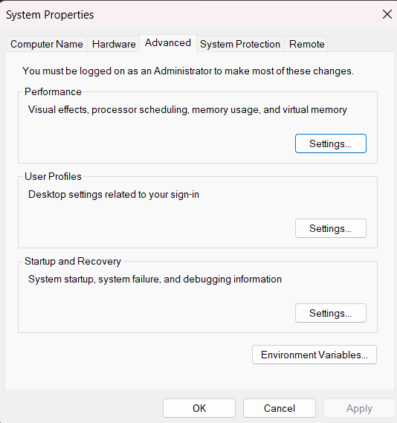
Click on “Environment Variables”
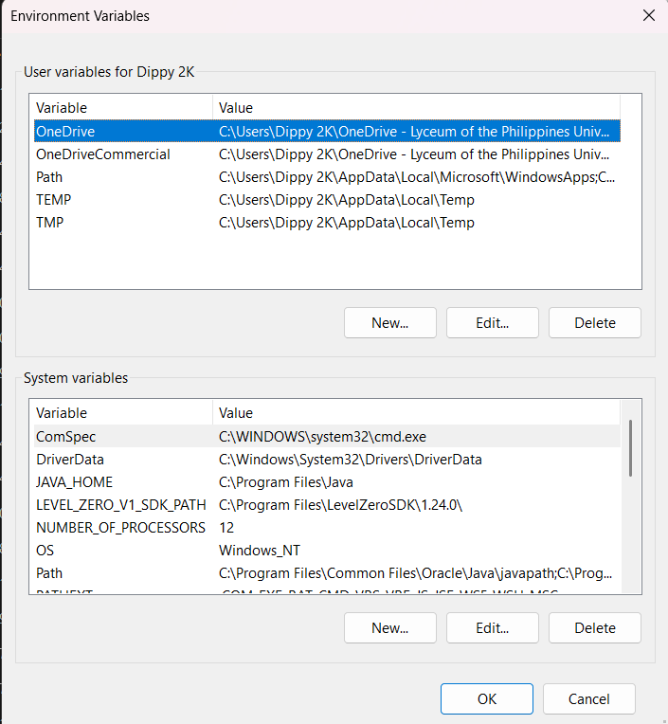
Choose “Path” on either side the top or bottom if you want to allow it for the whole pc (multiple users) choose System variables, if only for the current user, choose “Path” on the top side.

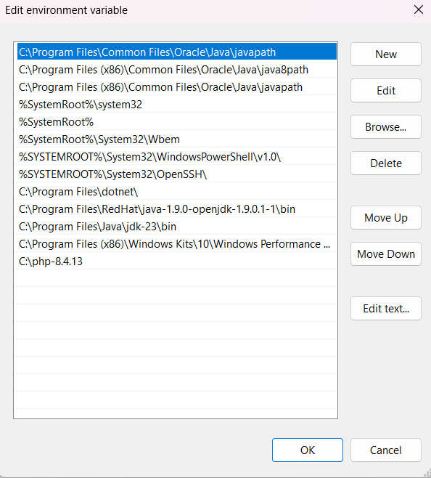
Click on the bottom of the last text, which should be blank and copy and paste the path directory of the php in your C drive there and click “OK”

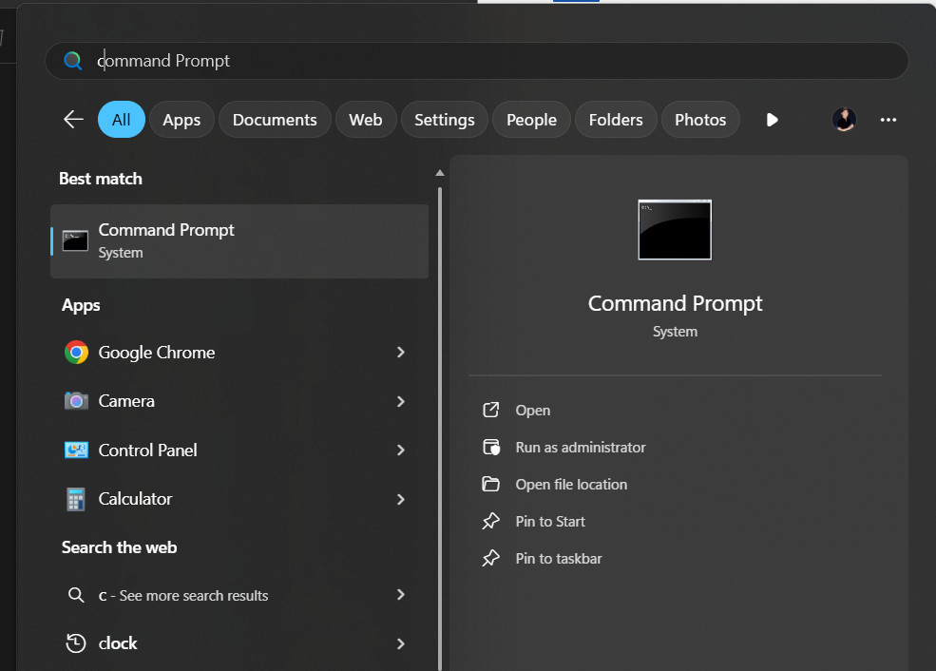
To verify if successful, open Command Prompt, and type
php --version
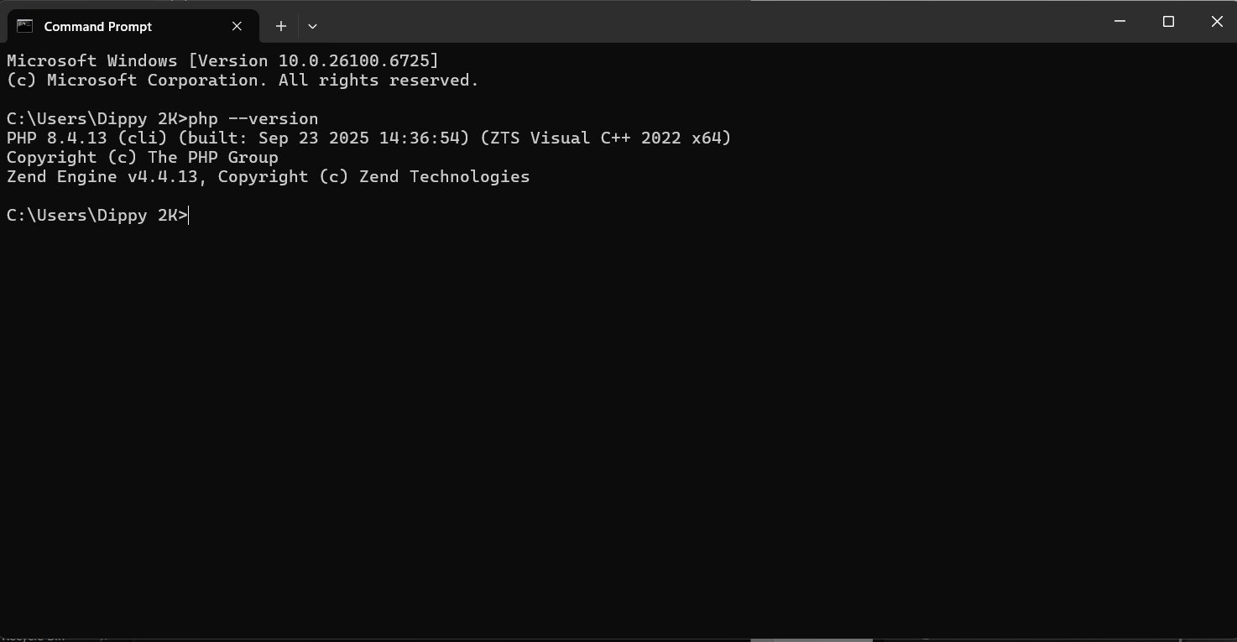
This should appear

