Ventura, Robert R. C335IT
2023-1-01666 October 14, 2025
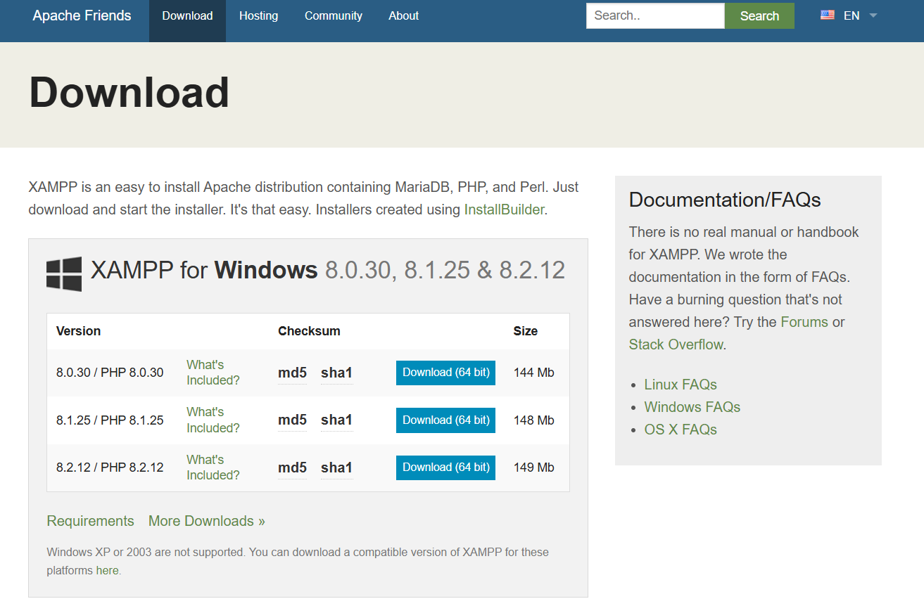
Click on the 8.0.20

