

**UML Diagrams**

**| Activity Diagram | Sequence Diagram | Deployment Diagrams**

**Name: Dipesh Bhattarai**

**University ID: 2357842**

1. **Deployment Diagram**

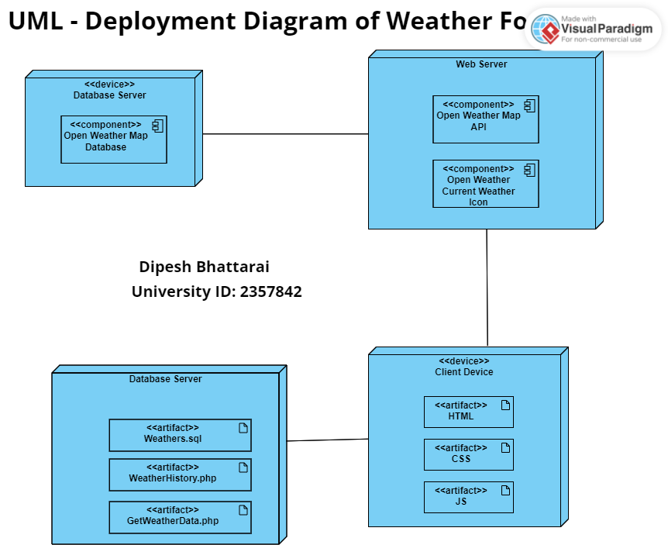

1. **Sequence Diagram**

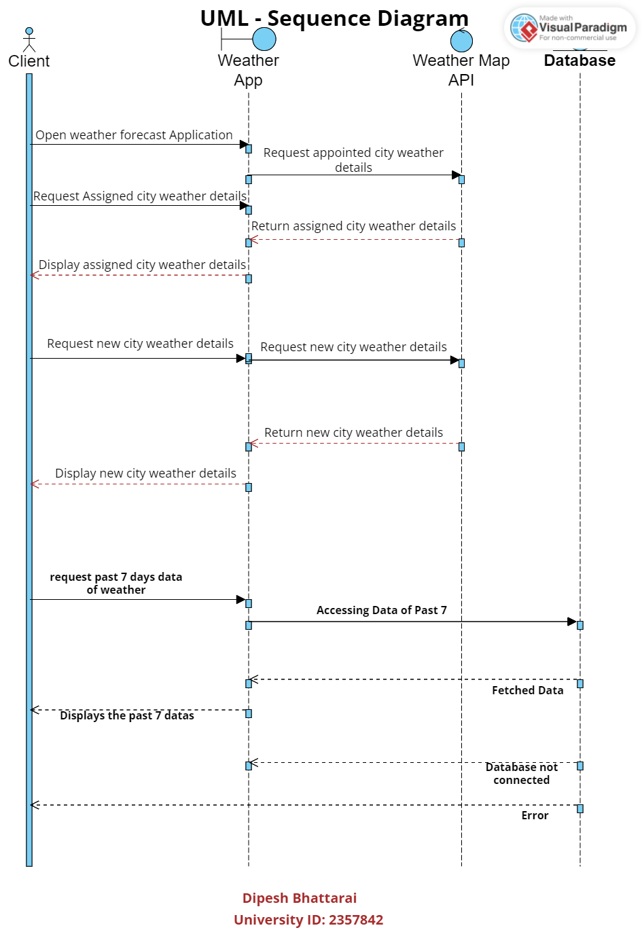

1. **Activity Diagram**

