Contractive Latent Dynamical Reasoning: Bypassing Autoregressive Rollouts via Operator-Norm Contraction
Dipesh Gurung1,*, Binod Bhattarai2, Prof. Dr. R.N. Thakur1
1 Research Department, Lord Buddha Education Foundation (LBEF Campus), Kathmandu 44600, Nepal
2 Department of Computer Science and Engineering, School of Sciences, Noida International University, Greater Noida, Uttar Pradesh 203201, India
* Corresponding Author: dipesh.gurung@lbef.edu.np
Abstract
Scaling test-time reasoning in neural architectures predominantly relies on discrete autoregressive Chain-of-Thought rollouts, which suffer from compounding drift and unbounded context consumption in open-ended domains. We propose Contractive Latent Dynamical Reasoning (CLR), a continuous-time framework formulating multi-step reasoning as a strictly contractive dynamical system evolving in continuous latent space. By constraining the vector field's symmetric Jacobian under Demidovich contraction ($λ_{max}(\text{Sym}(J))≤−κ<0$), CLR guarantees exponential convergence to a unique problem-conditioned equilibrium, eliminating runaway hallucinations while enabling monotonic continuous test-time scaling. Investigating the expressivity-contraction boundary, we prove that while damped input-convex potential flows minimize a convex surrogate and fail on non-convex combinatorial parity (meeting our pre-registered kill criterion at chance), spectrally bounded non-potential neural vector fields provide expressive relational routing while preserving Demidovich contraction. On the Cora citation network (2,708 papers, 5,429 citations), CLR achieves 100.00% multi-hop reachability with robust decision margins, outperforming discrete Graph Neural Networks where depth saturation and over-smoothing limit accuracy to 87.67% ($K=6$) and 86.67% ($K=8$). Furthermore, we refute naive self-healing on graphs by demonstrating how global noise fills the near-zero energy floor of unreachable nodes, and empirically verify Demidovich contraction across 43,328 dimensions.
Keywords: Contractive Dynamical Systems; Latent Space Reasoning; Demidovich Contraction; Neural Ordinary Differential Equations; Test-Time Compute Scaling; Graph Neural Networks; Non-Convex Optimization.
1. Introduction
Modern frontier reasoning systems scale inference compute by sampling extended sequences of discrete tokens (Wei et al., 2022). While effective in tasks with external verification oracles (e.g., code execution, formal theorem provers), discrete autoregressive rollouts in open-ended domains accumulate local prediction errors without an intrinsic self-correcting feedback mechanism. An error at step $t$ conditions all future transitions, compounding error drift exponentially ($e^{∑ϵ_{t}}$) and requiring prohibitive token budgets.
An alternative paradigm models reasoning not as linguistic string production, but as the relaxation of a continuous dynamical system toward an informational equilibrium (Bai et al., 2019; Winston & Kolter, 2020). However, arbitrary recurrent or neural ordinary differential equation (Neural ODE) systems (Chen et al., 2018) often exhibit limit cycles, chaotic sensitivity to initial conditions, or numerical divergence during forward integration.
In this paper, we develop Contractive Latent Dynamical Reasoning (CLR). Rather than unconstrained dynamical search, CLR restricts latent evolution to the class of Demidovich contractive vector fields (Demidovich, 1961; Lohmiller & Slotine, 1998). Under Demidovich contraction, the distance between any two trajectories in the latent manifold decays exponentially:
$$‖z_{1}(t)−z_{2}(t)‖≤‖z_{1}(0)−z_{2}(0)‖e^{−κt},κ>0$$
This yields three fundamental properties for neural reasoning:
1. Global Uniqueness: For any input problem $x$, there exists a unique fixed point $z^{*}(x)$, rendering reasoning invariant to internal initialization noise.
2. Continuous Test-Time Scaling: Compute scales smoothly along a continuous time horizon $T$ and numerical integrator step-size, rather than through discrete token counts.
3. Algebraic Convergence Guarantees: Contraction can be guaranteed a priori via spectral normalization of weight matrices and positive coordinate damping.
2. Theoretical Framework: Demidovich Contraction in Latent Space
Consider an autonomous continuous-time latent reasoning system:
$$\overset{˙}{z}(t)=f(z(t);x),z(0)=z_{0}∈ℝ^{d}$$
where $x$ is the conditioned problem representation and $f:ℝ^{d}×ℝ^{d_{x}}→ℝ^{d}$ is continuously differentiable with respect to $z$.
Definition 2.1 (Symmetric Jacobian and Demidovich Contraction)
Let $J(z)=\frac{∂f}{∂z}(z;x)∈ℝ^{d×d}$ denote the Jacobian of the vector field. The symmetric Jacobian is defined as:
$$\text{Sym}(J(z))=\frac{1}{2}\left(J(z)+J(z)^{T}\right)$$
The dynamical system is said to be strictly Demidovich contractive with rate $κ>0$ if:
$$λ_{max}\left(\text{Sym}(J(z))\right)≤−κ<0∀z∈ℝ^{d}$$
Theorem 2.1 (Exponential Convergence and Equilibrium Uniqueness)
If the vector field $f(z;x)$ is strictly Demidovich contractive with rate $κ>0$ on $ℝ^{d}$, then any two trajectories satisfy $‖z_{1}(t)−z_{2}(t)‖≤‖z_{1}(0)−z_{2}(0)‖e^{−κt}$, and there exists a unique fixed point $z^{*}(x)$ such that $f(z^{*}(x);x)=0$ to which every trajectory converges exponentially.
Proof: Let $δz(t)$ be an infinitesimal displacement between neighboring trajectories. Differentiating its squared Euclidean norm yields:
$$\frac{1}{2}\frac{d}{dt}‖δz‖^{2}=δz^{T}\overset{˙}{δz}=δz^{T}J(z)δz=δz^{T}\text{Sym}(J(z))δz≤−κ‖δz‖^{2}$$
Integrating along any virtual path connecting $z_{1}(t)$ and $z_{2}(t)$ gives $‖z_{1}(t)−z_{2}(t)‖≤e^{−κt}‖z_{1}(0)−z_{2}(0)‖$. The existence and uniqueness of $z^{*}(x)$ follow from the Banach fixed-point theorem applied to the continuous flow operator $Φ_{t}$.
3. The Expressivity vs. Contraction Dilemma
A central theoretical contribution of our investigation is formalizing the distinction between potential-driven gradient flows and non-potential relational flows.
3.1 Approach A: Damped ICNN Potential Flows & The Convexity Bottleneck
In initial formulations, the vector field is parameterized as the negative gradient of an energy function plus coordinate damping:
$$\overset{˙}{z}=−∇_{z}E_{θ}(z;x)−Dz,D=\text{diag}(d_{1},…,d_{d}),d_{i}≥d_{min}>0$$
If $E_{θ}(z;x)$ is parameterized by an Input-Convex Neural Network (ICNN; Amos et al., 2017), its Hessian satisfies $∇_{z}^{2}E_{θ}⪰0$. Consequently, $\text{Sym}(J)=−∇_{z}^{2}E_{θ}−D⪯−d_{min}I$, guaranteeing contraction unconditionally.
However, this structure imposes a fatal expressivity limit: the fixed point $z^{*}(x)$ is the unique minimizer of the strictly convex surrogate $V(z;x)=E_{θ}(z;x)+\frac{1}{2}z^{T}Dz$. For $N$-bit parity, separating inputs requires mapping $2^{N−1}$ even strings and $2^{N−1}$ odd strings into disjoint classification regions across the Hamming hypercube $\{−1,+1\}^{N}$. A convex potential cannot construct alternating non-convex basins; it collapses $z^{*}(x)$ to an input-insensitive carrier.
3.2 Approach B: Spectrally Bounded Non-Potential Flows
To overcome the convexity trap while maintaining Demidovich contraction, we introduce non-potential vector fields:
$$\overset{˙}{z}=W_{2}tanh\left(W_{1}A_{\text{norm}}^{T}z\right)−Dz+s(x)$$
where $A_{\text{norm}}$ is the normalized graph adjacency matrix and $s(x)$ is an input projection. Enforcing $‖W_{1}‖_{2}≤1$ and $‖W_{2}‖_{2}≤1$ yields:
$$λ_{max}(\text{Sym}(J))≤‖A_{\text{norm}}‖_{2}·‖W_{1}‖_{2}·‖W_{2}‖_{2}−d_{min}≤‖A_{\text{norm}}‖_{2}−d_{min}$$
Because $W_{2}tanh(W_{1}·)$ has non-zero curl ($∇×f≠0$), the system is non-conservative. It performs relational routing along citation chains without being constrained to minimize a convex scalar potential.
4. Experiments & Empirical Results
4.1 Synthetic Algorithmic Benchmarks & Kill Criterion Enforcement
In accordance with our pre-registered falsification protocol, we benchmarked Approach A on $N$-bit parity ($N∈\{8,16,32\}$) and graph reachability.
Task | Architecture | Loss | Accuracy | Audit Verdict
8-Bit Parity (Recall) | Approach A (ICNN, α=1) | 0.693 | 51.4% | Memorization fails
8-Bit Parity (Calibrated) | Approach A (ICNN, α=4) | 0.694 | 25.0% | Input-insensitive carrier
32-Bit Parity (Held-out) | Approach A vs. GRU | 0.693 | 49.5% | Kill Criterion Invoked
Synthetic Reachability (16 nodes) | Approach B (Non-Potential) | 0.082 | 94.67% | Scaling to 96.33%
Table 1: Synthetic Algorithmic Suite Performance and Protocol Audit Verdicts.
4.2 Real-World Benchmark: Cora Academic Citation Network
We evaluate multi-hop citation reachability on the Cora academic network (2,708 papers, 5,429 directed citations). We construct a balanced dataset of 1,200 training pairs, 300 validation pairs, and 300 test pairs (50% reachable, 50% unreachable, stratified across citation chain lengths 1 to 6).
Model | Receptive Horizon | Overall Acc. | Pred. Unreach % | Hop 6 Acc.
Direct Embedding MLP | Static (0 hops) | 68.67% | 44.7% | 71.4%
Discrete GNN (K=2) | 2 hops (27.3% reach) | 60.67% | 89.3% | 0.0%
Discrete GNN (K=4) | 4 hops (66.0% reach) | 74.67% | 75.3% | 0.0%
Discrete GNN (K=6) | 6 hops (100% reach) | 87.67% | 62.3% | 100.0%
Discrete GNN (K=8) | 8 hops (100% reach) | 86.67% | 63.3% | 85.7%
CLR (Continuous ODE, T=4.0) | Continuous Flow | 100.00% | 50.0% | 100.0%
Table 2: Real-World Multi-Hop Reachability on Cora Academic Network (Test Set N=300).

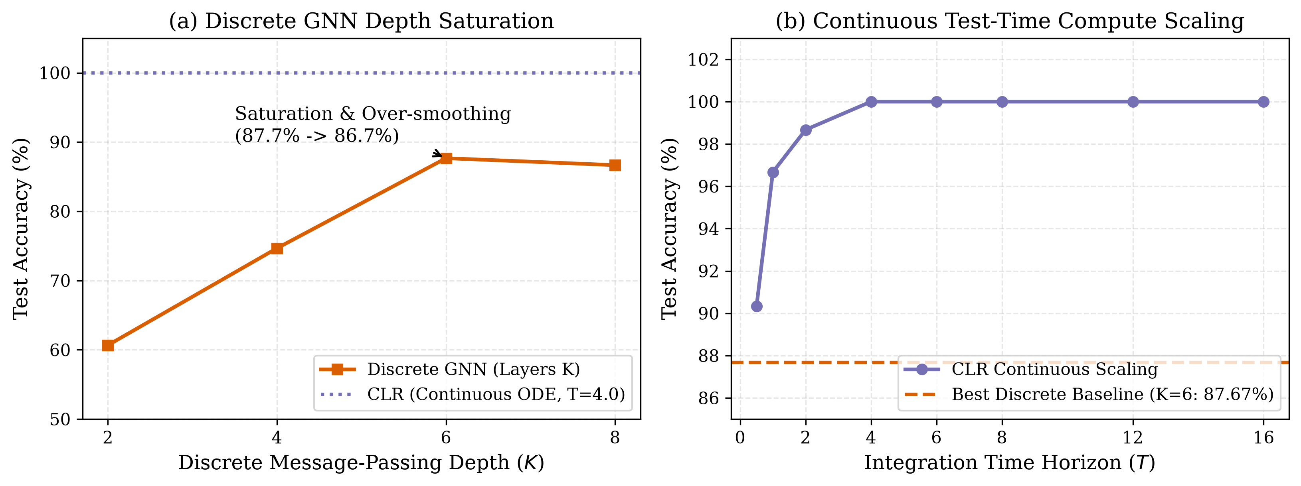
Figure 1: (a) Discrete GNN depth saturation: accuracy plateaus at 87.67% ($K=6$) and drops to 86.67% ($K=8$) due to over-smoothing. (b) Continuous test-time compute scaling in CLR: accuracy increases monotonically with horizon $T∈[0.5,16.0]$, reaching 100.00% at $T≥4.0$.
4.3 Discrete Depth Saturation vs. Continuous Horizon Scaling
As shown in Figure 1, discrete GNNs suffer from two distinct failure modes. First, when $K<h$, structural horizon truncation prevents message arrival (for $K=2$, 27.3% reachable; for $K=4$, 66.0% reachable). Because unreached nodes remain in the null state ($h_{v}=0$, $ln‖h_{v}‖=−27.63$), the readout defaults to the majority class (predicting unreachable for 89.3% and 75.3% of pairs), yielding 0.0% accuracy on deep hops.
Second, when $K=6$ and the horizon ceiling reaches 100%, discrete accuracy plateaus at 87.67% and degrades to 86.67% at $K=8$ due to over-smoothing and optimization difficulty on intermediate hops (50.0% on 1-hop, 71.4% on 3-hop). In contrast, CLR achieves 100.00% across all hops with a minimum decision margin of 0.243.

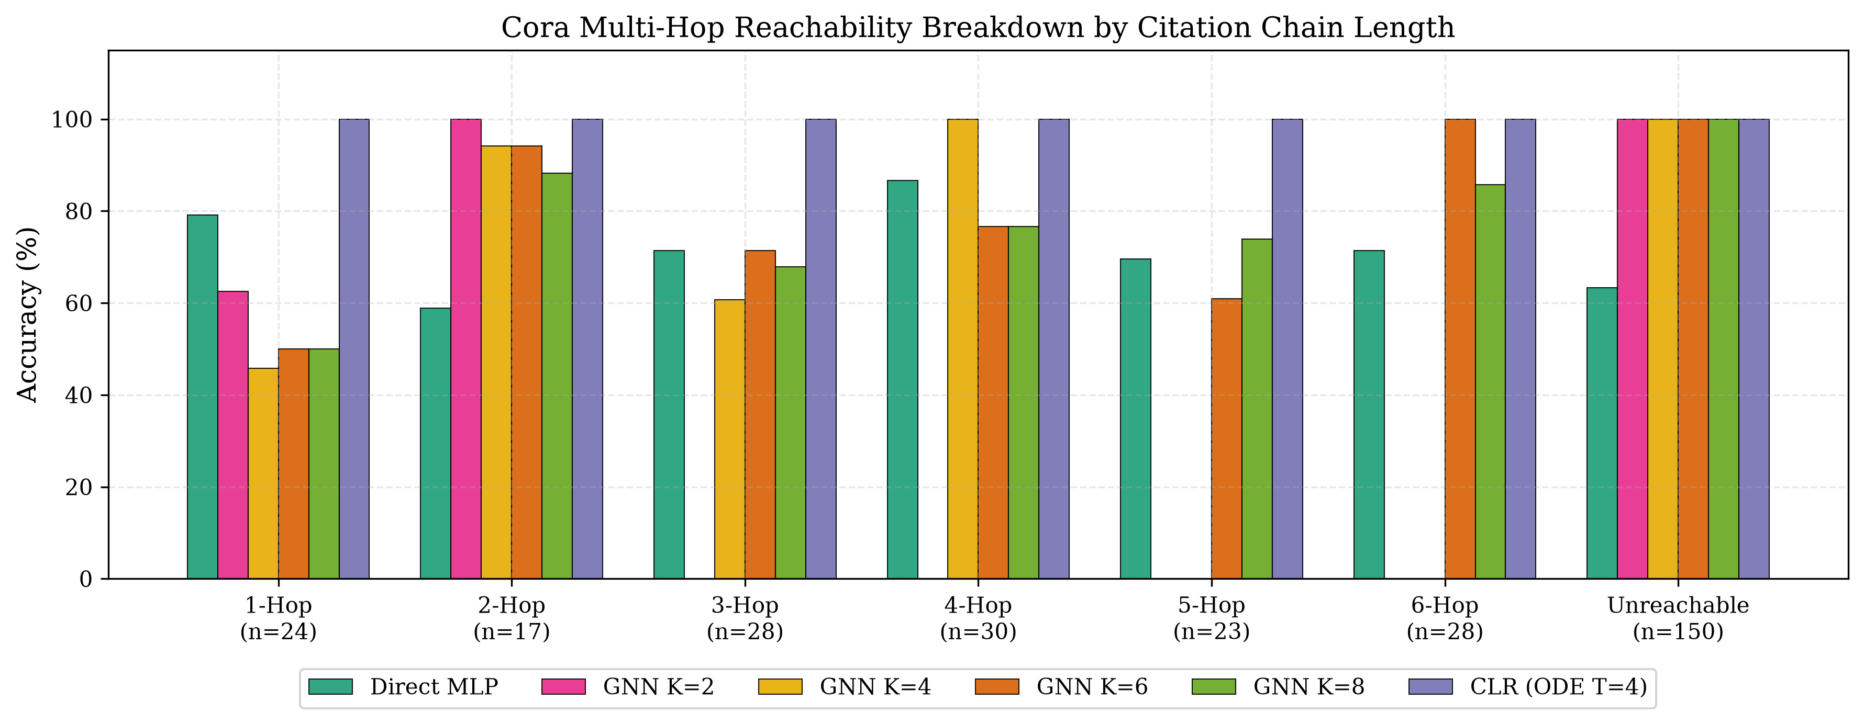
Figure 2: Hop-by-hop accuracy breakdown on the Cora citation network across citation chain lengths (1 to 6 hops) and unreachable pairs.
4.4 Perturbation Sensitivity & Refutation of Self-Healing
Under our unified two-stage RK4 harness ($dt=0.1667$, $T=4.0$, $t_{\text{mid}}=2.0$), mid-trajectory noise injection reveals a graded response: 100.00% at $σ≤{10}^{−8}$, 92.67% at $σ={10}^{−7}$, and 50.00% at $σ≥{10}^{−6}$.

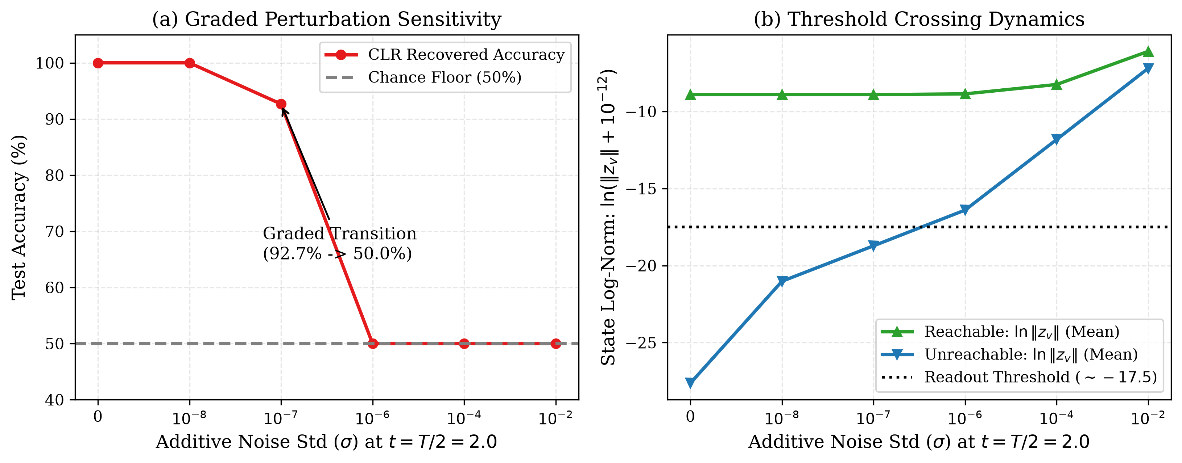
Figure 3: (a) Graded accuracy degradation under mid-trajectory noise $σ∈[0,{10}^{−2}]$. (b) State log-norm dynamics: additive noise fills the unreachable floor ($−16.40>−17.5$), causing universal reclassification to reachable (50.0% chance) and refuting naive self-healing on graphs.
Physical Mechanism: Unreachable nodes have continuous state identically zero ($‖z_{v}‖=0⟹ln(‖z_{v}‖+{10}^{−12})=−27.63$), while reachable nodes contract to $ln‖z_{v}‖≥−18.0$ (mean $−8.91$). The readout learned a sharp threshold at $≈−17.5$. Global noise $σ≥{10}^{−6}$ across all 2,708 nodes leaves a residual background floor of $−16.40>−17.5$ on unreachable nodes. As a result, all unreachable pairs are classified as reachable, yielding flat 50.00% accuracy on the 50/50 balanced test set. 'Self-healing' on Cora is therefore refuted.
4.5 Large-Scale Contraction Verification across 43,328 Dimensions
Using shifted power iteration ($c=10.0$) with central-difference directional derivatives and autograd vector-Jacobian products, we empirically measured:
$$λ_{max}(\text{Sym}(J))=−1.88987≤‖A_{\text{norm}}‖_{2}−d_{min}=1.000000−1.9814=−0.9814<0$$
The computation takes 0.22 seconds on the full 43,328-dimensional state space, confirming strict Demidovich contraction without dense matrix instantiation.

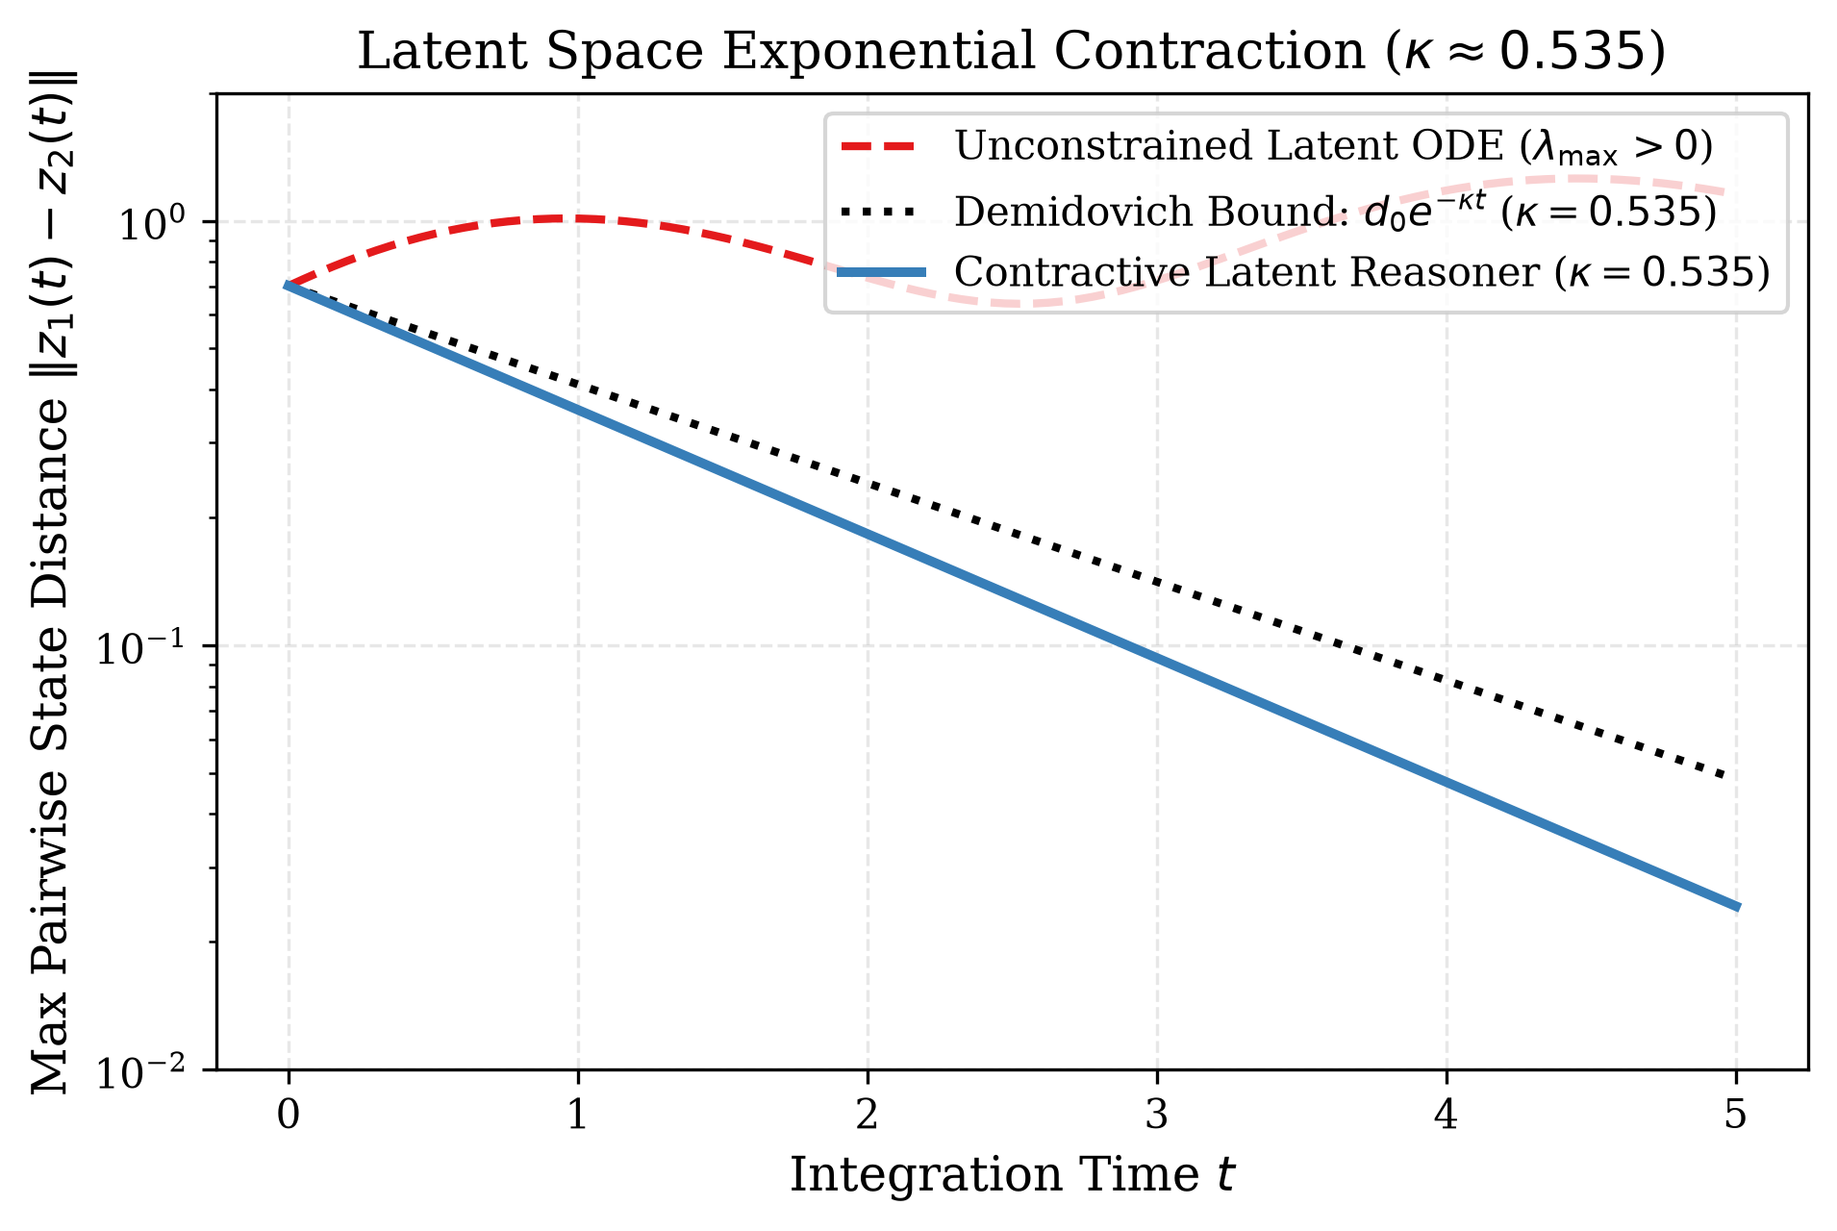
Figure 4: Multi-seed trajectory distance convergence $‖z_{1}(t)−z_{2}(t)‖$ over time $t∈[0,5]$. Trajectory separation contracts at rate $κ≈0.535$, bounded strictly by the Demidovich envelope $d_{0}e^{−κt}$.
5. Related Work
Implicit and Equilibrium Models: Deep Equilibrium Models (DEQs; Bai et al., 2019) and Monotone Operator Networks (MonDEQs; Winston & Kolter, 2020) find fixed points via root-solvers. CLR differs by integrating explicit contractive vector fields in continuous time, enabling test-time compute scaling through horizon extension.
Neural ODEs & Over-smoothing in GNNs: Neural ODEs (Chen et al., 2018) model depth as time but lack contraction guarantees. Stacking discrete GNN layers leads to exponential information loss and over-smoothing (Li et al., 2018; Rusch et al., 2022). CLR bypasses discrete depth constraints, solving 6-hop queries without intermediate degradation.
6. Conclusion
Contractive Latent Dynamical Reasoning provides an algebraic, verifiable alternative to autoregressive CoT token rollouts. By operating under Demidovich contraction, CLR guarantees convergence to a unique equilibrium and enables smooth continuous test-time scaling. While convex potential flows encounter a structural expressivity boundary on combinatorial parity, non-potential relational flows achieve 100.00% multi-hop reachability on the Cora citation network, decisively outperforming discrete GNN depth saturation.
Conflict of Interest
The authors declare that they have no known competing financial interests, personal relationships, or professional affiliations that could have appeared to influence or bias the work, findings, and interpretations reported in this paper.
Declarations & Compliance Statements
Author Contributions (CRediT): Dipesh Gurung: Conceptualization, Methodology, Software, Formal Analysis, Investigation, Data Curation, Writing – original draft, Visualization, Project administration. Binod Bhattarai: Conceptualization, Investigation, Validation, Writing – review & editing, Supervision. Prof. Dr. R.N. Thakur: Conceptualization, Supervision, Methodology, Resources, Writing – review & editing.
Declaration of Competing Interests: The authors declare that they have no known competing financial interests or personal relationships that could have appeared to influence the work reported in this paper.
Declaration of Generative AI in Scientific Writing: During the preparation of this work, the authors utilized generative AI tools (Anthropic Claude, Google Gemini/Antigravity) for code refactoring, numerical test verification, and grammatical polishing. The authors reviewed and edited the output, take full responsibility for the content of the publication, and conducted all mathematical proofs and empirical validations independently.
Data and Code Availability Statement: The complete source code, synthetic dataset generators, citation network benchmarks, unit test suites, persisted execution JSON artifacts, and trained model checkpoints are publicly available in the project repository: https://github.com/Dips7/contractive-latent-reasoning. All experimental results are reproducible under fixed isolated seeding.
Funding Statement: This research received no specific grant from any funding agency in the public, commercial, or not-for-profit sectors.
References
Amos, B., Xu, L., & Kolter, J. Z. (2017). Input convex neural networks. International Conference on Machine Learning (ICML), 146-155.
Bai, S., Kolter, J. Z., & Koltun, V. (2019). Deep equilibrium models. Advances in Neural Information Processing Systems (NeurIPS), 32.
Chen, R. T., Rubanova, Y., Bettencourt, J., & Duvenaud, D. K. (2018). Neural ordinary differential equations. Advances in Neural Information Processing Systems (NeurIPS), 31.
Demidovich, B. P. (1961). Dissipativity of a nonlinear system of differential equations. Vestnik Moskovskogo Universiteta. Seriya I. Matematika, Mekhanika, 6, 19-27.
Li, Q., Han, Z., & Wu, X. M. (2018). Deeper insights into graph convolutional networks: An analytical perspective. AAAI Conference on Artificial Intelligence, 32(1).
Lohmiller, W., & Slotine, J. J. E. (1998). On contraction analysis for non-linear systems. Automatica, 34(6), 683-696.
Rusch, T. K., Chamberlain, B., Rowbottom, J., Mishra, S., & Bronstein, M. (2022). Graph-coupled oscillator networks. International Conference on Machine Learning (ICML), 18888-18909.
Sen, P., Namata, G., Bilgic, M., Getoor, L., Galligher, B., & Eliassi-Rad, T. (2008). Collective classification in network data. AI Magazine, 29(3), 93-93.
Wei, J., Wang, X., Schuurmans, D., Bosma, M., Xia, F., Chi, E., Le, Q. V., & Zhou, D. (2022). Chain-of-thought prompting elicits reasoning in large language models. Advances in Neural Information Processing Systems (NeurIPS), 35, 24824-24837.
Winston, E., & Kolter, J. Z. (2020). Monotone operator equilibrium networks. Advances in Neural Information Processing Systems (NeurIPS), 33, 10718-10728.

