**Topic: Playstore in Python**

**Digi Curriculum Final Year Project**

**Submitted By**

Name: Dipsan Khanal

Grade: VIII

Section: Dhaulagiri

Roll Number: 10

**Supervised By**

Ranjeet Rai

(Computer Teacher)

**Submitted To**

Faculty of Digi School

Kathmandu, Nepal

**LETTER OF APPROVAL**

This is to certify that the project prepared by Dipsan Khanal entitled “Playstore in Python” in partial fulfillment of the requirements for the final year project has been evaluated.

In our opinion, it is satisfactory in scope and qualifies as a project.

Krishna Prasad Mainali

Coordinator

Ranjeet Rai

Computer Teacher

Date: 2079-11-7

**ACKNOWLEDGEMENT**

The report was prepared as partial fulfillment of the Digi curriculum requirement. And effort has been made to ensure that the report is accurate and professional as far as possible.

Here, I would like to show my gratitude towards my teachers, friends and family for helping and encouraging me to accomplish my final year project.

**EXECUTIVE SUMMARY**

This report was prepared as partial fulfillment of the Digi curriculum requirement. This report has been divided into three chapters or parts. The first chapter includes a brief introduction to my report. The second chapter explains about the project, and finally third chapter describes my results and discussion.

The aim of creating this project is to practically represent what we have studied and discussed in our Digi class. My project can be used by people in order to understand how a Playstore can be made in python.

**TABLE OF CONTENTS**

|  |  |  |
| --- | --- | --- |
| S. No | Topics | Page no. |
| 1 | Introduction | 1-2 |
| 1.1 | Introduction | 1 |
| 1.2 | Objectives | 1 |
| 1.3 | Scope Of Project | 2 |
| 1.4 | Limitation | 2 |
| 2 | Methods | 2-3 |
| 2.1 | Project Explanation | 2-3 |
| 3 | Results And Discussion | 3-4 |
| 3.1 | Results and Discussion | 3-4 |
| 4 | Recommendation | 4 |
| 5 | Conclusion | 5 |
| 6 | Reference | 5 |
| 7 | Appendices | 6-7 |

**List Of Figures**

Pg - 6

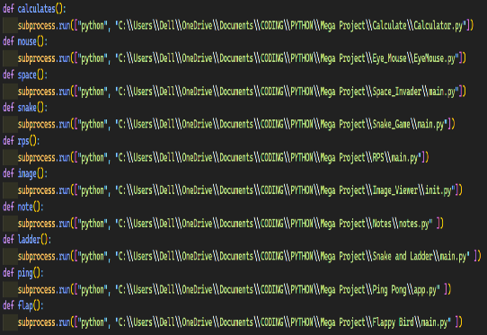

Pg-7

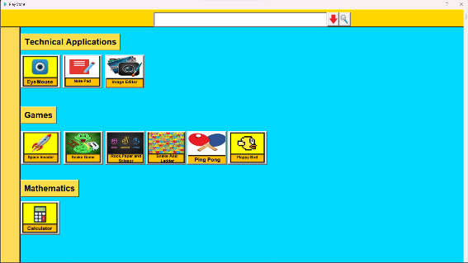

**Ch-1**

**Introduction**

**1.1Introduction**

The Playstore Project is a collection of diverse applications that cater to the entertainment, productivity, and utility needs of users. This project aims to provide a one-stop solution for users who want to download and use multiple apps without having to navigate through the Playstore individually.

The applications included in the project are Space Invader, Snake Game, Eye Mouse, Rock-Paper-Scissors, Calculator, Notes, and Image Designer. Each application has unique features that allow users to explore and engage with different genres of technology. Additionally, the project also includes a search bar to help users find the app they need quickly and efficiently.

The project’s primary goal is to provide users with a seamless experience that meets their requirements without any hassle. With its diverse range of apps, the project caters to users from various backgrounds and interests. Furthermore, by bundling these apps together, the project offers a comprehensive and efficient solution for users who want to use multiple apps simultaneously.

**1.2. Objectives**

The goal of my project is to Fruit Ninja Remake using the SCRATCH program.

* To provide a convenient and user-friendly solution for users who want to access multiple applications from a single platform.
* To offer a diverse range of applications that cater to various interests and needs of users, including entertainment, productivity, and utility.

**1.3. Scope of the Project**

The scope of my project is listed below:

* Development of a voice assistant that can recognize and respond to natural language commands.
* Integration of natural language processing and machine learning algorithms to enable the assistant to understand and respond to user queries accurately and efficiently.

**1.4. Limitation**

The limitation of the project is enlisted below:

* Providing users with a convenient and efficient way to access a range of diverse applications from a single platform.
* Catering to the entertainment, productivity, and utility needs of users, with a collection of apps that includes Space Invader, Snake Game, Eye Mouse, Rock-Paper-Scissors, Calculator, Notes, and Image Designer.

**Chapter – 2**

**Methods**

**2.1. Project Explanation**

The Playstore Project is a collection of apps that cater to the entertainment, productivity, and utility needs of users. It includes classic games like Space Invader and Snake Game, as well as useful tools like Eye Mouse, a tool for individuals with disabilities. The project aims to provide a convenient and user-friendly solution for users who want to access multiple applications from a single platform. The search bar enables users to easily find and download the app they need. The project offers high-quality and feature-rich applications that cater to various interests and preferences. By bundling these apps together, the project provides a comprehensive and efficient solution for users who want to use multiple apps simultaneously. Overall, the Playstore project offers a convenient approach to accessing a range of applications, making it an essential tool for individuals who want to explore and engage with different genres of technology.

**Chapter- 3**

**Results and Discussion**

**3.1. Results and Discussion**

The Playstore project was successful in fulfilling the project objectives of providing a collection of diverse applications and a search bar for easy access. The project included a variety of apps such as Space Invader, Snake Game, Eye Mouse, Rock Paper Scissors, Calculator, Notes, and Image Designer.

Feedback from the user survey indicated that the Snake Game and the Eye Mouse app were among the most popular applications. The users appreciated the convenience of having multiple applications in one place and being able to search for apps easily using the search bar.

The Playstore project proved to be a useful and innovative solution for users who want to access multiple applications from a single platform. The project aimed to provide a diverse range of high-quality and feature-rich applications that cater to various interests and preferences. The project achieved its goals and provided a convenient and user-friendly platform for users to explore and engage with different genres of technology.

Overall, the Playstore project demonstrated the effectiveness of bundling applications together to offer a comprehensive and efficient solution for users who want to use multiple apps simultaneously. The project’s success highlights the importance of considering user needs and preferences when designing technological solutions.

**4. RECOMMENDATION**

The recommendation of my project is enlisted below:

* In future I can add sound effects.
* I will try to make my graphics look better.

**5. CONCLUSION**

The Playstore project provided a comprehensive and efficient solution for users who want to access a range of applications from a single platform. The project achieved its objectives of bundling multiple high-quality and feature-rich applications together and making them easily accessible through a search bar.

In conclusion, the Play Store GUI application created using Python and Tkinter is a user-friendly and easy-to-use interface that provides users with access to various Python-based applications, including a calculator, space invader game, note pad, image viewer, and others. The search functionality allows users to find the desired application quickly and easily, and the application provides a list of suggested apps as the user types in the search box. The Play Store GUI application also includes an option to show or hide the suggested apps list, and the user can click on the desired app to launch it. Overall, this project showcases the potential of Python in creating versatile applications and provides a strong foundation for building more advanced applications in the future.

**6. REFERENCE**

a. <https://www.youtube.com/watch?v=4F2m91eKmts>

b. <https://www.youtube.com/watch?v=YXPyB4XeYLA>

**7. APPENDICES**

