Lab Sheet No 3:
Lab 3 : Uniformity Testing of random Numbers using Chi- Square Test
Activity 1: Write a program to test either the given random numbers are uniformly distributed or not.
Activity 2: Modify the above program and ask user to input N floating point numbers between 0.00 to 1.00 individually. Determine in which interval the given number lies and calculate the chi value.
Activity 3: Generate the N random numbers using Linear Congruential Method and test the uniformity of generated numbers using Chi-Square method. Before doing calculation of chi be sure that your generator has generated minimum 40 numbers.
Theory: Chi-square test is most commonly used uniformity test that can be used for distribution of any size.It is also called frequency test method.

The process includes following steps:
- Step1: Define the Hypothesis for Uniformity
Ho: Ri~U[0,1] The numbers are uniformly distributed
H1: Ri~U[0,1] The numbers are not uniformly distributed.

- Prepare a histogram of the observed data if data set is large create classes to organize data
- Compare observed frequencies with theoretical
k = Number of cells (or classes)
Oi= Observed frequency for ith cell
Ei= Expected frequency
Ei=N/n
n is the number of classes
N is the total frequency
i.e Ei defines the frequency per class
- Setting hypothesis
Null hypothesis H0: Given numbers are uniformly distributed over [0,1]
Alternate Hypothesis H1: Given numbers are uniformly distributed over [0,1]
4. Calculate the value of chi square χ2
χ2calc=∑i (Oi−Ei)^2 /Ei for i= 1 to n
- Determine the level of significance Alpha (α)
- 6. χ2observed has a chi-square distribution with k-1 degrees of freedom.
- χ2observed= χ2[1-α , k-1]
- Compare χ2calc with χ2[1-α , k-1]
Pass with confidence ‘α’ if χ2calc is less else reject null hypothesis
Data :
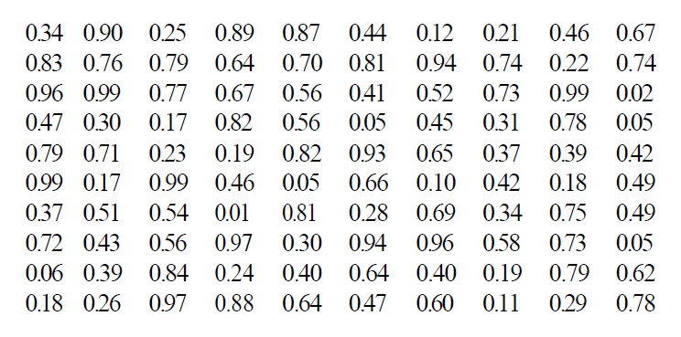
Interval | Oi | Ei | Oi-Ei | (Oi-Ei)^2 | (Oi-Ei)^2/ Ei
1 | 8 | 10 | -2 | 4 | 0.4
2 | 8 | 10 | -2 | 4 | 0.4
3 | 10 | 10 | 0 | 0 | 0
4 | 9 | 10 | -1 | 1 | 0.1
5 | 12 | 10 | 2 | 4 | 04
6 | 8 | 10 | -2 | 4 | 0.4
7 | 10 | 10 | 0 | 0 | 0
8 | 14 | 10 | 4 | 16 | 1.6
9 | 10 | 10 | 0 | 0 | 0
10 | 11 | 10 | 1 | 1 | 0.1
 | 100 | 100 |  |  | ∑=3.4
The value of ${\text{ꭙ}o}^{2}$ is 3.4
This is compared with the critical value ${\text{ꭙ}t}^{2}$0.05,9 =16.9.
Since ${\text{ꭙ}o}^{2}$ is much smaller than the tabulated value of ${\text{ꭙ}t}^{2}$ 0.05,9 , the null hypothesis of a uniform distribution is not rejected, That is, the numbers are
uniformly distributed.

