Lab 5: Implementation of Markov Process
Activity 1: Implementation Coke vs. Pepsi Example for Markov Process
- Given that a person’s last cola purchase was Coke, there is a 90% chance that his next cola purchase will also be Coke.
- If a person’s last cola purchase was Pepsi, there is an 80% chance that his next cola purchase will also be Pepsi.
T =[ 0.9 0.1
0.2 0.8 ]
For the above answer the following questions
- Given that a person is currently a Pepsi purchaser, what is the probability that he will purchase Coke two purchases from now?
T2= [0.83 0.17
0.34 0.66]
Ans: 0.34
- Given that a person is currently a Coke purchaser, what is the probability that he will purchase Pepsi three purchases from now?
Ans: .219
- Suppose 60% of all people now drink Coke, and 40% drink Pepsi . What fraction of people will be drinking Coke after three purchase from now?
P0=[0.6, 0.4]
Pn=P0*T^n
P3= P0*T^3 =(0.6438,0.3562)

STEP 1 : Take 2 by 2 matrix say T
Step2 : Ask for after how many times we need a prob of choice (say N)
STEP3: Multiply the transition matrix upto N times (T^N)
STE4: Pick the required index to get answer
step 5: display the answer

Activity 2: Election Process
- A population of vector are distributed between the Democratic (D), Republican (R) , and Independent (I) parties.
- Each election the voting population P=[ D, R, I] obeys the distribution like
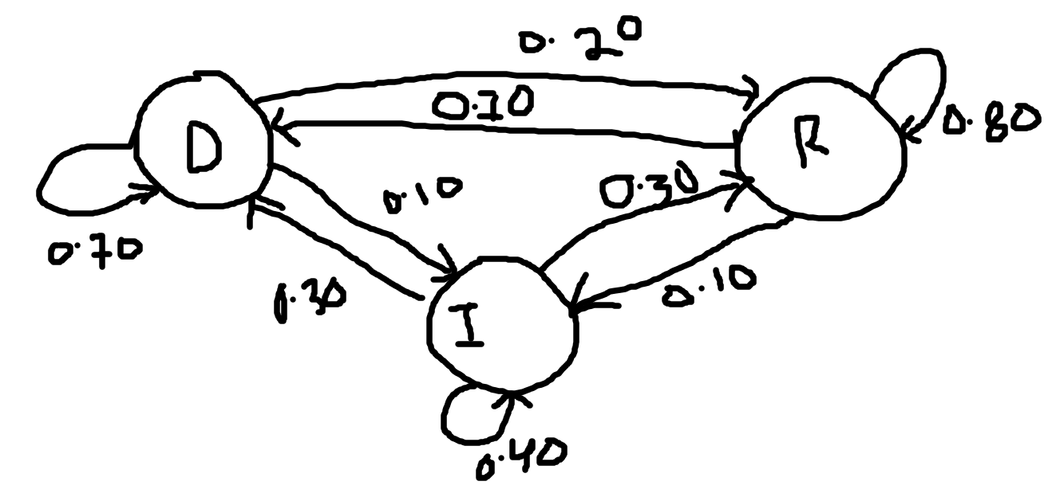
Fig: vote shift between two election
- In 2004 election, the voters were distributed according to the distribution vector
- P0= [0.48, 0.51, 0.1]
Q. The next expected population outcome of the 2008 election??
Ans: P0* T2 = 0.70*0.48 +0.10*0.51+0.30*0.10=0.417

