**Lab1 Manipulation & processing of image in visual basic**

1. **Copy image**

Private sub command1_click()

Dim color as long

for x = 0 to 132

for y = 0 to 132

color = getpixel(Picture1.hdc,x,y)

r = color mod 256

color = color/256

g = color mod 256

color = color/256

b = color

setpixel picture2.hdc,x,y,RGB(r,g,b)

Next y

Next x

End Sub

**2) Negative Image**

Private Sub Command2_click()

Dim color as Long

For x = 0 to 132

For y = 0 to 132

color = getpixel(picture1.hdc,x,y)

r = color mod 256

color = color/256

g = color mod 256

color = color /256

b = color

setpixel picture3.hdc,x,y,RGB(255-r,255-g,255-b)

Next y

Next x

End Sub

**3) Horizontal image //rgb chalaunu parena image lai horizontal flip garne matra tw honi**

Private sub command3_click()

Dim color as Long

For x = 0 to 132

For y = 0 to 132

color = getpixel(picture1.hdc,x,y)

setpixel picture4.hdc, 132-x,y,color

Next y

Next x

End Sub

**4) Vertical image //same tara y lai flip**

Private sub command4_click()

Dim color as Long

For x = 0 to 132

For y = 0 to 132

color = getpixel(picture1.hdc,x,y)

setpixel picture5.hdc,x, 132-y,color

Next y

Next x

End Sub

**5) Grey image**

Private sub command5_click()

Dim color as Long

For x = 0 to 132

For y = 0 to 132

color = getpixel(picture1.hdc,x,y)

r = color mod 256

color = color/256

g = color mod 256

color = color / 256

b = color

Grey = (r+g+b)/3

setpixel picture6.hdc,x,y,RGB(Grey,Grey,Grey)

Next y

Next x

End Sub

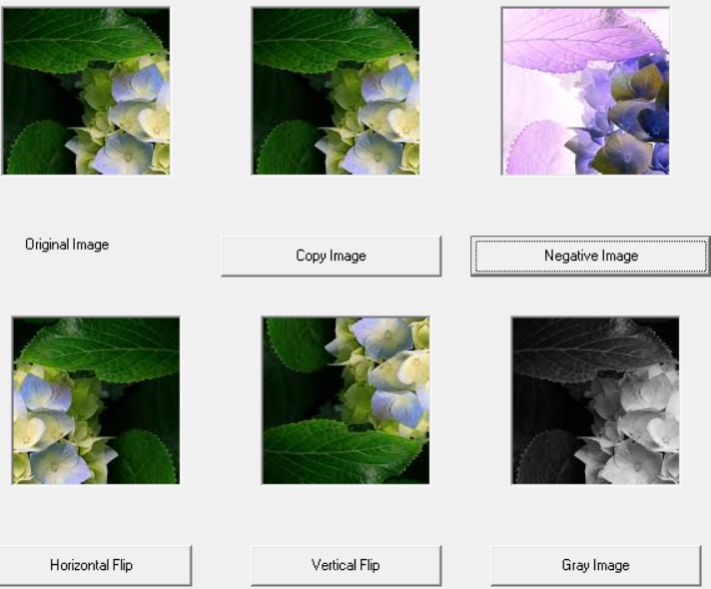

**lab2 (Dealing with RGB image processing)**

**1) Red Horizontal scrollbar**

Private sub HScroll1_Change()

Dim color as Long

For x = 0 to 132

For y = 0 to 132

color = GetPixel(Picture1.hdc,x,y)

r = color Mod 256

color = color / 256

g = color Mod 256

color = color / 256

b = color

setpixel Picture2.hdc,x,y,RGB(r + HScroll1.Value, g, b)

Next y

Next x

End Sub

**2) Green Horizontal Scrollbar**

Private sub HScroll2_Change()

Dim color as Long

For x = 0 to 132

For y = 0 to 132

color = GetPixel(picture1.hdc,x,y)

r = color Mod 256

color = color / 256

g = color Mod 256

color = color / 256

b = color

setpixel picture2.hdc,x,y,RGB(r, g + HScroll2.Value, b)

Next y

Next x

End Sub

**3) Blue Horizontal Bar**

Private sub HScroll3_Change()

Dim color as Long

For x = 0 to 132

For y = 0 to 132

color = GetPixel(picture1.hdc,x,y)

r = color Mod 256

color = color/256

g = color Mod 256

color = color/256

b = color

setpixel Picture2.hdc,x,y,RGB(r, g, b + HScroll3.Value)

Next y

Next x

End Sub

**4) Brightness horizontal bar**

Private Sub HScroll4_Change()

Dim color as Long

For x = 0 to 132

For y = 0 to 132

color = GetPixel(picture1.hdc,x,y)

r = color Mod 256

color = color / 256

g = color Mod 256

color = color / 256

b = color

setpixel Picture2.hdc,x,y,RGB(r + HScroll4.Value, g + HScroll4.Value, b + HScroll4.Value)

Next y

Next x

End Sub

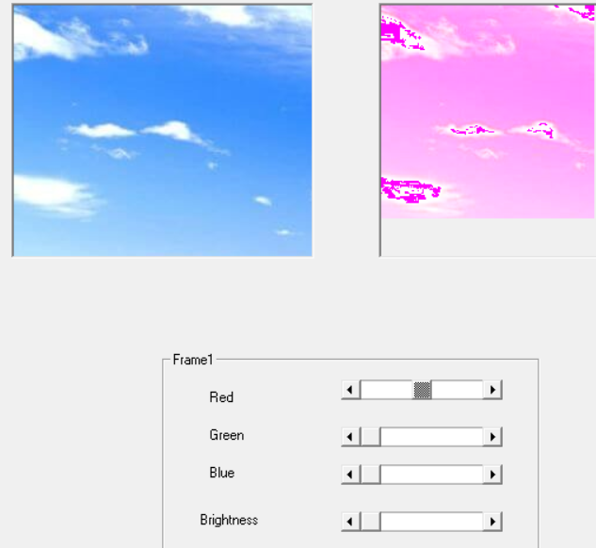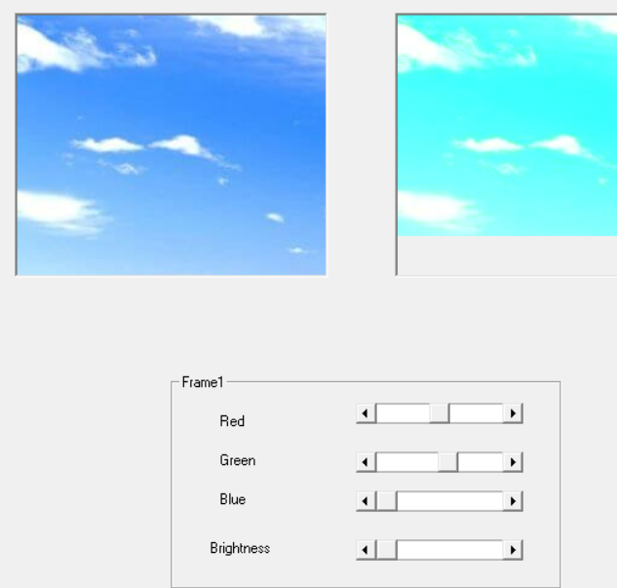

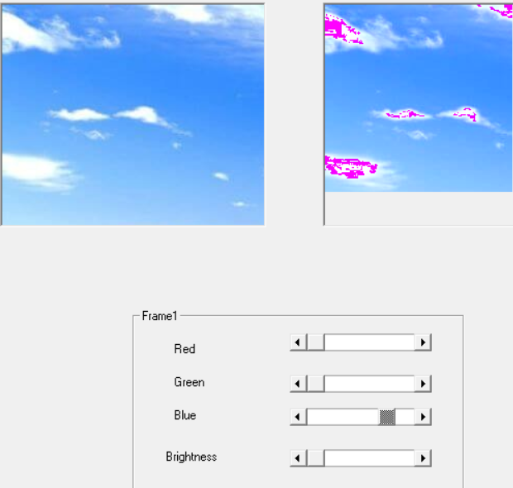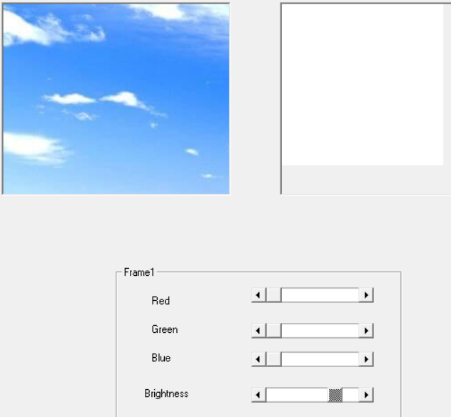

**Lab3 Intensity Level Slicing, Bit Plane Slicing and zooming by replication**

1. **Intensity level slicing with background**

Private Sub Option1_Click()

Dim color as Long

For x = 0 to 132

For y = 0 to 132

color = GetPixel(Picture1.hdc,x,y)

r = color Mod 256

color = color / 256

g = color Mod 256

color = color / 256

b = color

If r > 127 and r < 250 Then r = 256 - r Else r = r

If g > 127 and g < 250 Then g = 256 - g Else g = g

If b > 127 and b < 250 Then b = 256 - b Else b = b

SetPixel Picture2.hdc,x,y,RGB(r,g,b)

Next y

Next x

End Sub

1. **Intensity level slicing Without background**

Private Sub Option2_Click()

Dim color as Long

For x = 0 to 132

For y = 0 to 132

color = GetPixel(Picture1.hdc,x,y)

r = color Mod 256

color = color / 256

g = color Mod 256

color = color / 256

b = color

If r > 127 and r < 250 Then r = 256-r Else r = 0

If g > 127 and g < 250 Then g = 256-g Else g = 0

If b > 127 and b < 250 Then b = 256-b Else b = 0

SetPixel Picture2.hdc,x,y,RGB(r,g,b)

Next y

Next x

End Sub

1. **Bit plane slicing**

Private Sub Command1_Click()

Dim color as Long

For x = 0 to 132

For y = 0 to 132

color = GetPixel(Picture1.hdc,x,y)

r = color Mod 256

color = color / 256

g = color Mod 256

color = color / 256

b = color

n = Text1.Text

If (n<0) Then

n = 0

Text1.Text = 0

End If

If (n>7) Then

n = 7

Text1.Text = 7

End If

If (r > (2^n)-1) Then

r = 255

Else

r = 0

End If

If (g > (2^n)-1) Then

g = 255

Else

g = 0

End If

If (b > (2^n)-1) Then

b = 255

Else

b = 0

End If

SetPixel Picture2.hdc,x,y,RGB(r,g,b)

Next y

Next x

End Sub

1. **Zooming by replication**

Private Sub Command2_click()

Dim color as Long

Picture2.Height = Picture1.Height * 2

Picture2.Width = Picture1.Width * 2

For x = 0 to 132* 2

For y = 0 to 132* 2

color = GetPixel(Picture1.hdc,x/2,y/2)

SetPixel Picture2.hdc,x,y,color

Next y

Next x

End Sub

1. **Zooming by interpolation**

Private Sub Command3_Click()

Dim color as Long

Dim color1 as Long

Dim color2 as Long

Dim Gray as Long

For x = 0 to 132* 2

For y = 0 to 132* 2

If (x mod 2 = 0) Then

color = GetPixel(Picture1.hdc,x/2,y/2)

Gray = color And 255

SetPixel Picture2.hdc, x, y, RGB(Gray,Gray,Gray)

End If

Next y

Next x

For x = 0 to 132* 2

For y = 0 to 132* 2

color1 = GetPixel(Picture1.hdc,x-1,y) and 255

color2 = GetPixel(Picture2.hdc, x+1,y) and 255

Gray = (color1 + color2) /2

SetPixel Picture2.hdc, 2*x, 2*y+1, RGB(Gray,Gray,Gray)

Next y

Next x

For x = 0 to 132* 2

For y = 0 to 132* 2

color1 = GetPixel(Picture1.hdc,x,y-1) and 255

color2 = GetPixel(Picture2.hdc, x,y+1) and 255

Gray = (color1 + color2) /2

SetPixel Picture2.hdc, 2*x+1, 2*y, RGB(Gray,Gray,Gray)

Next y

Next x

End Sub

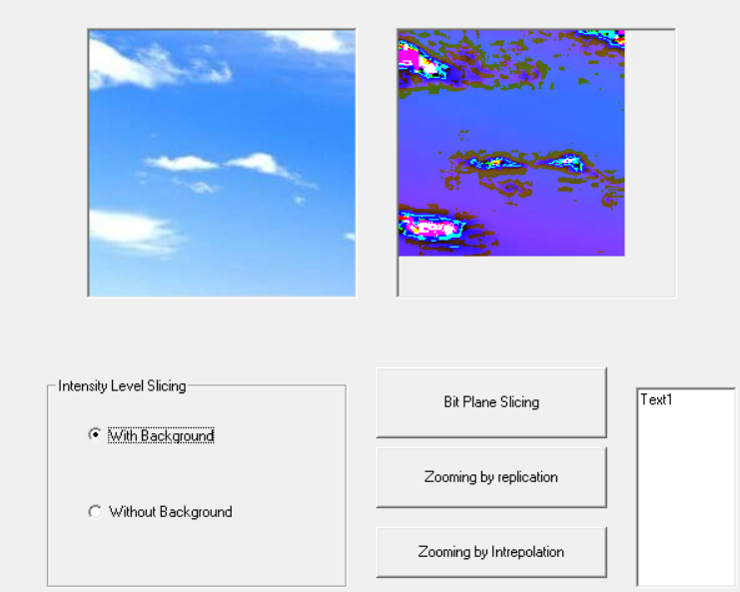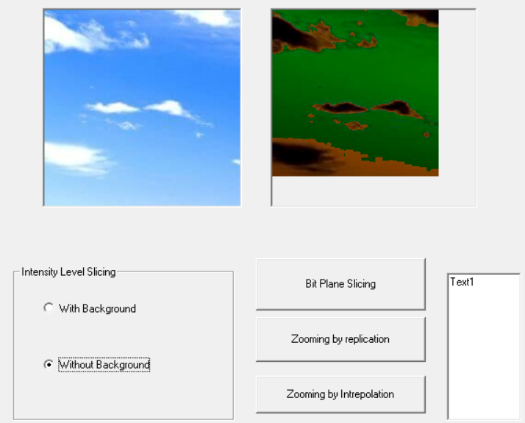

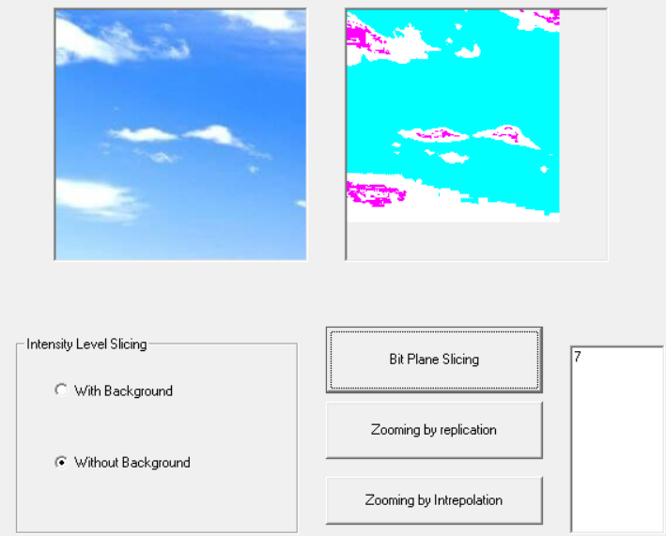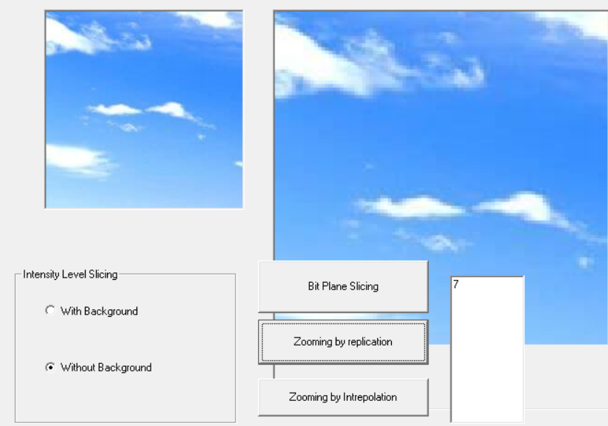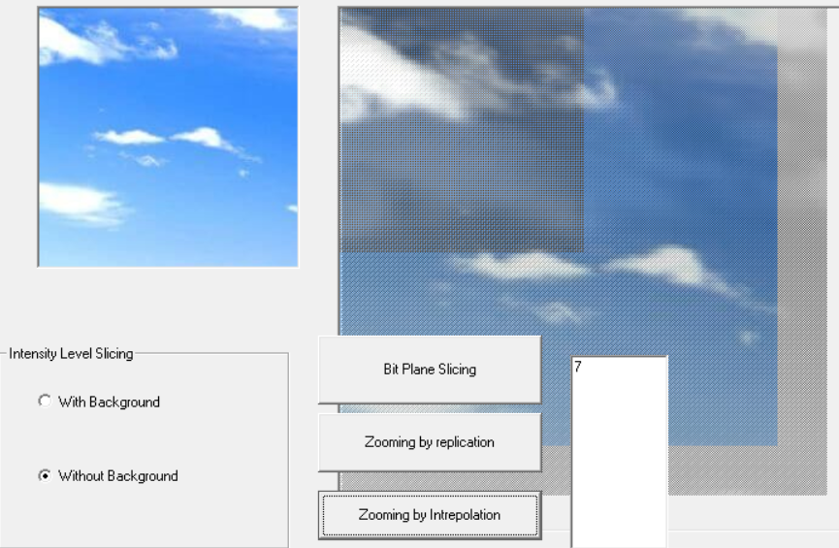

**Lab4 Mean Filter and Weighted Mean Filter**

**1) Mean Filter**

Private Sub Command1_Click()

Dim Color as Long

Dim rr as Long

Dim gg as Long

Dim bb as Long

For x = 0 to 132

For y = 0 to 132

color = GetPixel(Picture1.hdc,x,y)

r = color Mod 256

color = color/256

g = color Mod 256

color = color / 256

b = color

rr = rr + r

gg = gg + g

bb = bb + b

color = GetPixel(Picture1.hdc,x-1,y+1)

r = color Mod 256

color = color / 256

g = color Mod 256

color = color / 256

b = color

rr = rr + r

gg = gg + g

bb = bb + b

color = GetPixel(Picture1.hdc,x,y+1)

r = color Mod 256

color = color / 256

g = color Mod 256

color = color / 256

b = color

rr = rr + r

gg = gg + g

bb = bb + b

color = GetPixel(Picture1.hdc,x+1,y+1)

r = color Mod 256

color = color / 256

g = color Mod 256

color = color / 256

b = color

rr = rr + r

gg = gg + g

bb = bb + b

color = GetPixel(Picture1.hdc,x+1,y)

r = color Mod 256

color = color / 256

g = color Mod 256

color = color / 256

b = color

rr = rr + r

gg = gg + g

bb = bb + b

color = GetPixel(Picture1.hdc,x+1,y-1)

r = color Mod 256

color = color / 256

g = color Mod 256

color = color / 256

b = color

rr = rr + r

gg = gg + g

bb = bb + b

color = GetPixel(Picture1.hdc,x,y-1)

r = color Mod 256

color = color / 256

g = color Mod 256

color = color / 256

b = color

rr = rr + r

gg = gg + g

bb = bb + b

color = GetPixel(Picture1.hdc,x-1,y-1)

r = color Mod 256

color = color / 256

g = color Mod 256

color = color / 256

b = color

rr = rr + r

gg = gg + g

bb = bb + b

color = GetPixel(Picture1.hdc,x-1,y)

r = color Mod 256

color = color / 256

g = color Mod 256

color = color / 256

b = color

rr = rr + r

gg = gg + g

bb = bb + b

rr = rr * (1 / 9)

gg = gg * (1 / 9)

bb = bb * (1 / 9)

If (rr<0) Then rr = 0 Else If rr>255 Then rr = 255

If (gg<0) Then gg = 0 Else If gg>255 Then gg = 255

If (bb <0) Then bb = 0 Else If bb>255 Then bb = 255

SetPixel Picture2.hdc,x,y,RGB(rr,gg,bb)

Next y

Next x

End Sub

**2) Weighted Mean Filter**

Private Sub Command2_Click()

Dim color as Long

Dim rr as Long

Dim gg as Long

Dim bb as Long

For x = 0 to 132

For y = 0 to 132

color = GetPixel(Picture1.hdc,x,y)

r = color Mod 256

color = color / 256

g = color Mod 256

color = color / 256

b = color

rr = 4 * r

gg = 4 * g

bb = 4 * b

color = GetPixel(Picture1.hdc,x-1,y)

r = color Mod 256

color = color / 256

g = color Mod 256

color = color / 256

b = color

rr = rr + 2 * r

gg = gg + 2 * g

bb = bb + 2 * b

color = GetPixel(Picture1.hdc,x+1,y)

r = color Mod 256

color = color / 256

g = color Mod 256

color = color / 256

b = color

rr = rr + 2 * r

gg = gg + 2 * g

bb = bb + 2 * b

color = GetPixel(Picture1.hdc,x,y-1)

r = color Mod 256

color = color / 256

g = color Mod 256

color = color / 256

b = color

rr = rr + 2 * r

gg = gg + 2 * g

bb = bb + 2 * b

color = GetPixel(Picture1.hdc,x,y+1)

r = color Mod 256

color = color / 256

g = color Mod 256

color = color / 256

b = color

rr = rr + 2 * r

gg = gg + 2 * g

bb = bb + 2 * b

color = GetPixel(Picture1.hdc,x-1,y+1)

r = color Mod 256

color = color / 256

g = color Mod 256

color = color / 256

b = color

rr = rr + r

gg = gg + g

bb = bb + b

color = GetPixel(Picture1.hdc,x+1,y+1)

r = color Mod 256

color = color / 256

g = color Mod 256

color = color / 256

b = color

rr = rr + r

gg = gg + g

bb = bb + b

color = GetPixel(Picture1.hdc,x+1,y-1)

r = color Mod 256

color = color / 256

g = color Mod 256

color = color / 256

b = color

rr = rr + r

gg = gg + g

bb = bb + b

color = GetPixel(Picture1.hdc,x-1,y-1)

r = color Mod 256

color = color / 256

g = color Mod 256

color = color / 256

b = color

rr = rr + r

gg = gg + g

bb = bb + b

rr = rr * (1 / 16)

gg = gg * (1 / 16)

bb = bb * (1 / 16)

If (rr<0) Then rr = 0 Else If rr > 255 Then rr = 255

If (gg<0) Then gg = 0 Else If gg > 255 Then gg = 255

If (bb<0) Then bb = 0 Else If bb > 255 Then bb = 255

SetPixel Picture2.hdc, x, y, RGB(rr,gg,bb)

Next y

Next x

End Sub

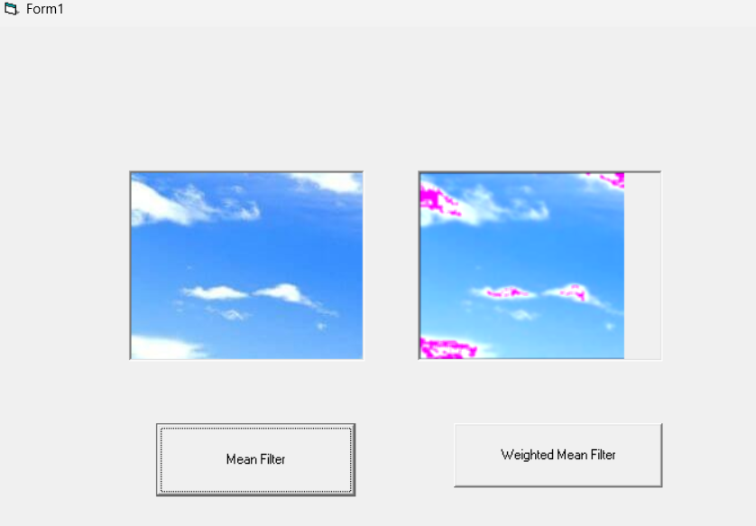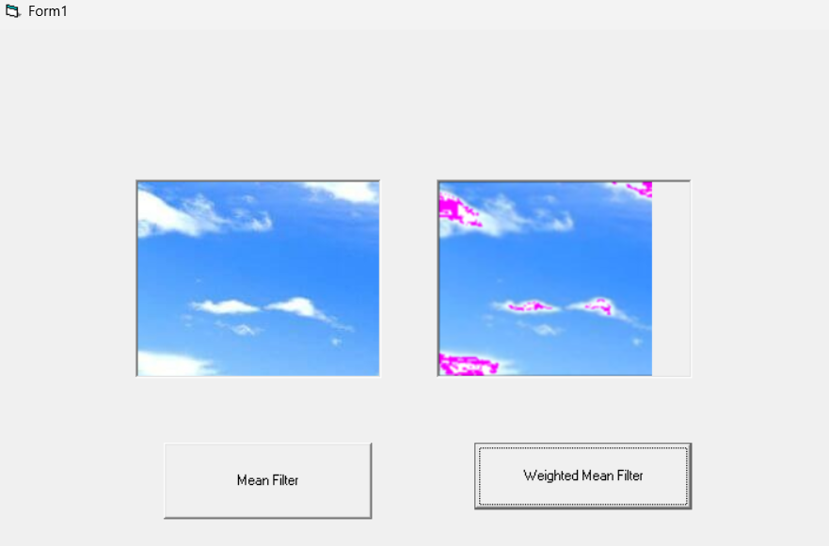

**Lab6 Implementation of Line Detection**

**'For Horizontal Line Detection'**

**'-1 -1 -1'**

**' 2 2 2'**

**'-1 -1 -1'**

Private Sub Command1_Click()

Dim Color As Long

Dim rr As Long

Dim gg As Long

Dim bb As Long

For x = 0 To 132

For y = 0 To 132

Color = GetPixel(Picture1.hdc, x, y)

r = Color Mod 256

Color = Color / 256

g = Color Mod 256

Color = Color / 256

b = Color

rr = 2 * r

gg = 2 * g

bb = 2 * b

Color = GetPixel(Picture1.hdc, x - 1, y + 1)

r = Color Mod 256

Color = Color / 256

g = Color Mod 256

Color = Color / 256

b = Color

rr = rr - r

gg = gg - g

bb = bb - b

Color = GetPixel(Picture1.hdc, x, y + 1)

r = Color Mod 256

Color = Color / 256

g = Color Mod 256

Color = Color / 256

b = Color

rr = rr - r

gg = gg - g

bb = bb - b

Color = GetPixel(Picture1.hdc, x + 1, y + 1)

r = Color Mod 256

Color = Color / 256

g = Color Mod 256

Color = Color / 256

b = Color

rr = rr - r

gg = gg - g

bb = bb - b

Color = GetPixel(Picture1.hdc, x + 1, y)

r = Color Mod 256

Color = Color / 256

g = Color Mod 256

Color = Color / 256

b = Color

rr = rr + 2 * r

gg = gg + 2 * g

bb = bb + 2 * b

Color = GetPixel(Picture1.hdc, x + 1, y - 1)

r = Color Mod 256

Color = Color / 256

g = Color Mod 256

Color = Color / 256

b = Color

rr = rr - r

gg = gg - g

bb = bb - b

Color = GetPixel(Picture1.hdc, x, y - 1)

r = Color Mod 256

Color = Color / 256

g = Color Mod 256

Color = Color / 256

b = Color

rr = rr - r

gg = gg - g

bb = bb - b

Color = GetPixel(Picture1.hdc, x - 1, y - 1)

r = Color Mod 256

Color = Color / 256

g = Color Mod 256

Color = Color / 256

b = Color

rr = rr - r

gg = gg - g

bb = bb - b

Color = GetPixel(Picture1.hdc, x - 1, y)

r = Color Mod 256

Color = Color / 256

g = Color Mod 256

Color = Color / 256

b = Color

rr = rr + 2 * r

gg = gg + 2 * g

bb = bb + 2 * b

If (rr < 0) Then rr = 0 Else If rr > 255 Then rr = 255

If (gg < 0) Then gg = 0 Else If gg > 255 Then gg = 255

If (bb < 0) Then bb = 0 Else If bb > 255 Then bb = 255

SetPixel Picture2.hdc, x, y, RGB(rr, gg, bb)

Next y

Next x

End Sub

**'For Vertical Line Detection'**

**'-1 2 -1'**

**'-1 2 -1'**

**'-1 2 -1'**

Private Sub Command2_Click()

Dim Color As Long

Dim rr As Long

Dim gg As Long

Dim bb As Long

For x = 0 To 132

For y = 0 To 132

Color = GetPixel(Picture1.hdc, x, y)

r = Color Mod 256

Color = Color / 256

g = Color Mod 256

Color = Color / 256

b = Color

rr = 2 * r

gg = 2 * g

bb = 2 * b

Color = GetPixel(Picture1.hdc, x - 1, y + 1)

r = Color Mod 256

Color = Color / 256

g = Color Mod 256

Color = Color / 256

b = Color

rr = rr - r

gg = gg - g

bb = bb - b

Color = GetPixel(Picture1.hdc, x, y + 1)

r = Color Mod 256

Color = Color / 256

g = Color Mod 256

Color = Color / 256

b = Color

rr = rr + 2 * r

gg = gg + 2 * g

bb = bb + 2 * b

Color = GetPixel(Picture1.hdc, x + 1, y + 1)

r = Color Mod 256

Color = Color / 256

g = Color Mod 256

Color = Color / 256

b = Color

rr = rr - r

gg = gg - g

bb = bb - b

Color = GetPixel(Picture1.hdc, x + 1, y)

r = Color Mod 256

Color = Color / 256

g = Color Mod 256

Color = Color / 256

b = Color

rr = rr - r

gg = gg - g

bb = bb - b

Color = GetPixel(Picture1.hdc, x + 1, y - 1)

r = Color Mod 256

Color = Color / 256

g = Color Mod 256

Color = Color / 256

b = Color

rr = rr - r

gg = gg - g

bb = bb - b

Color = GetPixel(Picture1.hdc, x, y - 1)

r = Color Mod 256

Color = Color / 256

g = Color Mod 256

Color = Color / 256

b = Color

rr = rr + 2 * r

gg = gg + 2 * g

bb = bb + 2 * b

Color = GetPixel(Picture1.hdc, x - 1, y - 1)

r = Color Mod 256

Color = Color / 256

g = Color Mod 256

Color = Color / 256

b = Color

rr = rr - r

gg = gg - g

bb = bb - b

Color = GetPixel(Picture1.hdc, x - 1, y)

r = Color Mod 256

Color = Color / 256

g = Color Mod 256

Color = Color / 256

b = Color

rr = rr - r

gg = gg - g

bb = bb - b

If (rr < 0) Then rr = 0 Else If rr > 255 Then rr = 255

If (gg < 0) Then gg = 0 Else If gg > 255 Then gg = 255

If (bb < 0) Then bb = 0 Else If bb > 255 Then bb = 255

SetPixel Picture3.hdc, x, y, RGB(rr, gg, bb)

Next y

Next x

End Sub

**'For +45 Line Detection'**

**'-1 -1 2'**

**'-1 2 -1'**

**' 2 -1 -1'**

Private Sub Command3_Click()

Dim Color As Long

Dim rr As Long

Dim gg As Long

Dim bb As Long

For x = 0 To 132

For y = 0 To 132

Color = GetPixel(Picture1.hdc, x, y)

r = Color Mod 256

Color = Color / 256

g = Color Mod 256

Color = Color / 256

b = Color

rr = 2 * r

gg = 2 * g

bb = 2 * b

Color = GetPixel(Picture1.hdc, x - 1, y + 1)

r = Color Mod 256

Color = Color / 256

g = Color Mod 256

Color = Color / 256

b = Color

rr = rr - r

gg = gg - g

bb = bb - b

Color = GetPixel(Picture1.hdc, x, y + 1)

r = Color Mod 256

Color = Color / 256

g = Color Mod 256

Color = Color / 256

b = Color

rr = rr - r

gg = gg - g

bb = bb - b

Color = GetPixel(Picture1.hdc, x + 1, y + 1)

r = Color Mod 256

Color = Color / 256

g = Color Mod 256

Color = Color / 256

b = Color

rr = rr + 2 * r

gg = gg + 2 * g

bb = bb + 2 * b

Color = GetPixel(Picture1.hdc, x + 1, y)

r = Color Mod 256

Color = Color / 256

g = Color Mod 256

Color = Color / 256

b = Color

rr = rr - r

gg = gg - g

bb = bb - b

Color = GetPixel(Picture1.hdc, x + 1, y - 1)

r = Color Mod 256

Color = Color / 256

g = Color Mod 256

Color = Color / 256

b = Color

rr = rr - r

gg = gg - g

bb = bb - b

Color = GetPixel(Picture1.hdc, x, y - 1)

r = Color Mod 256

Color = Color / 256

g = Color Mod 256

Color = Color / 256

b = Color

rr = rr - r

gg = gg - g

bb = bb - b

Color = GetPixel(Picture1.hdc, x - 1, y - 1)

r = Color Mod 256

Color = Color / 256

g = Color Mod 256

Color = Color / 256

b = Color

rr = rr + 2 * r

gg = gg + 2 * g

bb = bb + 2 * b

Color = GetPixel(Picture1.hdc, x - 1, y)

r = Color Mod 256

Color = Color / 256

g = Color Mod 256

Color = Color / 256

b = Color

rr = rr - r

gg = gg - g

bb = bb - b

If (rr < 0) Then rr = 0 Else If rr > 255 Then rr = 255

If (gg < 0) Then gg = 0 Else If gg > 255 Then gg = 255

If (bb < 0) Then bb = 0 Else If bb > 255 Then bb = 255

SetPixel Picture4.hdc, x, y, RGB(rr, gg, bb)

Next y

Next x

End Sub

**'For -45 Line Detection'**

**' 2 -1 -1'**

**'-1 2 -1'**

**'-1 -1 2'**

Private Sub Command4_Click()

Dim Color As Long

Dim rr As Long

Dim gg As Long

Dim bb As Long

For x = 0 To 132

For y = 0 To 132

Color = GetPixel(Picture1.hdc, x, y)

r = Color Mod 256

Color = Color / 256

g = Color Mod 256

Color = Color / 256

b = Color

rr = 2 * r

gg = 2 * g

bb = 2 * b

Color = GetPixel(Picture1.hdc, x - 1, y + 1)

r = Color Mod 256

Color = Color / 256

g = Color Mod 256

Color = Color / 256

b = Color

rr = rr + 2 * r

gg = gg + 2 * g

bb = bb + 2 * b

Color = GetPixel(Picture1.hdc, x, y + 1)

r = Color Mod 256

Color = Color / 256

g = Color Mod 256

Color = Color / 256

b = Color

rr = rr - r

gg = gg - g

bb = bb - b

Color = GetPixel(Picture1.hdc, x + 1, y + 1)

r = Color Mod 256

Color = Color / 256

g = Color Mod 256

Color = Color / 256

b = Color

rr = rr - r

gg = gg - g

bb = bb - b

Color = GetPixel(Picture1.hdc, x + 1, y)

r = Color Mod 256

Color = Color / 256

g = Color Mod 256

Color = Color / 256

b = Color

rr = rr - r

gg = gg - g

bb = bb - b

Color = GetPixel(Picture1.hdc, x + 1, y - 1)

r = Color Mod 256

Color = Color / 256

g = Color Mod 256

Color = Color / 256

b = Color

rr = rr + 2 * r

gg = gg + 2 * g

bb = bb + 2 * b

Color = GetPixel(Picture1.hdc, x, y - 1)

r = Color Mod 256

Color = Color / 256

g = Color Mod 256

Color = Color / 256

b = Color

rr = rr - r

gg = gg - g

bb = bb - b

Color = GetPixel(Picture1.hdc, x - 1, y - 1)

r = Color Mod 256

Color = Color / 256

g = Color Mod 256

Color = Color / 256

b = Color

rr = rr - r

gg = gg - g

bb = bb - b

Color = GetPixel(Picture1.hdc, x - 1, y)

r = Color Mod 256

Color = Color / 256

g = Color Mod 256

Color = Color / 256

b = Color

rr = rr - r

gg = gg - g

bb = bb - b

If (rr < 0) Then rr = 0 Else If rr > 255 Then rr = 255

If (gg < 0) Then gg = 0 Else If gg > 255 Then gg = 255

If (bb < 0) Then bb = 0 Else If bb > 255 Then bb = 255

SetPixel Picture5.hdc, x, y, RGB(rr, gg, bb)

Next y

Next x

End Sub

Private Sub Command5_Click()

**'For Laplacian'**

**' 0 -1 0'**

**'-1 4 -1'**

**' 0 -1 0'**

Dim Color As Long

Dim rr As Long

Dim gg As Long

Dim bb As Long

For x = 0 To 132

For y = 0 To 132

Color = GetPixel(Picture1.hdc, x, y)

r = Color Mod 256

Color = Color / 256

g = Color Mod 256

Color = Color / 256

b = Color

rr = 4 * r

gg = 4 * g

bb = 4 * b

Color = GetPixel(Picture1.hdc, x, y + 1)

r = Color Mod 256

Color = Color / 256

g = Color Mod 256

Color = Color / 256

b = Color

rr = rr - r

gg = gg - g

bb = bb - b

Color = GetPixel(Picture1.hdc, x + 1, y)

r = Color Mod 256

Color = Color / 256

g = Color Mod 256

Color = Color / 256

b = Color

rr = rr - r

gg = gg - g

bb = bb - b

Color = GetPixel(Picture1.hdc, x, y - 1)

r = Color Mod 256

Color = Color / 256

g = Color Mod 256

Color = Color / 256

b = Color

rr = rr - r

gg = gg - g

bb = bb - b

Color = GetPixel(Picture1.hdc, x - 1, y)

r = Color Mod 256

Color = Color / 256

g = Color Mod 256

Color = Color / 256

b = Color

rr = rr - r

gg = gg - g

bb = bb - b

If (rr < 0) Then rr = 0 Else If rr > 255 Then rr = 255

If (gg < 0) Then gg = 0 Else If gg > 255 Then gg = 255

If (bb < 0) Then bb = 0 Else If bb > 255 Then bb = 255

SetPixel Picture6.hdc, x, y, RGB(rr, gg, bb)

Next y

Next x

End Sub

**'For Sobel X-Filter'**

**'-1 0 1'**

**'-2 0 2'**

**'-1 0 1'**

Private Sub Command6_Click()

Dim Color As Long

Dim rr As Long

Dim gg As Long

Dim bb As Long

For x = 0 To 132

For y = 0 To 132

Color = GetPixel(Picture1.hdc, x - 1, y + 1)

r = Color Mod 256

Color = Color / 256

g = Color Mod 256

Color = Color / 256

b = Color

rr = rr - r

gg = gg - g

bb = bb - b

Color = GetPixel(Picture1.hdc, x + 1, y + 1)

r = Color Mod 256

Color = Color / 256

g = Color Mod 256

Color = Color / 256

b = Color

rr = rr + r

gg = gg + g

bb = bb + b

Color = GetPixel(Picture1.hdc, x + 1, y)

r = Color Mod 256

Color = Color / 256

g = Color Mod 256

Color = Color / 256

b = Color

rr = rr + 2 * r

gg = gg + 2 * g

bb = bb + 2 * b

Color = GetPixel(Picture1.hdc, x + 1, y - 1)

r = Color Mod 256

Color = Color / 256

g = Color Mod 256

Color = Color / 256

b = Color

rr = rr + r

gg = gg + g

bb = bb + b

Color = GetPixel(Picture1.hdc, x - 1, y - 1)

r = Color Mod 256

Color = Color / 256

g = Color Mod 256

Color = Color / 256

b = Color

rr = rr - r

gg = gg - g

bb = bb - b

Color = GetPixel(Picture1.hdc, x - 1, y)

r = Color Mod 256

Color = Color / 256

g = Color Mod 256

Color = Color / 256

b = Color

rr = rr - 2 * r

gg = gg - 2 * g

bb = bb - 2 * b

If (rr < 0) Then rr = 0 Else If rr > 255 Then rr = 255

If (gg < 0) Then gg = 0 Else If gg > 255 Then gg = 255

If (bb < 0) Then bb = 0 Else If bb > 255 Then bb = 255

SetPixel Picture7.hdc, x, y, RGB(rr, gg, bb)

Next y

Next x

End Sub

Private Sub Command7_Click()

**'For Sobel Y-Filter'**

**'-1 -2 -1'**

**' 0 0 0'**

**' 1 2 1'**

Dim Color As Long

Dim rr As Long

Dim gg As Long

Dim bb As Long

For x = 0 To 132

For y = 0 To 132

Color = GetPixel(Picture1.hdc, x - 1, y + 1)

r = Color Mod 256

Color = Color / 256

g = Color Mod 256

Color = Color / 256

b = Color

rr = rr - r

gg = gg - g

bb = bb - b

Color = GetPixel(Picture1.hdc, x, y + 1)

r = Color Mod 256

Color = Color / 256

g = Color Mod 256

Color = Color / 256

b = Color

rr = rr - 2 * r

gg = gg - 2 * g

bb = bb - 2 * b

Color = GetPixel(Picture1.hdc, x + 1, y + 1)

r = Color Mod 256

Color = Color / 256

g = Color Mod 256

Color = Color / 256

b = Color

rr = rr - r

gg = gg - g

bb = bb - b

Color = GetPixel(Picture1.hdc, x + 1, y - 1)

r = Color Mod 256

Color = Color / 256

g = Color Mod 256

Color = Color / 256

b = Color

rr = rr + r

gg = gg + g

bb = bb + b

Color = GetPixel(Picture1.hdc, x, y - 1)

r = Color Mod 256

Color = Color / 256

g = Color Mod 256

Color = Color / 256

b = Color

rr = rr + 2 * r

gg = gg + 2 * g

bb = bb + 2 * b

Color = GetPixel(Picture1.hdc, x - 1, y - 1)

r = Color Mod 256

Color = Color / 256

g = Color Mod 256

Color = Color / 256

b = Color

rr = rr + r

gg = gg + g

bb = bb + b

If (rr < 0) Then rr = 0 Else If rr > 255 Then rr = 255

If (gg < 0) Then gg = 0 Else If gg > 255 Then gg = 255

If (bb < 0) Then bb = 0 Else If bb > 255 Then bb = 255

SetPixel Picture8.hdc, x, y, RGB(rr, gg, bb)

Next y

Next x

End Sub

**'For Prewit X Filter'**

**'-1 0 1'**

**'-1 0 1'**

**'-1 0 1'**

Private Sub Command8_Click()

Dim Color As Long

Dim rr As Long

Dim gg As Long

Dim bb As Long

For x = 0 To 132

For y = 0 To 132

Color = GetPixel(Picture1.hdc, x - 1, y + 1)

r = Color Mod 256

Color = Color / 256

g = Color Mod 256

Color = Color / 256

b = Color

rr = rr - r

gg = gg - g

bb = bb - b

Color = GetPixel(Picture1.hdc, x + 1, y + 1)

r = Color Mod 256

Color = Color / 256

g = Color Mod 256

Color = Color / 256

b = Color

rr = rr + r

gg = gg + g

bb = bb + b

Color = GetPixel(Picture1.hdc, x + 1, y)

r = Color Mod 256

Color = Color / 256

g = Color Mod 256

Color = Color / 256

b = Color

rr = rr + r

gg = gg + g

bb = bb + b

Color = GetPixel(Picture1.hdc, x + 1, y - 1)

r = Color Mod 256

Color = Color / 256

g = Color Mod 256

Color = Color / 256

b = Color

rr = rr + r

gg = gg + g

bb = bb + b

Color = GetPixel(Picture1.hdc, x - 1, y - 1)

r = Color Mod 256

Color = Color / 256

g = Color Mod 256

Color = Color / 256

b = Color

rr = rr - r

gg = gg - g

bb = bb - b

Color = GetPixel(Picture1.hdc, x - 1, y)

r = Color Mod 256

Color = Color / 256

g = Color Mod 256

Color = Color / 256

b = Color

rr = rr - r

gg = gg - g

bb = bb - b

If (rr < 0) Then rr = 0 Else If rr > 255 Then rr = 255

If (gg < 0) Then gg = 0 Else If gg > 255 Then gg = 255

If (bb < 0) Then bb = 0 Else If bb > 255 Then bb = 255

SetPixel Picture9.hdc, x, y, RGB(rr, gg, bb)

Next y

Next x

End Sub

**'For Prewit Y Filter'**

**'-1 -1 -1'**

**' 0 0 0'**

**' 1 1 1'**

Private Sub Command9_Click()

Dim Color As Long

Dim rr As Long

Dim gg As Long

Dim bb As Long

For x = 0 To 132

For y = 0 To 132

Color = GetPixel(Picture1.hdc, x - 1, y + 1)

r = Color Mod 256

Color = Color / 256

g = Color Mod 256

Color = Color / 256

b = Color

rr = rr - r

gg = gg - g

bb = bb - b

Color = GetPixel(Picture1.hdc, x, y + 1)

r = Color Mod 256

Color = Color / 256

g = Color Mod 256

Color = Color / 256

b = Color

rr = rr - r

gg = gg - g

bb = bb - b

Color = GetPixel(Picture1.hdc, x + 1, y + 1)

r = Color Mod 256

Color = Color / 256

g = Color Mod 256

Color = Color / 256

b = Color

rr = rr - r

gg = gg - g

bb = bb - b

Color = GetPixel(Picture1.hdc, x + 1, y - 1)

r = Color Mod 256

Color = Color / 256

g = Color Mod 256

Color = Color / 256

b = Color

rr = rr + r

gg = gg + g

bb = bb + b

Color = GetPixel(Picture1.hdc, x, y - 1)

r = Color Mod 256

Color = Color / 256

g = Color Mod 256

Color = Color / 256

b = Color

rr = rr + r

gg = gg + g

bb = bb + b

Color = GetPixel(Picture1.hdc, x - 1, y - 1)

r = Color Mod 256

Color = Color / 256

g = Color Mod 256

Color = Color / 256

b = Color

rr = rr + r

gg = gg + g

bb = bb + b

If (rr < 0) Then rr = 0 Else If rr > 255 Then rr = 255

If (gg < 0) Then gg = 0 Else If gg > 255 Then gg = 255

If (bb < 0) Then bb = 0 Else If bb > 255 Then bb = 255

SetPixel Picture10.hdc, x, y, RGB(rr, gg, bb)

Next y

Next x

End Sub

