A close look at our Renewable Energy Journey and effect of air Quality in Solar Radiation forecasting

(USAID Project under LISA 2020 in collaboration with

Department of Statistics, University of Calcutta and National

Institute of Wind Energy, Government of India)

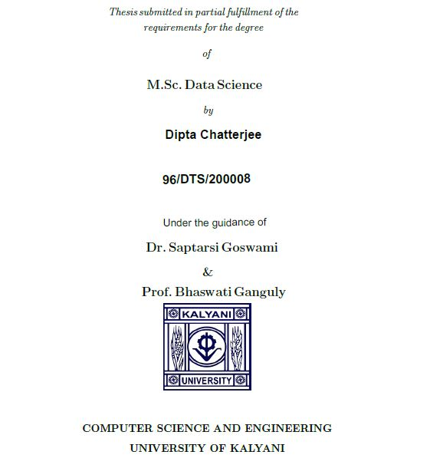

Acknowledgement

The journey of 5 months from March, 2022 to July, has been a life changing point in my life. The completion of this dissertation for the partial fulfillment of the pre-requisite for the award of Master of Science in Data Science, University of Kalyani, Nadia, India, has helped me to develop my statistical concepts, analytical thinking and data science skills.

I avail this opportunity to thank my professors and guides without whom this work would not have been possible. First, I would like to express my deepest gratitude to Dr. Bhaswati Ganguli, Professor, University of Calcutta, India and University of Calcutta, Dr. Saptarsi Goswami, Professor Department of Computer Science, Bangabasi Morning College, Kolkata, India for helping me building a research profile and also for walking me through the selection process in the team of the project. I would like to extend my sincere thanks to Dr. Anirban Mukhopadhyay, Professor and head of the Department, Department of Computer Science and Engineering, University of Kalyani, India for allowing me to experience and gain broader spectrum of exposure.

I would like to recognize my co-researchers for giving me support and enthusiasm and also occasional breaks from the constant research periods to start every hard step with a fresh mind.

I am obliged to my parents for always being on my side. I do not have such strong vocabulary to share how much they helped me with their affection, caring, sacrifice and support for me.

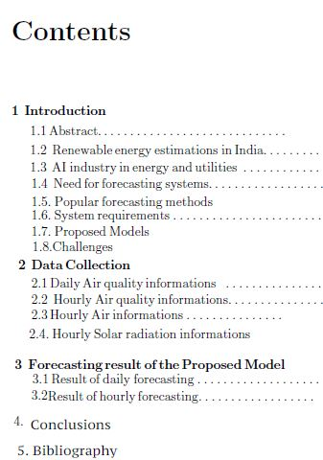

* 1. Abstract

In this study new features of air quality information have been added to the existing forecasting model of Global Horizontal Irradiance which is a solar radiation parameter. Here new proposed model has significantly increased the accuracy as compared to than the usual univariate GHI time series model. The air quality parameters has been processed and extracted from different satellites of NASA.

*Keywords:* GHI forecasting, Satellite Air Quality Data

* 1. Renewable Energy estimations in India

India is world's 3rd largest consumer of electricity and world's 3rd largest [renewable energy](https://en.wikipedia.org/wiki/Renewable_energy) producer with 38% of energy capacity installed in the year 2020 (136 GW of 373 GW) coming from renewable sources. [Ernst & Young](https://en.wikipedia.org/wiki/Ernst_%26_Young)'s (EY) 2021 Renewable Energy Country Attractiveness Index (RECAI) ranked India 3rd behind USA and China. In November 2021, India had a renewable energy capacity of 150 GW consisting of solar (48.55 GW), wind (40.03 GW), small hydro power (4.83 GW),  bio-mass (10.62 GW), large hydro (46.51 GW), and nuclear (6.78 GW).India has committed for a goal of 450 GW renewable energy capacity by 2030.

In 2016, [Paris Agreement](https://en.wikipedia.org/wiki/Paris_Agreement)'s [Intended Nationally Determined Contributions](https://en.wikipedia.org/wiki/Intended_Nationally_Determined_Contributions) targets, India made commitment of producing 50% of its total electricity from [non-fossil fuel](https://en.wikipedia.org/wiki/Fossil_fuel) sources by 2030. In 2018, India's [Central Electricity Authority](https://en.wikipedia.org/wiki/Central_Electricity_Authority_(India)) set a target of producing 50% of the total electricity from non-fossil fuels sources by 2030. India has also set a target of producing 175 GW by 2022 and 500 GW by 2030 from renewable energy.

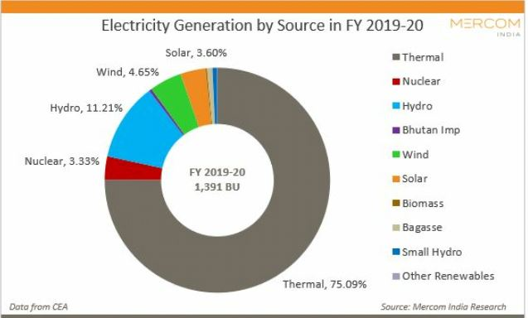

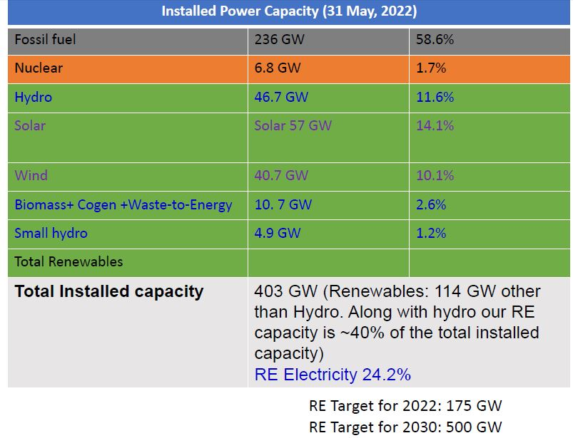

1.3.AI industry in Energy and utility

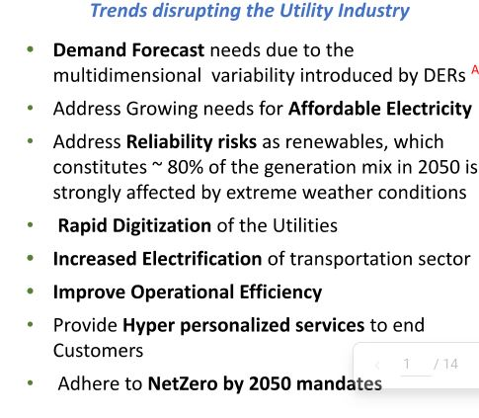

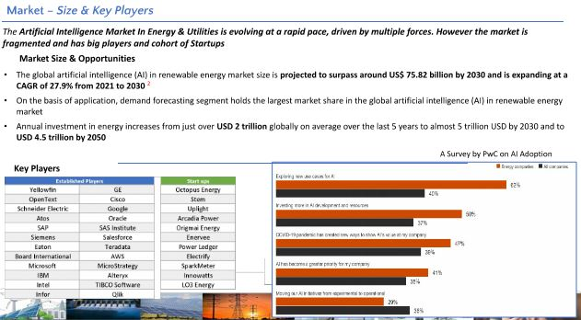

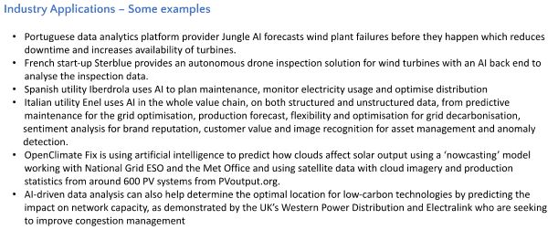

1.4 Need for forecasting models:

VRE forecasting affects a range of system operations including scheduling, dispatch, real-time balancing, and reserve requirements. By integrating VRE forecasts into system operations, power system operators can anticipate up- and down-ramps in VRE generation in order to cost-effectively balance load and generation in intra-day and daya headscheduling. This leads to reduced fuel costs, improved system reliability, and minimized curtailment of renewable resources.

1.5. Popular forecasting models:

In general, forecasting methods fall into two categories. Physical methods input weather

data (e.g., temperature, pressure, surface roughness, and obstacles) into numerical weather prediction (NWP) models to create terrain- specific weather conditions, which can then be converted to energy production. Statistical methods use historic and real-time generation data to statistically correct results derived from NWP models. Persistence forecasting is a simple statistical method that assumes current generation levels will remain unchanged in the very

near future. Persistence forecasts are often used as a benchmark or reference model

to evaluate more advanced methods .Wind energy forecasting is widely implemented among power systems with modest to high levels of wind power generation (e.g., Denmark, Ireland, Texas).Solar power forecasting is relatively new and not as widely used, though methodologies

and best-practices are rapidly evolving. Both wind and solar forecasts utilize NWP models to predict variables such as temperature, humidity, precipitation, and wind.

Solar forecasts also employ sky imagers (digital cameras that produce high-quality sky images)

and satellite imaging (data from networks of geostationary satellites) to track and predict

cloud formations at different timescales .Forecasts for distributed solar photovoltaic (PV)

generation are more difficult to produce and are most accurate when near real-time meter

data and detailed static data (e.g., location, hardware information, panel orientation, etc.)

are available for all interconnected systems. Up-scaling is a less detailed method that

uses a subset of representative PV systems to forecast regional generation.

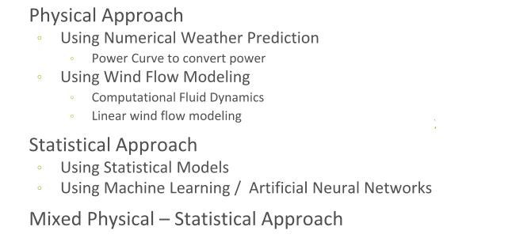

1.6. System requirements:

Meteorological data collecting instruments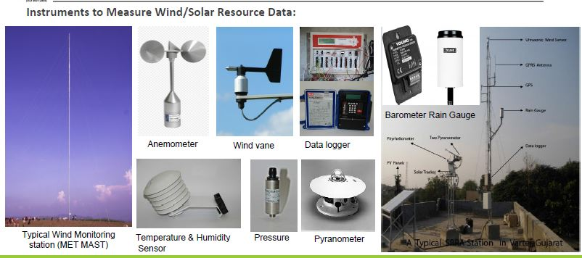

Data collection for power

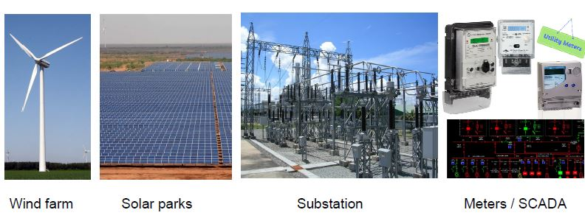

Data Management system of NIWE

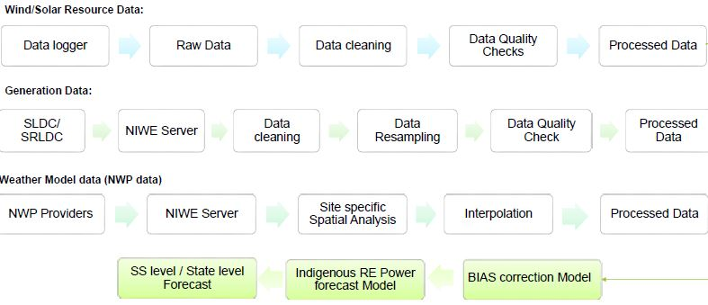

1.7. Proposed Model

Here, we have studied the effect of air quality for hourly Global Horizontal Index (GHI) forecasting using “Synoptic gridded (SYN1deg) version 4.1 data from NASA’s CERES” at a particular solar station using Uni-variate (Only GHI Values) and Multi-variate LSTM Models (GHI Values,Aerosol Optical Width (AOD) and other meteorological values.

1.8. Challenges

Here's NREL's list of the five features of VRE that pose challenges to grid managers:

**1) Variability:** This is the biggest and most vexing.

Power plants that run on fuel (along with some hydro and geothermal plants) can be ramped up and down on command. They are, in the jargon, "dispatchable." But VRE plants produce power only when the wind is blowing or the sun is shining. Grid operators don't control VRE, they accommodate it, which requires some agility.

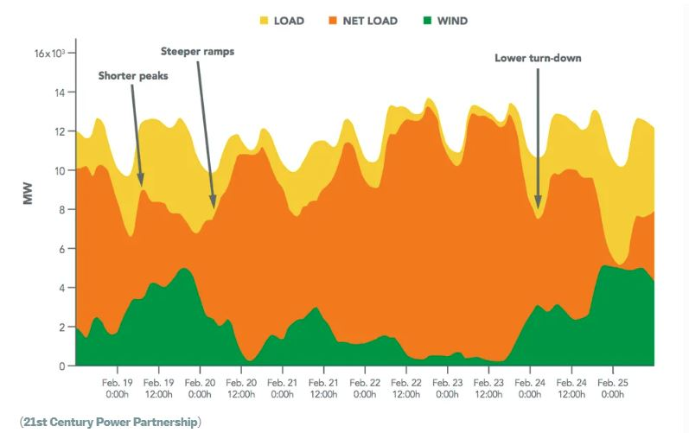

This shows one week of electricity supply and demand (details and location not particularly important). The green at the bottom is power coming in from wind. The yellow at the top is total demand. The orange in the middle is the gap between the two, the amount that has to be supplied by conventional power plants.

Another way of looking at it: from the perspective of the grid operator, who has control over a set amount of dispatchable power, VRE energy supply is functionally equivalent to reduction in demand — large, rapidly rising and falling fluctuations in demand for dispatchable power.

On the chart above, "shorter peaks" refers to times when conventional plants are supplying the day's "peak load," which is when power is most valuable. VRE reduces or "shaves" the peak, thus screwing with the economics of conventional plants. "Steeper ramps" refers to times when conventional plants have to increase or decrease their output quickly in response to fluctuations in VRE — often more quickly than they are designed or regulated for. And "lower turn-down" means that in times of high VRE supply, conventional plants will have to run at the lowest output they are capable of, i.e., "minimum load."

All these effects of variability pose challenges to the rules and economics that govern existing power infrastructure.

**2) Uncertainty:** The output of VRE plants cannot be predicted with perfect accuracy in day-ahead and day-of forecasts, so grid operators have to keep excess reserve running just in case.

**3) Location-specificity:** Sun and wind are stronger (and thus more economical) in some places than in others — and not always in places that have the necessary transmission infrastructure to get the power to where it's needed.

**4) Nonsynchronous generation:** Conventional generators provide voltage support and frequency control to the grid. VRE generators can too, potentially, but it's an additional capital investment.

**5) Low capacity factor:** VRE plants only run when sun or wind cooperates. According to the [Energy Information Administratio](http://www.eia.gov/electricity/monthly/epm_table_grapher.cfm?t=epmt_6_07_b)n, in 2014 the average capacity factor — production relative to potential — for utility-scale solar PV was around 28 percent; for wind, 34 percent. (By way of comparison, the average capacity factor of US nuclear power was 92 percent; those plants are almost always producing power.) Because of the low capacity factor of VRE, conventional plants are needed to take up the slack, but because of the high output of VRE in peak hours, conventional plants sometimes don't get to run as often as needed to recover costs.

So those are the challenges. Now let's take a look what NREL calls "emerging best practices" in addressing them.

**There are solutions for integrating solar and wind into the grid ...**

**Improved planning and coordination:** This is the first step, making sure that VRE is matched up with appropriately flexible dispatchable plants and transmission access so that energy can be shared more fluidly within and between grid regions.

**Flexible rules and markets:** Most grids are physically capable of more flexibility than they exhibit. Changes to the rules and markets that govern how plants are scheduled and dispatched, how reliability is assured, and how customers are billed, says NREL, "can allow access to significant existing flexibility, often at lower economic costs than options requiring new sources of physical flexibility."

This is the low-hanging fruit of grid flexibility. [Recent research](http://www.raponline.org/document/download/id/7600) from the Regulatory Assistance Project offers an overview of the changes needed in "market rules, market design, and market operations." A new Department of Energy [study](http://www.utilitydive.com/news/new-doe-report-outlines-how-utilities-can-best-manage-market-time-of-use/400907/) describes utility best practices in "time-of-use pricing," which varies the price of electricity throughout the day to encourage demand shifting. In New York, utility regulations are being  [fundamentally designed to optimize](http://www.utilitydive.com/news/in-new-york-utility-of-the-future-will-be-air-traffic-controller/373342/) the management of distributed energy resources (DERs). There's a ton of this stuff underway.

**Flexible demand and storage:** To some extent, demand can be managed like supply. "Demand response" programs aggregate customers willing to let their load be ramped up and down or shifted in time. The result is equivalent, from the grid operator's perspective, to dispatchable supply. There's a whole [range of demand-management tools](http://www.institutebe.com/InstituteBE/media/Library/Resources/Energy%20and%20Climate%20Policy/Role-of-Demand-Management_Dialogue-Summary.pdf) available and more coming online all the time.

Similarly, energy storage, by absorbing excess VRE at times when it's cheap and sharing it when it's more valuable, can help even out VRE's variable supply. It can even make VRE dispatchable, within limits. (For example, some concentrated solar plants have [molten-salt storage](http://www.institutebe.com/InstituteBE/media/Library/Resources/Energy%20and%20Climate%20Policy/Role-of-Demand-Management_Dialogue-Summary.pdf), which makes their power available 24 hours a day.)

**Flexible conventional generation:** Though older coal and nuclear plants are fairly inflexible, with extended shut-down, cool-off, and ramp-up times, lots of newer and retrofitted conventional plants are more nimble — and can be made more so by a combination of technology and improved practices. Grid planners can favor more flexible non-VRE options like natural gas and small-scale combined heat and power (CHP) plants.

Cycling conventional plants up and down more often does come with a cost, but the cost is typically smaller than the fuel savings from increased VRE.

**Flexible VRE:** New technology enables wind turbines to "provide the full spectrum of balancing services (synthetic inertial control, primary frequency control, and automatic generation control)," and both wind turbines and solar panels can now offer voltage control.

**Interconnected transmission networks:** This one's pretty simple. Wind and solar resources become less variable if aggregated across a broader region. The bigger the geographical area linked up by power lines, the more likely it is that the sun is shining or the wind is blowing somewhere within that area.

2.1. Daily Air Quality Data

We have downloaded the data as (.hdf) format from 27-03-2022  to 29-03-2022.There are total 20 datasets in between these days. The file list is shown below

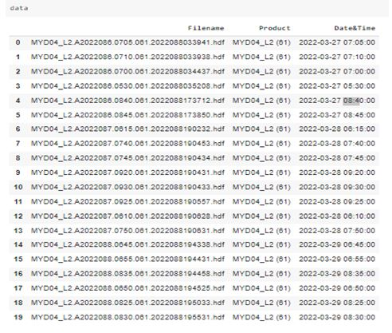

I have mentioned the code for i)Opening the hdf file. ii)Mapping each data

iii)Estimate AOD at any nearby location Iv)Calculate PM2.5 from slope of AOD curve. <https://colab.research.google.com/drive/1DFzdLBf2HIcAIYwRowFkvNQ38rt9tBy8#scrollTo=H8kRKfcrUraI>

The below picture is the AOD level and PM 2.5 observed in 2022-03-28 at 07:45:00

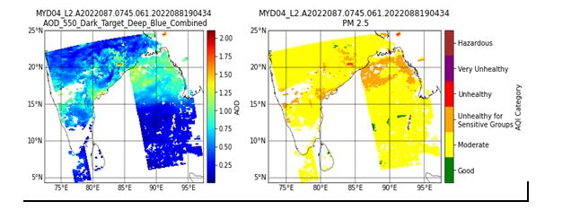

2.2. Hourly Air Quality Data:

The Aerosol Optical Width (AOD) data of land from NASA’S Terra + Aqua Edition 4.1 Satellite is available Monthly, Daily and Hourly basis in NASA’S CERES data product website. We have used the hourly  data of the following AOD at 0.84 micron, AOD at 0.55 micron, Cloud Skin Temperature , Surface Albedo and Column Ozone “Initial Meteorological Parameters” at different NIWE stations.

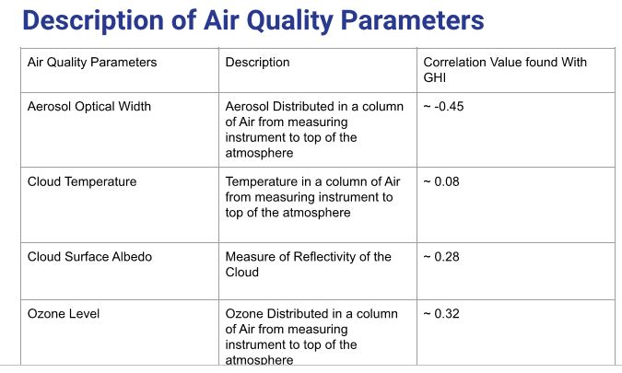

Hourly Solar Radiation Data

We have utilized five datasets for GHI at different NIWE stations with temporal resolution one hour given by NIWE for this project.

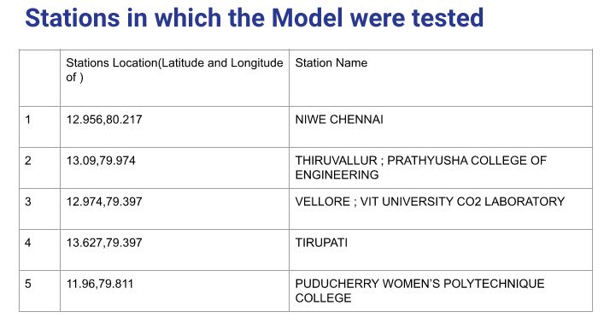

3.1. Results of Daily forecasting:

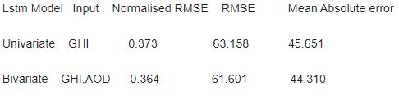

3.1. Results of Hourly Forecasting:

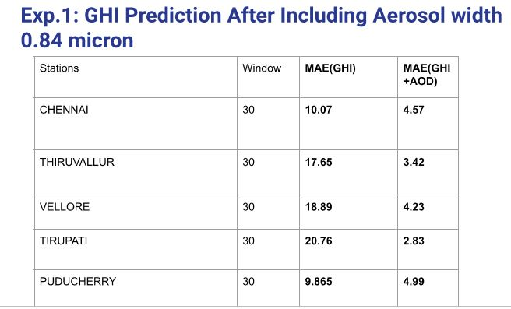

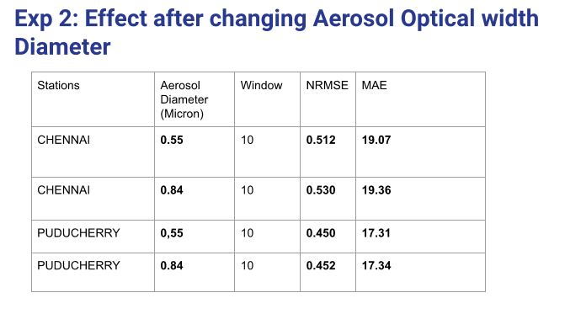

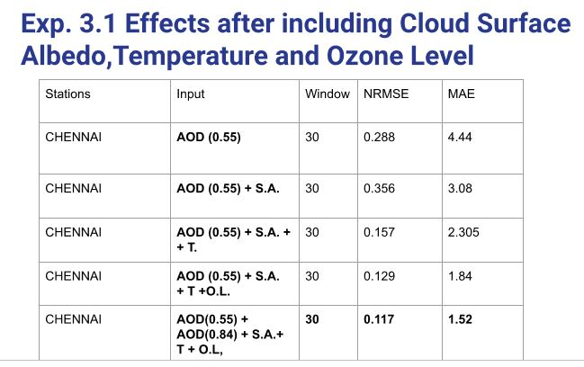

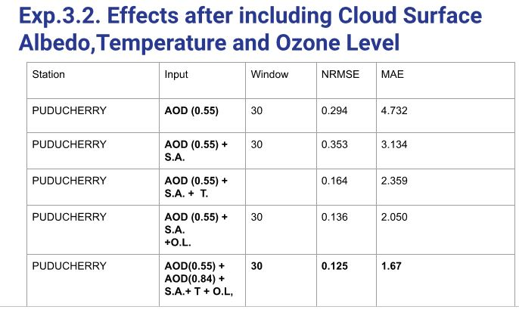

4.Conclusions:

Including air quality data seems to definitely improve accuracy of the forecasting of GHI model. Considering all variables we reached MAE less than 2 and NRMSE less than 0.15 on the other hand we had MAE greater than 20 and NRMSE higher than 0.30 in the Univariate GHI forecasting model.

**References**

1.Cleaner air would enhance India’s annual solar energy production by 6-28

TWh Sushovan Ghosh1, *Sagnik Dey1,2,3, *Dilip Ganguly1, Somnath Baidya Roy1, Kunal BaliCentre for Atmospheric Sciences, IIT Delhi, New Delhi 110016, India

Centre of Excellence for Research on Clean Air, IIT Delhi, New Delhi 110016, India

School of Public Policy, IIT Delhi, New Delhi, 110016, India*Corresponding Authors: sagnik@cas.iitd.ac.in (S. Dey) dilipganguly@cas.iitd.ac.in (D. Ganguly) Lastname, O. (2010). Online journal using DOI (digital object identifier). *Main Online Journal Name*, Vol#(Issue#), 159-192. <https://doi.org/10.1000/182>

<http://www.example.com>

**2**. The Influence of Air Quality on Solar irradiances in most air

polluted months in China

Zeng Fei1, Zhang Jinye1,2,3*, Liu Ruibei4, Lv Hui1,2,3, Wang Mingjie1, Yang Ling1