Data Analysis and Optimization for the experiment Adsorption of Tartazene via CNT :

In this experiment the operating parameters are i.Tartazene Concentration(ppm) ii.Adsorbent dose(g/L),iii.pH value,iv.Temperature(`C),v.Time(min).After treating with CNT with the help of Spectroscopy the absorbence value is calculated.Our target variable “%removal” value is deduced from the absorbance value.We aimed to observe how different operating parameters influenced the the % removal of Tartazene throughout the experiment.The data analysis of this experiment consists of the following steps,
- Setting up a Generative Adversarial Network(GAN) for synthetic tabular data generation
- Experimenting with different Algorithms to find an efficient prediction model.
- Optimization study employing the Response surface methodology (RSM) based on Central composite design (CCD)
- Apply Genetic Algorithm to find the best fit conditions
- Anova Test
- Model Deployment and making a web application with Streamlit
Let us look into them one by one
1.Setting up a Generative Adversarial Network(GAN) for synthetic tabular data generation:
Before we jump into building the prediction model with the help of ANN and Machine learning algorithms its very important that we have sufficient amount of data so that overfitting of the model is prevented.We have designed a GAN network with python in googlecolab that has generated 150 new data from 91 original dataset with mean absolute error of 9.13 and R2 score of 0.89.The basic architechture of GAN that we have used is shown in the below figure. The generative network generates candidates while the discriminative network evaluates them.The contest operates in terms of data distributions. Typically, the generative network learns to map from a latent space to a data distribution of interest, while the discriminative network distinguishes candidates produced by the generator from the true data distribution. The generative network's training objective is to increase the error rate of the discriminative network (i.e., "fool" the discriminator network by producing novel candidates that the discriminator thinks are not synthesized (are part of the true data distribution)).
A known dataset serves as the initial training data for the discriminator. Training it involves presenting it with samples from the training dataset, until it achieves acceptable accuracy. The generator trains based on whether it succeeds in fooling the discriminator. Typically the generator is seeded with randomized input that is sampled from a predefined latent space (e.g. a multivariate normal distribution). Thereafter, candidates synthesized by the generator are evaluated by the discriminator. Independent backpropagation procedures are applied to both networks so that the generator produces better samples, while the discriminator becomes more skilled at flagging synthetic samples. When used for image generation, the generator is typically a deconvolutional neural network, and the discriminator is a convolutional neural network.
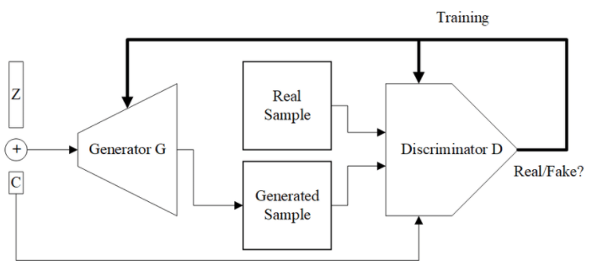
Description of our Neural Networks of Generator and Discriminator
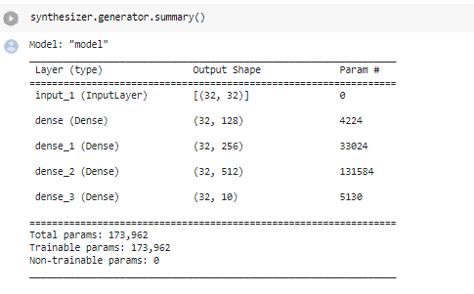
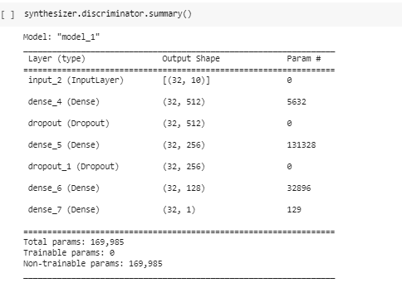

2.Experimenting with different algorithms to find an efficient prediction model:
A smart prediction model can help in many ways during the experiment.The experiment is designed in such a way that the observer has to note the values of the experimental parameters for time=0,15,30,45,……,120 minutes for one fixed values.That is why to completely store the data of reactions a minimum of 6-7 days are needed.The prediction model can predict the result let’s say for time=60,90,120 minutes if we give it the values for time=15,30,40,45,50,55 minutes in the range of mean absolute error as specified for each algorithm from our side.Thus it can reduce time and cost dramatically.It can also predict the target variable in any given operating parameters.
- Machine Learning Approaches:
Machine learning algorithms can be applied to a problem in many ways as shown in Figure1.Our casestudy falls under the lap of Supervised learning.The evolution of supervised learning approaches is shown in Figure 2.

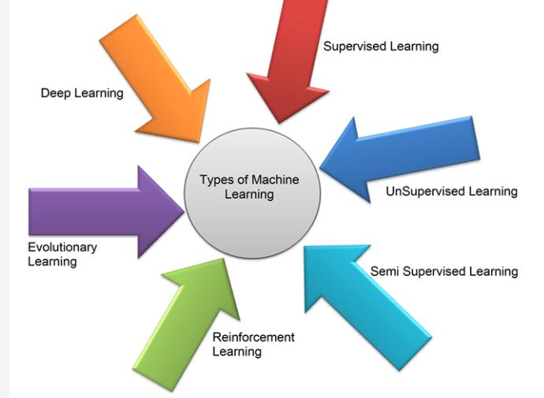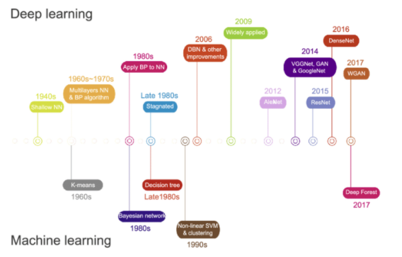
Figure 1:Types of Machine learning approaches Figure 2:Evolution of Machine learning and Deep learning
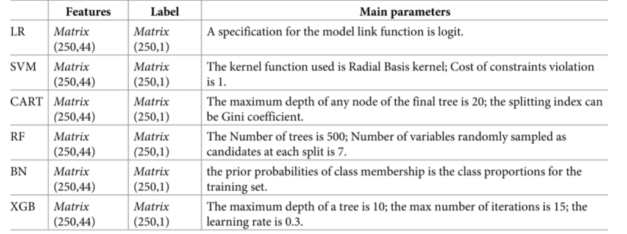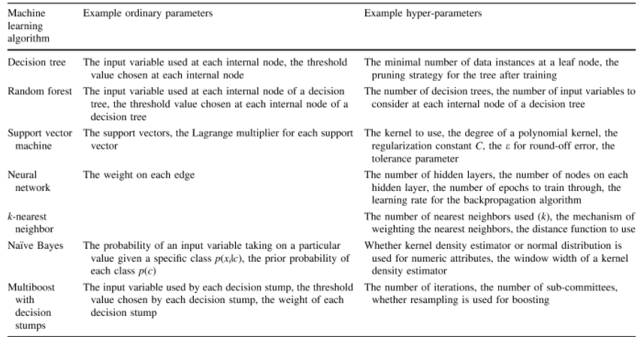
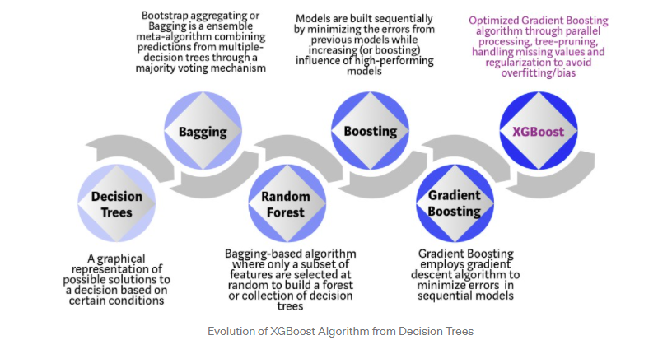
Figure 3: A brief summary of the traditional Supervised Machine Learning approaches

We have first experimented with the following traditional machine learning approaches,
- Linear Regression
- K nearest neighbor
- Random Forest
- Gradient Boosting
- Support Vector Regression
- Decision Tree
- Bagging
- Adaboost
A brief introduction to these algorithms is shown in Figure 3.The Mean absolute error and R2 score of each of the algorithms that we have applied is given in Figure 4
Algorithm | Mean Absolute Error | R2 Score
Linear Regression | 2.651 | 0.047
K nearest neighbor | 1.162 | 0.768
Support Vector Regression | 1.332 | 0.343
Decision Tree | 1.688 | 0.267
Bagging | 1.840 | 0.156
Gradient Boosting | 1.442 | 0.493
Adaboost | 1.687 | 0.267
Knn after tuning(Best) | 0.45 | 0.97

We found that Knn gives best accuracy after hyperparameter tuning.Visualization of the Scores are shown below.
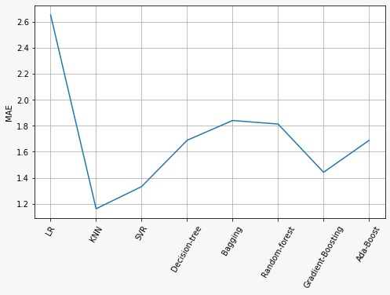
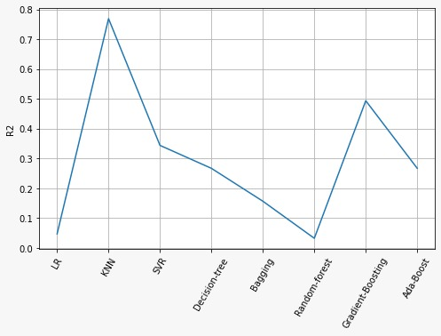
- ANN
Next we moved on making the our Artificial neural network. An ANN is based on a collection of connected units or nodes called artificial neurons, which loosely model the neurons in a biological brain.Each connection, like the synapses in a biological brain, can transmit a signal to other neurons. An artificial neuron receives a signal then processes it and can signal neurons connected to it. The "signal" at a connection is a real number, and the output of each neuron is computed by some non-linear function of the sum of its inputs. The connections are called edges. Neurons and edges typically have a weight that adjusts as learning proceeds. The weight increases or decreases the strength of the signal at a connection. Neurons may have a threshold such that a signal is sent only if the aggregate signal crosses that threshold. Typically, neurons are aggregated into layers. Different layers may perform different transformations on their inputs. Signals travel from the first layer (the input layer), to the last layer (the output layer), possibly after traversing the layers multiple times.
- Selecting the hyperparameters of the ANN

Hyperparameters are the parameters that manipulate the training of an Artificial Neural Network, by tuning those we could be able to produce high-quality solutions. Hyperparameters are not produced by the model during the training process unlike the weights of the model. The hyperparameters don’t change over training time and remain constant and manipulate the training process of a model. Finding optimal hyperparameters is a search problem, by utilizing which we might or might not end up with the best possible solution which is global optima. Hyperparameters of an Artificial Neural Network are,
- Number of layers to choose
- Number of neurons in a layer to choose
- Choice of the optimization function
- Choice of the learning rate for optimization function
- Choice of the loss function
- Choice of metrics
- Choice of activation function
- Choice of layer weight initialization
- The importance of Hyperparameter Tuning

Hyperparameter tuning is the process of searching optimal set of hyperparameters. It is really hard to find the optimal set of hyperparameters manually, so there are certain algorithms that make our hyperparameter search easier. Grid search is one of the algorithms that perform an exhaustive search which is time-consuming by nature, so an alternative to that is the Random Search algorithm that randomly searches the hyperparameter search space but it doesn’t guarantee a globally optimal solution. The algorithms that are more likely to provide globally optimal solutions are Bayesian optimization, Hyperband, and Hyperparameter optimization using Genetic algorithms.
- How do we evaluate a set of hyperparameters?
The hyperparameters are evaluated based on the losses of the model predictions, viz. the hyperparameters are set on the model, the model is trained on the data, and the performance of the model is evaluated based on the loss function. These steps are followed iteratively to find the optimal set of hyperparameters. As said earlier we might or might not end up with a globally optimal solution.
- Keras Tuner:

Keras tuner is an open-source python library developed exclusively for tuning the hyperparameters of Artificial Neural Networks. Keras tuner currently supports four types of tuners or algorithms namely,
      - Bayesian Optimization
      - Hyperband
      - Sklearn
      - Random Search
- Results:
The Mean Absolute error of our proposed ANN model is 1.39 .The summary of the model is shown in the figure below

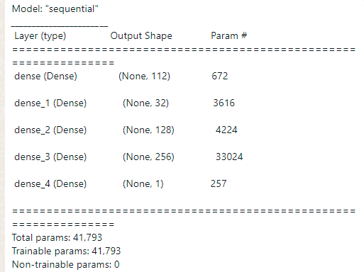

3.Optimization study employing the Response surface methodology (RSM) based on Central composite design (CCD)
The central composite design is the most commonly used fractional factorial design used in the response surface model. In this design, the center points are augmented with a group of axial points called star points. With this design, quickly first-order and second-order terms can be estimated. Any optimization process is achieving by going through certain phases, i.e., Screening; where identification of significant and important factor is important; Improvement; where factors need to be identified which is near to optimum, Response surface design; where optimum or best product has been designing by response surface method (RSM) by quantifying the relationship between one or more measured responses and vital input factor. It is always been a tedious tasks to choice a suitable experimental design, which can easily explain many response variables. Such variables often end as quadratic surface model. For such kind of interpretation central composite design can be an excellent choice. In the process of Optimization and finding the best possible product from the ongoing batches, an experimental design called the central composite design (CCD) concept has emerged. The CCD model is an integral part of response surface mythology. The biggest advantage of this type of optimization model is, it is more accurate, and no need for a three-level factorial experiment for building a second-order quadratic model. After excising the CCD model within the experiment, a linear regression model has been used to construct the model, and coadded values have been used . The CCD model is otherwise called A Box-Wilson Central Composite Design. In this design, the center points are eventually augmented with the group of “star points” that allows estimation of curvature. If the distance from the center of the design space to a factorial point is ±1 unit for each factor, the distance from the center of the design space to a star point is ± α with ׀α׀ > 1. The precise value of α depends on certain specific properties required for the design. Since there are many factors available in the CCD model, therefore, the possibility of more than two or many star points within the model is more palpable. The star points represent lower and higher extreme values. The CCD model allows to extends 2 level factors, which have been widely used in response surface modeling and Optimization.
Analysis of Variance
Source | DF | Adj SS | Adj MS | F-Value | P-Value
Model | 20 | 2552.58 | 127.63 | 129.71 | 0.000
Linear | 5 | 1529.31 | 305.86 | 310.84 | 0.000
Tar.(ppm) | 1 | 1380.63 | 1380.63 | 1403.12 | 0.000
Adose(g/L) | 1 | 0.30 | 0.30 | 0.30 | 0.601
pH | 1 | 0.71 | 0.71 | 0.73 | 0.423
Temperature | 1 | 13.38 | 13.38 | 13.59 | 0.008
time | 1 | 170.60 | 170.60 | 173.38 | 0.000
Square | 5 | 185.90 | 37.18 | 37.79 | 0.000
Tar.(ppm)*Tar.(ppm) | 1 | 142.88 | 142.88 | 145.21 | 0.000
Adose(g/L)*Adose(g/L) | 1 | 0.30 | 0.30 | 0.31 | 0.596
pH*pH | 1 | 0.71 | 0.71 | 0.73 | 0.423
Temperature*Temperature | 1 | 1.15 | 1.15 | 1.17 | 0.315
time*time | 1 | 11.48 | 11.48 | 11.67 | 0.011
2-Way Interaction | 10 | 131.14 | 13.11 | 13.33 | 0.001
Tar.(ppm)*Adose(g/L) | 1 | 0.01 | 0.01 | 0.01 | 0.939
Tar.(ppm)*pH | 1 | 0.02 | 0.02 | 0.02 | 0.893
Tar.(ppm)*Temperature | 1 | 6.49 | 6.49 | 6.60 | 0.037
Tar.(ppm)*time | 1 | 124.29 | 124.29 | 126.31 | 0.000
Adose(g/L)*pH | 1 | 0.16 | 0.16 | 0.16 | 0.703
Adose(g/L)*Temperature | 1 | 0.07 | 0.07 | 0.07 | 0.802
Adose(g/L)*time | 1 | 0.00 | 0.00 | 0.00 | 0.954
pH*Temperature | 1 | 0.00 | 0.00 | 0.00 | 0.948
pH*time | 1 | 0.05 | 0.05 | 0.05 | 0.836
Temperature*time | 1 | 0.06 | 0.06 | 0.06 | 0.811
Error | 7 | 6.89 | 0.98
Lack-of-Fit | 2 | 6.89 | 3.44 | 2.26563E+08 | 0.000
Pure Error | 5 | 0.00 | 0.00
Total | 27 | 2559.47
Regression Equation in Uncoded Units
Conc | = | 4.03 + 0.1714 Tar.(ppm) - 0.95 Adose(g/L) - 0.162 pH - 0.237 Temperature - 0.0216 time  + 0.001973 Tar.(ppm)*Tar.(ppm) + 0.259 Adose(g/L)*Adose(g/L) + 0.0139 pH*pH  + 0.00370 Temperature*Temperature + 0.000249 time*time - 0.00066 Tar.(ppm)*Adose(g/L)  - 0.00022 Tar.(ppm)*pH - 0.002123 Tar.(ppm)*Temperature - 0.001161 Tar.(ppm)*time  - 0.0329 Adose(g/L)*pH + 0.0115 Adose(g/L)*Temperature - 0.00033 Adose(g/L)*time  - 0.00056 pH*Temperature + 0.00022 pH*time - 0.000137 Temperature*time
Central Composite Design

Point Types
Cube points: | 16
Center points in cube: | 6
Axial points | 10
Center points in axial: | 0

Design Summary α = 2

Factors: | 5 | Replicates: | 1
Base runs: | 32 | Total runs: | 32
Base blocks: | 1 | Total blocks: | 1

Fits and Diagnostics for Unusual Observations
Obs | Conc | Fit | Resid | Std Resid
1 | 0.754 | 1.073 | -0.319 | -2.23 | R
2 | 11.578 | 10.848 | 0.729 | 2.27 | R
7 | 0.663 | 0.982 | -0.319 | -2.23 | R
10 | 0.359 | -0.097 | 0.456 | 2.65 | R
11 | 2.739 | 4.289 | -1.551 | -2.57 | R
17 | 0.097 | 0.416 | -0.319 | -2.23 | R
18 | 26.067 | 26.386 | -0.319 | -2.23 | R
22 | 0.913 | 0.457 | 0.456 | 2.65 | R
23 | 24.153 | 23.697 | 0.456 | 2.65 | R
24 | 0.504 | 0.048 | 0.456 | 2.65 | R
27 | 11.921 | 11.465 | 0.456 | 2.65 | R
28 | 23.676 | 23.220 | 0.456 | 2.65 | R

Model Summary
S | R-sq | R-sq(adj) | R-sq(pred)
0.991954 | 99.73% | 98.96% | 3.40%

- Graphs
Minitab provides built in packages with which we can get the Residual plots,Surface plots and Contour plots.These plots provides very good visualization on how the target variable is dependent upon the operating variables

Effects pareto of concentration
Residual plots of Concentration

Residuals for Conc vs Adose(g/L)

Residuals from Conc. Vs pH

Residuals from Conc. Vs Temperature

Residuals from Conc. Vs time
- Surface Plots:

Contour Plots:

Design of Experiment
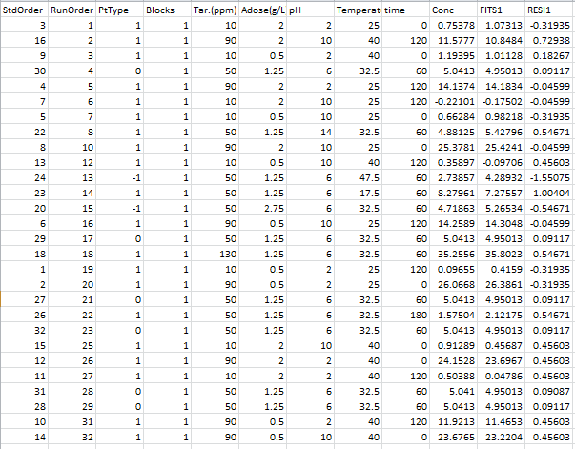

4.Applying Genetic Algorithm to find the best fit conditions
The genetic algorithm is a method for solving both constrained and unconstrained optimization problems that is based on natural selection, the process that drives biological evolution. The genetic algorithm repeatedly modifies a population of individual solutions. At each step, the genetic algorithm selects individuals from the current population to be parents and uses them to produce the children for the next generation. Over successive generations, the population "evolves" toward an optimal solution. You can apply the genetic algorithm to solve a variety of optimization problems that are not well suited for standard optimization algorithms, including problems in which the objective function is discontinuous, nondifferentiable, stochastic, or highly nonlinear. The genetic algorithm can address problems of mixed integer programming, where some components are restricted to be integer-valued.
This flow chart outlines the main algorithmic steps.
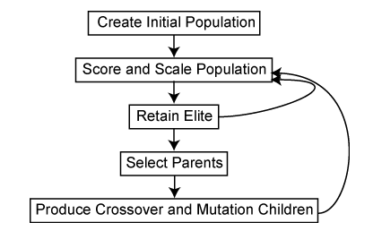
The genetic algorithm uses three main types of rules at each step to create the next generation from the current population:
  - Selection rules select the individuals, called parents, that contribute to the population at the next generation. The selection is generally stochastic, and can depend on the individuals' scores.
  - Crossover rules combine two parents to form children for the next generation.
  - Mutation rules apply random changes to individual parents to form children.
Results and Conclusions of all of the above processes are discussed below
5.ANOVA test:
Developed by Ronald Fisher, ANOVA stands for Analysis of Variance. One-Way Analysis of Variance tells you if there are any statistical differences between the means of three or more independent groups.Example of One Way ANOVA: You have a group of individuals randomly split into smaller groups and completing different tasks. For example, you might be studying the effects of tea on weight loss and form three groups: green tea, black tea, and no tea.Here with the help of One Way ANOVA we found that the most relevant individual parameter among the five that had effected the % removal.We have again used minitab’s built in packages to get the ANOVA table.The results are shown below

One-way ANOVA: Removal versus Sample
Method
Null hypothesis | All means are equal
Alternative hypothesis | Not all means are equal
Significance level | α = 0.05
Equal variances were assumed for the analysis.
Factor Information
Factor | Levels | Values
Sample | 3 | s1, s2, s3
Analysis of Variance
Source | DF | Adj SS | Adj MS | F-Value | P-Value
Sample | 2 | 8922 | 4460.8 | 9.17 | 0.000
Error | 88 | 42799 | 486.3
Total | 90 | 51720
Model Summary
S | R-sq | R-sq(adj) | R-sq(pred)
22.0533 | 17.25% | 15.37% | 9.88%
Means
Sample | N | Mean | StDev | 95% CI
s1 | 25 | 71.20 | 34.47 | (62.43, 79.96)
s2 | 21 | 83.33 | 25.36 | (73.77, 92.90)
s3 | 45 | 94.578 | 5.690 | (88.045, 101.111)
Pooled StDev = 22.0533
Tukey Pairwise Comparisons
Grouping Information Using the Tukey Method and 95% Confidence
Sample | N | Mean | Grouping
s3 | 45 | 94.578 | A
s2 | 21 | 83.33 | A | B
s1 | 25 | 71.20 |  | B
Means that do not share a letter are significantly different.

Conlcusion:
- The P value of the ANOVA table is less than 0.05.Thus we reject the null hypothesis that the sample means of our three samples are equal.
- Sample s3(pH variation) has the highest effect on removal followed by s2(Adose variation) and s1(tartazene variation)

- Model Deployment and making a web application with Streamlit
For a person

