European Listing Venues – Where Euronext Wins and Where It Doesn’t
FY2025 and H1 2026 · public data from exchanges, PwC and EY · figures not converted across currencies
Five takeaways
- Most listings, small deals (2025). Euronext admitted 76 new equity listings but raised €678m in IPOs, about €8.9m per listing and 5.4% of Europe’s €12.5bn (PwC, Jan–Nov).
- Proceeds went north and to Frankfurt. Nasdaq Stockholm and Helsinki raised at least €6,903m from 18 listings, led by Verisure; Frankfurt €1,186m from 3 IPOs; London £2.1bn from 23.
- H1 2026 reversed the picture. Euronext raised €4,595m from 39 listings, about 64% of Europe’s €7.2bn, and hosted CSG (€3.3bn), Europe’s largest IPO since 2022.
- But it rests on one deal: CSG alone is 72% of Euronext’s H1 IPO money. Repeatable mid-cap deals, the size of Ottobock in Frankfurt (€808m) or SMG on SIX (about CHF 903m), are the gap to close.
- The after-listing case is strong: listed companies raised €13.7bn in follow-ons in 2025, 20x IPO proceeds, and 36% of new listings were tech companies.
Talking points for an issuer pitch
- Large caps: Europe’s largest IPO since 2022 (CSG, €3.3bn) listed on Euronext Amsterdam in H1 2026.
- Tech and SMEs: 36% of 2025 listings were tech; about 700 listed tech companies worth €1.4tn.
- Life after IPO: €13.7bn of follow-ons in 2025, so listed companies keep raising capital.
- Reach: over 1,700 issuers and €6.7tn of market capitalisation across seven national exchanges.
Comparability: Euronext counts all new equity listings and includes over-allotment; PwC counts deals ≥ $5m and excludes greenshoe; London includes AIM; Nordic proceeds are a lower bound; 2025 PwC data stop at 30 November. See the Comparability sheet.
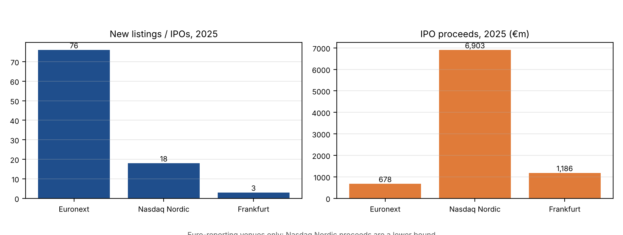
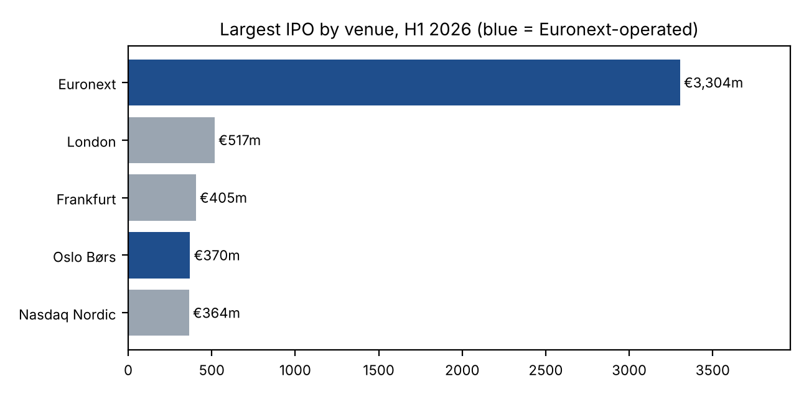
Sources: Euronext Q4/FY2025, Q1 and Q2 2026 results and 2025 listings release; EY UK IPO Eye Q4 2025; PwC Nordic IPO Watch 2025; PwC Germany Emissionsmarkt 2025; EY Switzerland and SIX 2025; PwC IPO Watch Europe 2025 and EMEA H1 2026. Links per figure in the Excel file.

