
- Logout

Project
Your first neural network
A part of the Deep Learning Nanodegree Foundation Program
- Project Review
- Code Review
- Notes
Share your accomplishment

Requires Changes

5 specifications require changes
Awesome submission! The neural net is implemented correctly and the calculations are correct. There are just some minor issues in the hyperparameters tuning and the run method which I explained in the comments. You can have training loss about 0.07 and validation loss about 0.17 as your goal to reach in this project. I also recommend you to watch the prediction plot when you tuned the model and think about why the model doesn't perform well from Dec 21 to Dec 31. Keep doing your awesome job! Happy learning 

Code Functionality
All the code in the notebook runs in Python 3 without failing, and all unit tests pass.
Good job for passing the unit tests. The problem that you were talking about is coming from the run method. You had put another for loop in the run method which is not necessary because we already have that loop in the Train method.
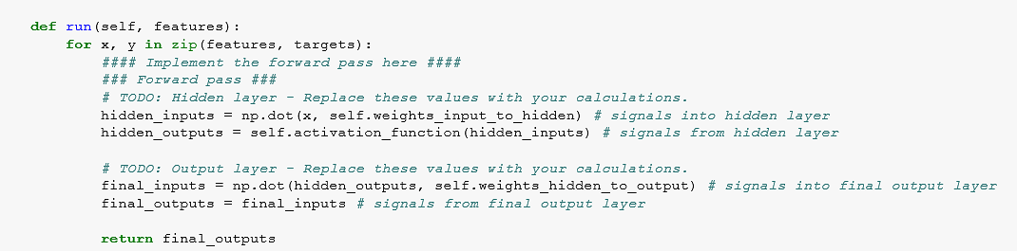
Please change the run method as the following:
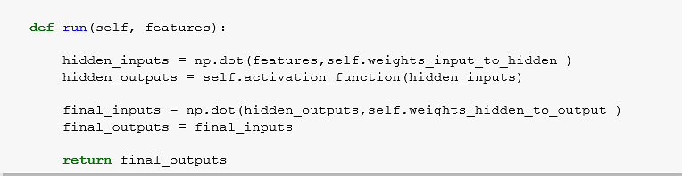
The sigmoid activation function is implemented correctly
Awesome, the sigmoid function is implemented correctly! To learn more about sigmoid or other activation functions like RelU and Tanh check out this page

Forward Pass
The input to the hidden layer is implemented correctly in both the train and run methods.
Your code in the train method is correct but it needs some modification in the run method as I explained in the first section.

run
hidden_inputs = np.dot(features, self.weights_input_to_hidden)
The output of the hidden layer is implemented correctly in both the train and run methods.
The input to the output layer is implemented correctly in both the train and run methods.
The output of the network is implemented correctly in both the train and run methods.
Awesome, since the network is being used for the regression so the output of the network is the raw input to the output unit and there is no need of an activation function here.

Backward Pass
The network output error is implemented correctly
Updates to both the weights are implemented correctly.
Awesome, the backpropagation is the trickiest part but you did it flawlessly! Following is a great article about backpropagation if you want to dig more in!
step-by-step-backpropagation-example

Hyperparameters
The number of epochs is chosen such the network is trained well enough to accurately make predictions but is not overfitting to the training data.
The epochs number is too low. You can increase the accuracy of the model by adding more epochs. But you should be careful if you go very high then it may cause overfitting. To check overfitting you can watch the behavior of both validations and training loss. If you see that the training loss is decreasing where the validation is going to increase then you should stop the training. This technique is called Early-Stopping I would suggest starting with higher values rather than the small ones. That way you can watch the trend in loss plot and refine your parameters. For this project, I recommend choosing numbers in the range of 3000-8000.
The number of hidden units is chosen such that the network is able to accurately predict the number of bike riders, is able to generalize, and is not overfitting.
The key point of choosing hidden nodes is to keep the balance between generalization and overfitting. The more nodes you choose the more sensitive model becomes to the data and as a result, the accuracy goes up, however, if you go too excessive then the model overfits. Try to have at least 8 nodes.
This a great discussion about how to choose the number of nodes.
The learning rate is chosen such that the network successfully converges, but is still time efficient.
0.1 is a good choice, however, please note that in the weight updating part we are calculating this:
self.weights_hidden_to_output += self.lr * delta_weights_h_o / n_records
self.weights_input_to_hidden += self.lr * delta_weights_i_h / n_records
in other words, we are multiplying the delta_weights to the quotient of the learning rate / the number of records. The n_records is equal to 128 so if we divide the LR over 128 we will get 0.00078 ! as a result, the value of the delta turns into a fraction of its original value and at each step, we just update the weights very insignificantly. I would recommend considering the value of the quotient of the learning rate / the number of records and keep it in the range of 0.004 - 0.01
Again I want to emphasize this fact that because of the division over n_records we are choosing higher values for the LR.
Following is a great reference for evaluating learning rate.
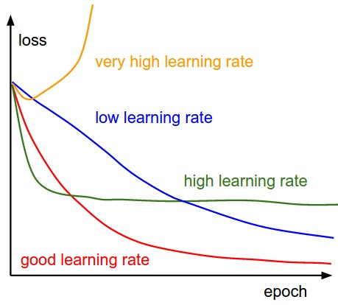
source
Additional study:
Effect of Learning Rate on Artificial Neural Network in Machine Learning
Download Project


Best practices for your project resubmission
Ben shares 5 helpful tips to get you through revising and resubmitting your project.
Watch Video (3:01)

- Student FAQ

