Selenium Installation and
Troubleshooting Assignment
Python • WebDriver • Browser Automation • Diagnostic Skills
Names | Diptarka Samanta  Ankan Patra  Sudipa Mondal  Ayush Krishna Nandy | Roll No.
Section |  | Date

1. Assignment Purpose
Install and configure Selenium with Python, verify browser automation, investigate the underlying components, and diagnose common installation and execution failures. The emphasis is on independent technical problem-solving and evidence-based reporting.

2. Submission Instructions
- Complete the work individually unless your instructor permits collaboration.
- Do not copy ready-made answers. Find the solution using official documentation, reliable technical sources, terminal output, and your own experiments.
- Submit one PDF report and a ZIP folder containing all Python scripts and supporting screenshots.
- For every source used, provide the page title and URL. Clearly distinguish copied facts from your own observations.
- Never submit passwords, API keys, private browsing data, or personal account information.

3. Required Environment
- Python 3.10 or later
- pip and a virtual environment
- A current Chrome, Firefox, or Edge browser
- Selenium 4.x
- A code editor or IDE
- Internet access for installation and documentation lookup

4. Part A — Installation and Verification Tasks (20 marks)
- Record the operating system, Python version, pip version, browser name, and browser version.
Ans. To check the Operating System press windows + r ;Then type winver and press enter. It will show the windows version.
To check the python version open command prompt and type python --version
To check the pip version open command prompt and type pip --version
To check the brouser name (chrome brouser) go to the address bar and type chrome://settings/help then press enter.

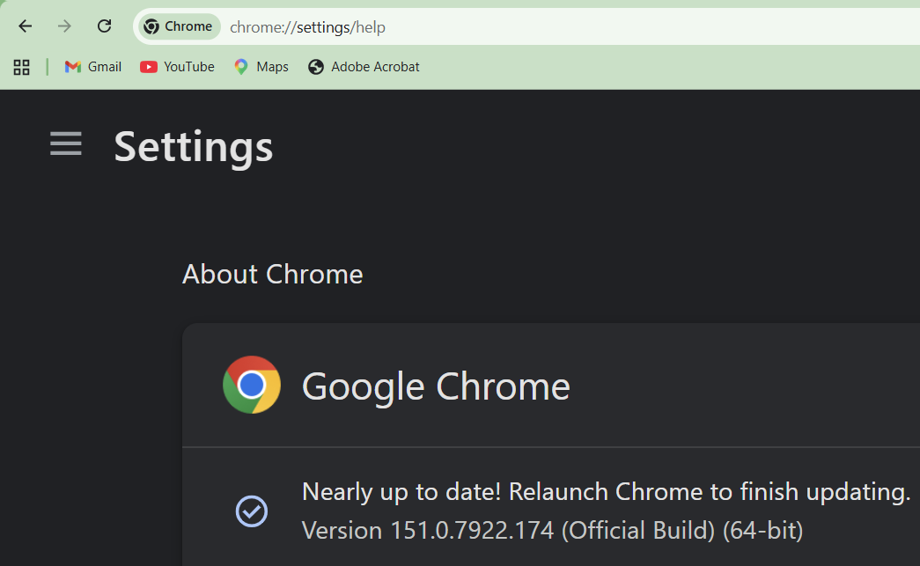
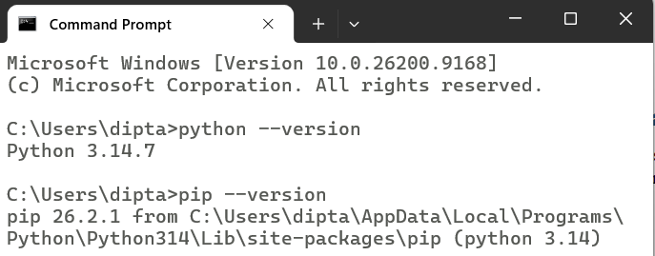
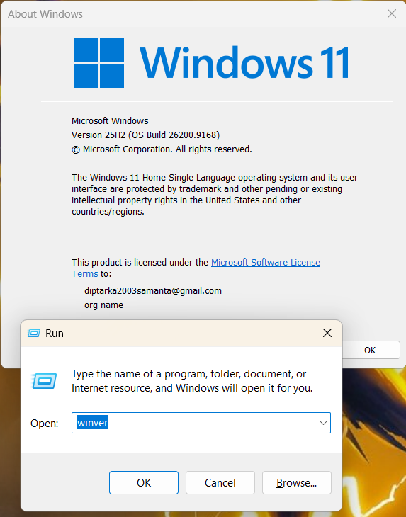

- Create a new project folder and a virtual environment. Activate it and show evidence that the environment is active.
Ans.
Go to the specific location where the user want to create the project folder.
In this case user choose a folder named projects in the D drive to store all the project works. There a new folder wipro is created. In this location the virtual environment is needed to be setup.
To create virtual environment at first user can choose any code editor. First Visual Studio code editor is selected.
In the vs code open the targeted folder. Then open one terminal from the top. Switch the terminal to the command prompt if it is default selected to powershell. To switch the terminal click the + icon at the top right side of the terminal and from there user can easily switch the terminal type.
- To create a virtual environment user have to type python -m venv .venv and press enter.
- To activate it type .venv\Scripts\activate and press enter.
- (.venv) prefix is added to the path of the folder which gives the evidence that the virtual environment is activated
- To deactivate the virtual environment type deactivate and press enter.
- To remove the venv folder type rmdir /s /q .venv and press enter.
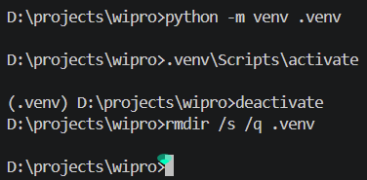

If the user want to use the powershell instead of command prompt, then commands are a little bit different.
- To create a virtual environment user have to type python -m venv .venv and press enter.
- To activate it type .\.venv\Scripts\Activate.ps1 and press enter.
- (.venv) prefix is added to the path of the folder which gives the evidence that the virtual environment is activated
- To deactivate the virtual environment type deactivate and press enter.
- To remove the venv folder type Remove-Item -Recurse -Force .venv and press enter.
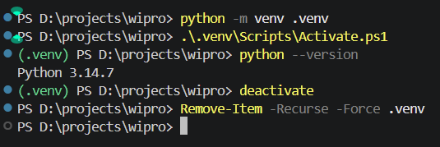
If the user use Pycharm then During the time to create new project the virtual environment is being created automatically. Just create new project and give the path of the folder where the project need to be created. Then Interpreter type choose project venv and click the create button. Thus the virtual environment will automatically be created. To check the virtual environment is actually active, check the bottom right corner, there .venv and the version of python is shown. Also click the terminal button (Alt + f12) and there also (.venv) is shown as prefix of the folder location which give the evidence that the virtual environment is active.
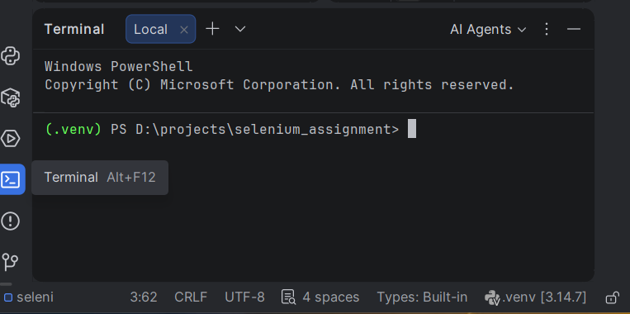
- Install Selenium using pip. Record the exact command and installed Selenium version.
Ans. Below video link is there.
Python Installation
https://drive.google.com/drive/folders/1TF-ufZPzEX__EC0O7cbBkANaoy7RW6Sw?usp=sharing
Selenium Installation
https://drive.google.com/drive/folders/1kPcFRtCHn-XAmVMtAF9WgYPEklaqOlK5?usp=drive_link

To install Selenium just type pip install selenium in the command prompt and press enter.
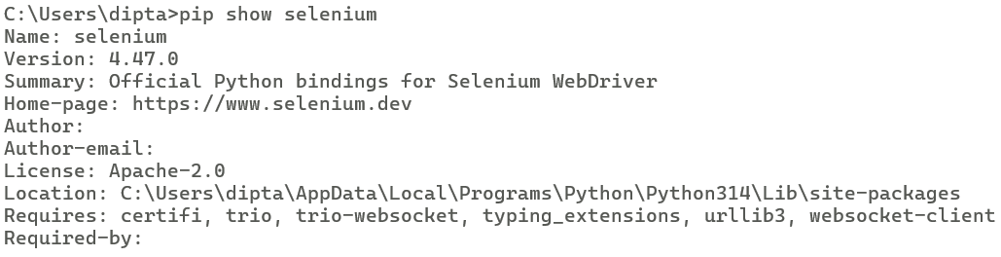
To check the version of the Selenium type pip show selenium in the command prompt and press enter.

- Create a script that starts the browser, opens https://example.com, prints the page titleenium version. and current URL, and closes the browser safely.
Create a file named: selenium_test.py
Use the following source code:
from selenium import webdriver
driver = webdriver.Chrome()
try:
driver.get("https://example.com")
print("Page Title:", driver.title)
print("Current URL:", driver.current_url)
finally:
driver.quit()

- Run the script twice. Explain whether a driver was downloaded or discovered automatically and where you found the evidence.
Make sure the virtual environment is activated and run: python selenium_test.py
The browser should open automatically and display: https://example.com
The terminal should display output similar to:
Page Title: Example Domain
Current URL: https://example.com/

- Generate a requirements.txt file and explain how another student can reproduce the same environment.
Run the script once: python selenium_test.py
Then run it again: python selenium_test.py

Evidence checklist
- Screenshot of version commands
- Screenshot of successful package installation
- Source code with meaningful comments
- Browser opened at the required page
- Terminal output showing title and URL
- requirements.txt included in the ZIP

5. Part B — Technical Investigation Questions (30 marks)
Q1. What is Selenium, and which types of applications is it designed to automate? State two suitable and two unsuitable use cases.
Ans.
Selenium is an open-source tool that automates web browser and web applications. It includes web browsers like Chrome, Firefox, Edge, and Safari. It is primarily used for testing websites and web-based applications.
Suitable use cases: Login-page testing and checkout testing in e-commerce sites.
Unsuitable use cases: Testing desktop applications and mobile devices/hardware sensors.

Q2. Differentiate Selenium WebDriver, Selenium IDE, and Selenium Grid.
Ans.
Selenium WebDriver | Selenium IDE | Selenium Grid
Selenium WebDriver helps develop automated browser tests through the use of programming languages like Python, Java, and C#. | Selenium IDE is an add-on for browsers that helps record and playback browser operations with little to no coding involved. | Selenium Grid lets one test on multiple browsers and operating systems.
WebDriver is ideal for complex automation | IDE works well for basic tests | whereas Grid works well for parallel testing.

Q3. Explain the roles of the test script, Selenium client library, browser driver, browser, and WebDriver protocol during one command such as driver.get().
Ans.
Test Script | the test script contains commands such as driver.get("https://example.com").
Selenium client library | The Selenium client library converts the Python command into a WebDriver request.
Browser driver | The browser driver receives the request and controls the actual browser.
Browser | the browser performs the requested action, such as navigating to the specified URL.
WebDriver protocol | The WebDriver protocol defines how commands are communicated between Selenium and the browser driver.

Q4. Why is a virtual environment recommended? What problem can occur when packages are installed globally?
Ans.
Virtual environment provides a standalone Python environment for a specific project. This helps the project to install its own version of Selenium and other relevant packages. In absence of virtual environment, globally installed packages can create conflicts with different projects. This is because upgrading Selenium in one project can break another project. Hence, virtual environments provide better dependency management and reproducibility.

Q5. What is Selenium Manager? How has it changed driver setup in recent Selenium versions?
Ans.
Selenium Manager is an inbuilt Selenium utility that manages browser drivers automatically. It detects the browser installed and provides an appropriate driver whenever necessary. In new Selenium releases, the driver is not needed to be downloaded by users manually. For instance, the function of webdriver.Chrome() can launch Chrome browser without setting the path for chromedriver.

Q6. Differentiate driver.find_element() and driver.find_elements(). What is returned when no element matches?
Ans.
driver.find_element() is used when you want to find one element on the webpage. It returns a single WebElement object representing the first matching element. If no matching element is found, it raises a NoSuchElementException.
driver.find_elements() is used to find multiple elements matching the locator. It returns a list of WebElement objects; if no element matches, it returns an empty list [].

Q7. Compare ID, name, class name, CSS selector, and XPath locators. Which locator strategy would you prefer for stable tests, and why?
Ans.
- ID is generally fast and stable when the ID is unique and does not change.
- Name and class name can be useful, but they may become unreliable if developers change HTML attributes.
- CSS selectors are powerful, readable, and usually preferred for many stable element selections.
- XPath is flexible and useful for complex relationships between elements.
For stable tests, we would prefer unique IDs or reliable CSS selectors, because they are generally simpler and less fragile than complex XPath expressions.

Q8. Differentiate implicit wait, explicit wait, and time.sleep(). Give one appropriate use case for each.
Ans.
Implicit wait | Explicit wait | time.sleep()
An implicit wait tells Selenium to wait for a specified amount of time when searching for elements. | An explicit wait waits for a specific condition, such as an element becoming clickable or visible. | time.sleep() simply pauses the program for a fixed amount of time.
Implicit wait can be useful for handling generally slow element searches. | Explicit wait is best for dynamic pages, | sleep() is mainly appropriate for simple debugging or unavoidable fixed delays.

Q9. Why should driver.quit() normally be placed in a finally block or teardown method? How is it different from driver.close()?
Ans.
driver.quit() ends the whole WebDriver session by closing the browser. When put inside finally, it makes sure that cleanup is done regardless of whether there is an exception. The teardown method in the testing framework can do it automatically after every test too. driver.close() simply closes the currently active browser tab. This means that quit() is generally more preferable since it doesn't leave anything behind.

Q10. What causes StaleElementReferenceException? Describe two robust ways to handle it without hiding a genuine application defect.
Ans.
The scenario where such an exception arises is one where Selenium has a reference to an element which is not attached anymore to the current page DOM. This is quite common in scenarios where the page gets refreshed or where an element is replaced using JavaScript.
There are two approaches to fix such an issue – locating the element once again and using an explicit wait to check if the element is available for use.

Q11. What is headless browser execution? Identify two benefits and two limitations.
Ans.
The headless mode of execution is one that runs the browser but does not render its graphical user interface (GUI). This approach is suitable when performing Selenium test executions on a server. Advantages: Uses less graphical power and is good for pipeline execution. Disadvantages: The output of some browser actions may be different from the regular execution mode. It is also hard to debug since the tester cannot see the browser's actions.

Q12. Explain how browser and driver version mismatch can affect a Selenium session. Is this still relevant when Selenium Manager is used? Justify.
Ans.
Selenium requires a browser driver for communication with the browser, which is why an incompatible browser driver version may lead to session start failures. Incompatibility might result in problems with the browser launching or specific WebDriver commands failing. Using Selenium Manager allows for mitigating this issue, as this tool finds or gets a proper driver in compatible configurations. Nevertheless, version incompatibility may be caused by some other factors. Thus, using Selenium Manager minimizes efforts related to driver management but does not guarantee complete incompatibility avoidance.

Q13. Why can a script work on one computer but fail on another? Discuss at least four environment-related reasons.
Ans.
Various computers may have varying versions of Python, Selenium, or browsers. The browser or the operating system itself may have differing configurations or settings. While one computer may have the necessary environment variables or dependencies needed for the program to run, other computers may lack such variables and dependencies. Network restrictions may also hinder the execution of the code.

Q14. What information should be collected before reporting a Selenium defect so another person can reproduce it?
Ans.
It is recommended that the tester note down the error message, type of exception, and stack trace. Information on the operating system, the version of Python, Selenium, and browser must be noted down by the tester. Information about the browser driver needs to be included if applicable. The test case details, URL, steps to replicate, expected behavior, and actual behavior need to be written down by the tester.

Q15. Identify three ethical or security precautions required when automating a website.
Ans.
- Automation should only be performed on websites where the tester has permission to test.
- The automation should respect the website's rate limits and avoid generating excessive traffic.
- Sensitive information such as passwords, API keys, cookies, and personal data should not be exposed in scripts or logs.

6. Part C — Installation Challenges to Solve (30 marks)
For each challenge, diagnose the root cause, apply a justified fix, and record the evidence. The hint guides your investigation but is not the complete solution.
C1 — pip is not recognized
Problem: The terminal reports that ‘pip’ is not recognized or the command cannot be found.
Hint: Check whether Python is installed correctly, inspect PATH, and try invoking pip through the Python interpreter.
Ans.
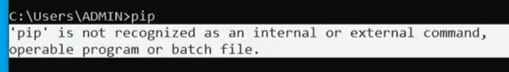
To solve the issue pip not recognized, The environment variables are needed to be added to the path.
Search Edit the system environment variables in the search bar and press enter. Then from the Advanced section go to environment variables. Then go to system variable and open the Path option. In there add the python file path and python scripts file path. Then click ok. Thus the problem will be resolved.
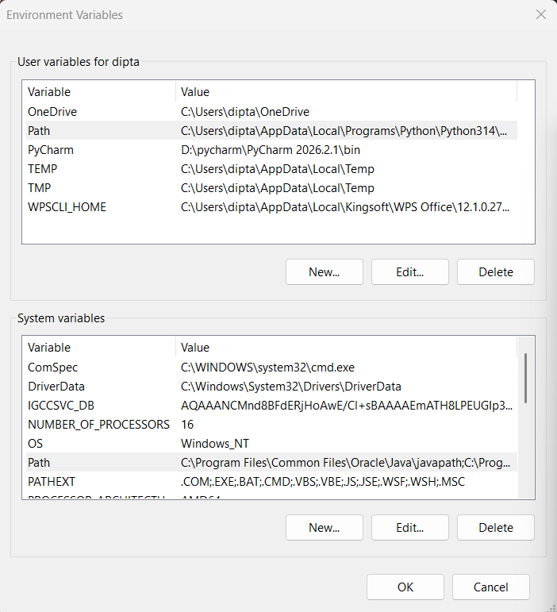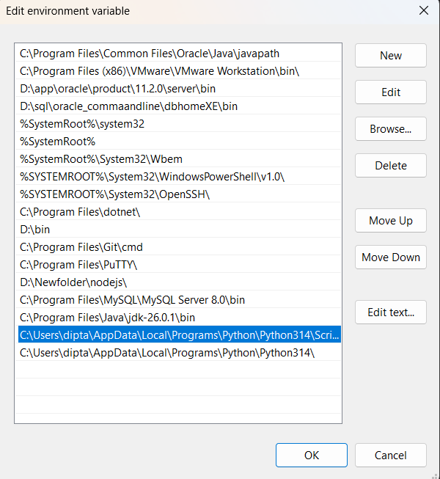
C2 — Package installed, import fails
Problem: pip reports a successful Selenium installation, but the IDE shows ModuleNotFoundError: No module named 'selenium'.
Hint: Compare the Python interpreter used by the IDE with the interpreter used by pip. Inspect active virtual environments.
Ans.
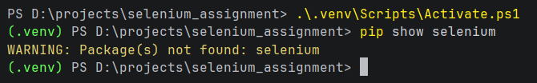
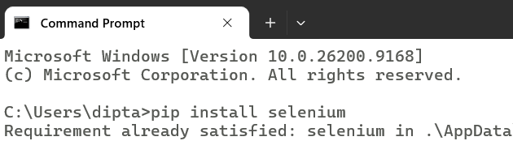
The main cause of the problem is that the selenium was installed in other python environment.
There is a command pip show selenium that will help to find out where the selenium is downloaded in the system using the command prompt
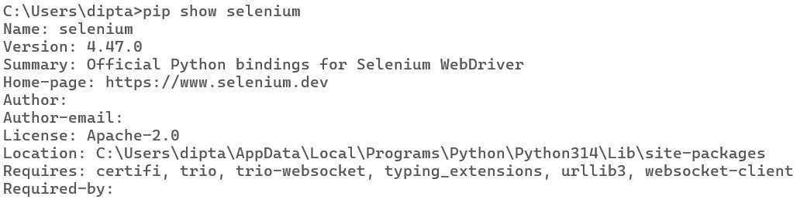
If python virtual environment is used then activate it first and run the command pip install selenium. This will help to download selenium in the virtual environment.
C3 — Driver/browser mismatch
Problem: The session fails with a message that the driver supports a different browser version.
Hint: Record both versions. Investigate Selenium Manager, driver cache, PATH entries, and stale manually downloaded drivers.
Ans.
Check the version of chrome
To check the brouser name (chrome brouser) go to the address bar and type chrome://settings/help then press enter.
The root cause may be chrome brouser and chromedriver versions are not compatible.
Update the latest selenium version. Type python -m pip install --upgrade selenium in cmd and press enter.This will help to resolve the issue.

C4 — Browser binary not found
Problem: Selenium cannot locate the browser executable.
Hint: Confirm that the browser is installed and find its actual binary location. Research the relevant browser option for a non-standard installation path.
Ans.
This error may occurs because of several causes; Chrome is not installed, Chrome is not installed in non standard location. The executable browser was moved.
Search windows for chrome.exe.
If chrome not installed then install it.
If chrome is installed in some non standard path then add the below line in the code with the exact path of the exe file. Options.binary_location = r“D:\Mychrome\chrome.exe”

C5 — Permission or antivirus blocking
Problem: The driver is downloaded but cannot execute, or security software quarantines it.
Hint: Inspect file permissions, quarantine/security logs, and organizational policy. Do not disable security controls without authorization.
Ans.
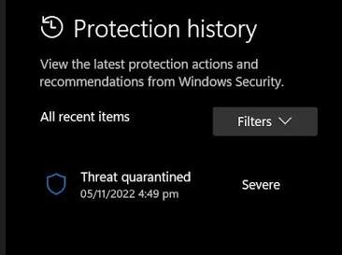
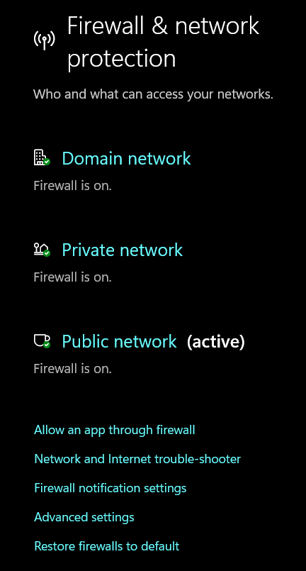
The cause of the problem might be windows file permission prevent the execution of chrome driver. Antivirus blocks the driver. Give the required user permission to execute the file. Check the antivirus security detection. Verify that the driver come from trusted source.
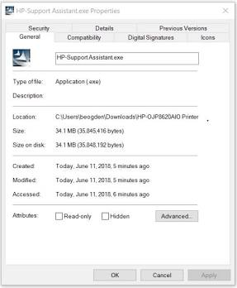

C6 — Proxy or firewall failure
Problem: Automatic driver download fails on a campus or corporate network.
Hint: Test network reach-ability, inspect proxy settings, and investigate an approved offline/manual driver strategy.
Ans.
Root cause may be firewall block the connection, restricted internet access, proxy configuration not available to Selenium etc.
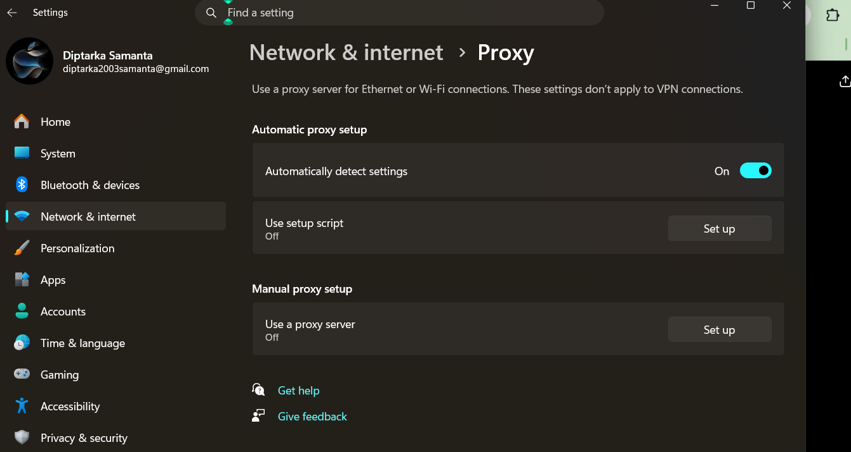
First check if the internet is working
In the cmd type ping google.com and press enter.
Checking windows proxy
Inspect windows proxy settings (Settings => Network and Internet => Proxy). Check whether Automatically detect settings on or not. Under Manual proxy setup, check Use a proxy server. If organization provides a proxy:
- Click Set up
- Enter the proxy address
- Enter the port
- Click Save
Restart PyCharm. Run the Selenium program again.

If firewalls block selenium manager
Firewall must not be disabled
- Open Windows Security
- Click Firewall & network protection
- Check which network is active: Domain / Private / Public
- If this is a college/company computer, contact the network administrator and request permission for Selenium Manager/driver downloads.

C7 — SSL certificate error during pip install
Problem: pip cannot verify a certificate while connecting to the package index.
Hint: Check system date/time, certificate store, network inspection proxy, and the institution's approved certificate configuration. Avoid unsafe bypass flags.
Ans.
First upgrade selenium. python -m pip install --upgrade selenium .
In search bar type internet options
Go to advanced
Uncheck two option
- Check for publisher’s certificate revocation.
- Check for server certificate revocation.
Click ok
In search bar type internet option
Go to security tab
Set the bar to medium high
Click trusted sites then click sites give the website name.
Click add then close then ok
Now go to Settings => Time & Language => Date & Time to check system date and time.
Set time automatically option unchecked once and checked then again.
Click the sync now button under additional setting option.

C8 — Browser opens and immediately closes
Problem: The browser window appears briefly and disappears before the result can be inspected.
Hint: Review program flow, terminal exceptions, and cleanup placement. Use logging or a debugger instead of adding an arbitrary long sleep.
Ans.
Open your Selenium Python file in PyCharm.
Check whether driver.quit() is immediately written after driver.get()
Import time and from time use sleep command to pause the website for some seconds.
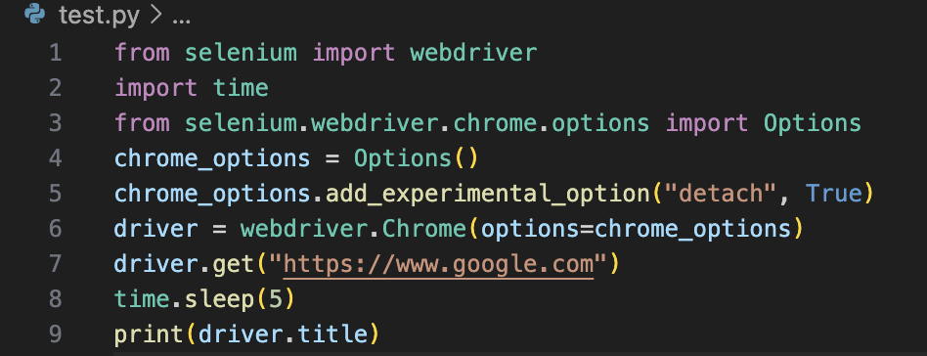

C9 — Element not found
Problem: The page loads, but NoSuchElementException occurs for a visible element.
Hint: Check locator uniqueness, page loading, iframe context, shadow DOM, dynamic IDs, and explicit waits.
Ans.
Open the webpage in Chrome. Right-click the element you want Selenium to find => Inspect. Check its locator:
- id
- name
- class
- CSS selector
- XPath
· Prefer a stable, unique ID if available:
element = driver.find_element(By.ID, "element_id")
If the element loads dynamically, use an explicit wait:
from selenium.webdriver.common.by import By
from selenium.webdriver.support.ui import WebDriverWait
from selenium.webdriver.support import expected_conditions as EC
element = WebDriverWait(driver, 10).until(
EC.visibility_of_element_located((By.ID, "element_id"))
)
If the element has a changing/dynamic ID, don't depend on that changing ID. Use a stable CSS selector or XPath instead.
C10 — Headless works differently
Problem: The script passes in normal mode but fails in headless mode.
Hint: Compare viewport size, downloads, rendering, permissions, user agent, and timing. Capture a headless screenshot and page source.
Ans.
Open your Selenium Python file in PyCharm.
Check your headless configuration:
Set a fixed viewport size:
options.add_argument("--window-size=1920,1080")
Run the script again. Check the project folder for headless.png, page.html.
Open headless.png and compare it with normal brouser version.
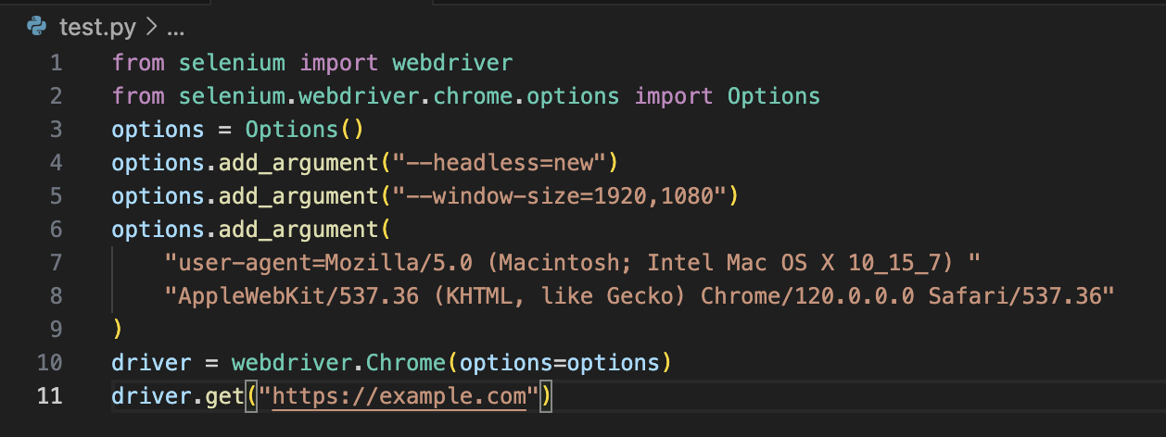

Required response format for each challenge
- Observed error message (exact text)
- Likely root cause
- Diagnostic commands or checks performed
- Solution attempted
- Result after the fix
- Screenshot or log evidence
- One preventive recommendation

7. Part D — Mini Automation Task (15 marks)
Write a Selenium script that completes all of the following on a public practice site approved by your instructor:
- Open the site and verify the page title.
- Locate and interact with at least three different element types.
- Use at least two locator strategies.
- Use an explicit wait for a meaningful condition.
- Capture a screenshot after successful interaction.
- Handle one expected failure using exception handling and a useful error message.
- Close the session safely even if an error occurs.
Add comments explaining why each locator and wait strategy was selected. Do not automate login to a real personal account.

Ans.
Video demonstration
https://drive.google.com/file/d/1DlWv9WpwgRkb1DzUTlZZlVqMJcWd8vCm/view?usp=sharing
Code of Python Selenium
https://drive.google.com/file/d/1kXuZGLCQR7RDbrsOr_u723bYfRAPoMFq/view?usp=sharing

8. Reflection (5 marks)
R1. Which installation or execution issue required the most reasoning, and how did you isolate its cause?
R2. What would you change in your setup to make future Selenium projects easier to reproduce?
R3. Which source was most useful, and how did you verify that its advice applied to your Selenium version?

9. Assessment Rubric
Component | Criteria | Marks
Installation and verification | Correct, reproducible setup with complete evidence | 20
Technical questions | Accurate explanations supported by investigation | 30
Troubleshooting challenges | Systematic diagnosis, justified fixes, and evidence | 30
Mini automation task | Functional, readable, safe, and well-explained script | 15
Reflection | Specific and thoughtful learning analysis | 5

10. Final Submission Checklist
- ☐ Report exported as PDF
- ☐ Python scripts execute without syntax errors
- ☐ requirements.txt included
- ☐ Screenshots are readable and labelled
- ☐ Exact error messages and fixes documented
- ☐ Sources cited with URLs
- ☐ ZIP filename follows the instructor's naming convention
- ☐ No credentials or personal data included

Academic integrity note: Your submission must demonstrate your own installation, testing, diagnosis, and explanation.

