**Steps to create a Bot in Telegram and add to Group.**

1. Download and install Telegram on your mobile.

2. Search for the **BotFather** Bot in Telegram.

3. send it a message called **/newbot.**

4. Follow all the steps, it will create a new Bot for you.

6. Once the Bot is created, you will get a message

with the Bot API token ID. Save the token id.

**Example message:**

**Done! Congratulations on your new bot. You will find it at t.me/jritistel_bot. You can now add a description, about section and profile picture for your bot, see /help for a list of commands. By the way, when you've finished creating your cool bot, ping our Bot Support if you want a better username for it. Just make sure the bot is fully operational before you do this.**

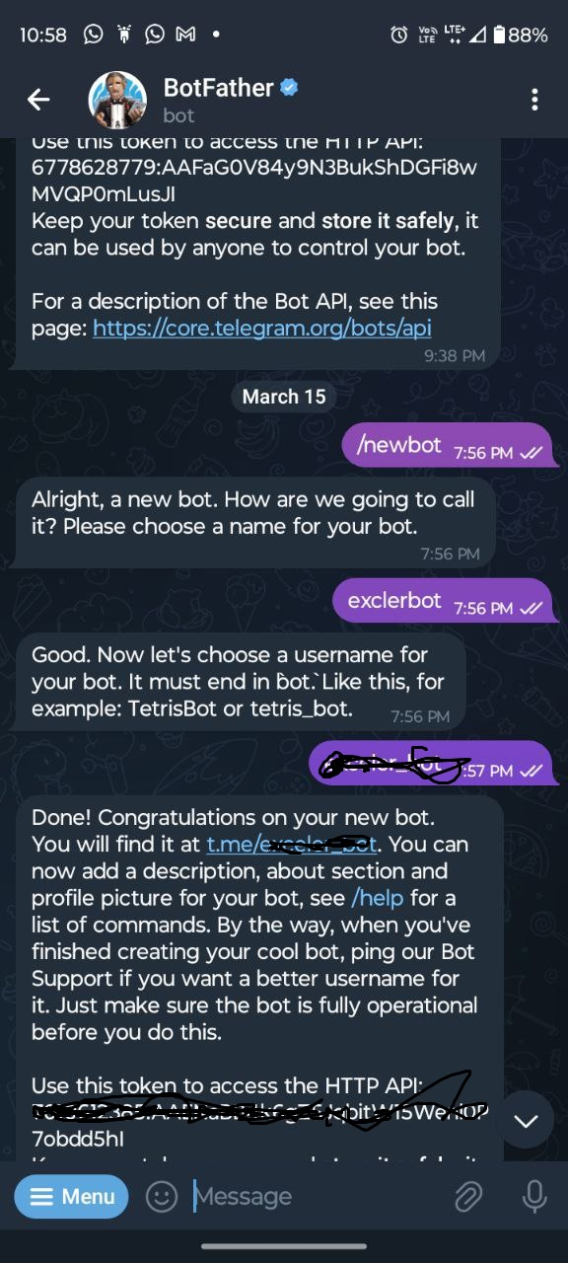

Use this token to access the HTTP API:

API Token id example : **8A26206848:AAGkWxomKYigScxQ4t7HvfLPygwFz-OgVzc**

Keep your token secure and store it safely, it can be used by anyone to control your bot.

**For a description of the Bot API, see this page: https://core.telegram.org/bots/api**

7. Create a new Telegram Group.

8. Add new members on the group as also the Newly created bot.

9. Promote the Bot to Admin.

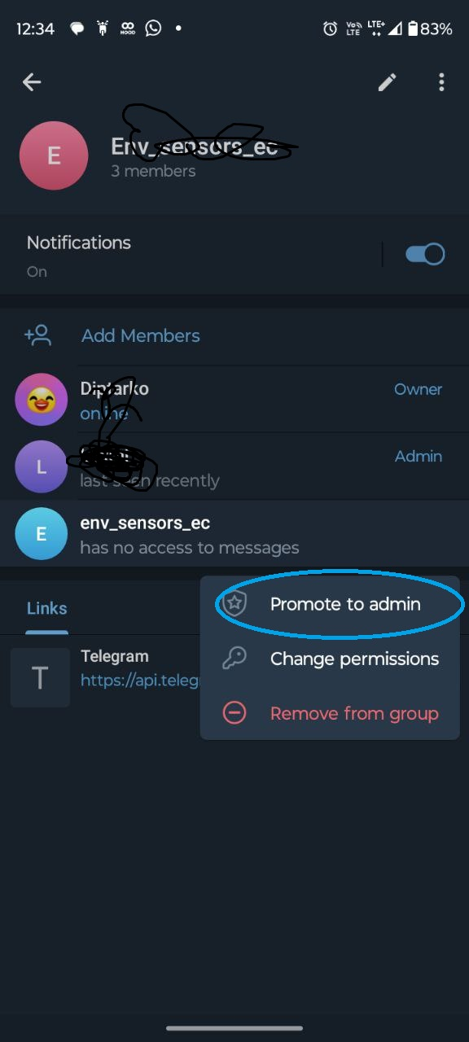

10. Now go to the group and send a test message, let’s say ‘Hi’

11. Now open the following link on your browser:  
[https://api.telegram.org/bot<BOT](https://api.telegram.org/bot%3cBOT) API ID>/getUpdates

For example , if your Bot API ID is **8A26206848:AAGkWxomKYigScxQ4t7HvfLPygwFz-OgVzc**

Then the URL should be as follows:-  
https://api.telegram.org/bot**8A26206848:AAGkWxomKYigScxQ4t7HvfLPygwFz-OgVzc** /getUpdates

12. Note the Json response:  
{"ok":true,"result":[{"update_id":768596105,

"message":{"message_id":2,"from":{"id":5735154757,"is_bot":false,"first_name":"Diptarko"},"chat**":{"id":-4215067530**,"title":"Env_sensors_ec","type":"group","all_members_are_administrators":true},"date":1718434605,"text":"Hi"}}]}

The text marked in yellow is the group chat id.

Save this group chat id as well in your configuration file.