**Comparison of two Programming languages used for Data Science:**

|  |  |  |
| --- | --- | --- |
|  | **Python** | **MATLAB** |
| Origination | Written in C. Interpreted and platform independent. | Written in C. Interpreted and platform independent. |
| Cost | Open source hence free for use. The core package doesn’t contain IDE but many IDE s externally are available. Moreover, it can run on Python shell as well. As it is free many third party have created software extending Python. | Propriety and closed-source software hence expensive but it has a variant Octave which is free. The core package comes with in-built IDE. The algorithm used are proprietary so there is no way to know whether the implementation is correct or not. |
| Libraries | Extensive libraries for data visualisation, data manipulation, research and machine learning area available.  Scipy package provided most of the functionalities offered by MATLAB. | Standard library does not have much for general programming. It only includes toolkit for performing matrix algebra but extensive library is available at higher cost for plotting and processing data |
| Usage | A high-level general-purpose programming language. Used for web programming, xml processing and building GUI applications. | Cannot used for creating stand-alone applications. High performance language for advanced mathematical computations. Mainly used for matrix manipulation and to solve problems related to linear algebra. |
| Syntactical differences (few listed here) | Everything is an object. 0 based indexing. Negative indexing is also supported. Wide space is significant. Calling functions and indexing uses different brackets. No switch case in python. | In MATLAB every object is considered an array. Supports 1 based indexing which is helpful in vectors and matrices. Wide spaces are not significant |
| GUI | It does not have a User Interface. | It provides a user interface as well. Better GUI than python because it is well integrated with third party packages. |
| Performance | Explained later with the help of data | Explained later with the help of data |
| Image processing | Using OpenCV image processing can be done way faster than MATLAB because its implemented in C/C++. Moreover, it offers wider choices for graphics package and toolkit. | MATLAB is built on top of many wrappers hence it consumes more time. |

**Ecosystem:**

Courtesy: <http://www.jds-online.com/files/150%E5%AE%8C%E6%88%90V.pdf>

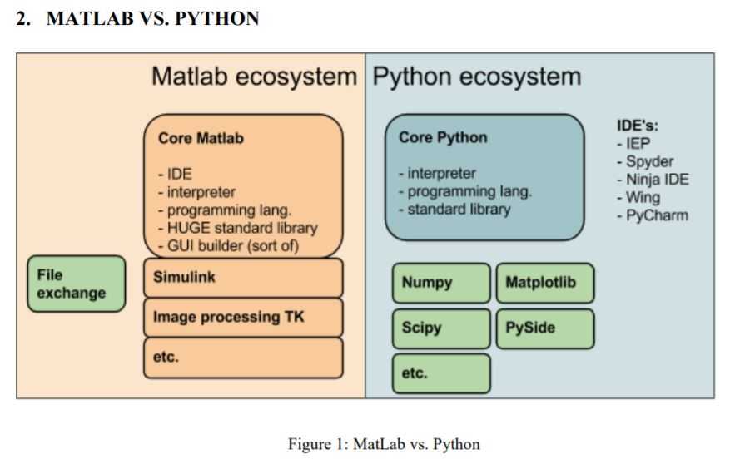

* Core MATLABis an integrated package that comes with an IDE whereas Core Python contains only standard libraries. There are many external IDEs available.
* Both languages are implemented in C and are interpreted hence platform independent.
* MATLAB has extensive library to support GUI whereas Python can be integrated with third party to provide same functionality.
* Python is supported by powerful libraries like numpy, pandas, matplotlib etc to provide visualisation facility. In MATLAB however, it is inbuilt.
* There is no alternative for Simulink toolbox in python. This offers advanced capabilities for signal processing/modelling in MATLAB.
* With very less technical knowledge, data can be visualised beautifully with the help of MATLAB whereas in Python basic code needs to be written in order to achieve the same.

**Top 15 programming languages as per Tiobe Index**:

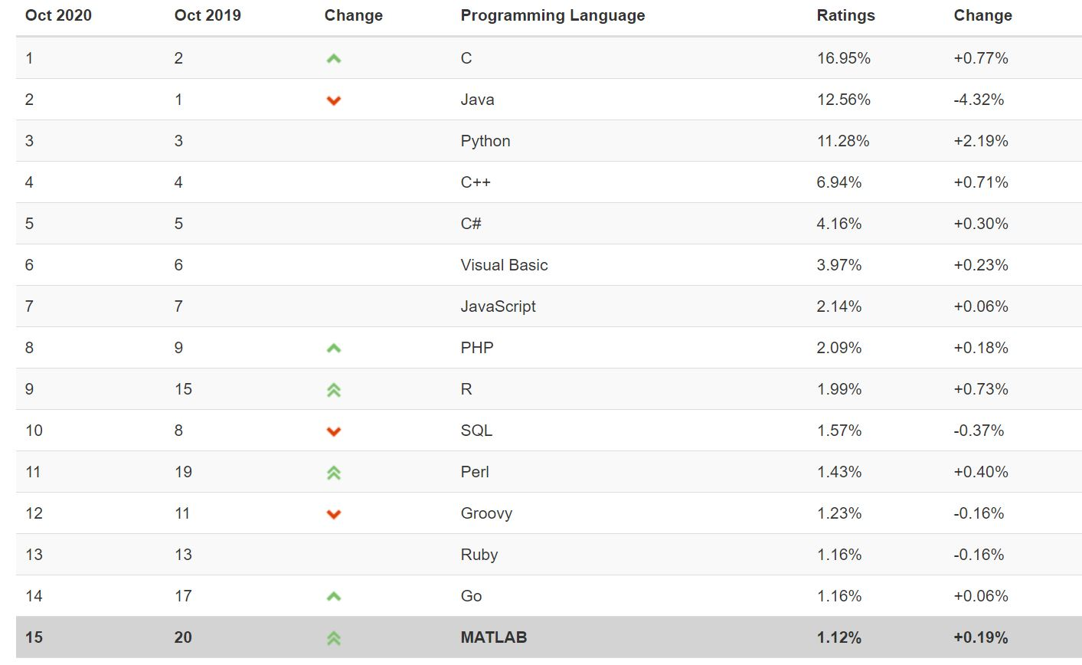

**MATLAB and Python trends over last 20 years:**

**Courtesy:** https://www.tiobe.com/tiobe-index/

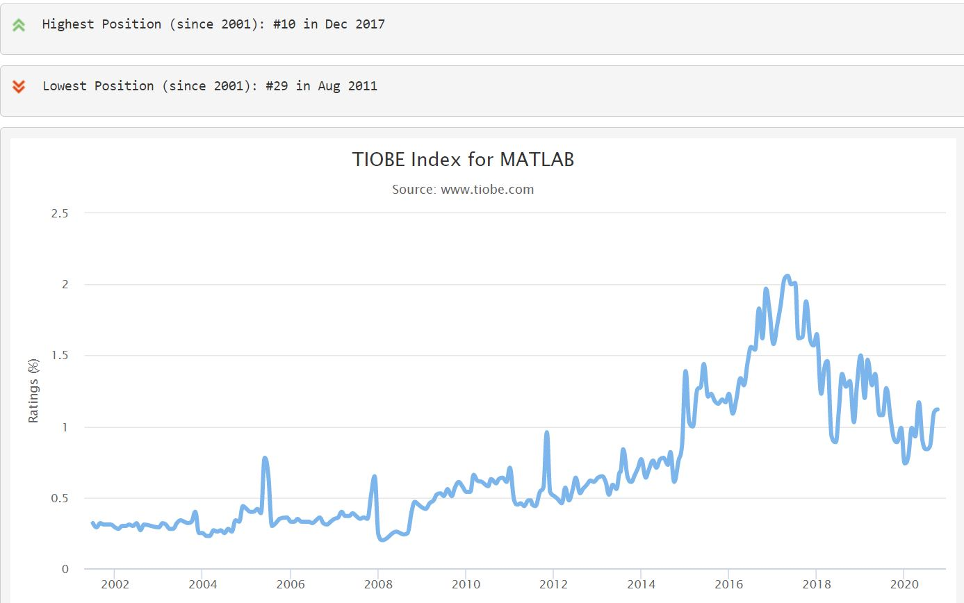

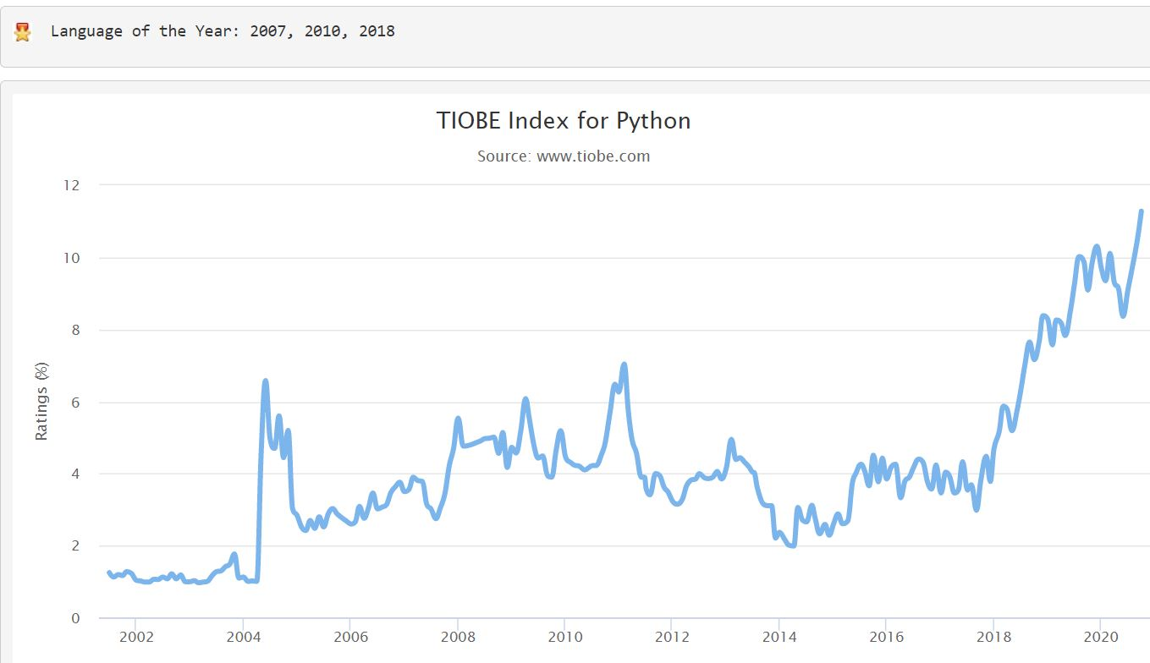

**IEEE Spectrum ranking for 2020:**

Courtesy: https://developer-tech.com/news/2020/jul/27/ieee-spectrum-python-top-programming-language-2020/

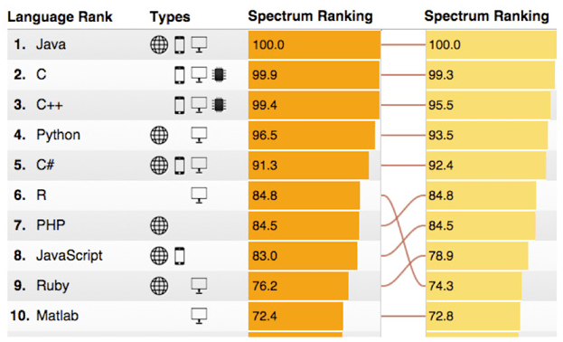

**Performance of functions across various languages:**

1. **Check performance of popular functions**

Courtesy: https://modelingguru.nasa.gov/docs/DOC-2783

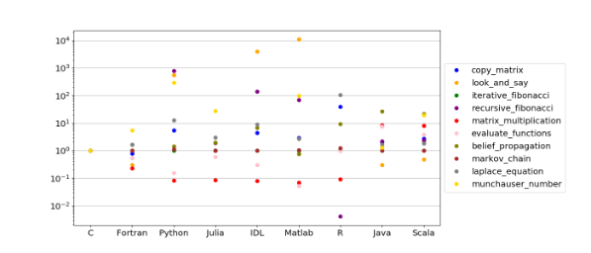

Courtesy: <https://modelingguru.nasa.gov/docs/DOC-2625>

1. **Check average time taken to execute loops on matrix**

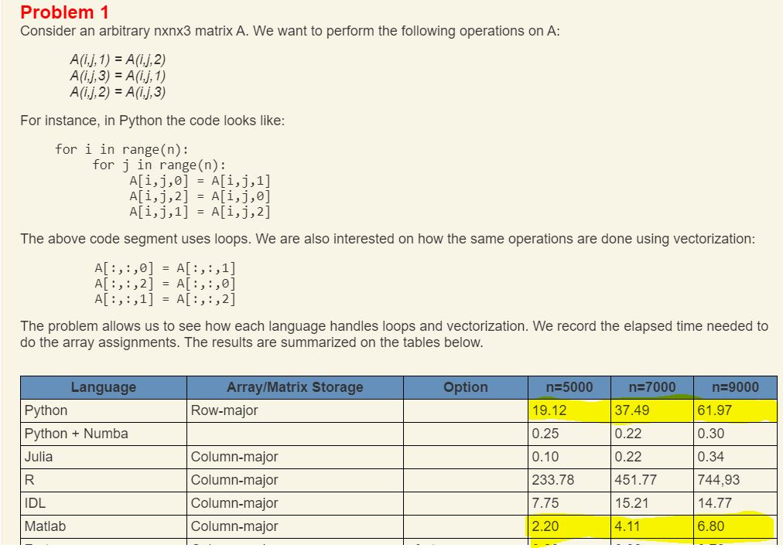

***References:***

<https://www.kdnuggets.com/2019/11/data-science-managers-programming-languages.html>

<https://statanalytica.com/blog/python-vs-matlab/>

<http://www.jds-online.com/files/150%E5%AE%8C%E6%88%90V.pdf>

https://sites.google.com/site/pythonforscientists/python-vs-matlab

<https://machinelearningmastery.com/best-programming-language-for-machine-learning/>

<https://www.eeweb.com/python-vs-matlab-for-electrical-engineers/>

<http://r4stats.com/articles/popularity/>

<https://social.hse.ru/data/2018/07/23/1152319264/Matlab%20vs%20Python%2043.pdf>

<https://ultimateqa.com/best-programming-languages-to-learn/>

https://www.tiobe.com/tiobe-index/

https://developer-tech.com/news/2020/jul/27/ieee-spectrum-python-top-programming-language-2020/