EMPLOYEE ATTRITION &
WORKFORCE INTELLIGENCE SYSTEM

An AI-Powered HR Analytics Dashboard for
Employee Attrition Analysis, Risk Prediction and Workforce Insights
PROJECT REPORT

Particular | Details
Student Name | Dipti Kumari
Programme | B.Tech — Computer Science & Engineering (Data Science)
Institution | ABES Engineering College, Ghaziabad
Academic Year | 2026–27
Internship Context | IBM PBL Virtual Internship — Data Analytics with AI

Table of Contents
1. Abstract
2. Introduction
3. Problem Statement
4. Objectives
5. Dataset Description
6. Technologies and Tools
7. System Architecture and Methodology
8. Exploratory Data Analysis
9. Machine Learning Methodology
10. Machine Learning Model Evaluation
11. Employee Risk Prediction
12. Workforce Segmentation
13. Workforce Intelligence
14. Model Explainability
15. Dashboard Design and Screenshots
16. Key Findings
17. Limitations
18. Ethical Considerations
19. Future Scope
20. Conclusion
21. References

1. Abstract
Employee attrition is an important workforce-management problem because unexpected employee departures can affect continuity, productivity, recruitment effort and organizational knowledge. This project presents an end-to-end Employee Attrition & Workforce Intelligence System developed using Python and Streamlit. The application analyzes the IBM HR Analytics Employee Attrition & Performance dataset and combines exploratory data analysis, interactive visualization, machine learning, risk prediction, workforce segmentation and model explainability in a single dashboard. The dataset contains 1,470 employee records and 35 original attributes, with Attrition as the target variable. After preprocessing, four classification algorithms—Logistic Regression, Decision Tree, Random Forest and Gradient Boosting—are trained using an 80/20 stratified split. Class imbalance is addressed through balanced class weights, and the models are evaluated using Accuracy, Precision, Recall, F1-Score and ROC-AUC. Logistic Regression obtains the highest F1-Score (0.4966) and ROC-AUC (0.8074) among the tested models. The system also applies K-Means clustering to identify natural workforce segments and uses feature importance and model coefficients to support interpretation. Interactive filters and dashboards allow users to examine workforce composition, compensation, satisfaction, attrition patterns and employee-level risk predictions. The project is designed as an academic and portfolio-level demonstration; its findings represent observed associations in the historical dataset and should not be interpreted as causal conclusions or employment decisions.

2. Introduction
Human resource analytics has evolved from descriptive reporting toward predictive and decision-support systems. Instead of only reporting how many employees have already left, organizations can analyze historical workforce data to understand patterns associated with attrition and identify groups that may require additional attention.
The IBM HR Analytics Employee Attrition & Performance dataset provides a compact environment for demonstrating this workflow. It includes demographic, job, compensation, satisfaction, tenure, travel and work-pattern variables. These variables can be explored individually and jointly to understand how employee characteristics relate to attrition.
This project converts that dataset into an interactive Streamlit application. The system follows a complete data-science lifecycle: data loading, cleaning, preprocessing, exploratory analysis, feature preparation, supervised learning, evaluation, interactive prediction, unsupervised segmentation and explainability.

3. Problem Statement
Traditional HR dashboards are often retrospective and may not provide a unified environment for exploring attrition patterns, estimating individual risk, segmenting the workforce and interpreting model behavior. The project therefore addresses the following problem:
- How can employee data be transformed into an interactive analytics system that reveals workforce and attrition patterns?
- How can machine learning be used to estimate attrition risk while accounting for class imbalance?
- How can employees be grouped into data-driven workforce segments?
- How can model outputs and workforce findings be presented in an interpretable dashboard?
Scope note: The system is an educational decision-support prototype. It does not establish that any variable causes attrition and it should not be used as an automated employment-decision system.

4. Objectives
- Perform exploratory data analysis to identify patterns in workforce composition and employee attrition.
- Compare four classification algorithms for attrition risk prediction.
- Handle the imbalanced target variable using class-weighted learning and evaluate models using multiple metrics.
- Provide an interactive employee risk prediction interface with a probability-based risk result.
- Apply K-Means clustering to identify natural workforce segments.
- Provide model explainability through tree-based feature importance and Logistic Regression coefficients.
- Develop a professional Streamlit dashboard with interactive filters and business-oriented visualizations.
- Present evidence-based workforce intelligence while clearly distinguishing association from causation.

5. Dataset Description

5.1 Source and Overview
The project uses the IBM HR Analytics Employee Attrition & Performance dataset, a widely used educational dataset for demonstrating people analytics and attrition modeling. The dataset contains fictional/anonymized employee records and is therefore appropriate for academic experimentation but should not be treated as a direct representation of any specific organization.
Characteristic | Value
Rows | 1,470 employees
Original features | 35 columns
Target | Attrition (Yes / No)
Employees who left | 237
Employees retained | 1,233
Observed attrition rate | 16.1%
Missing values | None identified in the project dataset
Class distribution | 83.9% No / 16.1% Yes

5.2 Feature Categories
Category | Representative Features
Demographic | Age, Gender, MaritalStatus, Education, EducationField
Job-related | Department, JobRole, JobLevel, JobInvolvement, OverTime
Compensation | MonthlyIncome, DailyRate, HourlyRate, MonthlyRate, PercentSalaryHike, StockOptionLevel
Satisfaction | JobSatisfaction, EnvironmentSatisfaction, RelationshipSatisfaction, WorkLifeBalance
Tenure | YearsAtCompany, YearsInCurrentRole, YearsSinceLastPromotion, YearsWithCurrManager, TotalWorkingYears
Travel / Distance | BusinessTravel, DistanceFromHome

5.3 Preprocessing Decisions
- EmployeeCount, Over18 and StandardHours were removed because they are constant and carry no discriminative information.
- EmployeeNumber was treated as an identifier and excluded from the machine-learning feature matrix.
- Attrition was converted to a binary AttritionFlag: 1 for Yes and 0 for No.
- Categorical variables were label-encoded using scikit-learn LabelEncoder.
- StandardScaler was applied inside the machine-learning pipelines so scaling is learned from training data only.
- The target imbalance was addressed using class_weight='balanced' for the applicable classifiers.

6. Technologies and Tools
Technology / Library | Purpose
Python | Core programming language
Streamlit | Interactive dashboard and web application
Pandas | Data loading, cleaning and tabular analysis
NumPy | Numerical operations
Plotly | Interactive charts and visualizations
Scikit-learn | Preprocessing, machine learning, clustering and evaluation
Jupyter / VS Code | Development and analysis environment
Git / GitHub | Version control and project sharing

The application is implemented primarily in a single app.py file, with a requirements.txt file specifying the Python dependencies and the IBM HR dataset stored separately.

7. System Architecture and Methodology
The system follows a sequential analytics and machine-learning workflow. The same processed dataset feeds both the descriptive dashboard and the predictive components.
Stage | Implementation
1. Data Collection | Load the CSV dataset using Pandas.
2. Data Preprocessing | Remove constant fields, create the binary target and encode categorical variables.
3. Exploratory Data Analysis | Generate KPI cards, distributions, attrition-rate comparisons, correlation analysis and descriptive statistics.
4. Feature Preparation | Prepare the model feature matrix and derived groups such as age, income and tenure bands for visualization.
5. Model Training | Train Logistic Regression, Decision Tree, Random Forest and Gradient Boosting pipelines using a stratified 80/20 split.
6. Evaluation | Compare Accuracy, Precision, Recall, F1-Score and ROC-AUC and inspect confusion matrices and ROC curves.
7. Prediction & Segmentation | Use the selected model for interactive risk estimation and K-Means for workforce segmentation.
8. Explainability & Insights | Display feature importance, coefficients and automatically calculated evidence-based workforce insights.

8. Exploratory Data Analysis

8.1 Workforce Snapshot
The dashboard provides an executive-level view of workforce size, attrition, average income, age and tenure. The KPI snapshot reports 1,470 total employees, 237 employees who left, 1,233 employees retained, a 16.1% observed attrition rate, approximately $6,503 average monthly income, an average age of about 36.9 years and average tenure of about 7.0 years.

8.2 Demographic and Workforce Composition
The workforce composition views examine attrition distribution, department size, gender distribution, job roles, business travel and overtime. The dashboard allows these dimensions to be interpreted together rather than as isolated charts.

8.3 Satisfaction and Work-Life Indicators
Job satisfaction, environment satisfaction, relationship satisfaction and work-life balance are presented as ordinal distributions. These variables can be compared with attrition in the Attrition Analysis section to identify observed differences across satisfaction levels.

8.4 Compensation and Tenure
Monthly income varies substantially across job levels and departments. Scatter plots also show a positive relationship between total working years and monthly income in the dataset, while the attrition overlay allows potential differences between employees who stayed and those who left to be explored.
Interpretation principle: Charts describe patterns present in the dataset. A visible association between two variables does not establish that one variable causes the other.

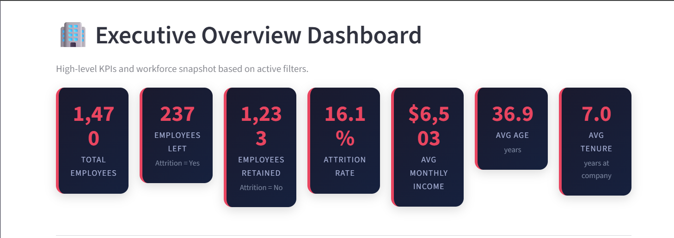
Figure 1. Executive Overview — KPI snapshot of the workforce.
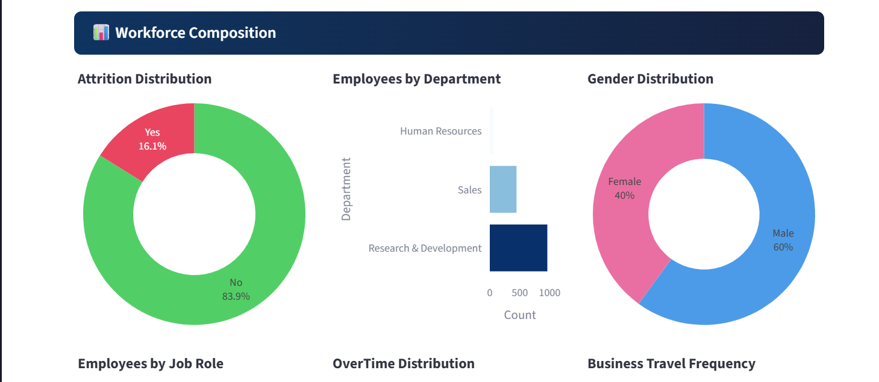
Figure 2. Workforce Composition — attrition, department and gender distribution.
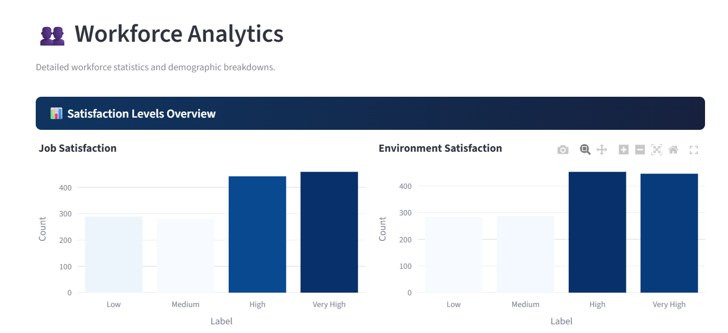
Figure 3. Workforce Analytics — satisfaction-level distributions.
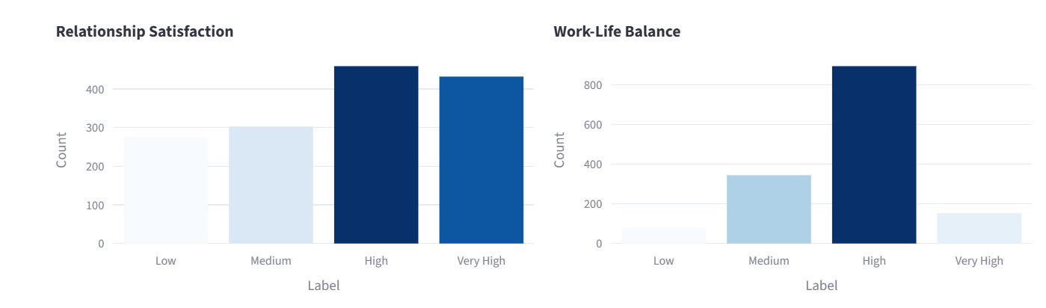
Figure 4. Workforce Analytics — relationship satisfaction, work-life balance.
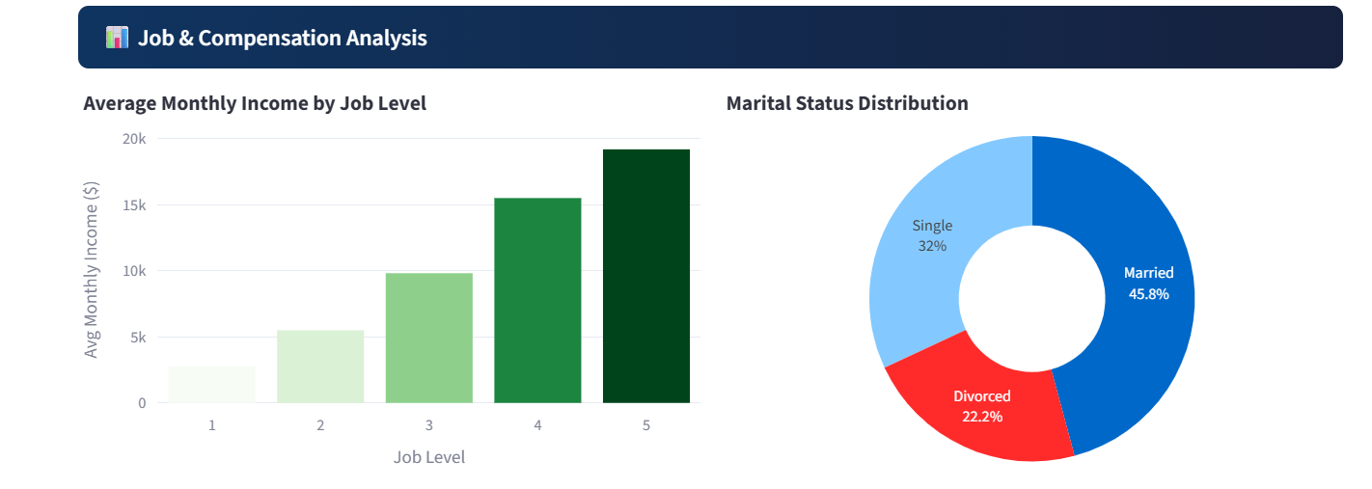

Figure 5. Workforce Analytics — job and compensation analysis.

9. Attrition Analysis
The Attrition Analysis dashboard examines the observed attrition rate across multiple dimensions, including department, role, age, income, tenure, distance from home, job level, overtime and satisfaction. This allows the user to move from the overall 16.1% rate to more granular workforce comparisons.

9.1 Major Observed Patterns
- Overtime employees show a substantially higher observed attrition rate than employees who do not work overtime.
- Employees in early stages of company tenure show higher observed attrition rates than longer-tenured employees.
- Job Level 1 employees show higher observed attrition rates than more senior job levels.
- Employees who left have lower average monthly income than employees who stayed.
- Frequent business travelers show higher observed attrition rates than non-travelers in this dataset.
- Lower satisfaction levels are generally associated with higher observed attrition rates.
These are dataset-level associations. They should be treated as analytical signals for further investigation rather than direct explanations of why an individual employee leaves.
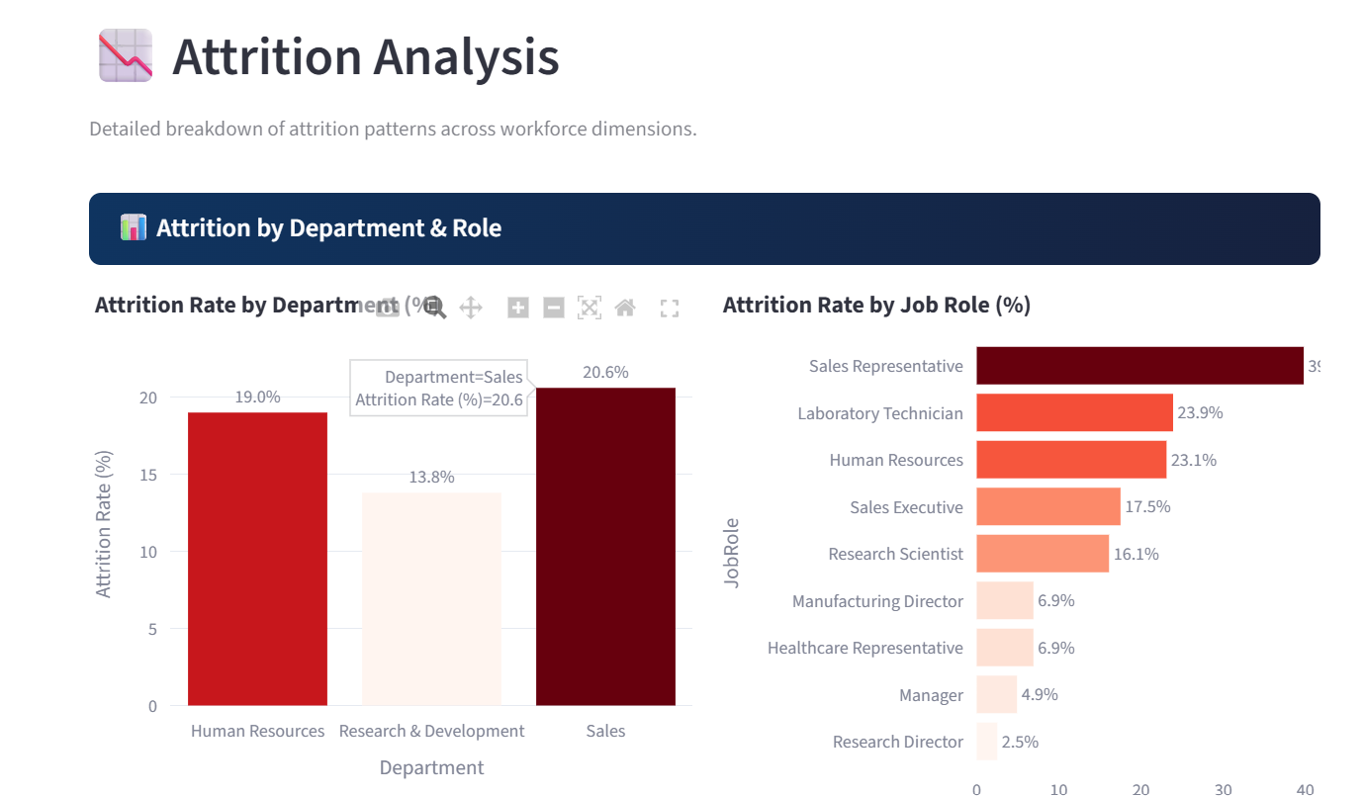
Figure 6. Attrition Analysis — attrition rate by department and role.
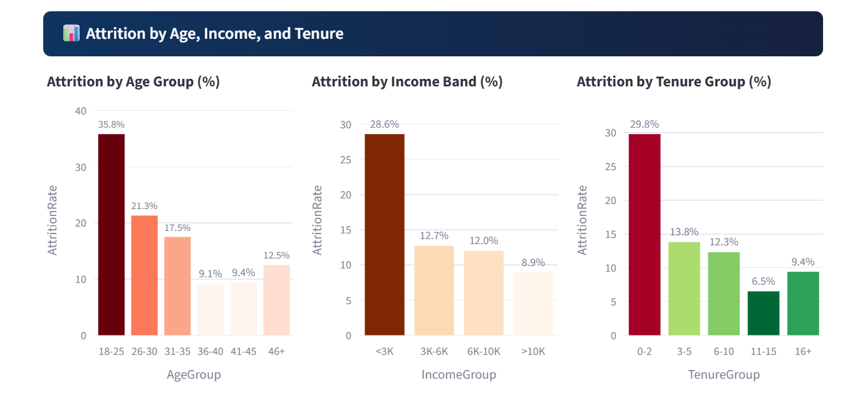
Figure 7. Attrition Analysis — attrition by age, income and tenure.
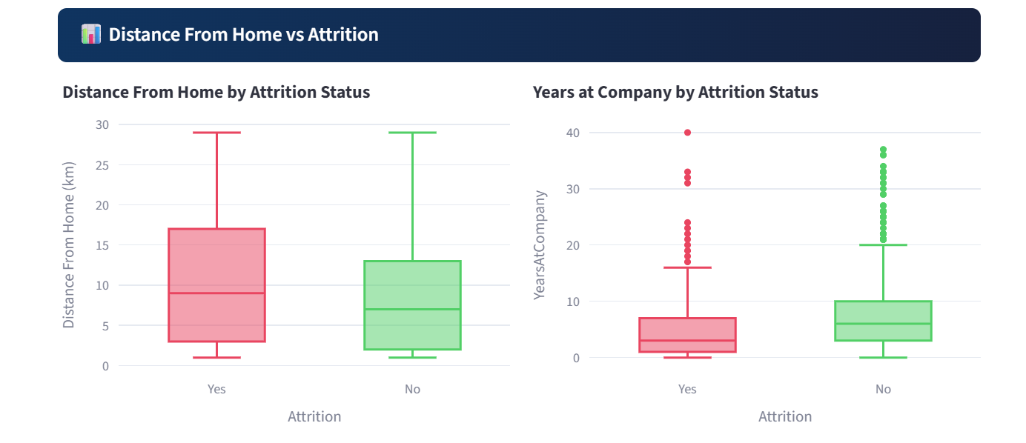
Figure 8. Attrition Analysis — distance-from-home and tenure comparisons.

10. Correlation and Feature Analysis
The Correlation & Feature Analysis page provides a Pearson correlation matrix for numerical variables, a ranking of features by absolute correlation with the binary attrition indicator, distribution comparisons and descriptive statistics. Correlation is useful for screening relationships but does not prove causality.

10.1 Correlation Heatmap
The heatmap helps identify groups of variables that move together, such as tenure and experience-related variables. It also provides a compact view of the relationship between numerical features and AttritionFlag.

10.2 Distribution Comparison
Distribution plots compare numerical variables for employees who stayed and employees who left. Such comparisons can reveal shifts in the distribution even when the overall relationship is not linear.
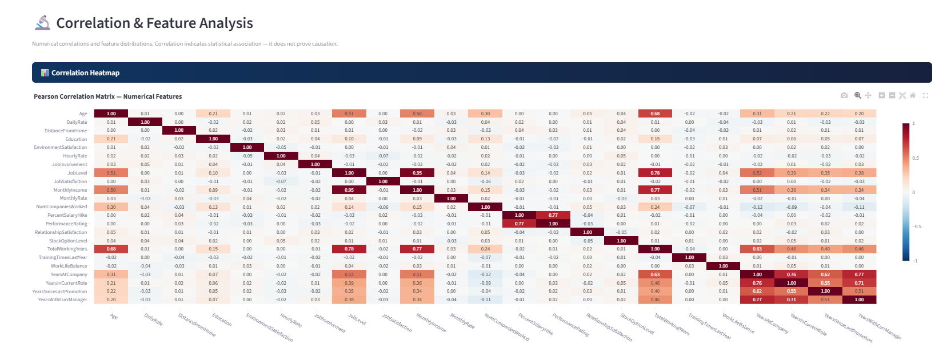
Figure 9. Correlation & Feature Analysis — Pearson correlation matrix.

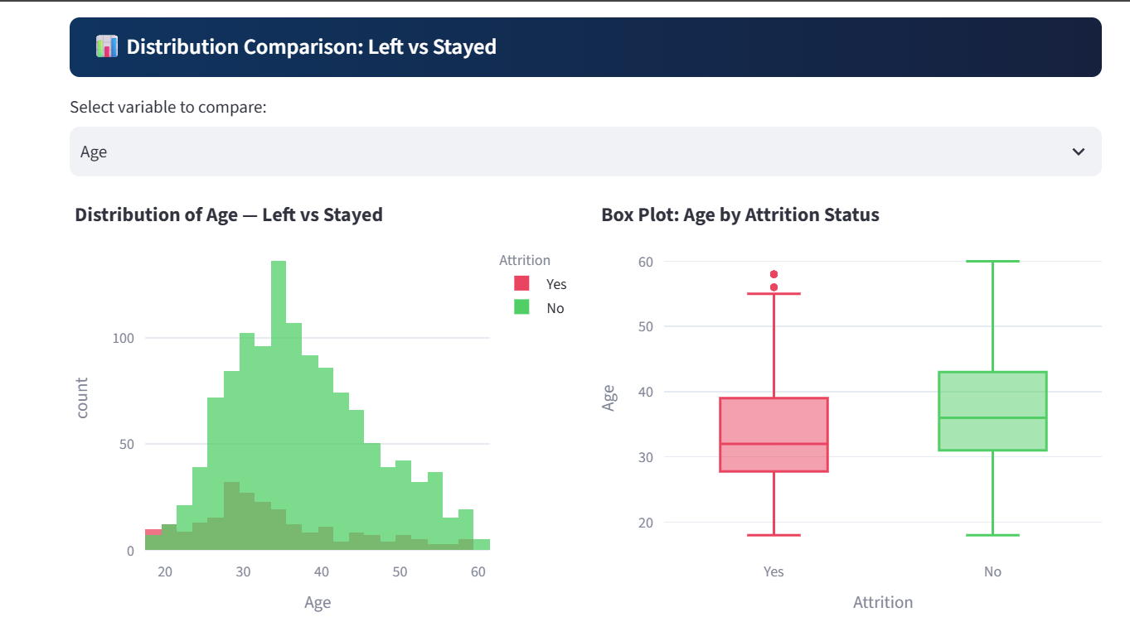
Figure 10. Correlation & Feature Analysis — selected feature distributions by attrition.

11. Machine Learning Methodology and Evaluation

11.1 Train-Test Split
The dataset is divided into 80% training and 20% testing data using train_test_split with stratify=y and random_state=42. The test set contains 294 records. Stratification preserves the approximate class distribution in both partitions.

11.2 Class Imbalance
Only 16.1% of employees in the dataset belong to the attrition class. Therefore, accuracy alone can be misleading. The classification pipelines use class-weight balancing for the models that support it, increasing the relative importance of the minority class during training.

11.3 Models
Model | Configuration / Role
Logistic Regression | Interpretable baseline; StandardScaler + class_weight='balanced'
Decision Tree | max_depth=6; captures non-linear rule-like patterns
Random Forest | 200 estimators; max_depth=8; balanced class weights
Gradient Boosting | 150 estimators; learning_rate=0.08; max_depth=4

11.4 Evaluation Metrics
- Accuracy: proportion of all predictions that are correct.
- Precision: proportion of predicted attrition cases that are actually attrition cases.
- Recall: proportion of actual attrition cases detected by the model.
- F1-Score: harmonic mean of Precision and Recall.
- ROC-AUC: ranking/discrimination performance across probability thresholds.

11.5 Actual Model Results
Model | Accuracy | Precision | Recall | F1-Score | ROC-AUC
Logistic Regression | 0.7517 | 0.3673 | 0.7660 | 0.4966 | 0.8074
Decision Tree | 0.7585 | 0.3421 | 0.5532 | 0.4228 | 0.6381
Random Forest | 0.8299 | 0.4211 | 0.1702 | 0.2424 | 0.7812
Gradient Boosting | 0.8401 | 0.5000 | 0.1489 | 0.2295 | 0.7980

Selected model: Logistic Regression is selected for the interactive attrition-risk component because it provides the highest F1-Score (0.4966) and the highest ROC-AUC (0.8074) among the tested models. This selection is tied to the project's emphasis on identifying the minority attrition class rather than maximizing accuracy alone.

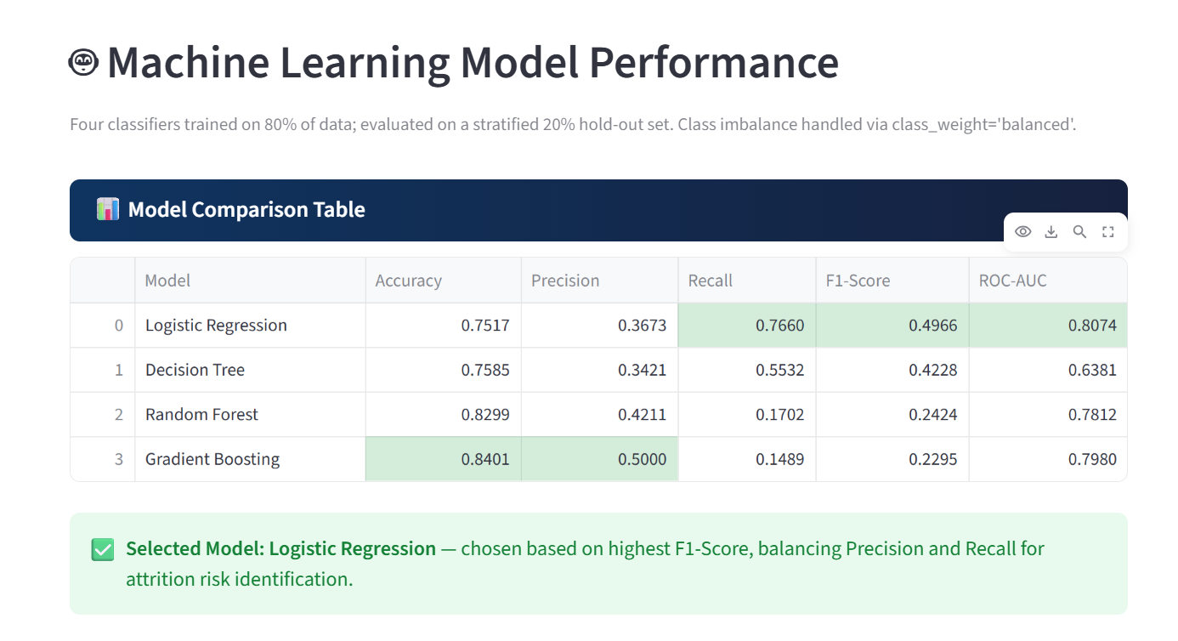
Figure 11. Machine Learning Model Performance — metric comparison table.
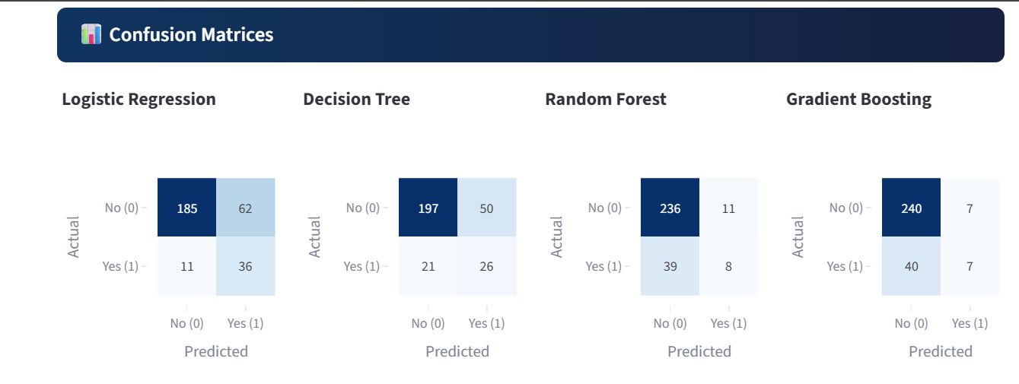
Figure 12. Machine Learning Model Performance — confusion-matrix comparison.
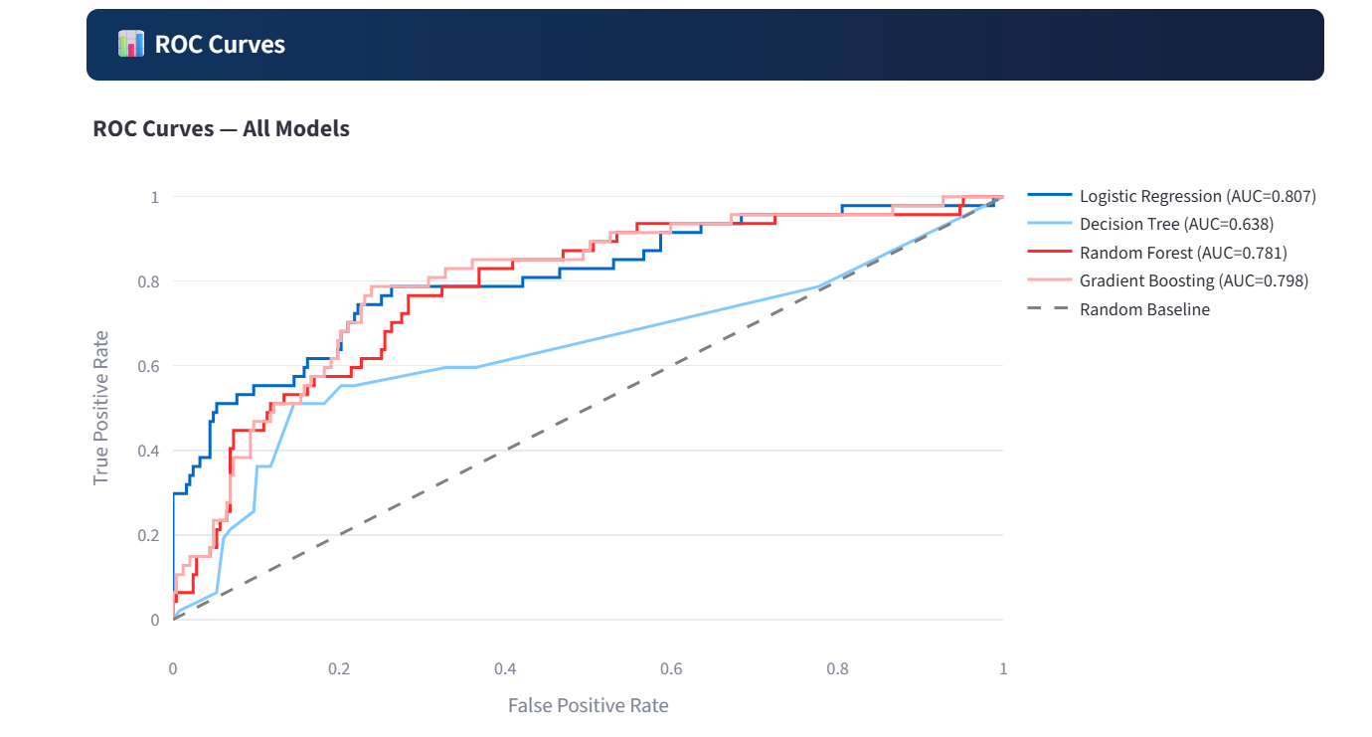
Figure 13. Machine Learning Model Performance — ROC curves.

12. Employee Attrition Risk Prediction
The Employee Risk Prediction page provides an interactive form in which user-selected employee attributes are passed through the same preprocessing and selected Logistic Regression pipeline used during model training. The application returns a predicted class and an estimated attrition probability.
The prediction interface is intended to demonstrate how a trained model can be embedded in a practical decision-support workflow. The probability should be interpreted as a model estimate conditioned on the dataset and training process, not as a certainty about the employee's future behavior.
Prediction Output | Interpretation
Predicted class | Model classification based on the configured threshold.
Attrition probability | Estimated probability produced by the classifier.
Risk indicator | Visual communication of the probability range.
Context | Prediction should be interpreted alongside employee circumstances and broader HR evidence.

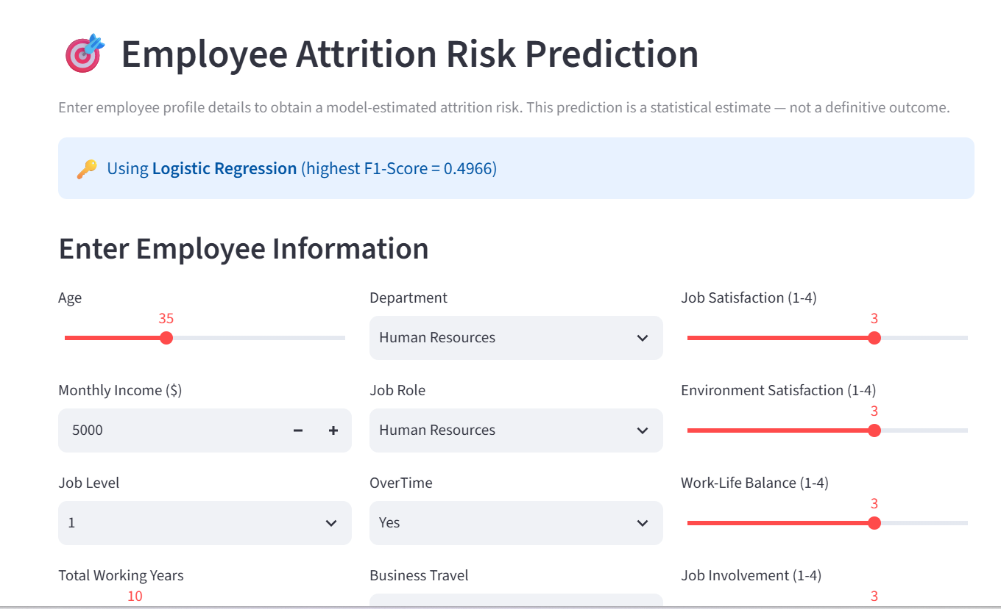
Figure 14. Employee Attrition Risk Prediction — interactive employee information and model output interface.

13. Workforce Segmentation
K-Means clustering is used to group employees according to similarities across ten workforce variables: Age, MonthlyIncome, TotalWorkingYears, YearsAtCompany, JobSatisfaction, WorkLifeBalance, EnvironmentSatisfaction, JobLevel, DistanceFromHome and NumCompaniesWorked.

13.1 Cluster Selection
The application evaluates candidate values of k from 2 through 6 using the elbow method and silhouette scores. The selected value is based on the observed clustering quality rather than a predetermined business label.

13.2 PCA Visualization
Principal Component Analysis is used only to visualize the clusters in two dimensions. The actual K-Means clustering is performed on the standardized ten-feature space rather than on the two PCA components.

13.3 Cluster Profiles
For each cluster, the dashboard calculates descriptive statistics and observed attrition rates. The resulting profiles help identify workforce segments such as comparatively early-career or higher-tenure groups without imposing labels in advance.
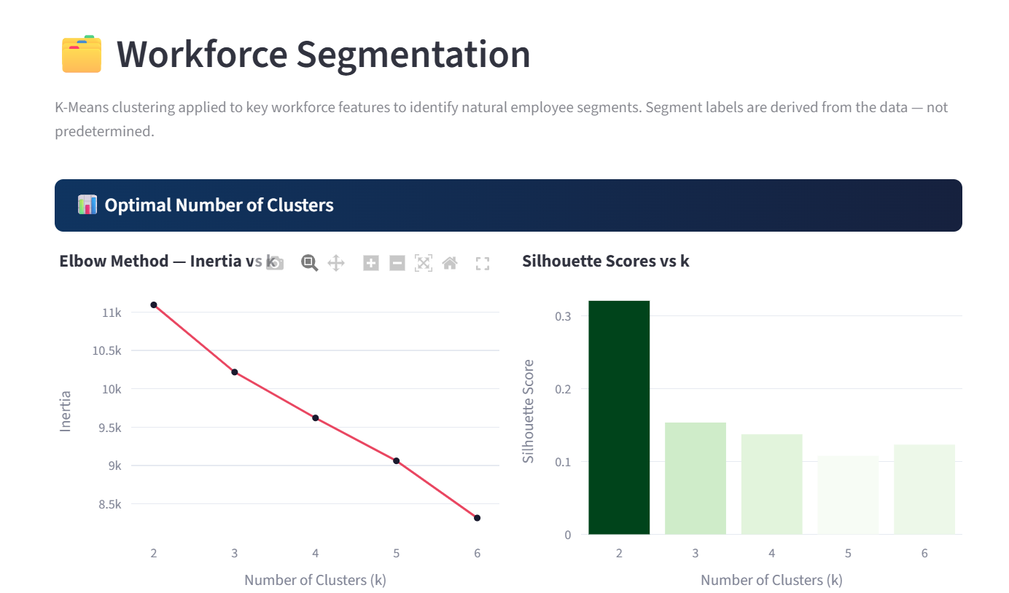
Figure 15. Workforce Segmentation — cluster-selection analysis using elbow and silhouette views.
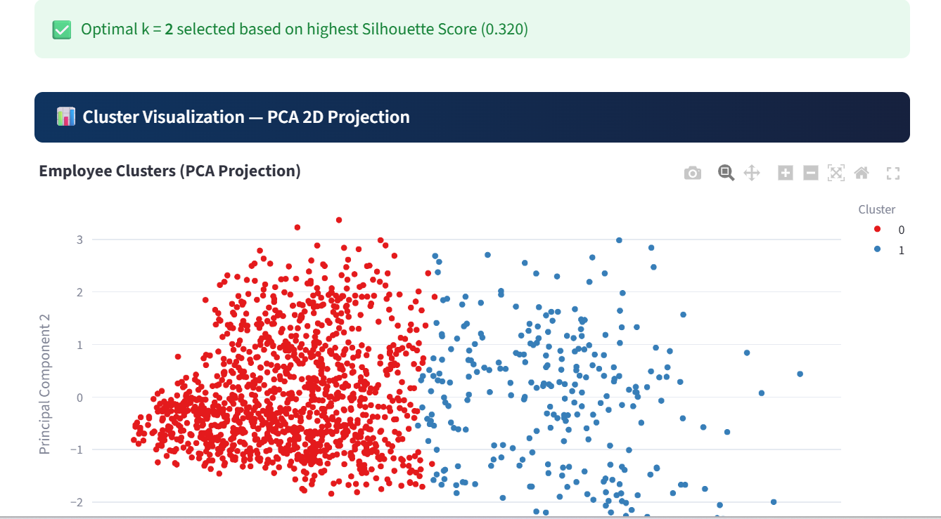
Figure 16. Workforce Segmentation — PCA-based cluster visualization.
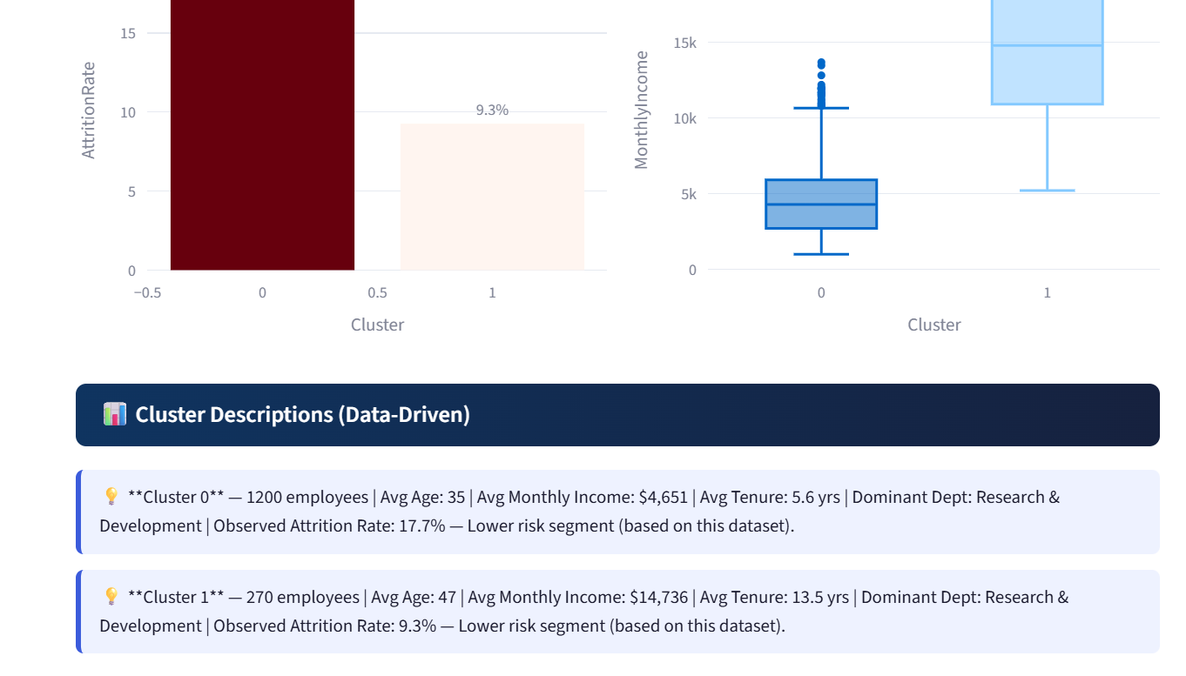
Figure 17. Workforce Segmentation — cluster profile and distribution views.

14. Workforce Intelligence
The Workforce Intelligence page converts analytical results into concise evidence-based observations. The insights are generated from the filtered dataset and focus on dimensions such as overtime, business travel, job role, tenure, compensation, satisfaction, stock options and job level.
The design goal is not to produce generic HR advice, but to connect dashboard observations to the actual dataset. For example, the system can flag that overtime is associated with a higher observed attrition rate, while explicitly presenting the result as an association rather than proof of causation.
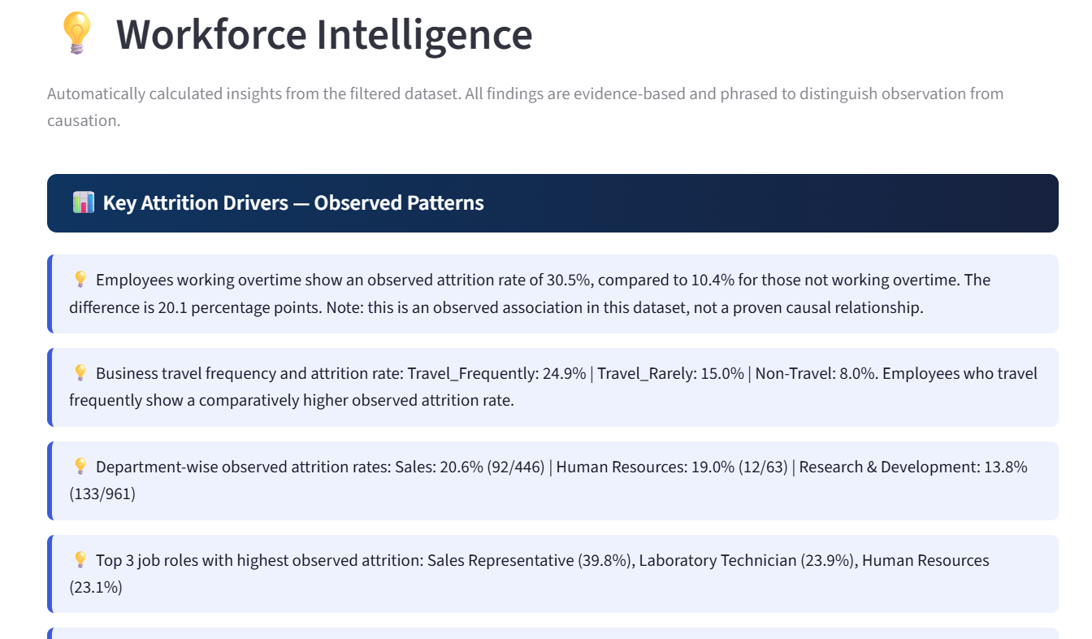
Figure 18. Workforce Intelligence — automatically generated evidence-based workforce observations.

15. Model Explainability
Model explainability is included to make the predictive component easier to interpret. Tree-based models provide feature-importance scores, while Logistic Regression provides standardized coefficient information. These outputs show which features contribute most strongly to the fitted models.

15.1 Important Interpretation Limitation
Feature importance is not the same as causal importance. A feature may be influential because it is correlated with another variable, because it reflects organizational processes, or because of interactions that are not visible in a simple importance ranking. Therefore, explainability outputs should be treated as model diagnostics rather than causal evidence.
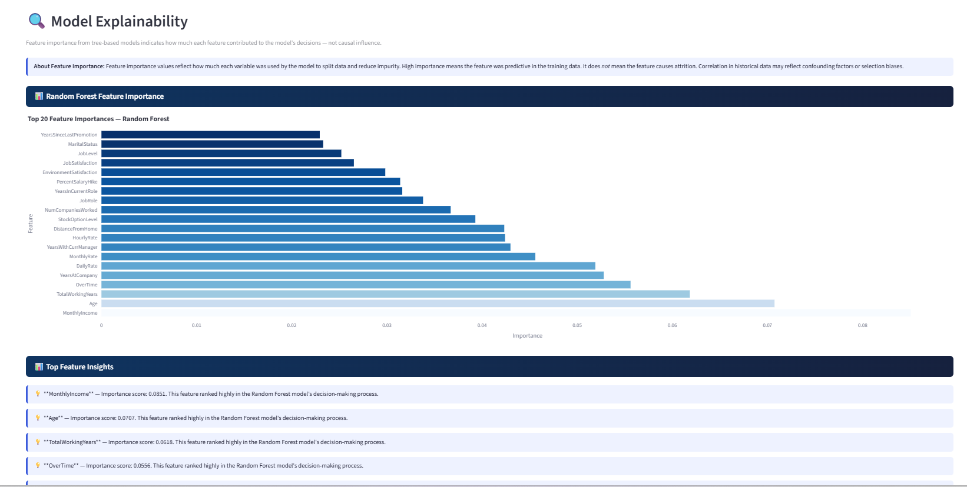
Figure 19. Model Explainability — feature-importance visualization.
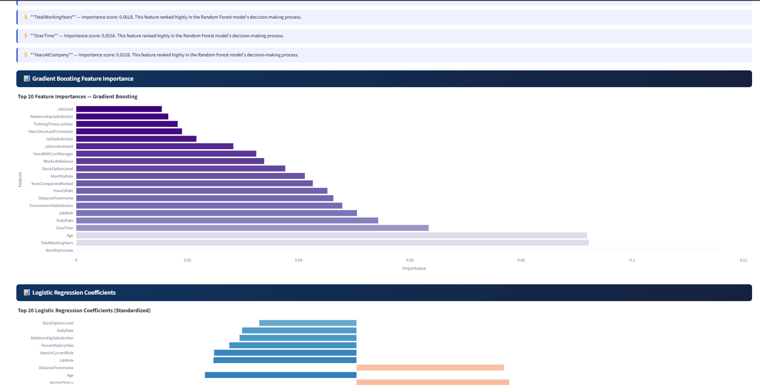
Figure 20. Model Explainability — additional feature contribution views.

16. Dashboard Design and Screenshots
The final Streamlit application contains nine navigable dashboard pages. Interactive sidebar filters can be used across the relevant analytical pages. The application uses Streamlit caching to avoid redundant data loading and model retraining during interaction.
Page | Purpose
Executive Overview | KPI snapshot and high-level workforce composition.
Workforce Analytics | Satisfaction, compensation, demographic and experience analysis.
Attrition Analysis | Attrition rates across workforce dimensions.
Correlation & Features | Correlation matrix, feature ranking, distributions and descriptive statistics.
ML Model Performance | Model comparison, confusion matrices and ROC curves.
Employee Risk Prediction | Interactive individual risk estimation.
Workforce Segmentation | K-Means clustering, cluster selection and profiles.
Workforce Intelligence | Automatically generated evidence-based workforce insights.
Model Explainability | Feature importance and model coefficient analysis.

The screenshots in this report were captured from the running dashboard and are included to document the implemented user interface and analytical outputs.

17. Key Findings
- Overall observed attrition is 16.1%, with 237 employees leaving and 1,233 retained.
- Overtime is one of the strongest observable categorical associations with attrition in the dataset.
- Employees in early company-tenure stages show higher observed attrition rates than many longer-tenured groups.
- Job Level 1 employees show higher observed attrition rates than more senior job levels.
- Employees who left have lower average monthly income than employees who stayed.
- Lower satisfaction levels are associated with higher observed attrition rates in several satisfaction dimensions.
- Frequent business travel is associated with higher observed attrition in the dataset.
- Logistic Regression provides the strongest F1-Score and ROC-AUC among the four tested classifiers.
- K-Means provides a complementary unsupervised view by identifying natural workforce segments.
Important: These findings are descriptive or predictive associations from a historical educational dataset. They do not establish causal relationships and should not be used to make automated employment decisions.

18. Limitations
- The IBM HR dataset is fictional/anonymized and may not represent the workforce structure or behavior of a real organization.
- The dataset contains only 1,470 records, limiting the complexity and generalizability of the models.
- The target class is imbalanced, making minority-class prediction challenging.
- The dataset is not longitudinal, so the system cannot model time-to-event attrition dynamics.
- Hyperparameter optimization is limited; systematic GridSearchCV, RandomizedSearchCV or Bayesian optimization could be explored in future work.
- The project does not currently implement a dedicated fairness audit across demographic groups.
- Feature importance and correlation describe statistical/model relationships and do not prove causation.

19. Ethical Considerations

19.1 Probabilistic Predictions
A predicted attrition probability is an estimate generated by a statistical model. It does not mean that an employee will leave or that the organization should take action against that employee.

19.2 Human Oversight
HR professionals should interpret model outputs alongside employee context and human judgment. The system should support investigation and retention planning rather than replace responsible decision-making.

19.3 Privacy and Data Governance
A real deployment would require strict access control, secure storage, data minimization, appropriate authorization and compliance with applicable privacy requirements.

19.4 Fairness and Bias
Historical HR data may contain structural or measurement biases. Before real-world use, the model should be audited for differences in performance and potential disparate impact across relevant demographic groups.

19.5 Non-Punitive Use
Attrition analytics should be used to identify opportunities to improve employee experience, workload, engagement and organizational processes—not to punish employees based on predicted risk.

20. Future Scope
- Integrate SHAP or similar methods for per-prediction explanations.
- Perform systematic hyperparameter optimization and cross-validation.
- Add batch CSV upload and bulk attrition-risk scoring.
- Introduce survival analysis when longitudinal employee records are available.
- Add a dedicated fairness and subgroup-performance dashboard.
- Integrate with secure HR information systems through controlled APIs.
- Add model monitoring, drift detection and periodic retraining for a production deployment.
- Expand the dashboard with scenario analysis so HR users can explore how changes in workload or compensation patterns affect model estimates without treating the results as causal simulations.

21. Conclusion
The Employee Attrition & Workforce Intelligence System demonstrates how data analytics and machine learning can be combined into a practical HR analytics dashboard. The project covers the complete workflow from raw data loading and preprocessing to exploratory visualization, predictive modeling, evaluation, individual risk estimation, workforce segmentation and explainability.
The four-model comparison shows that the simplest tested classifier, Logistic Regression, provides the strongest F1-Score and ROC-AUC for this particular dataset and modeling setup. This illustrates why model selection should be guided by the actual business objective and evaluation metric rather than by model complexity alone.
The project also demonstrates the importance of responsible interpretation. Attrition patterns, feature correlations, cluster profiles and model probabilities are useful analytical signals, but they do not prove causation or guarantee future behavior. With stronger validation, fairness auditing, longitudinal data, model monitoring and secure HR-system integration, the prototype could be extended toward a more robust workforce decision-support platform.

22. References
[1] IBM HR Analytics Employee Attrition & Performance Dataset, Kaggle. https://www.kaggle.com/datasets/pavansubhasht/ibm-hr-analytics-attrition-dataset
[2] Pedregosa, F. et al. (2011). Scikit-learn: Machine Learning in Python. Journal of Machine Learning Research, 12, 2825–2830. https://scikit-learn.org/
[3] Streamlit Documentation. https://docs.streamlit.io/
[4] Plotly Python Documentation. https://plotly.com/python/
[5] Pandas Documentation. https://pandas.pydata.org/docs/
[6] Hastie, T., Tibshirani, R., & Friedman, J. (2009). The Elements of Statistical Learning, 2nd ed. Springer.
[7] Chawla, N. V. et al. (2002). SMOTE: Synthetic Minority Over-sampling Technique. Journal of Artificial Intelligence Research, 16, 321–357.
[8] IBM AI Fairness 360 documentation. https://aif360.mybluemix.net/

Appendix A — Project Structure
The project package contains the following primary files:
File | Purpose
app.py | Complete Streamlit application and analytics/modeling logic.
WA_Fn-UseC_-HR-Employee-Attrition.csv | IBM HR Analytics dataset used by the application.
requirements.txt | Python package dependencies.
README.md | Project overview, setup instructions, methodology and documented results.
project_report.docx | Academic project report included in the original project package.

Appendix B — Reproducibility
To run the application locally, install the packages listed in requirements.txt and execute the Streamlit application from the project directory.
Command: streamlit run app.py
The application expects the CSV dataset to be available in the same directory as app.py. The model-training process uses random_state=42 and a stratified 80/20 train-test split for reproducibility.

