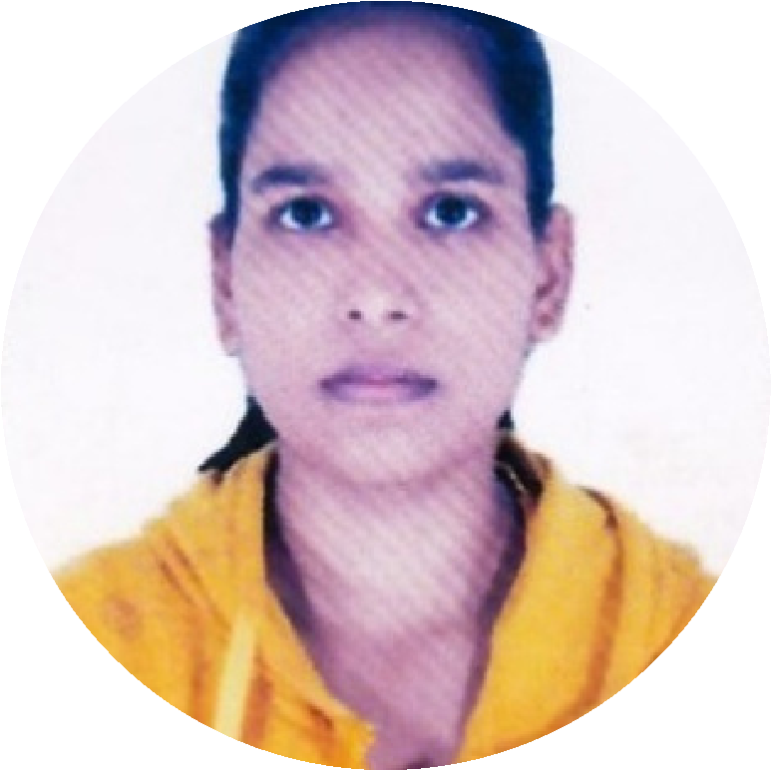

**PROFILE**

Business Administration and IT

student.

I consider my self a

responsible and orderly

person.

I I am looking forward for

my first work

experience.

**CONTACT ME**

9120106560

Diptimaurya024@gmail.com

Chandauli, village-

Sogai, saidraja Uttar

pradesh

232110

**PERSONAL INFORMATION**

Father's Name : Narendra Kumar Singh

Date of Birth : 7th April 2003

Gender : Female

Martial status : Unmarried

Nationality : Indian

Hobbies : Sketching, Planting , Reading

**EDUCATION**

**CHANDERPRABHU JAIN COLLEGE OF**

**HIGHER STUDIES & SCHOOL OF LAW**

*Pursuing BBA(CAM) 2023-2025*

**NIRMALA CONVENT HIGH SCHOOL**

*2020*

*th from CBSE board in*

*10*

*Percentage- 65.75%*

*2022*

*12*

*th from CBSE board in*

*Percentage- 75.75%*

**LANGUAGE**

English.

Hindi

**COMPUTER SKILLS**

Well knowledge of Ms excel, Ms

Word , Ms power point , Python, SQL , Tableau , PowerBI ,HTML ,CSS , Javascript

**DIPTI**

**MAURYA**

**Student**

Basic Comupter knowledge Applicatin.