KIET GROUP OF INSTITUTIONS
SOFTWARE ENGINEERING & DESIGN PRINCIPLES LAB — CS311P
EXPERIMENT 9: SOFTWARE ARCHITECTURE DESIGN AND UML STATE MODELING
Project: Loan Eligibility Prediction System
Project Team: Dipti Gupta — Project Manager & GenAI; Diksha Verma — Backend Developer; Kashika Maurya — Frontend Developer & Testing/QA

1. Aim
To design the overall architecture of the Loan Eligibility Prediction System using a suitable architectural approach and to prepare a UML State Diagram for the request-processing workflow.

2. Project Scope
As specified in the project SRS, the application accepts applicant details, validates and preprocesses the data, applies a trained classification model and displays a preliminary eligibility prediction. The system is intended for decision support. Final loan approval remains outside the system.
Evidence note: the supplied ZIP contains documentation and UML images but no application source code. The architecture below is therefore a logical design derived from the SRS/README, not a claim that the shown components are deployed or implemented as separate services.

3. Selected Architectural Approach
A layered architecture is suitable for this project because it separates the user interface, application logic, prediction functionality and model/data resources. It provides clear responsibilities and can make the system easier to test and maintain.
Client-server can be used if the user interface sends requests to a separate backend through an API. The supplied documents mention Python/machine-learning libraries and optional web/API technologies, but do not establish a specific deployed topology. Therefore, the diagram does not prescribe an unverified framework or database.
Microservices are treated as a possible future option rather than a current implementation requirement. A modular application is likely simpler for a student project until there is a demonstrated need to deploy services independently.

4. Architecture Components
Component | Responsibility | SRS mapping
Presentation layer | Collect applicant details and display validation messages/results. | FR-01, FR-05, FR-06
Validation component | Check required fields and acceptable input formats. | FR-02, FR-06
Preprocessing component | Prepare or encode data for the trained classifier. | FR-03
Prediction component | Invoke the trained classification model and return a predicted class. | FR-04
Result presentation | Present the result clearly as a preliminary prediction. | FR-05
Model/data resources | Provide model and data resources; maintenance by authorised administrator when implemented. | FR-07
Optional GenAI assistance | Explain results in simple language; does not make final loan decisions. | GenAI Component in SRS

5. Architecture Data Flow
- Applicant enters income, credit history, loan amount, employment status, education and other selected attributes.
- The presentation layer sends the submitted details to validation.
- If required fields or formats are invalid, the system displays an understandable validation message and requests correction.
- Valid information is preprocessed/encoded into the feature format expected by the trained model.
- The prediction component applies the classification model and returns the predicted class.
- The result presentation component displays the prediction and clarifies that it is not guaranteed or final loan approval.
- If GenAI assistance is implemented, it may explain the result in simple language as supplementary assistance, without changing the classifier output.

6. UML State Modeling
A UML State Diagram represents the states an application/request can occupy and the events that cause transitions between states. The supplied diagram models the lifecycle of one prediction request.
State | Meaning | Transition/event
Idle | No request is being processed. | Applicant starts entering details.
Entering Details | Applicant provides the required attributes. | Applicant submits the form.
Validating Input | System checks required fields and formats. | Invalid input leads to Validation Error; valid input leads to Preprocessing.
Validation Error | System shows an error and allows correction. | Applicant corrects details and returns to Entering Details.
Preprocessing | Valid attributes are prepared for the model. | Prepared features are passed to prediction.
Generating Prediction | Classifier generates a predicted class. | Prediction is returned to the result screen.
Displaying Result | Preliminary prediction is shown to the user. | User finishes/closes the request.
Note: these are request-processing states. They do not represent a bank's actual underwriting or final approval process. The state diagram should be updated if the implemented application uses different states.

7. Design Patterns and Extension
The supplied source files do not confirm use of a named design pattern. A Service Layer could be introduced to coordinate validation, preprocessing and prediction. A Strategy pattern could be considered if the system needs to switch between multiple model implementations. These are optional design recommendations and should not be described as existing code unless implemented.

8. Quality and Security Considerations
- Input validation must occur before prediction.
- Errors should be handled without exposing internal stack traces or sensitive data.
- Applicant financial and personal information should be protected and collected only when needed.
- Model/data changes should be documented and tested when maintenance functionality is implemented.
- Model performance and potential bias should be evaluated before any real-world use.
- Results must be presented as preliminary predictions, not guaranteed lending decisions.

9. Conclusion
The proposed layered architecture separates user interaction, validation, preprocessing, prediction and result presentation. The UML State Diagram represents the request lifecycle from idle to result display, including invalid-input recovery. Both artefacts align with the project SRS and should be compared with the actual implementation before final submission.

References
1. Loan Eligibility Prediction System — README.md, supplied project repository ZIP.
2. Software Requirements Specification (SRS), docs/SRS/SRS_Loan_Eligibility_Prediction_System.docx.
3. Requirement Analysis Report, docs/Requirement_Report/Requirement_Report_Loan_Eligibility_Prediction_System.docx.
4. CS311P Software Engineering & Design Principles Lab — revised list of experiments.

Appendix A: System Architecture Diagram
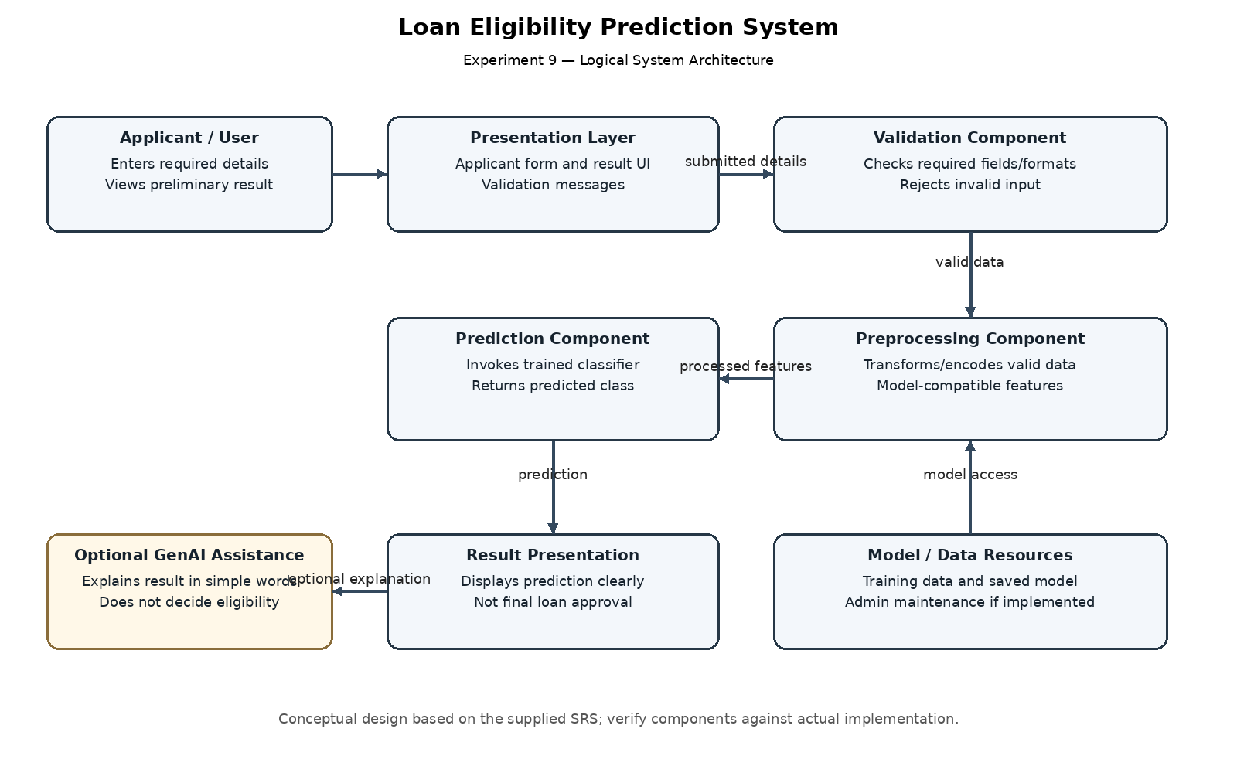

Appendix B: UML State Diagram
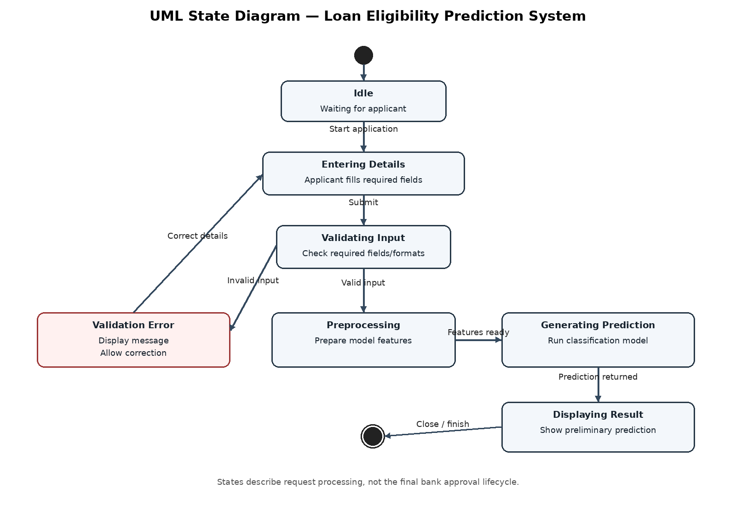
Student Signature: __________________________ Faculty Signature: __________________________

