

ASSIGNMENT
FULL STACK - II
Name : Dipti Sinha
UID : 23BAI70069
Section/Group : 23AML(2-B)

Institute Name: Chandigarh University

Faculty Coordinator: Prof. Akash Mahadev Patil

Date of Submission: 13 February 2025
1. Summarize the benefits of using design patterns in frontend development.
Design patterns are reusable and proven solutions to common software design problems. In frontend development, design patterns help in organizing code structure, improving maintainability, enhancing scalability, and ensuring efficient collaboration among developers. Modern frontend frameworks like React, Angular, and Vue follow several design patterns to manage UI components, state, and application logic effectively.
Benefits of Using Design Patterns in Frontend Development
1. Improved Code Reusability
Design patterns encourage modular development. Components can be reused across different parts of an application, reducing duplication of code. For example, in React, the Component Pattern allows developers to create reusable UI components like buttons, forms, and cards. This saves development time and improves consistency.
2. Better Maintainability
Structured code is easier to understand and modify. When design patterns are used, the application follows a predictable structure, making debugging and updates simpler. Developers can quickly identify where logic, UI, or data handling is implemented.
3. Scalability of Applications
Design patterns help applications grow without becoming complex or unmanageable. As new features are added, the structured architecture ensures that existing functionality remains stable. Patterns like MVC separate responsibilities, making scaling easier.
4. Separation of Concerns
One of the biggest advantages is separation of concerns. UI logic, business logic, and data management are separated into different modules. This improves clarity and reduces complexity. For example, Redux separates state management from UI components.
5. Enhanced Team Collaboration
When teams follow standard design patterns, it creates a common understanding of code structure. New developers can easily understand the project architecture. This improves teamwork and reduces onboarding time.
6. Improved Testing Capability
Design patterns promote modular code. Individual components or modules can be tested independently using unit testing frameworks. This increases software reliability and reduces bugs in production.
7. Better Performance Optimization
Certain design patterns improve performance. Lazy loading loads components only when required. Observer Pattern ensures efficient state updates. Virtual DOM optimizes rendering and reduces unnecessary DOM manipulations.
8. Reduced Development Time
Instead of solving the same architectural problems repeatedly, developers use predefined pattern solutions. This speeds up development and ensures best practices are followed.
9. Increased Code Readability
A structured design makes code easier to read and understand. This is especially important in large full-stack applications where frontend and backend teams work together.
10. Long-Term Project Stability
Design patterns prevent unstructured and poorly organized code. They ensure that applications remain stable and manageable over time, especially in enterprise-level projects.
Common Frontend Design Patterns
Pattern Name | Purpose | Example Usage
Component Pattern | Creates reusable UI components | React Components
MVC Pattern | Separates Model, View, Controller | Angular Architecture
Observer Pattern | Notifies changes in application state | Redux State Management
Singleton Pattern | Ensures only one instance of an object | Configuration Object
Example Code (Component Pattern in React)
function Button(props) {
return (
<button onClick={props.onClick}>
{props.label}
</button>
);
}
export default Button;
Diagram
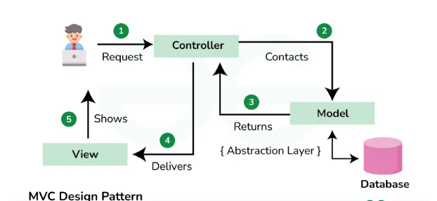

In frontend development, design patterns provide structured architecture, improve maintainability, enhance scalability, and promote reusable and testable code. They are essential in modern full-stack applications for building efficient, scalable, and professional user interfaces.
2. Classify the difference between global state and local state in React.
In React, state refers to data that represents the conditions of a component at a point in time. It determines how UI elements behave and render.
State management becomes essential as applications grow. Two major types of state exist in React: Local State and Global State. Understanding their differences helps in building scalable, maintainable, and efficient applications.
Local State in React
Local state is the state that is managed within a single component. It is created and updated inside that component and remains private to it.
Key Characteristics
- Defined using the useState() hook in functional components.
- Applicable only to the component where it is declared.
- Not directly accessible by other components.
- Best for UI-specific data such as toggles, form inputs, visible states, animation flags.
Example of Local State
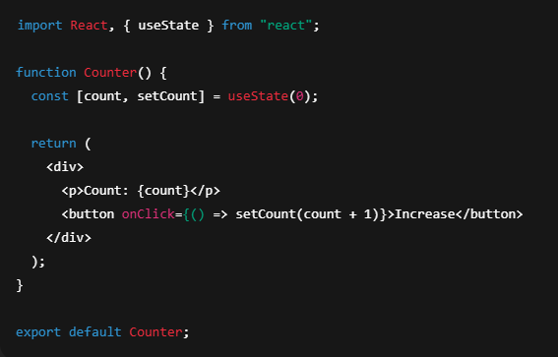
Global State in React
Global state is shared across multiple components in an application and can be accessed or updated from many places.
Key Characteristics
- Shared across multiple components.
- Managed at a higher level using tools like Context API, Redux, Zustand, Recoil, etc.
- Helps avoid prop drilling – passing props through many layers.
How Global State Works
The global state lives outside individual components or at top-level and persists for the lifetime of the application session.
Tools implementing global state help manage performance and consistency, especially for larger applications.

Tabular Comparison of Local vs Global State
Feature | Local State | Global State
Definition | Inside one component | Shared across many components
Scope | Component-level | Application-wide
Accessibility | Only that component | Many components
Implementation | useState(), useReducer() | Context API, Redux, etc.
Use Cases | UI toggles, input fields | Auth info, theme, cart
Complexity | Simple | More complex
Reusability | Limited | High

When to Use Which State
Local State:
- When data affects only one component.
- Useful for temporary UI changes like showing an alert, toggling a modal.
Global State:
- When multiple components need the same data.
- E.g., user’s login status, app theme shared across UI.

Conclusion
Local and global states are core concepts in React.
- Local state manages component-specific interactions.
- Global state manages shared application data.

3.Compare different routing strategies in Single Page Applications (client-side, server-side, and hybrid) and analyze the trade-offs and suitable use cases for each.
Introduction
Routing decides how URL requests map to UI and data. In modern web apps there are three broad routing strategies:
- Client-side routing (CSR) — the browser JS handles route changes and renders views without full page reloads.
- Server-side routing (SSR / classic server routing) — the server responds to each URL with the full HTML page (or rendered HTML).
- Hybrid routing (SSR + CSR / Universal / Isomorphic / Static + Client Hydration) — combines server rendering for initial loads and client routing for subsequent navigation.
Below is a ready-to-copy, exam-style comparative answer with trade-offs and recommended use cases.

Short definitions (one line each)
- Client-side routing: Browser loads a JS bundle; route changes update the URL and view via history API (no full reload).
- Server-side routing: Server returns the HTML for each URL; navigation causes full page reloads (or partial server-rendered responses).
- Hybrid routing: Server renders the initial HTML (for SEO/perf) then hands control to client JS for in-app navigation (or mixes server and client routing where appropriate).

Comparison table
Aspect | Client-side Routing (CSR) | Server-side Routing (SSR/classic) | Hybrid Routing (SSR + CSR / Universal)
Initial page load | Loads JS bundle first; initial view may be blank until JS runs (can be optimized) | Server sends ready-to-display HTML immediately | Server sends pre-rendered HTML for initial load, then hydrates to client
Navigation after load | Fast, instant view updates (no full reload) | Each navigation triggers full page reload → slower UX | Subsequent navigations behave like CSR (fast)
SEO / crawler friendliness | Poor by default (requires pre-rendering/SSR) | Excellent — content available in HTML | Excellent for initial load
Time to First Paint (TTFP) | Can be slower (JS parse) | Usually faster perceived TTFP for content | Best TTFP for content (server renders HTML)
Complexity | Simple deploy infra; more client JS complexity | Simpler app logic per page, can be simpler caching | More complex build & runtime (server + client)
Resource use (server) | Low per navigation (static serving) | Higher — server handles rendering per request | Moderate-high (server renders initial; API for data)
Caching & CDNs | Easy to cache static assets | HTML caching possible but dynamic pages harder | Static initial pages + API caching possible
State hydration | Needs client state management after navigation | State loaded per request; easier consistency | Needs hydration logic to sync server-rendered state with client
Progressive enhancement / accessibility | Harder if JS disabled | Works without JS | Works without JS for initial view
Typical tools / frameworks | React Router, Vue Router, Angular Router | Express, Rails, Django, PHP; server frameworks | Next.js, Nuxt, Remix, Angular Universal, SvelteKit

Detailed analysis — trade-offs
1. Client-side routing (CSR)
How it works: Browser downloads an app bundle (JS + assets). Routes handled by client router (history API). The server usually serves a single index.html.
Benefits
- Smooth, app-like navigation (no page refresh).
- Very fast subsequent navigations and UI transitions.
- Rich client interactions and offline capabilities (PWA).
- Lower server CPU per request when app is static.
Drawbacks
- Initial load can be slower (large JS bundles).
- SEO and social preview issues unless pre-rendered.
- Requires more client memory and CPU — not ideal for low-power devices.
- Accessibility and progressive enhancement suffer if JS fails.
When to use
- Internal dashboards, admin tools, or authenticated SPAs not depending on SEO.
- Apps where UX snappiness and interactive features dominate (e.g., Gmail-like apps).
- Teams preferring simple hosting (static hosting / CDN).

2. Server-side routing (SSR / classic server rendering)
How it works: Server builds full HTML for each URL on request (templates or server rendering) and returns it to client.
Benefits
- Fast first meaningful paint and immediate content availability.
- Excellent SEO and social sharing (meta tags in HTML).
- Works when JS is disabled; better progressive enhancement.
- Easier to reason about for simple websites.
Drawbacks
- Navigation feels slower (full page reloads) unless augmented with AJAX.
- Server scalability & CPU cost — server renders each request (can be mitigated by caching).
- Less interactive UX unless plenty of client JS is added.
When to use
- Content-heavy sites, marketing pages, blogs, and documentation.
- Sites that must work reliably without JavaScript.
- Applications with limited client interactivity.

3. Hybrid (Universal) routing
How it works: Server renders initial HTML for each route (server rendering or static generation). Client JS then “hydrates” to make the page interactive; further navigation is handled client-side.
Benefits
- Best of both worlds: fast initial paint + good SEO + app-like navigation after load.
- Better perceived performance and sharing (OG tags available).
- Can pre-render static pages (SSG) for ultra fast delivery.
- Improves accessibility and progressive enhancement for first load.
Drawbacks
- Higher implementation complexity: build pipelines must support server render + client hydration.
- More complex caching and invalidation strategies.
- Potential duplication of rendering logic (server and client) unless framework unifies it.
- Risk of hydration mismatches if server/client outputs differ.
When to use
- Public-facing apps that need SEO and good UX: e-commerce, SaaS marketing + app dashboards.
- Projects that need fast initial load for new users and dynamic interactions for signed-in users.
- Teams using modern meta-frameworks (Next.js, Remix, Nuxt, SvelteKit) that handle many complexities.

Practical considerations & patterns
A. Static Site Generation (SSG) vs Server Render on Request
- SSG: Pre-generate HTML at build time (very fast; ideal for blogs/products with infrequent updates). Often used in hybrid setups.
- SSR on request: Dynamic server render per request — necessary when page content is user-specific or frequently changing.
B. Code Splitting & Lazy Loading
- Use code splitting to reduce CSR initial bundle size (both CSR and hybrid benefit). Lazy load route components.
C. Caching & CDNs
- For SSR, cache rendered HTML on CDN/edge when content is the same for many users. For CSR, cache static assets and use API caching for data.
D. Authentication & Private Routes
- CSR: store auth tokens in memory or secure storage; protect client routes.
- SSR/hybrid: can render a personalized initial view server-side (safer for secure UX) and still hand-off to client.
E. SEO & Meta Tags
- CSR alone: need pre-rendering or server render to get meta tags indexed properly. Hybrid/SSR handles this natively.

Example stacks & real-world mapping
- CSR heavy: Single-page admin dashboards using React + React Router + static hosting (Netlify, Vercel static).
- SSR/classic: Django/Rails/PHP websites, or server templated apps.
- Hybrid (recommended for many modern apps):
  - Next.js (React) — supports SSG, SSR, and client routing.
  - Nuxt (Vue) — similar capabilities for Vue.
  - Remix — focuses on network and progressive enhancement.
  - SvelteKit — server + client rendering with minimal overhead.

4. Examine Common Component Design Patterns (Container–Presentational, Higher-Order Components, Render Props) and Identify Appropriate Use Cases
Introduction
In React and modern frontend development, component design patterns help organize logic and UI in a reusable and maintainable way. They improve separation of concerns, enhance scalability, and promote clean architecture. Three widely used patterns are:
- Container–Presentational Pattern
- Higher-Order Components (HOC)
- Render Props
Each pattern solves different architectural problems.

1. Container–Presentational Pattern
Concept
This pattern separates components into two types:
- Container Components → Handle business logic, state, and data fetching
- Presentational Components → Focus only on UI rendering
It enforces separation of concerns.

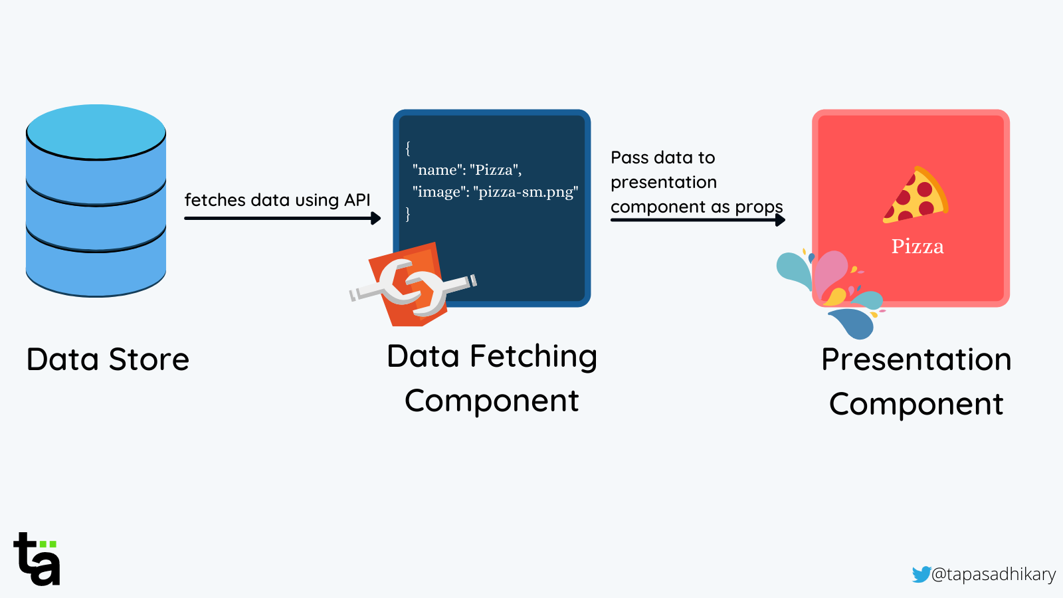

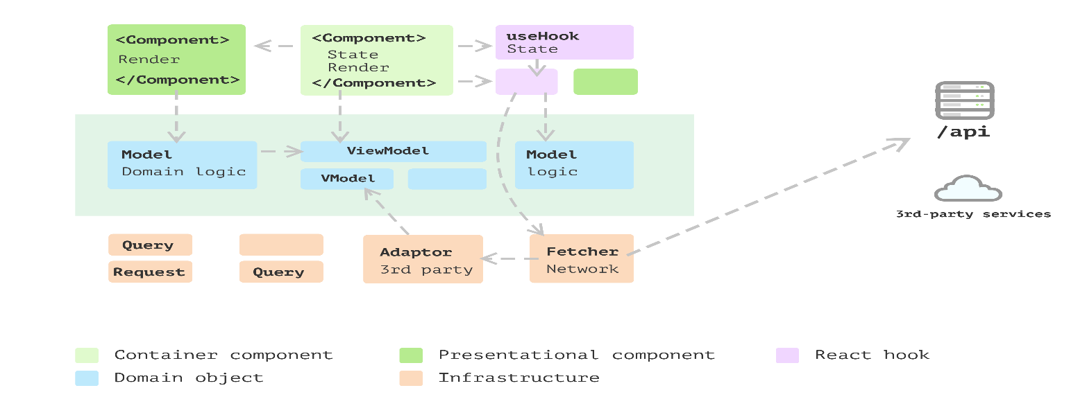

Structure
Container → Fetches data → Passes props → Presentational Component → Renders UI

Example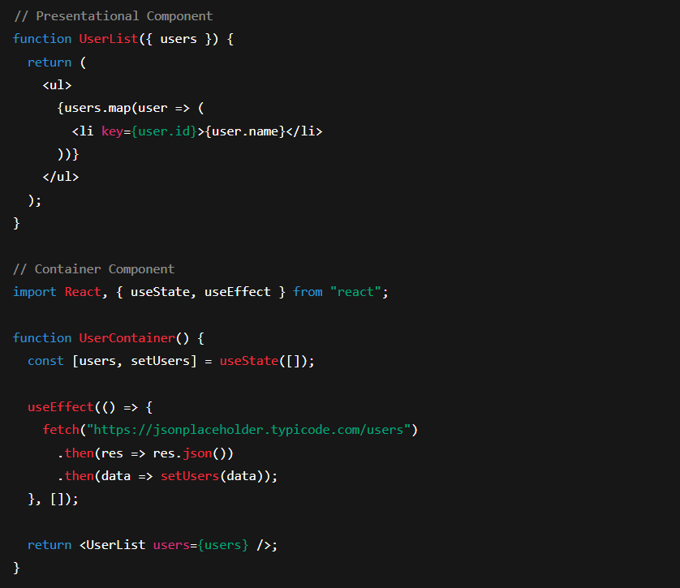
Advantages
- Clear separation of UI and logic
- Easy to test presentational components
- Reusable UI components
- Cleaner project structure
Use Cases
- Medium to large applications
- When UI must remain reusable
- When separating data logic from UI logic is required

2. Higher-Order Components (HOC)
Concept
A Higher-Order Component is a function that takes a component as input and returns a new enhanced component.
It is used to reuse component logic.

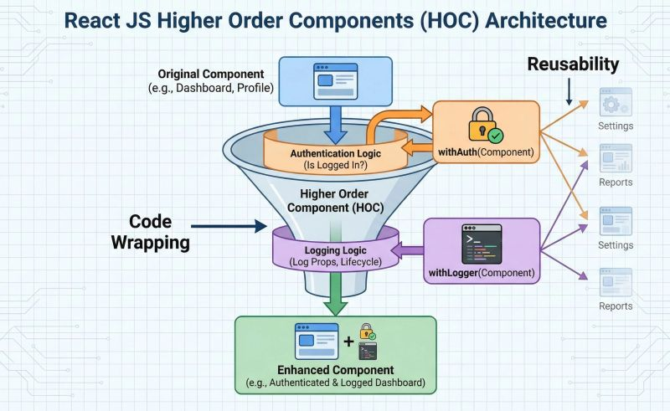
Syntax
const EnhancedComponent = higherOrderFunction(WrappedComponent);
Example
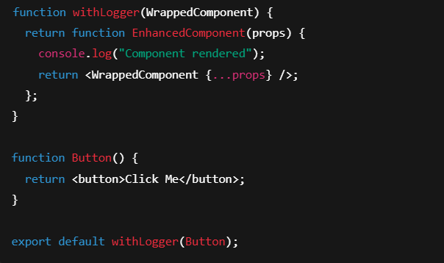
Advantages
- Reuse logic across components
- Avoid code duplication
- Easy to add authentication, logging, permissions
Disadvantages
- Can create nested wrapper complexity
- Harder debugging
- “Wrapper hell” problem
Use Cases
- Authentication checks
- Logging
- Role-based access control
- Data fetching abstraction

3. Render Props Pattern
Concept
Render Props is a technique where a component receives a function as a prop and uses that function to render content.
It provides flexibility in sharing logic.

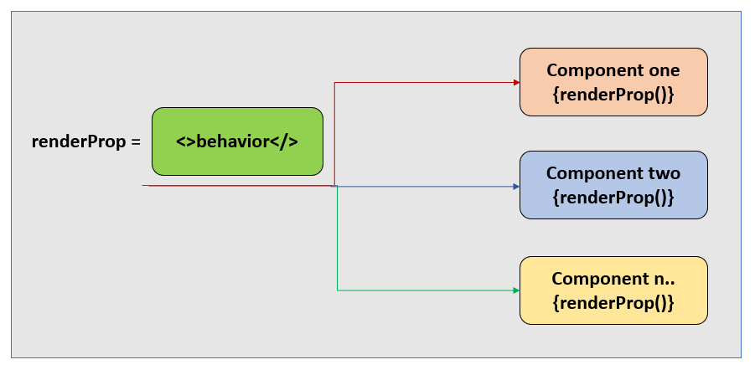
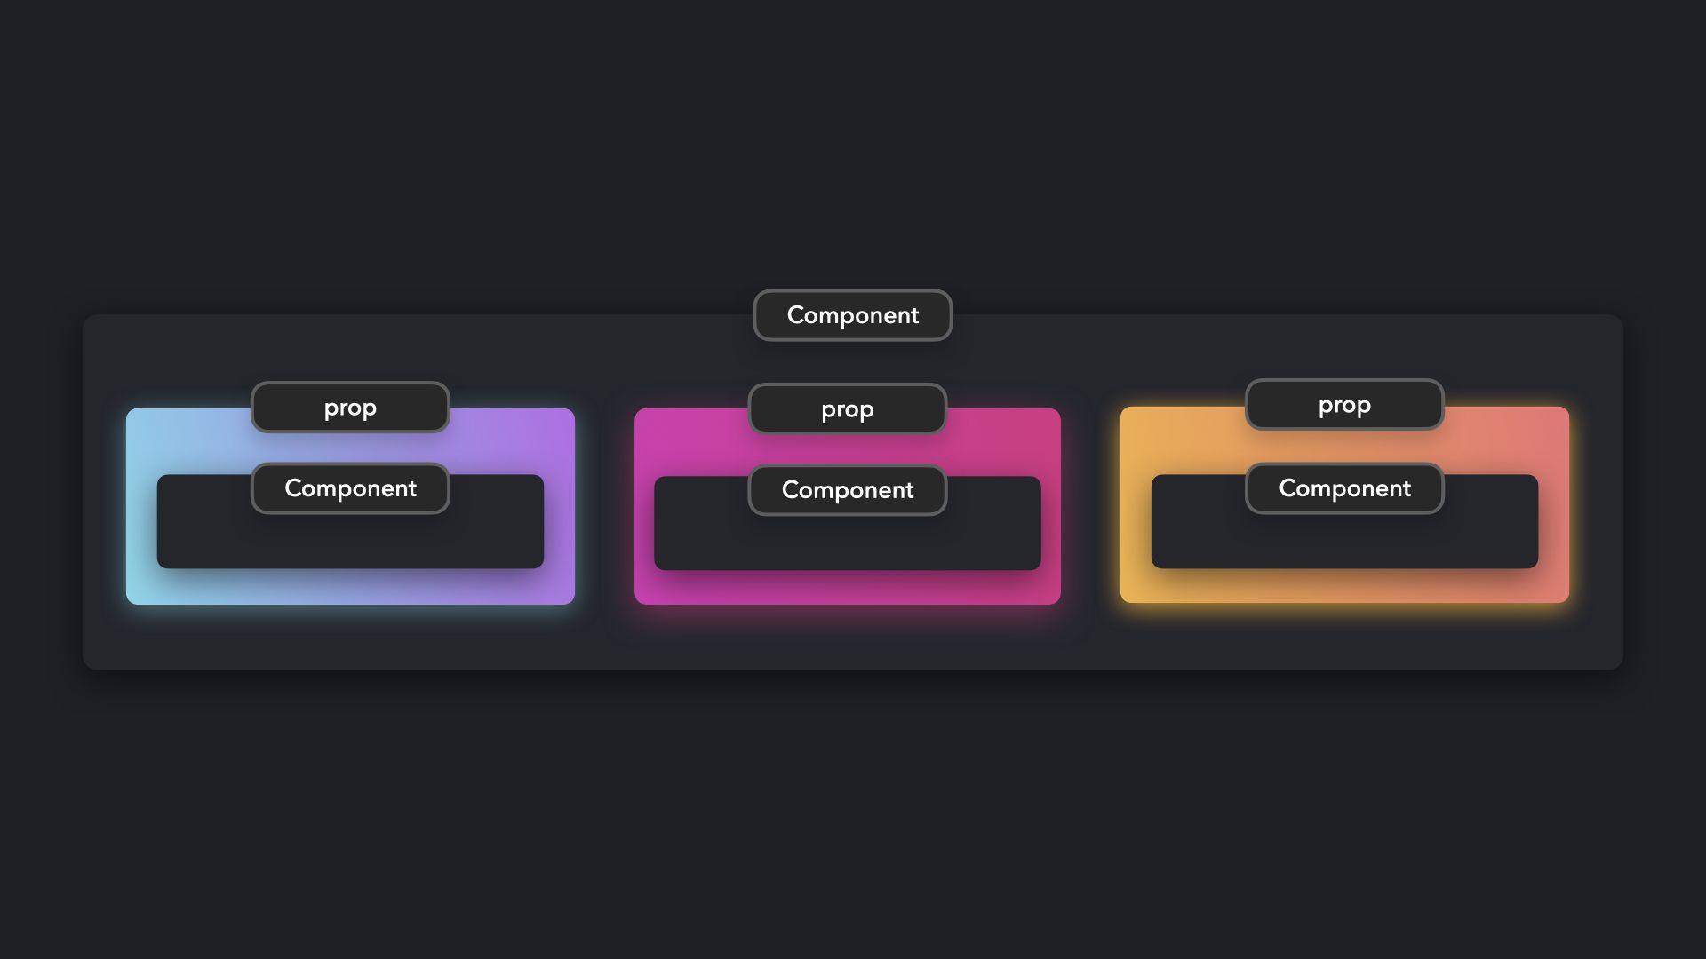
Example
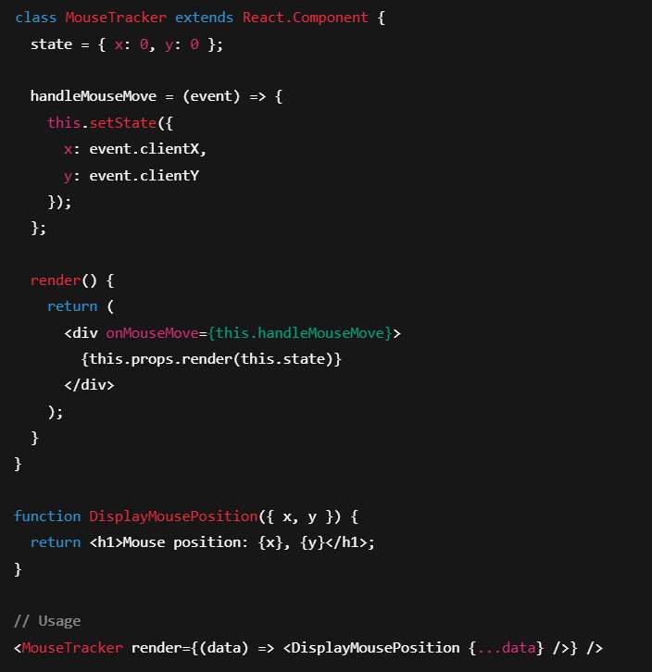
Advantages
- Flexible logic reuse
- Clear separation of logic and rendering
- Avoids wrapper nesting problem
Disadvantages
- Can reduce readability
- Complex prop passing
Use Cases
- Sharing stateful logic
- Mouse tracking
- Form validation libraries
- Animation logic
Comparison Table
Feature | Container–Presentational | HOC | Render Props
Purpose | Separate UI & logic | Reuse component logic | Share dynamic rendering logic
Structure | Two component types | Function wrapping component | Function passed as prop
Complexity | Low to Medium | Medium | Medium
Modern Replacement | Custom Hooks | Custom Hooks | Custom Hooks

Conclusion
These design patterns improve reusability, maintainability, and scalability. While modern React encourages Custom Hooks as an alternative, understanding these patterns is essential for mastering component architecture in full-stack development.

5. Demonstrate and develop a responsive navigation bar using Material UI components while applying appropriate styling and breakpoint configurations.
Introduction
Material UI (MUI) is a popular React component library that provides pre-built responsive UI components following Google’s Material Design principles. A responsive navigation bar adapts to different screen sizes using breakpoints.

Key Components Used
- AppBar
- Toolbar
- Typography
- IconButton
- Menu
- MenuItem
- Drawer
- Box
- useMediaQuery
Responsive Navbar Code Example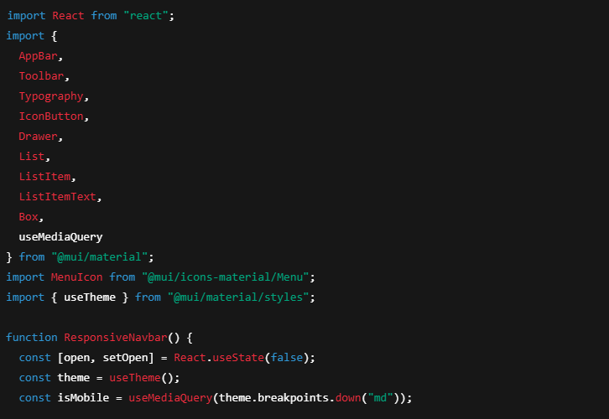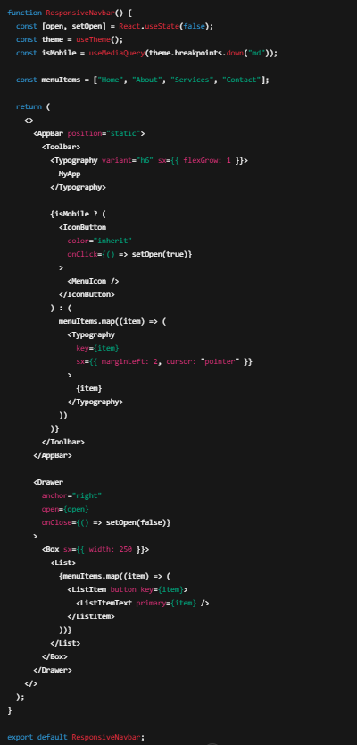
Breakpoint Configuration
Material UI default breakpoints:
Breakpoint | Screen Size
xs | 0px
sm | 600px
md | 900px
lg | 1200px
xl | 1536px
In the example:
const isMobile = useMediaQuery(theme.breakpoints.down("md"));
This means:
- If screen width < 900px → show Drawer (mobile view)
- Otherwise → show horizontal menu (desktop view)

Features of This Responsive Navbar
- Uses AppBar and Toolbar
- Automatically switches layout
- Uses Drawer for mobile navigation
- Uses breakpoints properly
- Clean Material UI styling
- Fully responsive

Conclusion
Material UI simplifies responsive design using pre-built components and breakpoint utilities. By combining AppBar, Drawer, and useMediaQuery, we can create scalable and adaptive navigation systems suitable for modern full-stack applications.

6. Evaluate and design a complete frontend architecture for a collaborative project management tool with real-time updates. Include: a) SPA structure with nested routing and protected routes b) Global state management using Redux Toolkit with middleware c) Responsive UI design using Material UI with custom theming d) Performance optimization techniques for large datasets e) Analyze scalability and recommend improvements for multi-user concurrent access.
Introduction
A collaborative project management tool (like Trello or Asana) requires:
- Real-time task updates
- Multi-user concurrent access
- Role-based permissions
- Large dataset handling
- Responsive UI across devices
The frontend architecture must ensure scalability, maintainability, and high performance.
High-Level Frontend Architecture
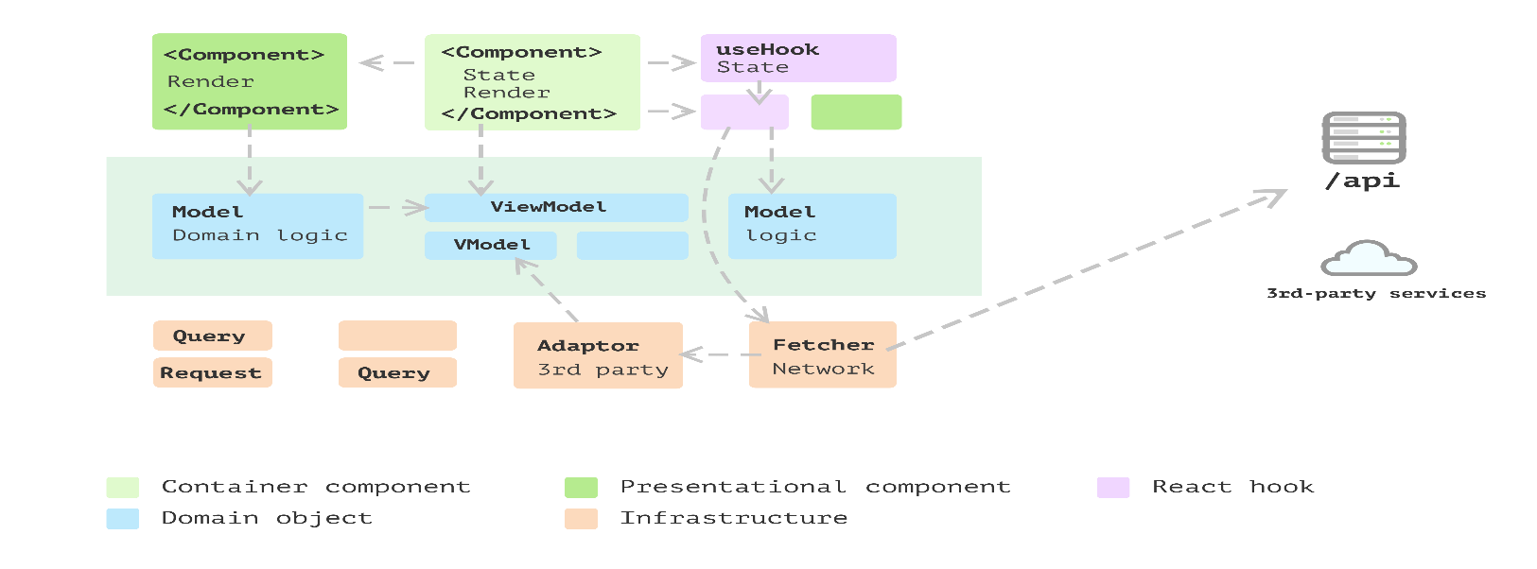

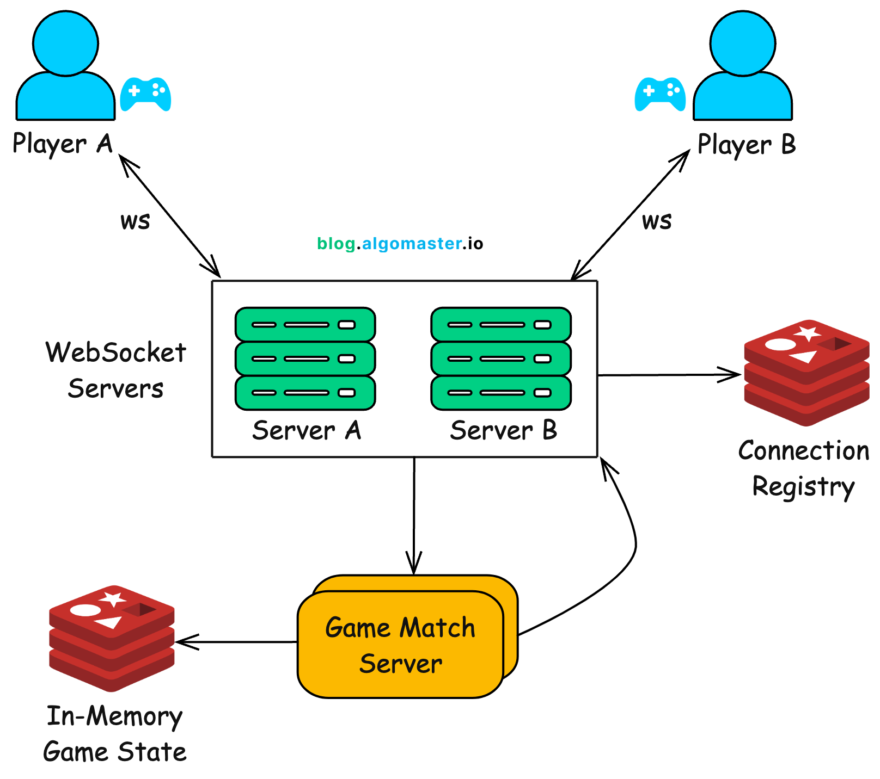
4
Architecture Layers
- Presentation Layer (Material UI Components)
- Routing Layer (React Router)
- State Layer (Redux Toolkit)
- Real-Time Communication Layer (WebSockets)
- API Layer (REST/GraphQL services)
- Utility Layer (Helpers, hooks, services)

a) SPA Structure with Nested Routing and Protected Routes
SPA Structure
We use React SPA architecture with nested routes using React Router.
Route Structure Example
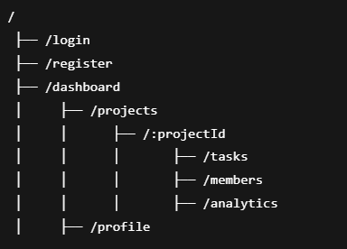
Protected Routes (Role-Based Access)
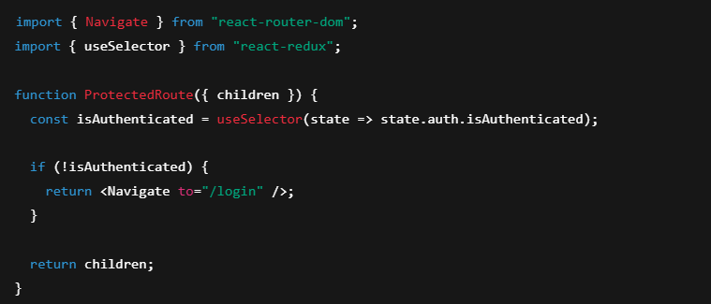
Usage:
Why Needed?
- Prevent unauthorized access
- Role-based route protection (Admin, Member, Viewer)
- Security at UI level

b) Global State Management Using Redux Toolkit with Middleware
We use Redux Toolkit for scalable state management.
State Slices
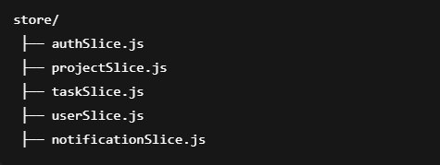

Store Configuration
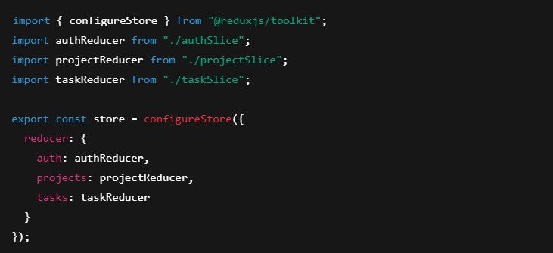
Middleware for Real-Time & Logging
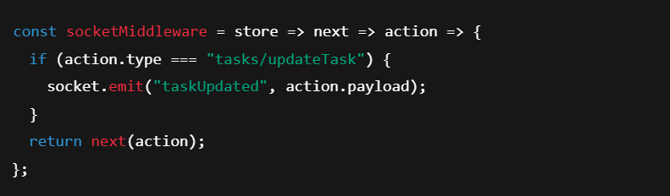Add middleware:

Why Redux Toolkit?
- Centralized state
- Predictable state transitions
- Middleware support
- DevTools debugging
- Efficient scaling

Real-Time Updates (WebSockets)
Use:
- WebSocket
- Socket.IO
Flow:
- User updates task
- Redux dispatch
- Middleware emits WebSocket event
- Server broadcasts update
- Other clients receive event
- Redux updates state
This ensures real-time sync across users.

c) Responsive UI Using Material UI with Custom Theming
Use Material UI for design consistency.

Custom Theme
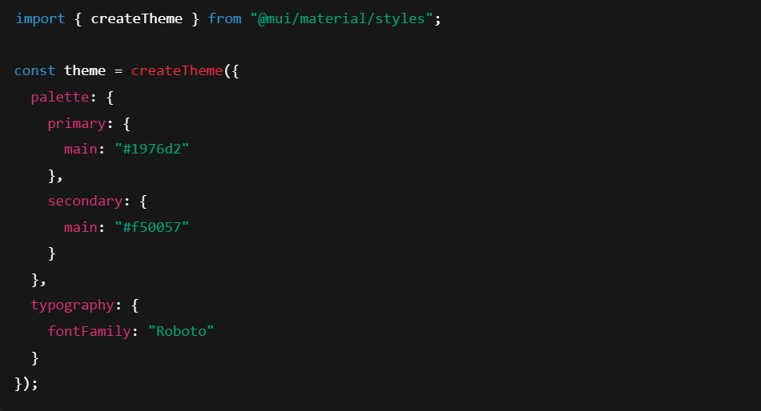

Responsive Layout Techniques
- Grid system
- useMediaQuery
- Drawer for mobile navigation
- Breakpoints (xs, sm, md, lg, xl)

d) Performance Optimization for Large Datasets
In project management tools, large datasets include:
- Hundreds of tasks
- Activity logs
- Comments
- Notifications

1. Virtualization
Use libraries like:
- react-window
- react-virtualized
Only visible rows are rendered.

2. Memoization
const MemoizedTask = React.memo(TaskCard);
Use:
- useMemo
- useCallback

3. Code Splitting
const Dashboard = React.lazy(() => import("./Dashboard"));

4. Pagination & Infinite Scroll
Load data in chunks.

5. Optimistic UI Updates
Update UI before server confirmation for smoother UX.

e) Scalability Analysis for Multi-User Concurrent Access
Challenges
- Data conflicts
- Simultaneous edits
- WebSocket scaling
- Server load

Scalability Recommendations
1. Optimistic Concurrency Control
Use version numbers or timestamps.
2. Conflict Resolution Strategy
Last-write-wins or merge strategy.
3. WebSocket Scaling
Use:
- Redis Pub/Sub
- Horizontal scaling
4. Data Normalization
Store entities in normalized structure in Redux.
Example:
tasks: {
byId: {},
allIds: []
}

5. Lazy Loading Projects
Load only active project data.

6. Role-Based Rendering
Render only permitted components.

Overall Architectural Flow
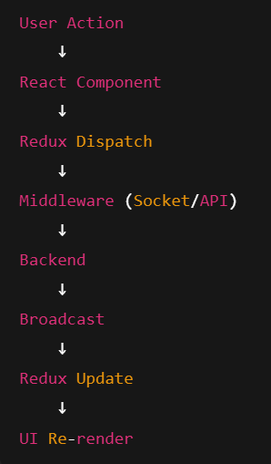
Conclusion
A scalable collaborative project management frontend should:
- Use SPA with nested and protected routing
- Manage global state via Redux Toolkit with middleware
- Implement real-time updates using WebSockets
- Use Material UI with custom theming
- Optimize performance for large datasets
- Implement concurrency control and scalable WebSocket architecture
This architecture ensures maintainability, responsiveness, and high scalability for multi-user environments.

