**DIFFERENT CI/CD TOOLS**

Buddy:

* Lightning-fast deployments based on changesets(a changeset is a set of changes which should be treated as an indivisible group; the list of differences between two successive versions in the repository. ).
* Buddy is a smart CI/CD tool for web developers designed to lower the entry threshold to DevOps
* Builds are run in isolated containers with cached dependencies
* Supports all popular languages, frameworks & task managers
* Integrates with AWS, Google, DigitalOcean, Azure, Shopify, WordPress & more.

Jenkins

* Jenkins is an open-source continuous integration tool. It is written using the Java programming language.
* It facilitates real-time testing and reporting on isolated changes in a

larger code base.

* Jenkins is a cross-platform CI tool and it offers configuration both

through GUI interface and console commands.

* Easy to install and upgrade on different operating systems
* Support shell and window command execution in pre-build steps
* It’s a simple and user friendly interface
* It is used to manage big projects.

Team City

* Team city is a paid software.
* It can manage parallel builds simultaneously on different

environment

* It is easy to customize and interact
* It keeps the CI server functional and stable
* It provides extensibility and customization
* It provides multiple ways to reuse settings an configurations of the

parent project to sub project

* It provides better code quality or any project
* It maintains CI server healthy and stable even when no builds are running
* It provides comprehensive VCS integration
* It performs remote run and pre-tested commit

GoCD

* + [GoCD](https://www.gocd.org/) is an Open source Continuous Integration server.
  + It is used to model and visualize complex workflows with ease.
  + This CI tool allows continuous delivery and provides an intuitive interface for building CD pipelines.
  + It supports parallel and sequential execution. Dependencies can be easily configured.
  + It allows deploy any version, anytime
  + It allows deploy to production securely.
  + It provides handle user authentication and authorization
  + It allows to keep orderly configuration
  + It provides tons of plugins to enhance functionality.

Circle CI

* It is a flexible CI tool that runs in any environment like cross-platform

mobile app, Python API server or Docker cluster. This tool reduces

bugs and improves the quality of the application.

* It has continuous and branch specific deployment
* It is highly customizable
* It has automated merging and custom commands for package

uploading

* It has fast setup and unlimited builds
* It is also a paid software
* It integrates with Bit bucket, Git hub and Git Hub Enterprise.
* In this CI we have easy debugging.
* Allows to select Build Environment
* Supports many languages like Linux, including C++, Javascript, NET, PHP, Python, and Ruby
* Support for Docker lets you configure customized environment
* Automatically cancel any queued or running builds when a newer build is triggered
* It split and balance tests across multiple containers to reduce overall build time

Bamboo

* It is a continuous integration build server which performs - automatic

build, test, and releases in a single place.

* It is also a paid software
* It supports many languages
* Run parallel batch tests
* Setting up Bamboo is pretty simple
* Per-environment permissions feature allows developers and QA to deploy to their environments
* It can trigger builds based on changes detected in the repository, push notifications from Bitbucket.
* It supports up to 100 builds agents
* It fix critical bugs quickly using custom agents that can be assigned for immediate

builds

* Compatible with Bit bucket and JIRA for a comprehensive CI experience
* Custom deployment projects to archive the history of each of your release version

Codeship

* It is a powerful CI tool that automates the development and deployment workflow. It triggers automated workflow by simplifying pushing to the repository.
* It is also a paid software
* It provides one-click signup for GitHub, GitLab, and Bit bucket
* It is highly customizable with native support for Docker
* It has efficient infrastructure that monitors and scale as per your requirements
* It contains simple configuration file management, getting your workflow going quickly
* It has simple UI for setting up workflows, while keeping a history of change

Travis

* It is also a paid software
* It is free for public open source projected on GitHub
* It is as simple as signing up, adding a project, and you can begin testing
* It has automated pull request verification
* It can works with Email, Slack, HipChat and others for easy notifications
* Extended API and CMD tools for custom management

GitLab CI

* It is a part of GitLab. It is a web application with an API that stores its

state in a database. It manages projects and provides a friendly user

interface, besides offering the advantage of all the features of GitLab.

* GitLab Container Registry is a secure registry for Docker images
* GitLab offers a convenient way to change metadata of an issue or merge request without adding slash commands in the comment field
* It provides APIs for most features, so it allows developers to create deeper integrations with the product
* Helps developers to put their idea into production by finding areas of improvement in their development process
* It helps you to keep your information secure with Confidential Issues
* Internal projects in GitLab allow promoting inner sourcing of internal repositories.
* Add additional machines to scale your tests for performance
* It has CMD build scripts allow you to program them in any language
* Custom version tests to check branches individually
* It contain manual deployment, and effortless rollback capabilities

**Strider**

* It is an open source tool. Its written in Node.JS / JavaScript. It uses MongoDB as a backing store. Hence, MongoDB and Node.js are essential for installing this CI. The tool offers supports for different plugins that modify the database schema & register HTTP routes.
* Strider integrates with many projects like GitHub, BitBucket, Gitlab, etc.
* Allows to add hooks to execute arbitrary build actions
* Build and test your software projects continuously
* Integrates seamlessly with Github
* Publish and subscribe to socket events
* Create and modify Striders user interfaces
* Powerful plugins to customize default functionalities
* Supports Docker

**JENKINS INSTALLATION:**

For installing Jenkins we need to have java 8 or above (not 9 because it is not supported by Jenkins)

1. Installation of java
2. Use command :sudo apt search jdk

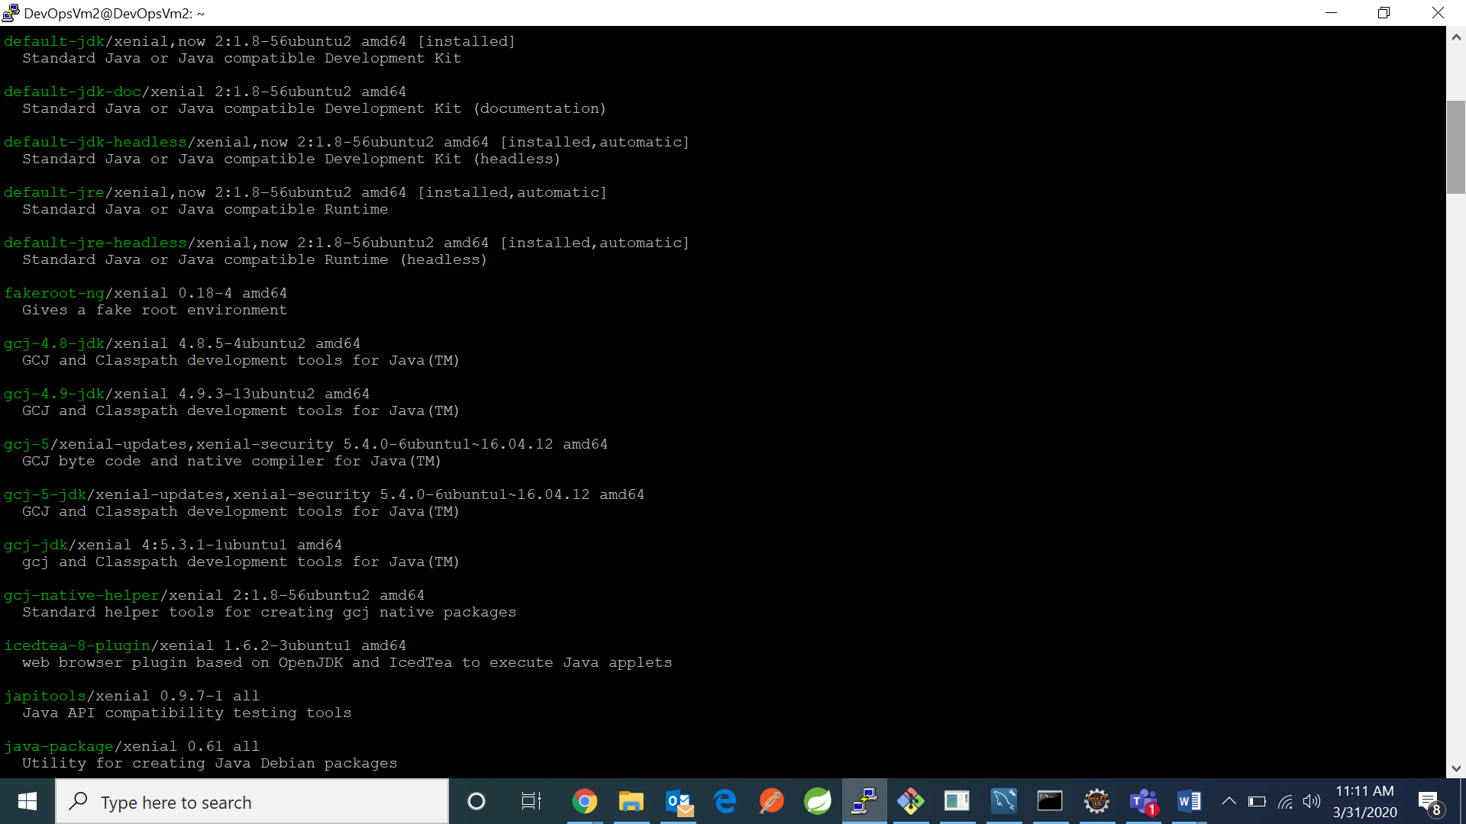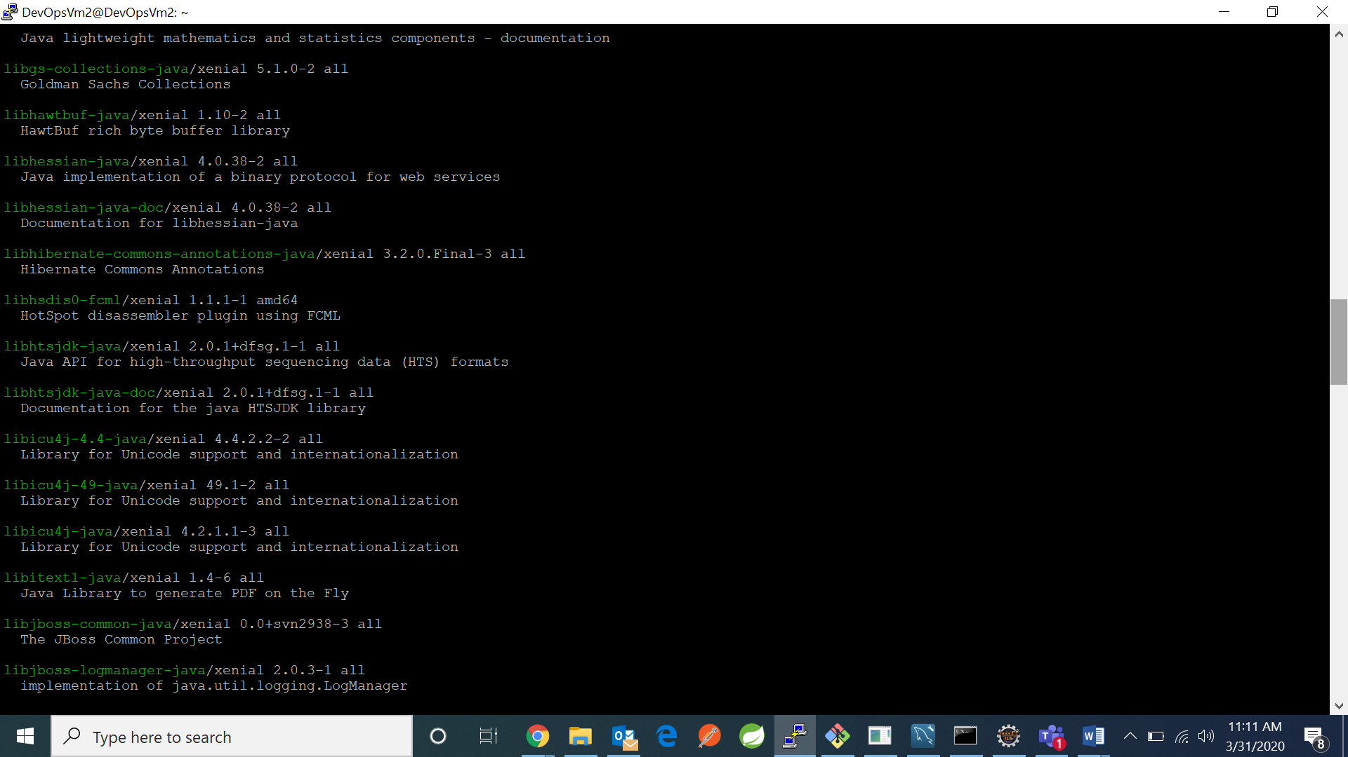

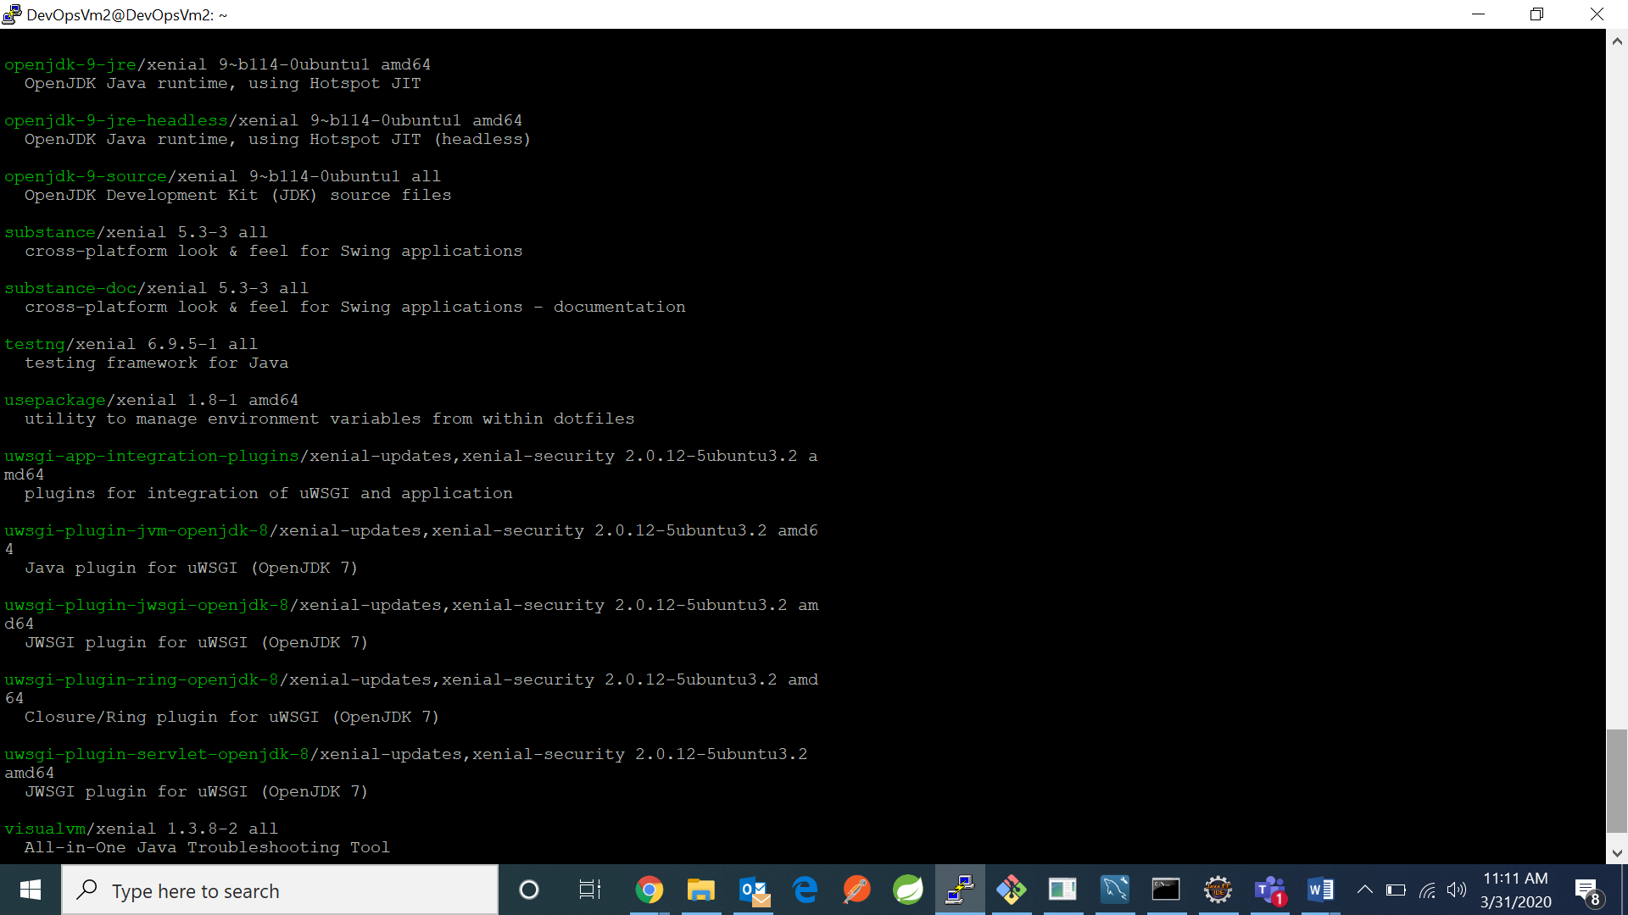

1. Use command :sudo apt install openjdk-8-jre

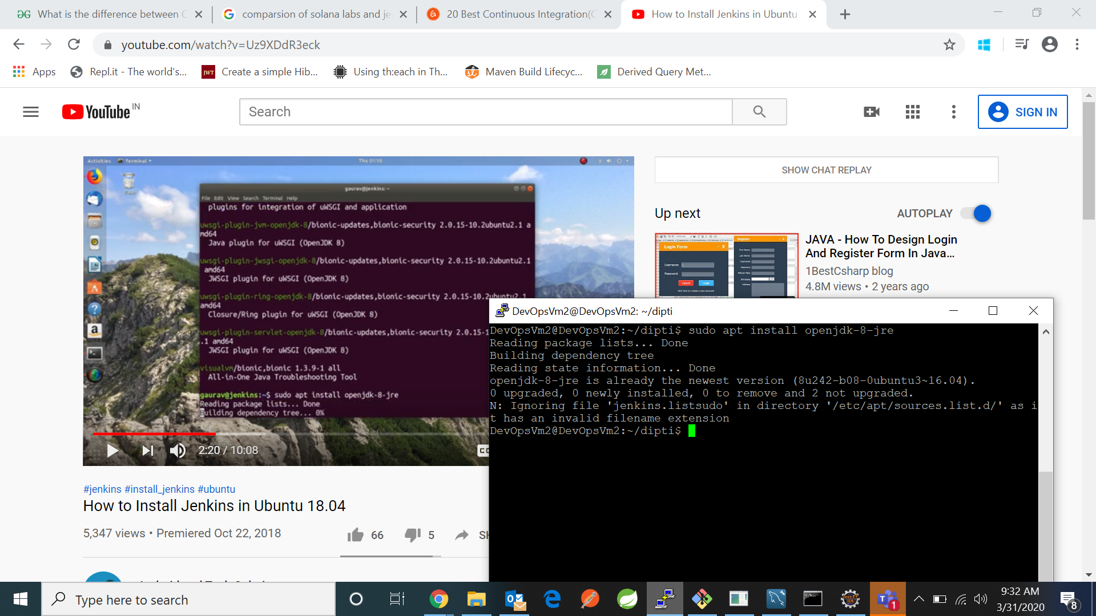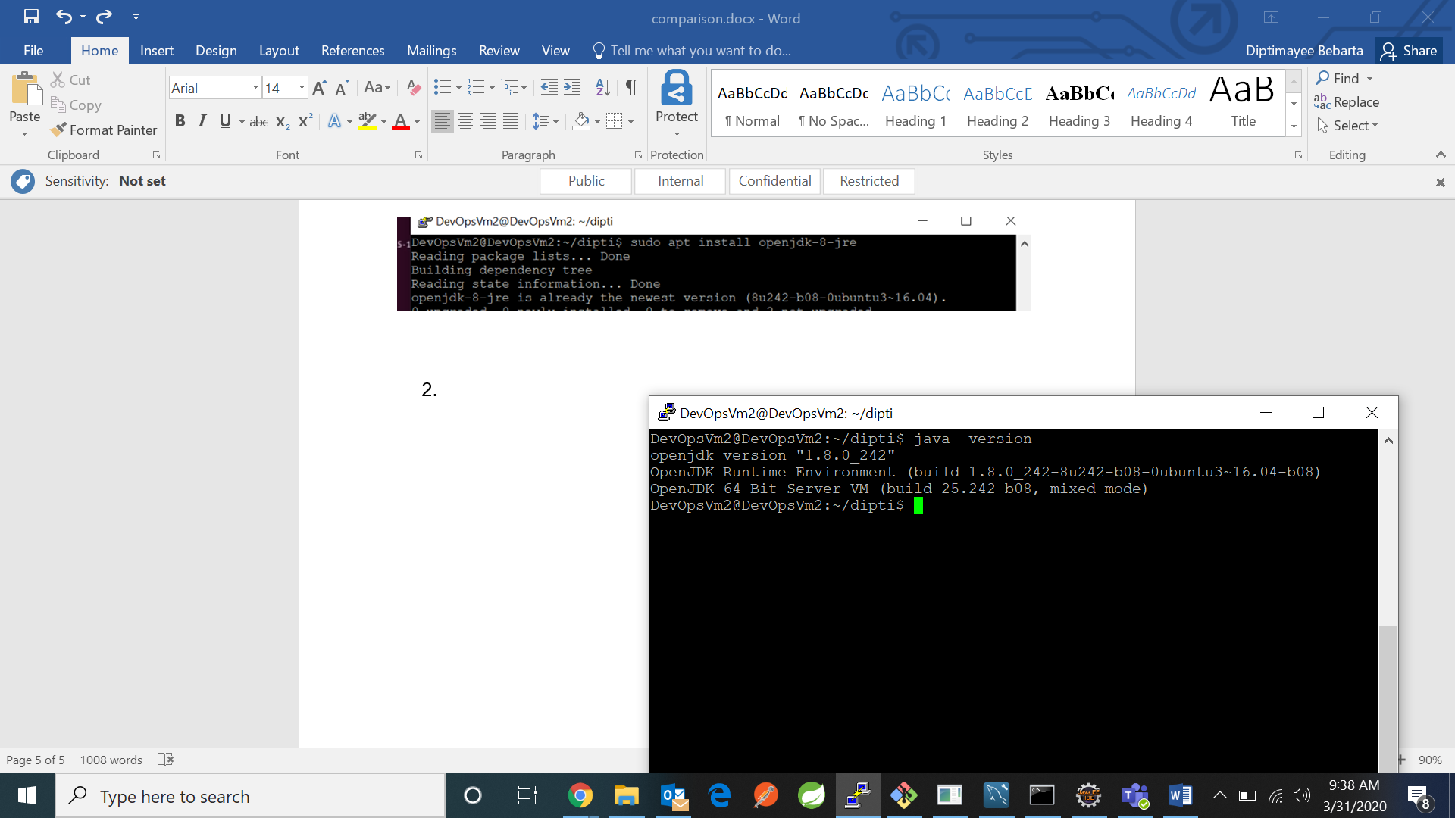

1. Use comman: wget -q -O - https://pkg.jenkins.io/debian/jenkins.io.key | sudo apt-key add - :It adds trusted apt-keys for repositories.

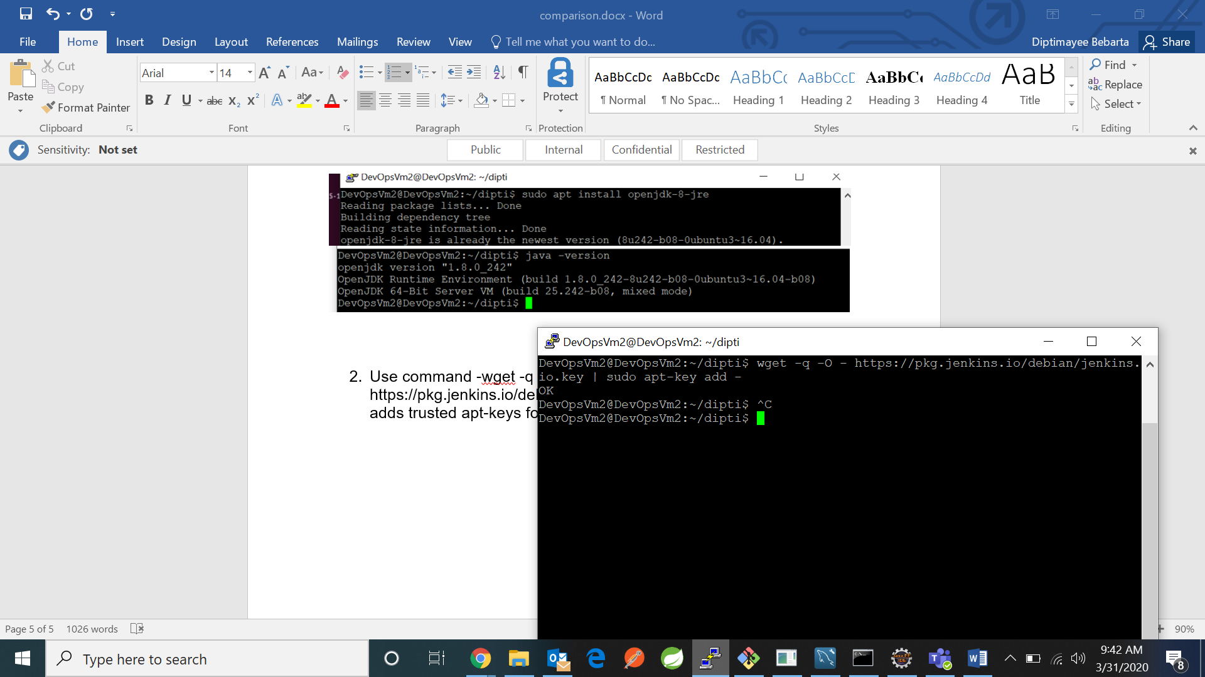

Now type command sudo nano “cd /etc/apt/sources.list”

And in that file add “deb [https://pkg.jenkins.io/debian binary/](https://pkg.jenkins.io/debian%20binary/)”

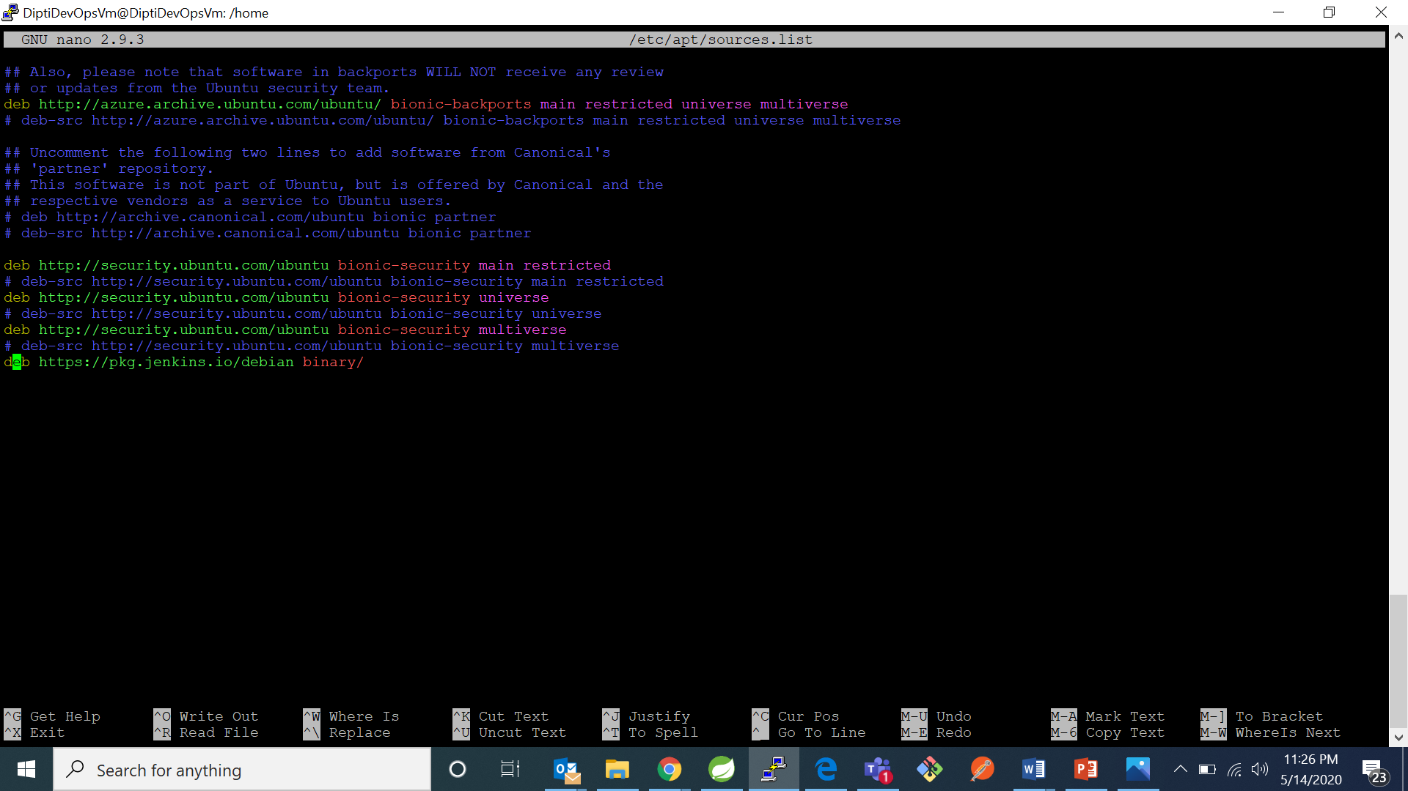

Now save the file

1. Use command – sudo apt-get update : used to download package information from all configured sources.

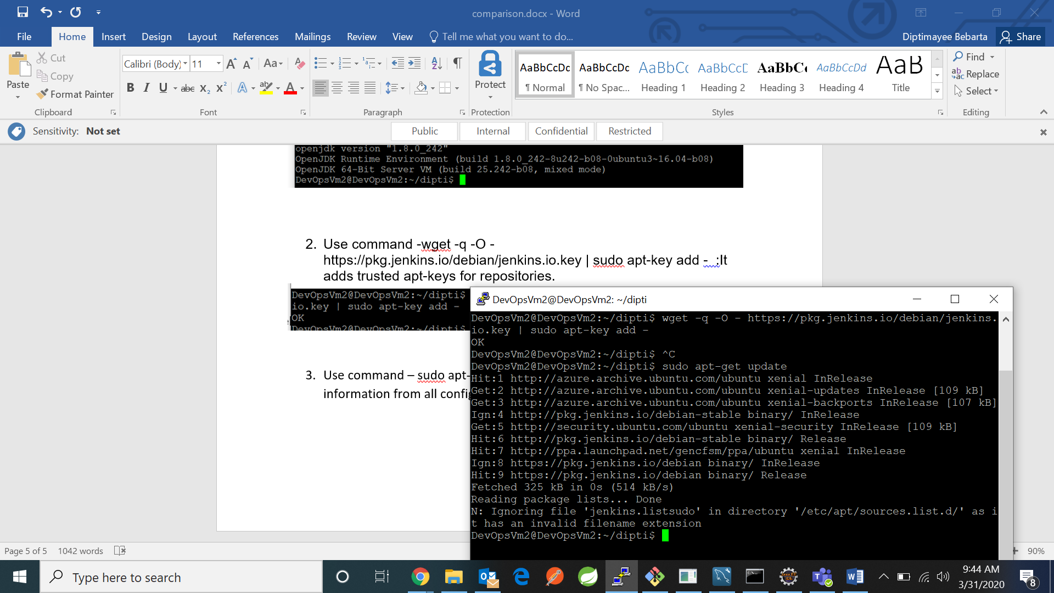

1. Use command: sudo apt-get install Jenkins-downloads the jenkins

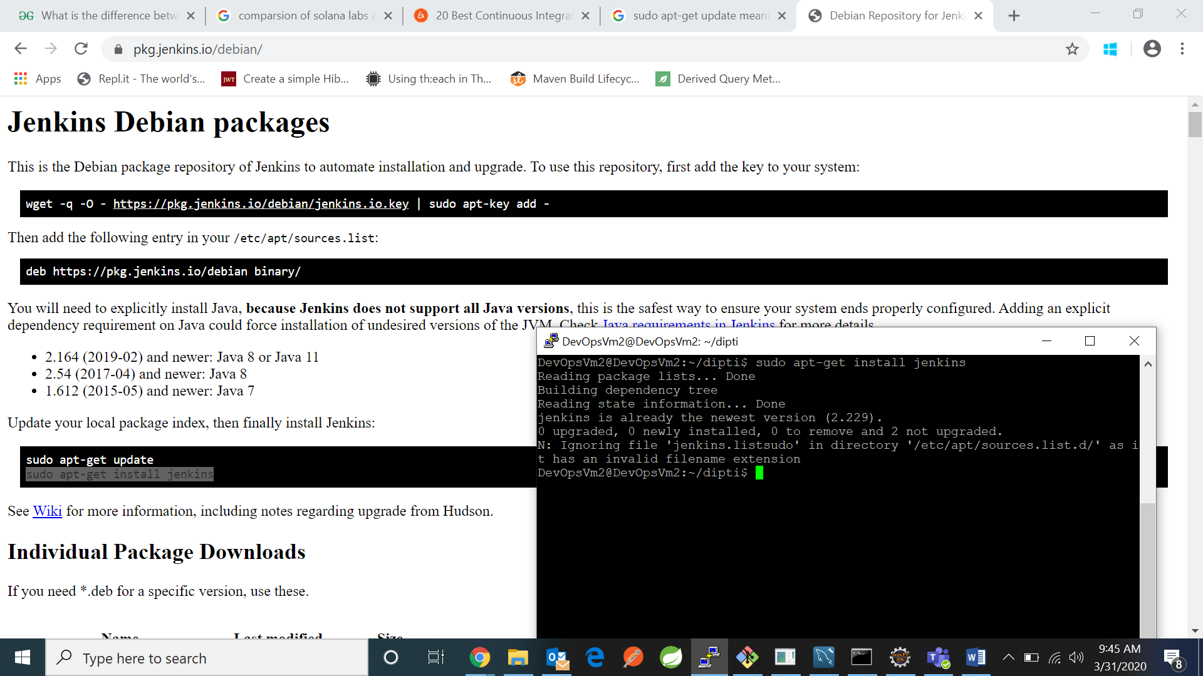

1. Use sudo cat lib address to view the password and then register and login