**Build a pipeline project and deploy on Tomcat Assignment**

1. First Create a Dynamic Web Project
2. First go to eclipse and click on New -> Maven Project

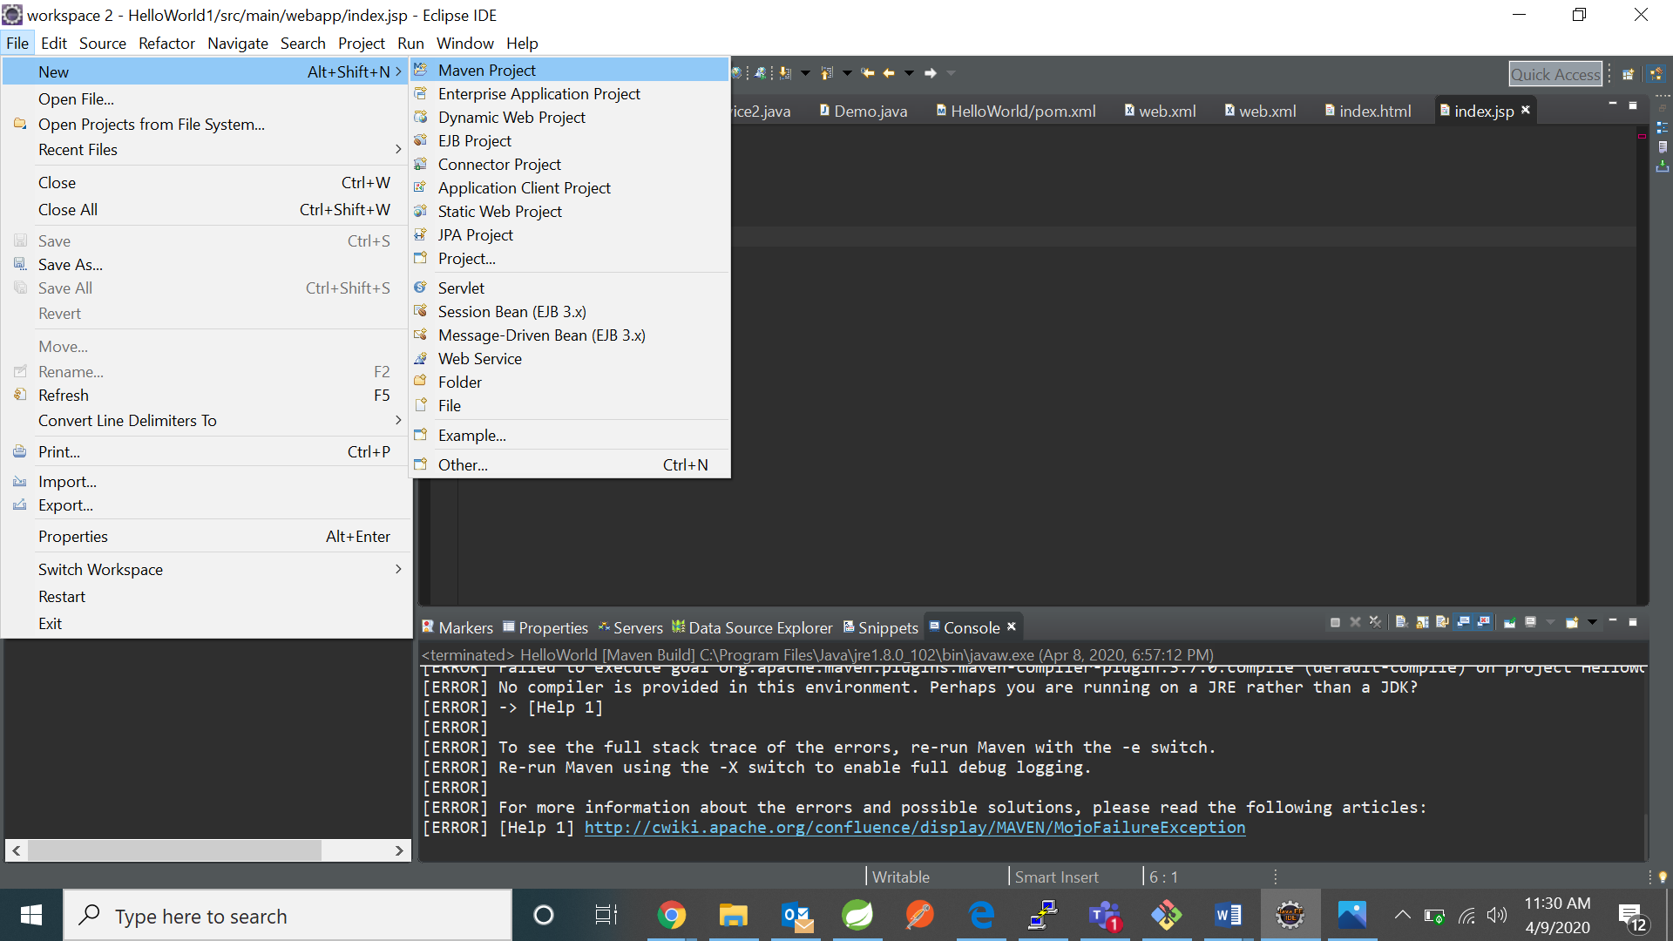

1. Click on next

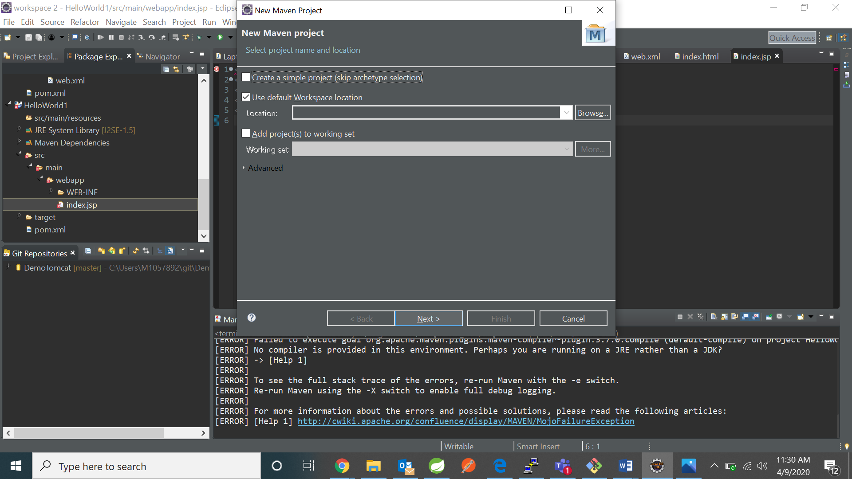

1. Click on maven –archetype-webapp and click next

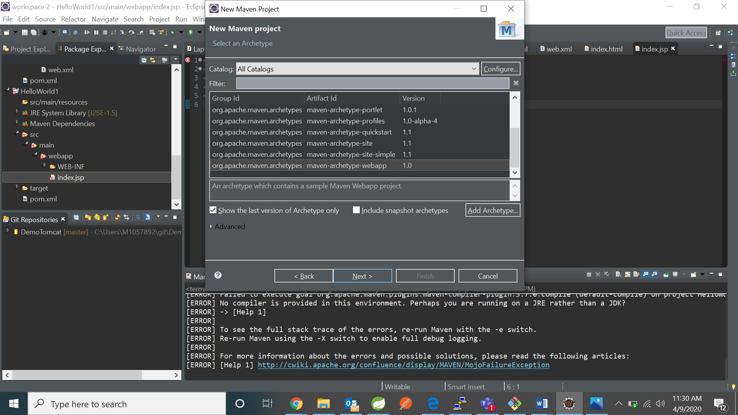

1. Fill the groupid and artifact id

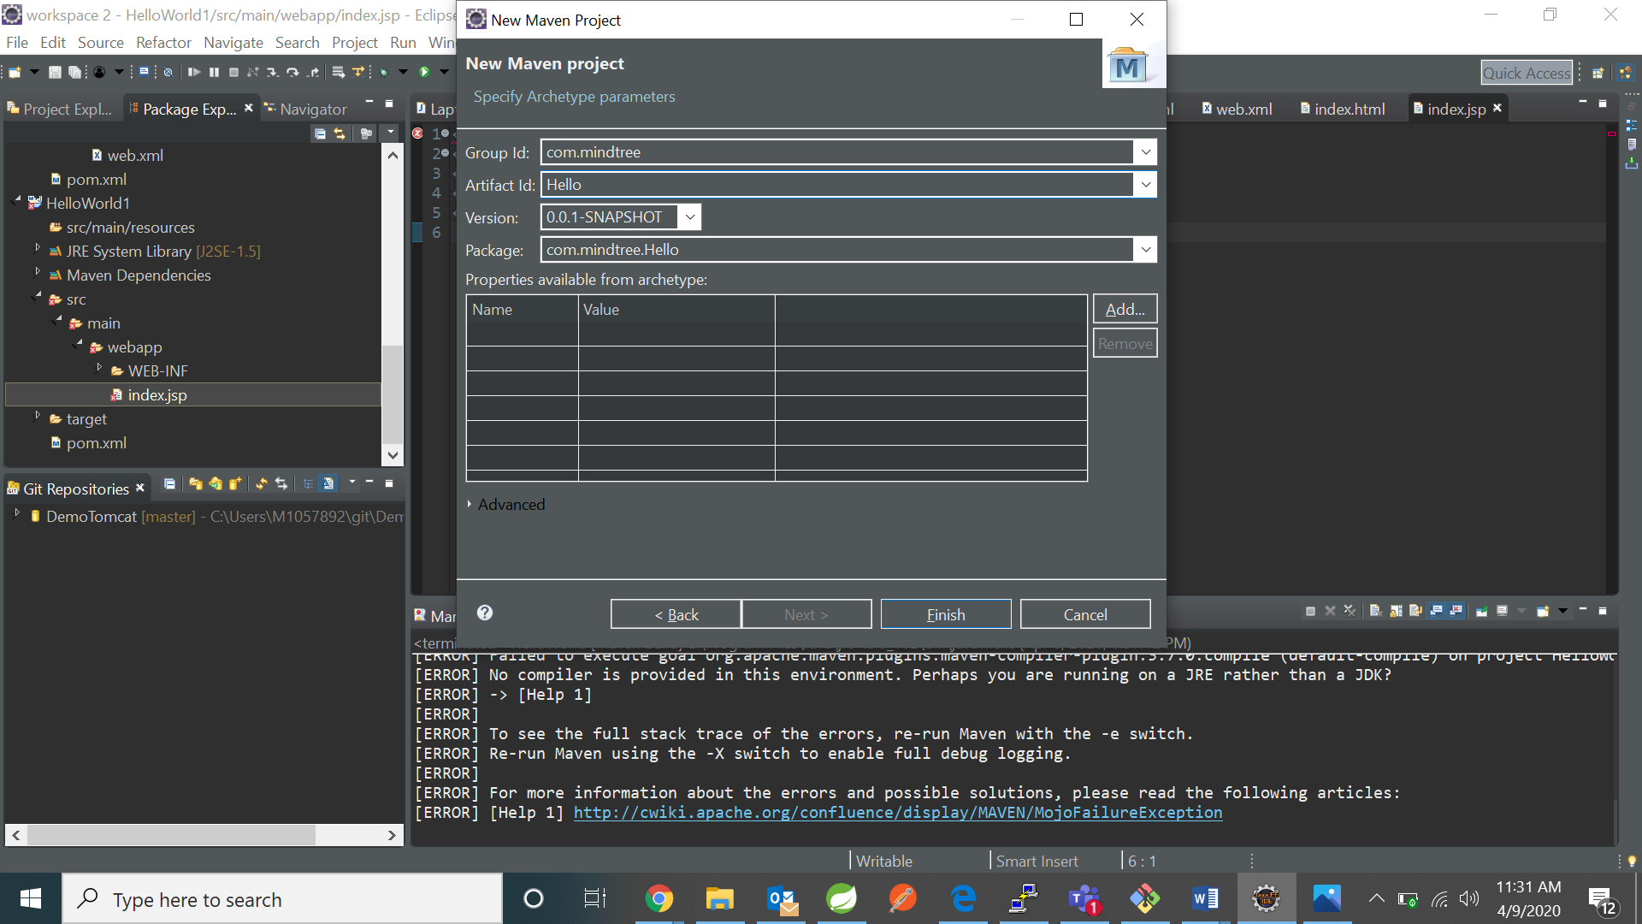

1. Push to github

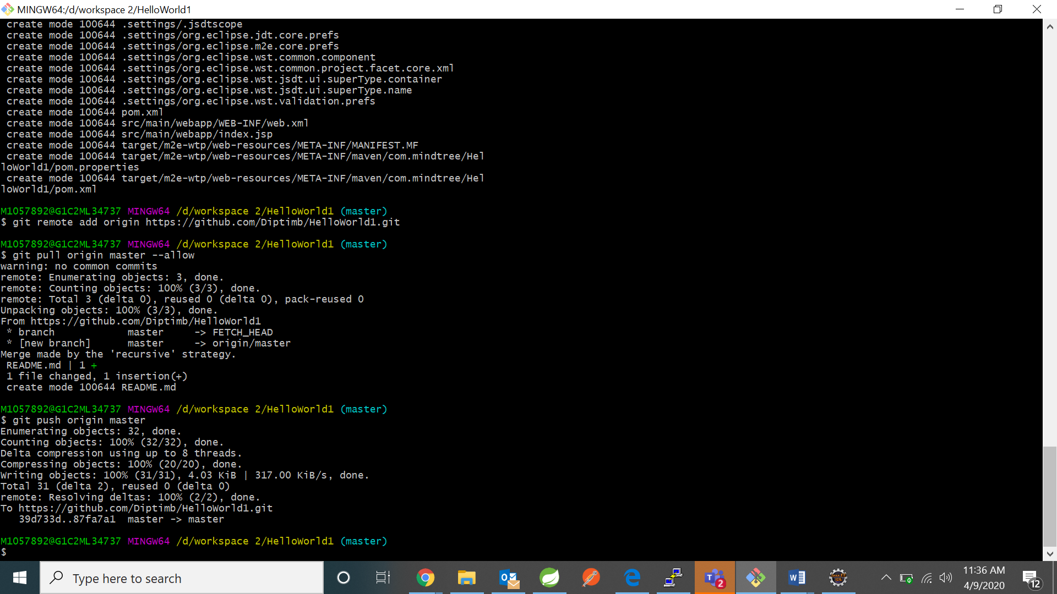

1. Use Jenkins to build and deploy on tomcat
2. Click one new item

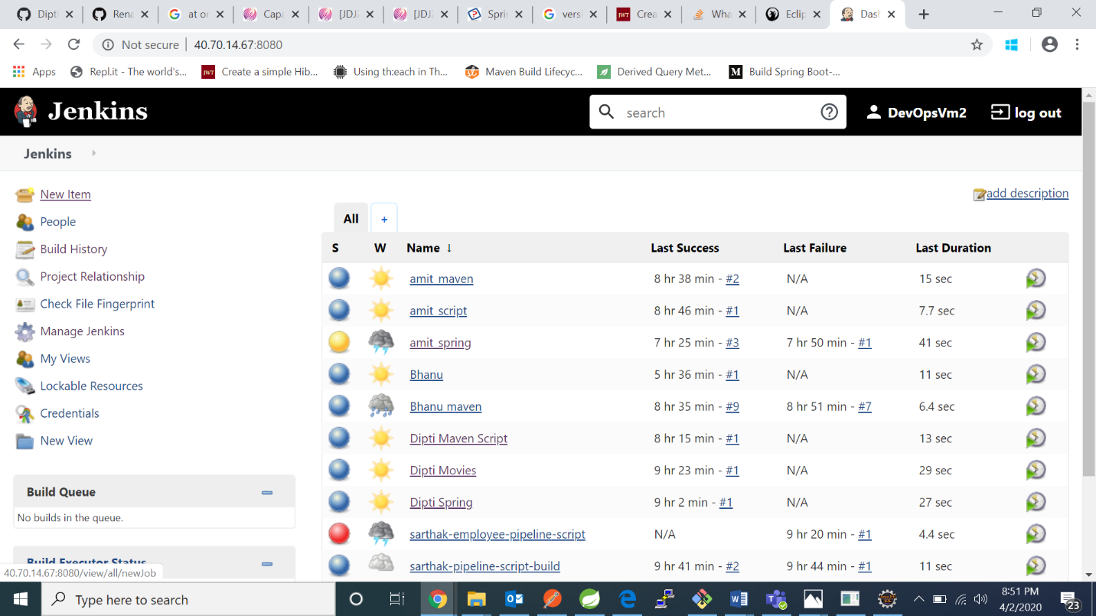

1. Fill the project name and click on pipeline

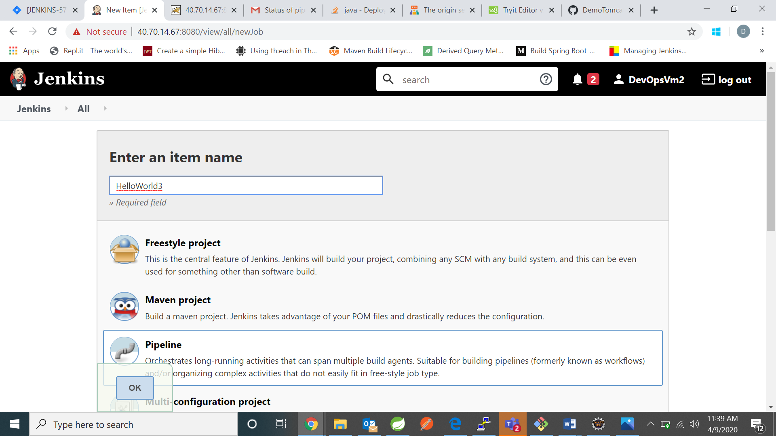

1. Go to pipeline and save

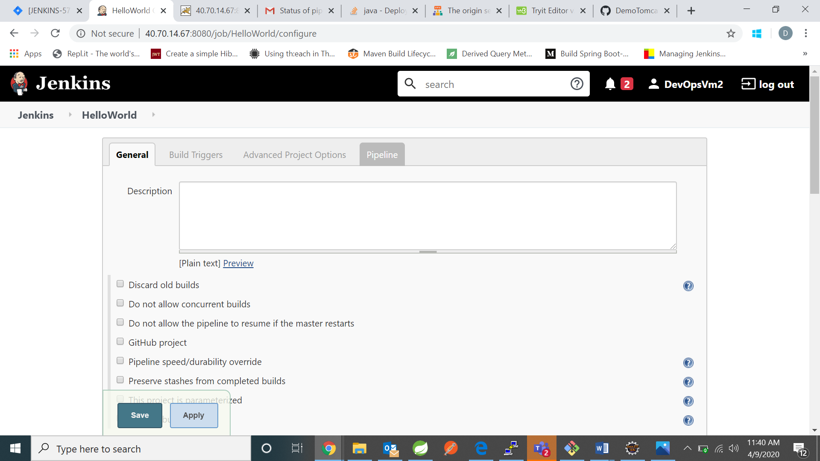

1. Now write down the declarative pipeline as follows and then click save:

pipeline{

agent any

stages{

stage('Source'){

steps{ git 'https://github.com/Diptimb/DemoTomcat1.git'}

}

stage('Compile package'){

tools {

maven 'Maven 3'

}

steps{

sh 'mvn clean package'

}

}

stage('Deploy'){

steps{

sh "cp /var/lib/jenkins/workspace/HelloWorld/target/*.war /opt/tomcat/webapps/"}

}

}

post{ always {

mail to: 'deepubebarta@gmail.com',

subject: "Status of pipeline: ${currentBuild.fullDisplayName}",

body: "${env.BUILD_URL} has result ${currentBuild.result}"

}}

}

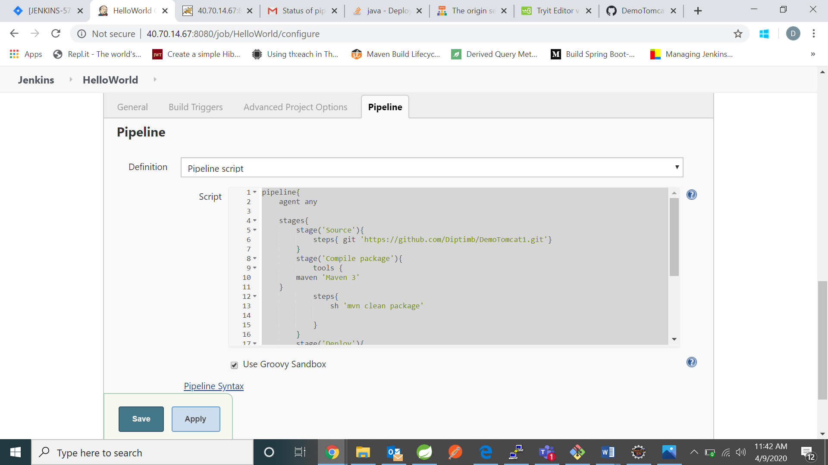

1. Before building install “Deploy Weblogic Plugin” from Manage Jenkins -> Plugins Manager -> Install

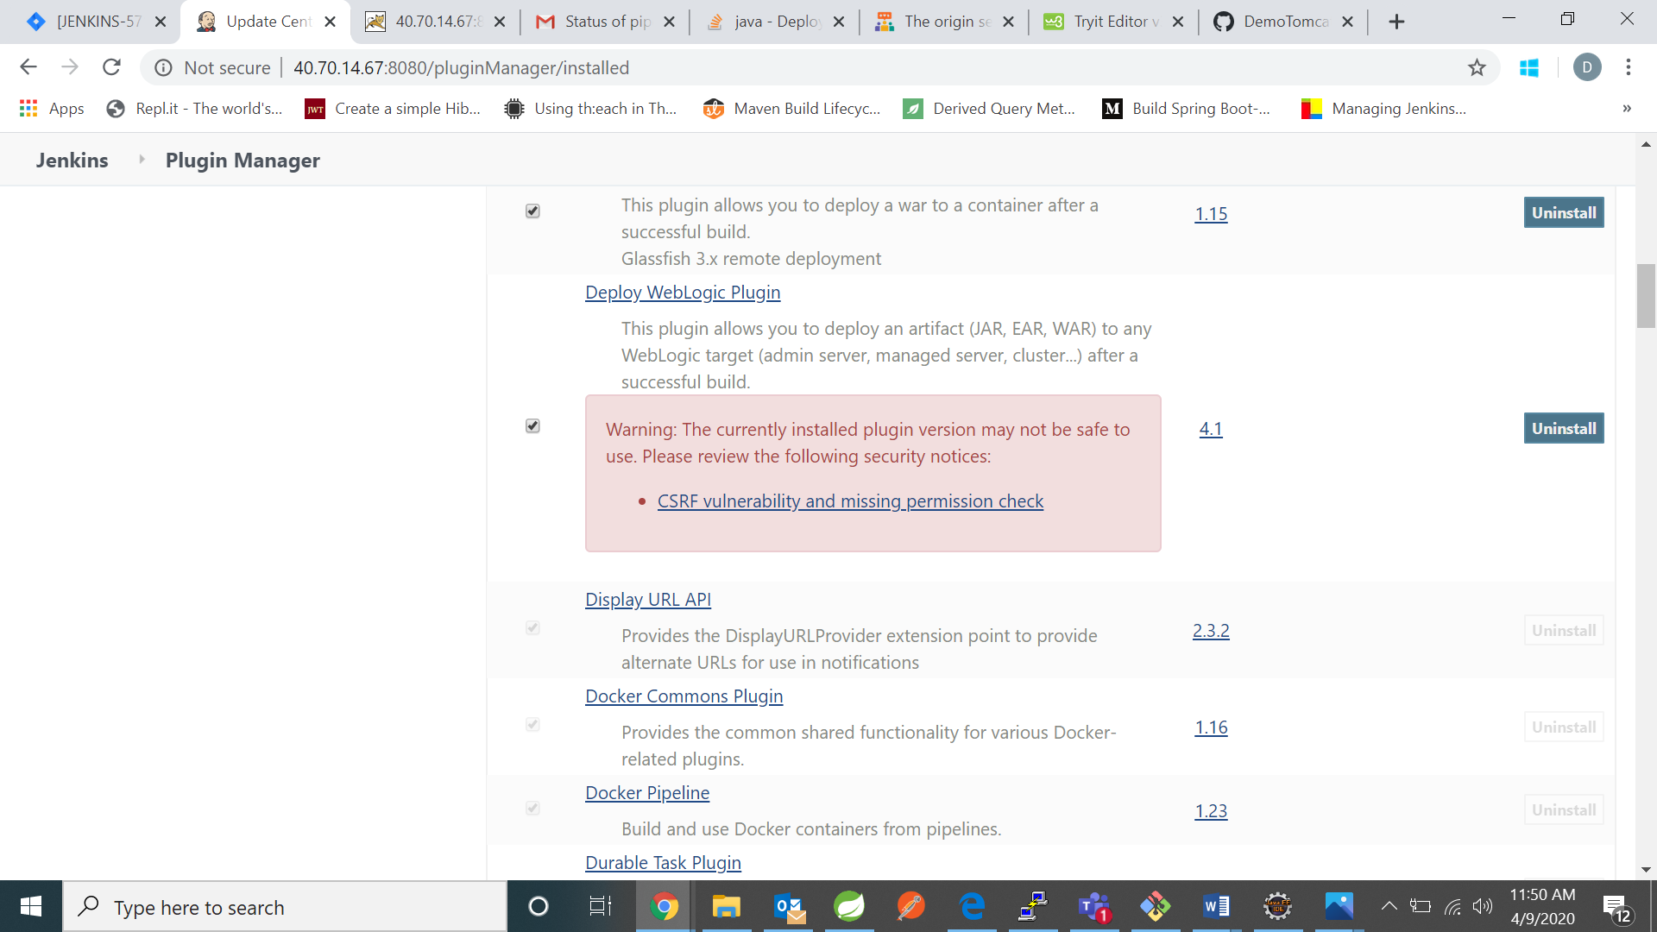

1. Now click on build now.

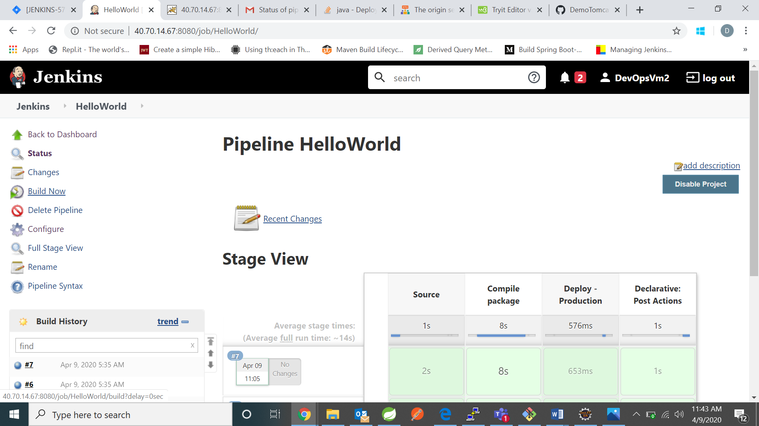

1. After your build and deploy is successful open tomcat server with your project name

