

**Mesh Networking with NodeMCU ESP8266 and painless Mesh**

**Course Title:** Internet of Things

**Course Code:** CSE 406

**Section:** 01

**Submitted by**

**Name:** Mahir Faysal Haque Dipto

**ID:** 2022-2-60-044

**Date:** 11/08/2025

**Submitted to**

**Dr. Raihan Ul Islam (DRUI)**

Associate Professor, Department of Computer Science and Engineering East West University

**Other Group Members**

|  |  |
| --- | --- |
| Jobayer Faisal Fahim | 2022-2-60-130 |
| Shafiqul Islam Fahim | 2022-2-60-085 |
| Akash Saha | 2022-2-60-081 |

# Introduction

This lab explores the concept of mesh networking in IoT systems using NodeMCU ESP8266 microcontrollers and the painlessMesh library. A mesh network enables nodes to communicate directly or via intermediate nodes without requiring a central router. This architecture improves network resilience, supports self-healing, and extends communication range through multi-hop routing.

The main objective is to implement and understand broadcasting, direct messaging, and multi-hop routing using painlessMesh, along with interpreting network event callbacks.

Required Materials

Hardware:

* 3 × NodeMCU ESP8266 boards
* Micro-USB cable

Software:

* Arduino IDE
* *painlessMesh* library (via Library Manager)

* ESPAsyncTCP library (dependency for painlessMesh)

## Tools

* **Serial Monitor**: Used for observing node behavior and messages exchanged between nodes during the experiment.

# Tasks and Implementation:

## Task 1: Message Interpretation

**Objective:** This task aimed to understand PainlessMesh's standard system messages and demonstrate broadcast operation to reveal the mesh network's internal behavior.

Message Types:

• **New Connection:** Triggered when a new node joins and connects directly.



• **Connection Change:** Indicates topology changes such as nodes joining or leaving.

• **Adjusted Time:** Synchronizes clocks across all nodes for coordinated actions.

## Task 2: **Direct Messaging**

**Objective:** Modify code to send a message to a single target node using mesh.sendSingle()

Output:

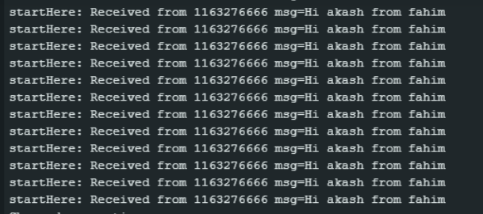

## Task 3: Multi-Hop Messaging

The purpose of multi-hop messaging is to let devices communicate even when they are too far apart for a direct connection.

In a mesh network, the message can “hop” through intermediate nodes (other devices) until it reaches the destination.  
This helps:

* **Extend range** — connect devices over longer distances.
* **Avoid dead zones** — use alternate paths if direct links are blocked.
* **Improve reliability** — if one path fails, the message can take another route.

**Advantages of Mesh Topology**

* **Resilience:** No single point of failure.
* **Scalability:** New nodes can be added without affecting others.
* **Extended Range:** Messages can hop between intermediate nodes.
* **Dynamic Routing:** Automatic path adjustment based on signal conditions.

**Potential Applications**

* Smart home automation
* Distributed sensor networks
* Disaster recovery communications
* Agricultural monitoring systems

**Conclusion**

This lab demonstrated the creation and modification of a mesh network using NodeMCU ESP8266 boards and painlessMesh. Broadcasting, direct messaging, and multi-hop routing were implemented and tested. The exercise provided insights into decentralized IoT communication, network self-healing, and adaptive routing mechanisms.