## **Name: Ahmed Md. Foyaz**

## **Id:17-35214-2**

## **Lab Report 10**

**ASk:**

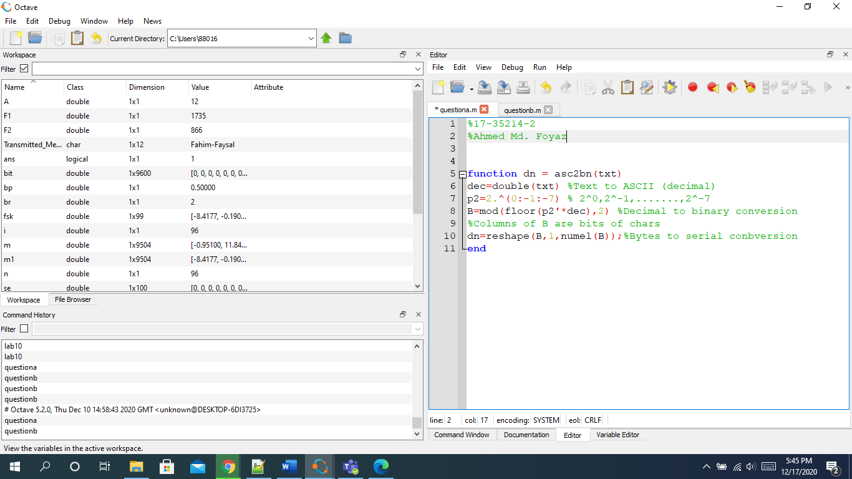

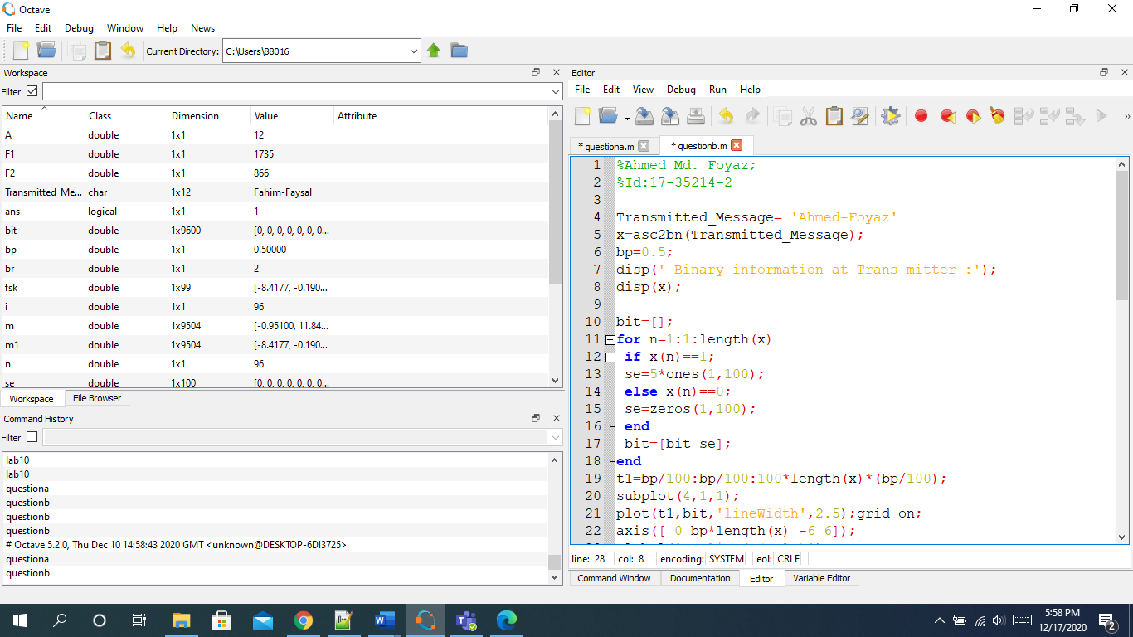

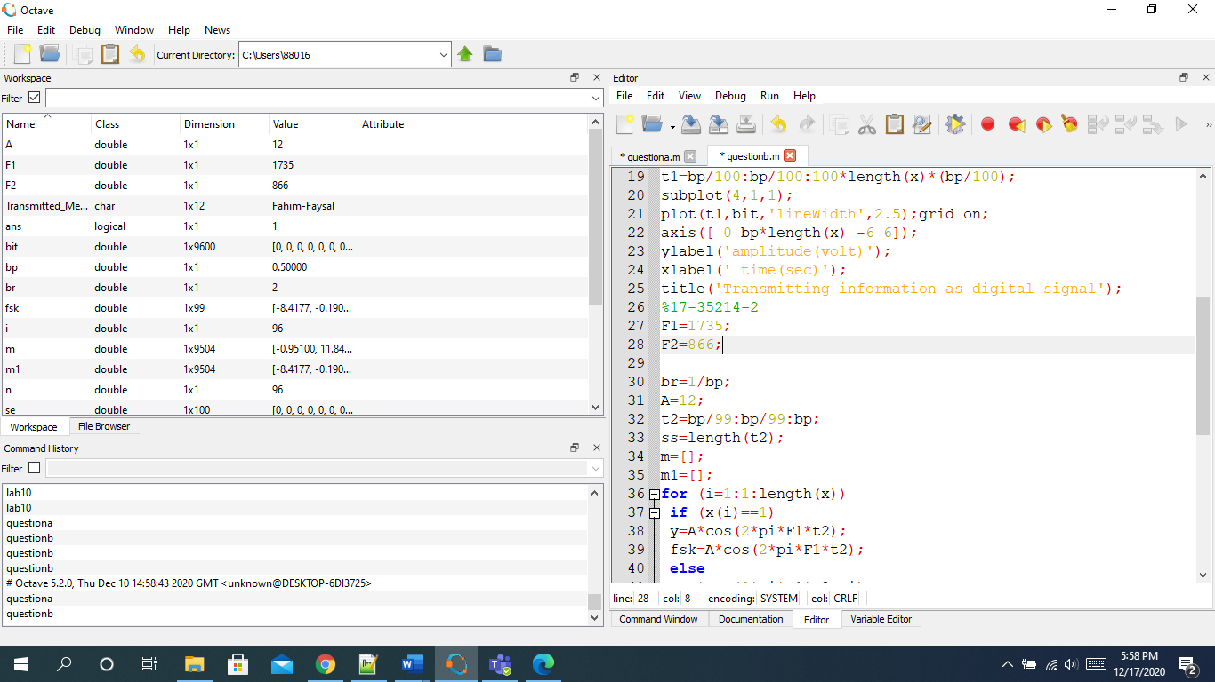

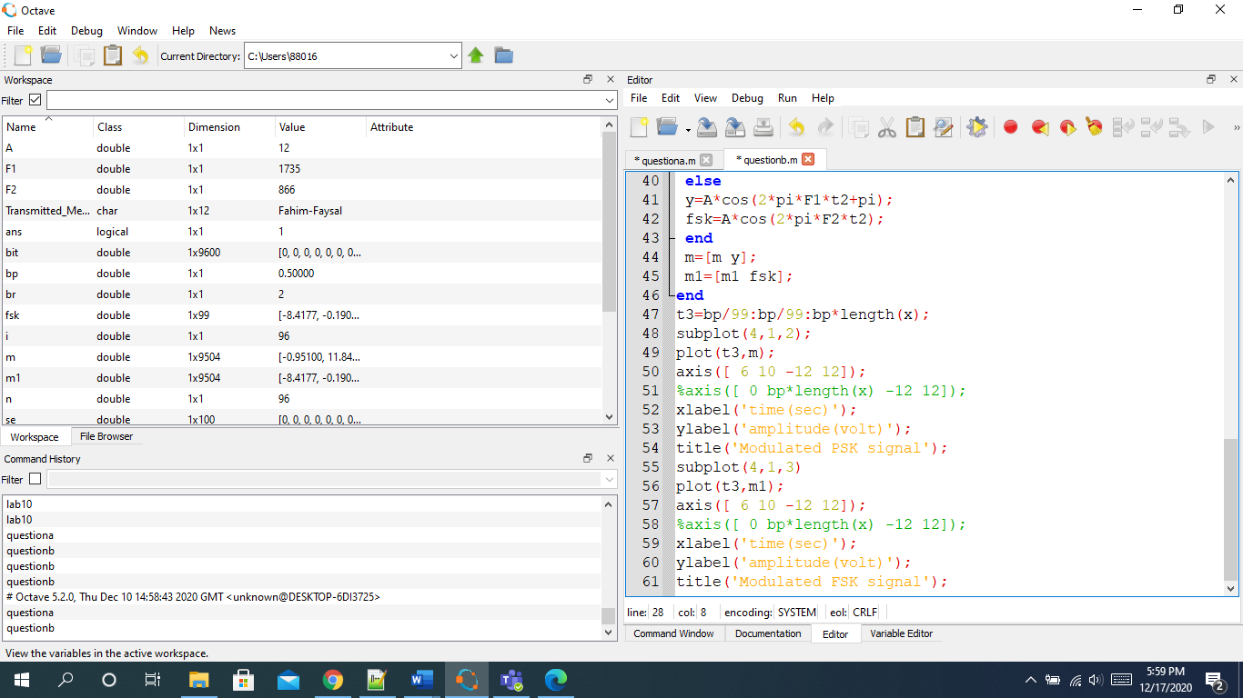

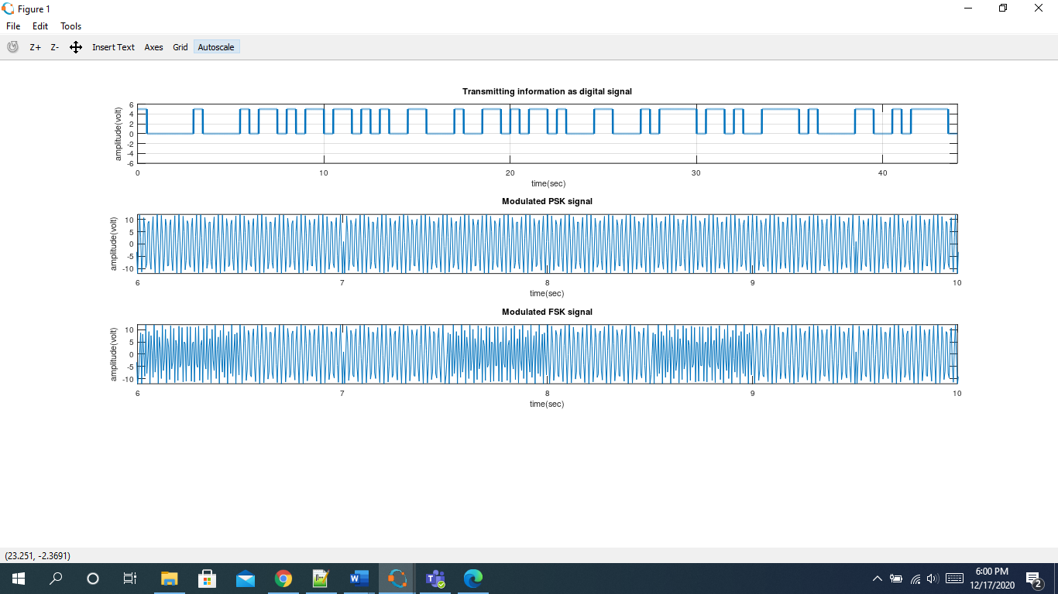

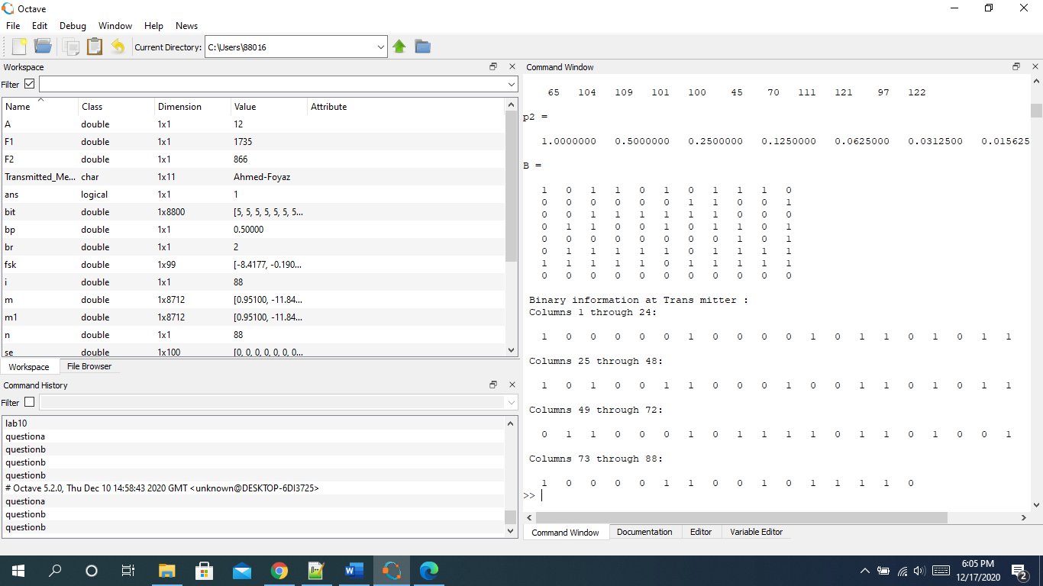

Psk:

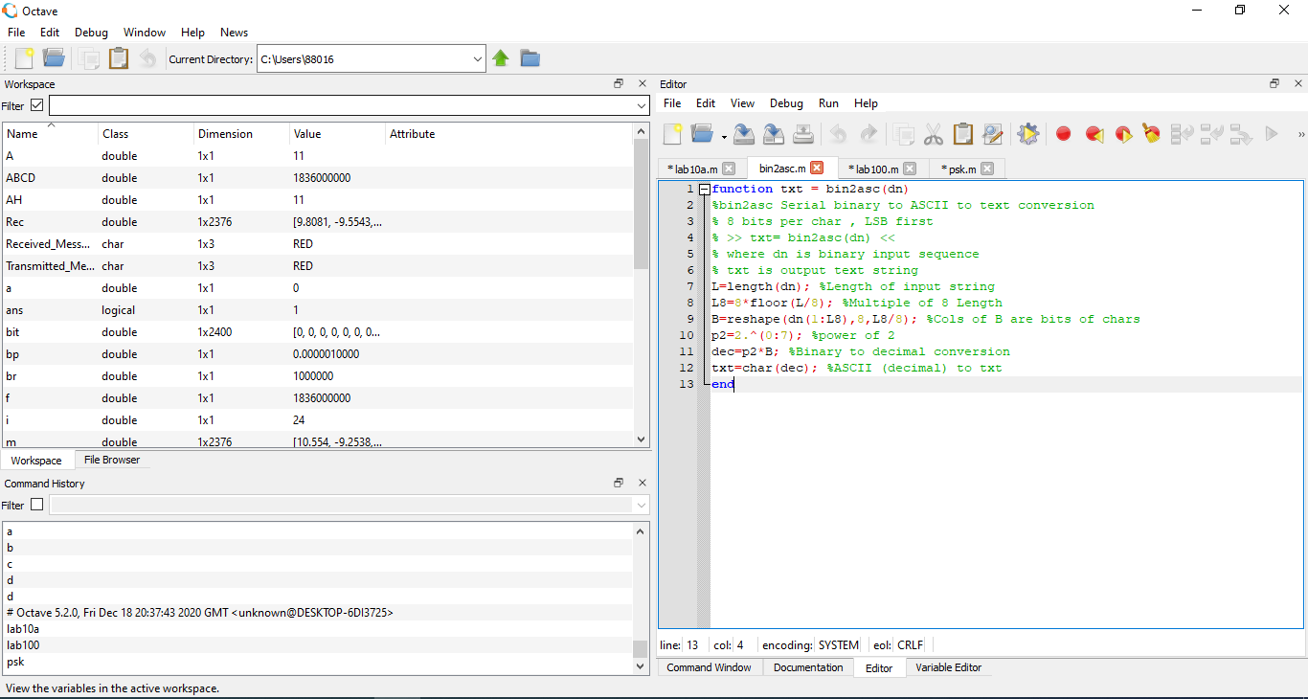

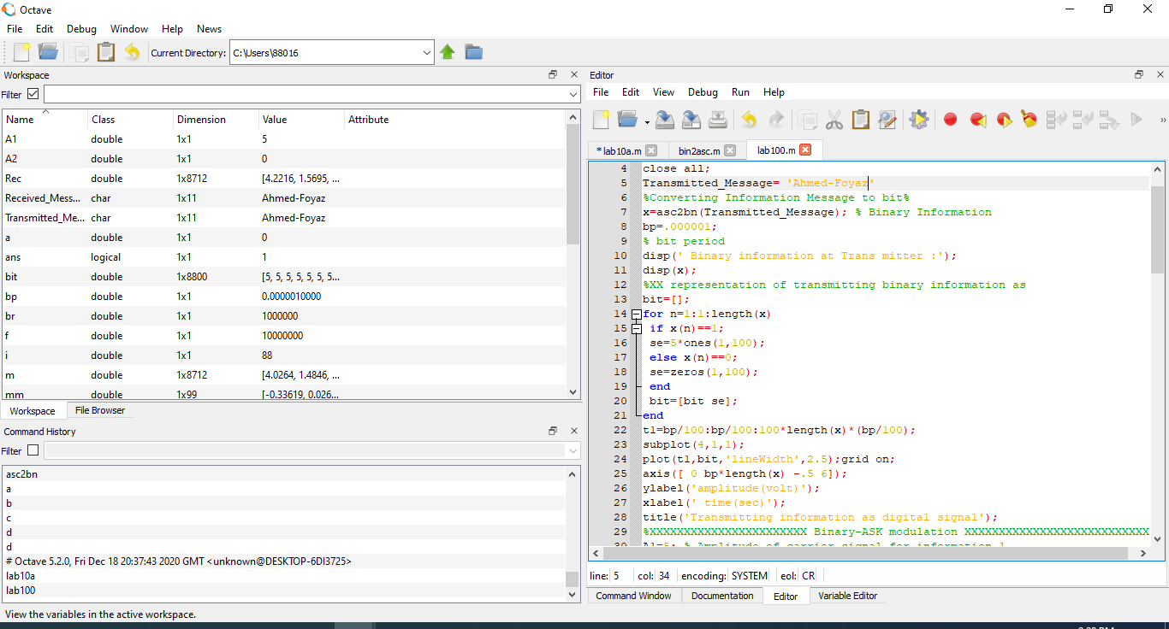

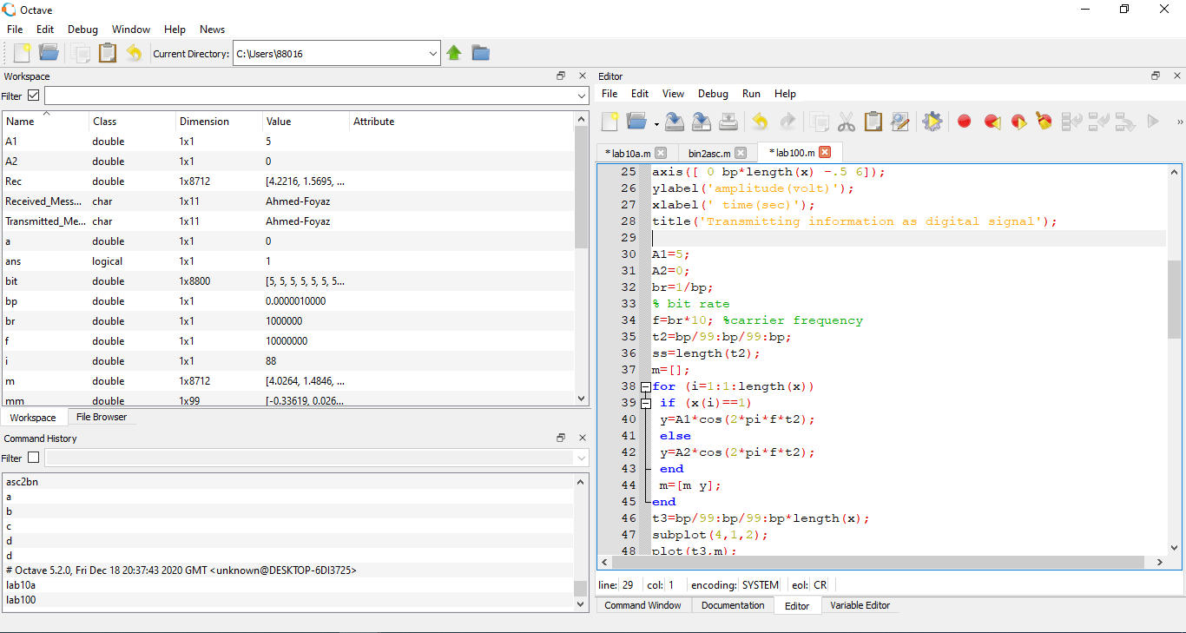

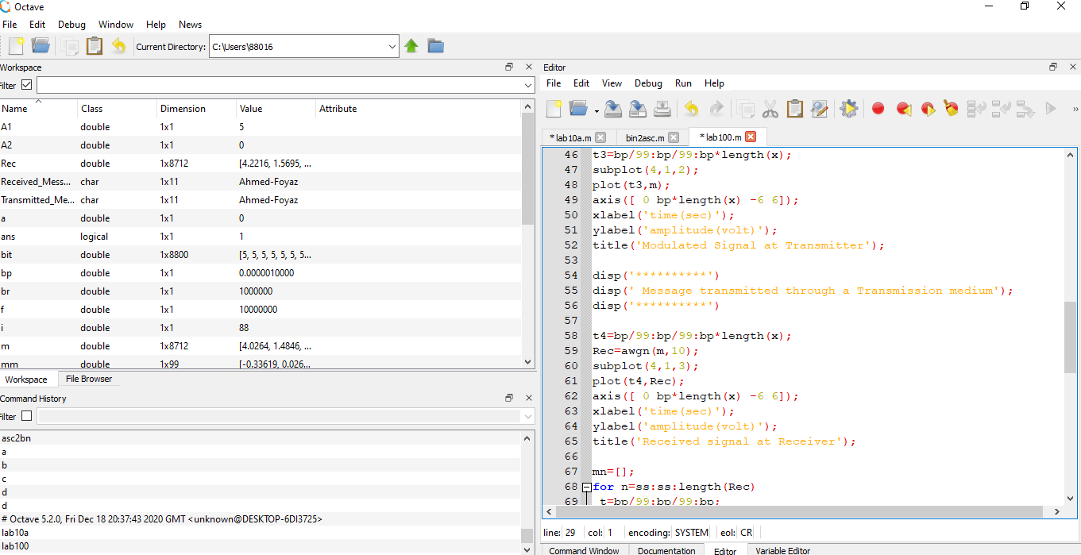

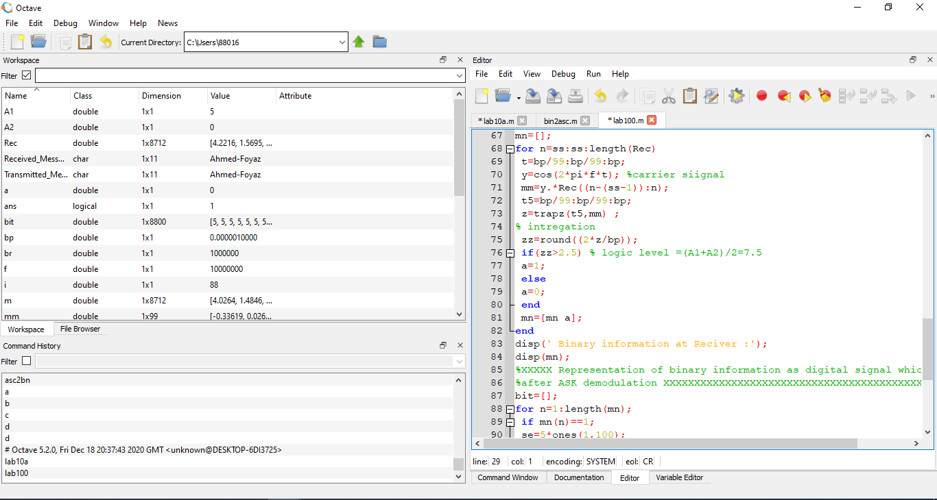

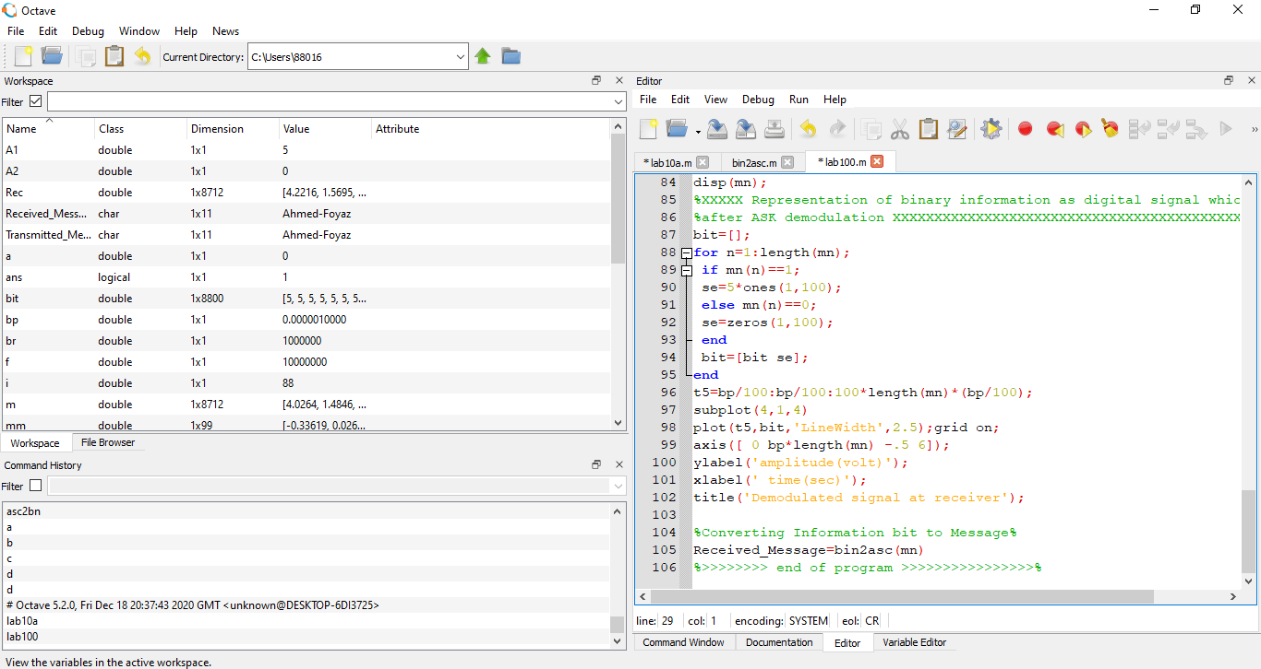

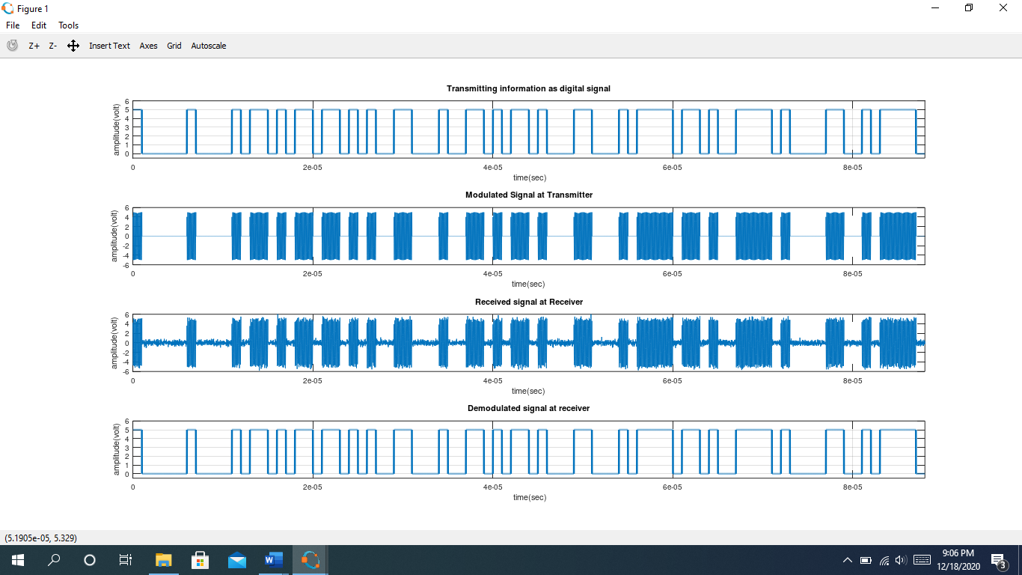

Source Code Done by Octave:

Function:

%17-35214-2

%Ahmed Md. Foyaz

function dn = asc2bn(txt)

dec=double(txt) %Text to ASCII (decimal)

p2=2.^(0:-1:-7) % 2^0,2^-1,.......,2^-7

B=mod(floor(p2'*dec),2) %Decimal to binary conversion

%Columns of B are bits of chars

dn=reshape(B,1,numel(B));%Bytes to serial conbversion

end

Rest code:

%Ahmed Md. Foyaz;

%Id:17-35214-2

Transmitted_Message= 'Ahmed-Foyaz'

x=asc2bn(Transmitted_Message);

bp=0.5;

disp(' Binary information at Trans mitter :');

disp(x);

bit=[];

for n=1:1:length(x)

if x(n)==1;

se=5*ones(1,100);

else x(n)==0;

se=zeros(1,100);

end

bit=[bit se];

end

t1=bp/100:bp/100:100*length(x)*(bp/100);

subplot(4,1,1);

plot(t1,bit,'lineWidth',2.5);grid on;

axis([ 0 bp*length(x) -6 6]);

ylabel('amplitude(volt)');

xlabel(' time(sec)');

title('Transmitting information as digital signal');

%17-35214-2

F1=1735;

F2=866;

br=1/bp;

A=12;

t2=bp/99:bp/99:bp;

ss=length(t2);

m=[];

m1=[];

for (i=1:1:length(x))

if (x(i)==1)

y=A*cos(2*pi*F1*t2);

fsk=A*cos(2*pi*F1*t2);

else

y=A*cos(2*pi*F1*t2+pi);

fsk=A*cos(2*pi*F2*t2);

end

m=[m y];

m1=[m1 fsk];

end

t3=bp/99:bp/99:bp*length(x);

subplot(4,1,2);

plot(t3,m);

axis([ 6 10 -12 12]);

%axis([ 0 bp*length(x) -12 12]);

xlabel('time(sec)');

ylabel('amplitude(volt)');

title('Modulated PSK signal');

subplot(4,1,3)

plot(t3,m1);

axis([ 6 10 -12 12]);

%axis([ 0 bp*length(x) -12 12]);

xlabel('time(sec)');

ylabel('amplitude(volt)');

title('Modulated FSK signal');

Function:

%Ahmed Md. Foyaz;

%Id:17-35214-2

function txt = bin2asc(dn)

%bin2asc Serial binary to ASCII to text conversion

% 8 bits per char , LSB first

% >> txt= bin2asc(dn) <<

% where dn is binary input sequence

% txt is output text string

L=length(dn); %Length of input string

L8=8*floor(L/8); %Multiple of 8 Length

B=reshape(dn(1:L8),8,L8/8); %Cols of B are bits of chars

p2=2.^(0:7); %power of 2

dec=p2*B; %Binary to decimal conversion

txt=char(dec); %ASCII (decimal) to txt

end

Rest code:

pkg load communications;clc;clear all;close all;Transmitted_Message= 'Ahmed-Foyaz'%Converting Information Message to bit%x=asc2bn(Transmitted_Message); % Binary Informationbp=.000001;% bit perioddisp(' Binary information at Trans mitter :');disp(x);%XX representation of transmitting binary information asbit=[];for n=1:1:length(x) if x(n)==1; se=5*ones(1,100); else x(n)==0; se=zeros(1,100); end bit=[bit se];endt1=bp/100:bp/100:100*length(x)*(bp/100);subplot(4,1,1);plot(t1,bit,'lineWidth',2.5);grid on;axis([ 0 bp*length(x) -.5 6]);ylabel('amplitude(volt)');xlabel(' time(sec)');title('Transmitting information as digital signal');A1=5; A2=0; br=1/bp;% bit ratef=br*10; %carrier frequencyt2=bp/99:bp/99:bp;ss=length(t2);m=[];for (i=1:1:length(x)) if (x(i)==1) y=A1*cos(2*pi*f*t2); else y=A2*cos(2*pi*f*t2); end m=[m y];endt3=bp/99:bp/99:bp*length(x);subplot(4,1,2);plot(t3,m);axis([ 0 bp*length(x) -6 6]);xlabel('time(sec)');ylabel('amplitude(volt)');title('Modulated Signal at Transmitter');disp('**********')disp(' Message transmitted through a Transmission medium');disp('**********')t4=bp/99:bp/99:bp*length(x);Rec=awgn(m,10);subplot(4,1,3);plot(t4,Rec);axis([ 0 bp*length(x) -6 6]);xlabel('time(sec)');ylabel('amplitude(volt)');title('Received signal at Receiver');mn=[];for n=ss:ss:length(Rec) t=bp/99:bp/99:bp; y=cos(2*pi*f*t); %carrier siignal mm=y.*Rec((n-(ss-1)):n); t5=bp/99:bp/99:bp; z=trapz(t5,mm) ;% intregation zz=round((2*z/bp)); if(zz>2.5) % logic level =(A1+A2)/2=7.5 a=1; else a=0; end mn=[mn a];enddisp(' Binary information at Reciver :');disp(mn);%XXXXX Representation of binary information as digital signal which achived%after ASK demodulation XXXXXXXXXXXXXXXXXXXXXXXXXXXXXXXXXXXXXXXXXXXXXXXXXXXbit=[];for n=1:length(mn); if mn(n)==1; se=5*ones(1,100); else mn(n)==0; se=zeros(1,100); end bit=[bit se];endt5=bp/100:bp/100:100*length(mn)*(bp/100);subplot(4,1,4)plot(t5,bit,'LineWidth',2.5);grid on;axis([ 0 bp*length(mn) -.5 6]);ylabel('amplitude(volt)');xlabel(' time(sec)');title('Demodulated signal at receiver');%Converting Information bit to Message%Received_Message=bin2asc(mn)%>>>>>>>> end of program >>>>>>>>>>>>>>>>%