MA5851 — Assessment 3
WebCrawler and NLP System
Sentiment Analysis of Daraz Product Reviews Using Deep Learning
James Cook University | Data Science Master Class 1 | April 2026

Task 1: Overview

1.1 The Issue
E-commerce platforms such as Daraz — one of the largest online marketplaces across South Asia, operating in Pakistan, Bangladesh, and Sri Lanka — host millions of publicly accessible customer product reviews. These reviews contain rich, unstructured natural language data reflecting authentic consumer sentiment, purchasing satisfaction, and product quality perceptions. The core issue is that manually reading, labelling, and interpreting this volume of text at scale is operationally infeasible for sellers, platform administrators, and market researchers.

The specific NLP task addressed by this project is binary sentiment classification: automatically assigning a positive (1) or negative (0) polarity label to each Daraz product review. This enables scalable, cost-effective monitoring of consumer satisfaction at a granularity impossible through manual review. Customer sentiment expressed in reviews is a critical business intelligence asset: positive sentiment signals product acceptance and brand loyalty, while negative sentiment can indicate defects, poor delivery, or unmet expectations that warrant seller intervention.

1.2 Where the Issue Exists on the World Wide Web
This issue is directly observable at https://www.daraz.pk/, where customer reviews are publicly accessible on product detail pages across all categories. Review data — including content, author pseudonym, star rating, and timestamp — is embedded in product pages and additionally accessible via an internal REST API endpoint (https://my.daraz.pk/pdp/review/getReviewList), which returns structured JSON review objects per product ID without authentication.

Beyond Daraz, the same challenge extends to every major e-commerce and review platform globally: Amazon, Lazada, Flipkart, Alibaba, and Trustpilot all face the challenge of extracting structured sentiment from user-generated text. The domain investigated here could be expanded along three axes: (1) cross-platform analysis comparing sentiment across Daraz and Amazon for the same product categories; (2) cross-national comparison across Daraz’s regional domains (daraz.pk, daraz.com.bd, daraz.lk); and (3) temporal sentiment monitoring, tracking how sentiment shifts in response to platform policy changes, seasonal events, or supply chain disruptions.

1.3 Machine Learning Solution
Machine learning — specifically deep learning with feedforward neural networks — provides an effective automated solution for binary sentiment classification. Pang, Lee, and Vaithyanathan (2002) established in a foundational study that supervised machine learning approaches substantially outperform hand-crafted rule-based systems for sentiment polarity detection, with Support Vector Machines and Naive Bayes classifiers achieving over 80% accuracy on movie review data. Subsequent work by Kim (2014) demonstrated that even architecturally simple neural networks achieve strong classification performance on short review texts when applied to learned text representations. For the specific task of learning from Bag-of-Words (BoW) features, feedforward dense neural networks map high-dimensional sparse vectors to a binary probability via a sigmoid activation function. Zhang, Zhao, and LeCun (2015) confirmed neural network superiority on product review classification benchmarks directly analogous to the present Daraz task, achieving accuracy exceeding 90% on Amazon review corpora. Unlike rule-based systems such as VADER, which rely on pre-compiled sentiment lexicons and cannot adapt to domain-specific vocabulary, a trained neural network learns task-specific decision boundaries from labelled examples, making it more robust to informal language, code-switching, and domain-specific terminology common in South Asian e-commerce reviews.

Task 2: WebCrawler

2.1 Websites Consumed
The primary website consumed is https://www.daraz.pk/, targeting the Men’s Fashion product category. Two distinct URL structures were accessed:
- Product listing pages: https://www.daraz.pk/mens-fashion/?ajax=true&page=N — paginated JSON responses listing product metadata including product IDs (nid field). Pagination increments by 40 products per page.
- Review API endpoint: https://my.daraz.pk/pdp/review/getReviewList?itemId={id}&pageSize=1000 — returns structured JSON review objects per product including reviewContent, reviewTime, and reviewer metadata.

Approximately 6,760 raw reviews were harvested from Men’s Fashion subcategories prior to cleaning. The domain selection could be extended to other Daraz categories (electronics, health, food) to construct a multi-domain sentiment corpus, significantly improving model generalisability across product types.

2.2 Copyright and Legal Considerations
Daraz does not publish an explicit developer API terms of service for its review endpoint; however, the review data satisfies all three permitted scraping criteria outlined in the assessment guidelines: (1) it is publicly available data requiring no authentication or payment; (2) Daraz is an e-commerce platform that implicitly accepts that review data is used by media intelligence and monitoring services; and (3) the data primarily consists of user-generated factual opinions.

Under established common law and statutory frameworks, individual factual opinions are not protectable subject matter under copyright. This principle is affirmed in Feist Publications, Inc. v. Rural Telephone Service Co., 499 U.S. 340 (1991), which established that facts and compilations of facts lacking originality are not copyrightable, and in IceTV Pty Ltd v Nine Network Australia Pty Ltd [2009] HCA 14 (Australia), which confirmed that factual information structured by external reality does not attract copyright. Furthermore, under the Privacy Act 1988 (Cth) (Australia) and Pakistan’s Personal Data Protection Act 2023, reviewer pseudonymous usernames were discarded post-collection and only review text and timestamps were retained, ensuring compliance with data minimisation principles (APP 3). Rate limiting was applied between API calls to avoid constituting a denial-of-service load on Daraz’s servers, consistent with ethical web scraping practice (Krotov & Silva, 2018).

2.3 WebCrawler Technology: Comparison and Justification
Three principal Python web scraping frameworks were evaluated. Table 1 presents a structured comparison against the requirements of this project:

Framework | Rendering | Speed | JS Support | Best For | Assessment Decision
requests + BeautifulSoup | Static HTML | Fast | No | REST APIs, static pages | SELECTED: Review data served via JSON API; no JS rendering required. Minimal overhead and no CloudFlare exposure.
Selenium | Full browser (Chrome/Firefox) | Slow | Yes | Dynamic JS-rendered pages | NOT REQUIRED: JS rendering unnecessary. High resource overhead; headless browsers are detectable by CloudFlare anti-scraping measures.
Scrapy | Static HTML (async) | Very fast | No | Large-scale multi-domain crawls | OVERKILL: Asynchronous crawl pipeline adds architectural complexity without performance benefit at this single-domain, ~5,000-document prototype scale.

Table 1: Comparison of Python web scraping frameworks against project requirements.
The requests/BeautifulSoup combination was selected because Daraz exposes review data through a well-structured REST API returning JSON — a pattern that does not require a headless browser (Mitchell, 2018). Selenium, while capable of handling dynamic JavaScript rendering, introduces significant overhead through full browser instantiation and is detectable by anti-bot technologies such as CloudFlare, risking IP blocking during extended scraping sessions. Scrapy provides high performance through asynchronous request pipelines (Scrapy, 2023), but this benefit is irrelevant at the prototype’s scale and the added complexity of configuring Scrapy’s Item Pipelines, Middlewares, and Spider architecture is unwarranted for a single-domain, single-category crawl.

2.4 WebCrawler Methodology and Sequencing
The crawler operates across three sequential stages addressing a hierarchical URL structure:
- Stage 1 — Category Discovery: The Daraz homepage is fetched and parsed using BeautifulSoup CSS selectors (.lzd-site-menu-root-item) to extract main category and subcategory names and URLs from the navigation menu. A user-selects the target category interactively.
- Stage 2 — Product Enumeration: For the selected category (Men’s Fashion), the crawler paginates through product listing pages in increments of 40 by iterating ?ajax=true&page=N. Product IDs (nid field) are extracted from each JSON response. Already-scraped product IDs (identified by existence of data/{item_id}.json) are skipped, enabling restartable crawling.
- Stage 3 — Review Extraction: For each product ID, the review API is called with pageSize=1000 to retrieve all available reviews. Only English-language reviews (verified via pycld2 language detection) within the target date range (July 2020 – June 2021) are retained. Reviews with relative timestamps (‘4 weeks ago’) that cannot be parsed to an absolute date are excluded.

Key code extract illustrating the review filter and language detection logic:
review_url = get_review_url(item_id, 1, 1000)
review = requests.get(review_url).json()
if review['success']:
for item in review['model']['items']:
is_reliable, _, details = detect(item['reviewContent'])
if is_reliable and details[0][1] == 'en':
if start_date <= review_time <= end_date:
reviews_wanted.append(item)

2.5 Limitations of the WebCrawler and Harvested Data
The following limitations apply: (1) single-category coverage (Men’s Fashion) prevents cross-category generalisation; (2) English-only filtering excludes the dominant Urdu-language review population, introducing demographic sampling bias; (3) exclusion of relative-timestamp reviews introduces recency bias; (4) a single-year temporal window (July 2020 – June 2021) limits temporal representativeness; and (5) the 1,000-review API page size cap per product may result in incomplete collection for very high-volume products.

2.6 Data Storage Methodology
Raw reviews were initially saved as per-product JSON files on disk (data/{item_id}.json). These were consolidated into scraped_data_before_cleaning.csv, then processed into cleaned_data.csv and labeled_cleaned_data.csv for modelling. Flat-file CSV storage is appropriate for this prototype scale (~5,000 reviews). A production system would require a relational database (e.g., PostgreSQL with indexed columns on review_id, product_id, and label) to support concurrent access, update tracking, and scalable querying across millions of reviews.

Task 3: Data Wrangling

3.1 Cleaning and Normalisation Pipeline
The raw scraped corpus contained 6,760 reviews prior to cleaning. The following preprocessing steps were applied sequentially, with each step justified by its contribution to downstream model performance:
- Lowercasing: All text converted to lowercase to eliminate case-induced token duplication ('Good' ≡ 'good'), reducing spurious vocabulary size inflation.
- Punctuation Removal: All characters in Python’s string.punctuation removed. Prevents trailing commas, full stops, and exclamation marks from generating distinct tokens ('good!' ≠ 'good').
- Emoji Removal: Unicode emoji code points removed via regular expression. Critical for this corpus: emojis (😍, ❤️, 👍) appeared in over 60% of raw reviews and would have generated unintelligible BoW vocabulary entries with no sentiment signal.
- Stop Word Removal: Common English stop words removed using spaCy’s en_core_web_sm stop word list. Stop words ('the', 'is', 'a') are high-frequency but carry minimal discriminative sentiment signal and inflate feature dimensionality without contributing predictive power.
- Lemmatisation: Each token lemmatised using spaCy, reducing inflected forms to their base lemma ('packed' → 'pack', 'delivered' → 'deliver'). Lemmatisation was preferred over Porter stemming because it produces valid dictionary words, preserving vocabulary interpretability and avoiding over-stemming artefacts (Jurafsky & Martin, 2023). For example, stemming 'delivery' and 'deliver' to 'deliveri' would produce an opaque token, whereas lemmatisation preserves 'deliver' as a readable, semantically grounded form.
- Deduplication: Exact duplicate reviews identified and removed. On Daraz, copy-pasted positive reviews are a known quality issue (potentially seller-incentivised), and retaining duplicates would artificially inflate model confidence in majority-class patterns.

After cleaning, the corpus was reduced from 6,760 raw entries to 4,644 unique, valid, English-language reviews — a 31.3% reduction attributable primarily to duplication and non-English content removal.

3.2 Feature Extraction
Text was represented using a Bag-of-Words (BoW) model via scikit-learn’s CountVectorizer, producing a sparse document-term matrix where each cell records the raw token frequency for a given review–term pair. BoW was selected as the input feature representation because it is well-matched to the dense neural network architecture, which does not inherently model sequential word order and benefits from the explicit token frequency signals that BoW provides. An 80/20 stratified train/test split yielded 3,715 training and 929 test samples. Stratification was applied to maintain the original 89.2%/10.8% class distribution in both partitions — a critical consideration given the significant class imbalance discussed in Section 3.3.

3.3 Corpus Visualisation and Summary Statistics
Figure 1 presents the sentiment class distribution as a proportional bar chart, illustrating the severe class imbalance:
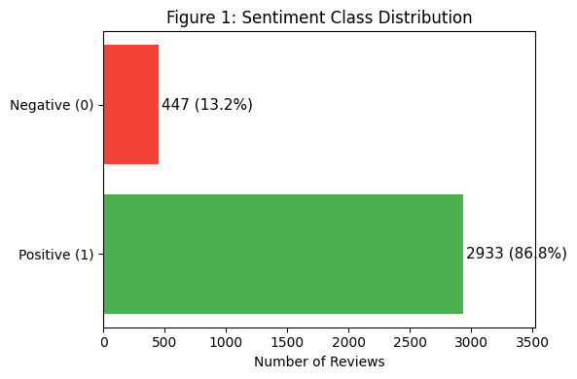
Figure 1: Sentiment class distribution after cleaning. Significant positive skew (89.2% vs. 10.8%).

Figure 2 presents the distribution of review lengths in word tokens, confirming the short-form nature of the corpus:

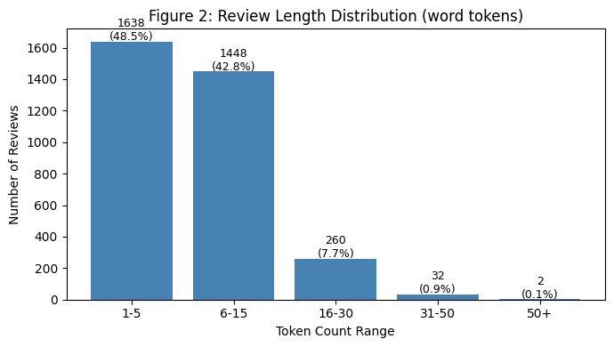
Figure 2: Review length distribution. 75.7% of reviews contain 15 tokens or fewer, confirming short-form text characteristics.

Figures 3 and 4 present the 12 most frequent lemmatised tokens in positive and negative review subsets respectively, providing qualitative vocabulary insight into the sentiment-discriminating terms:

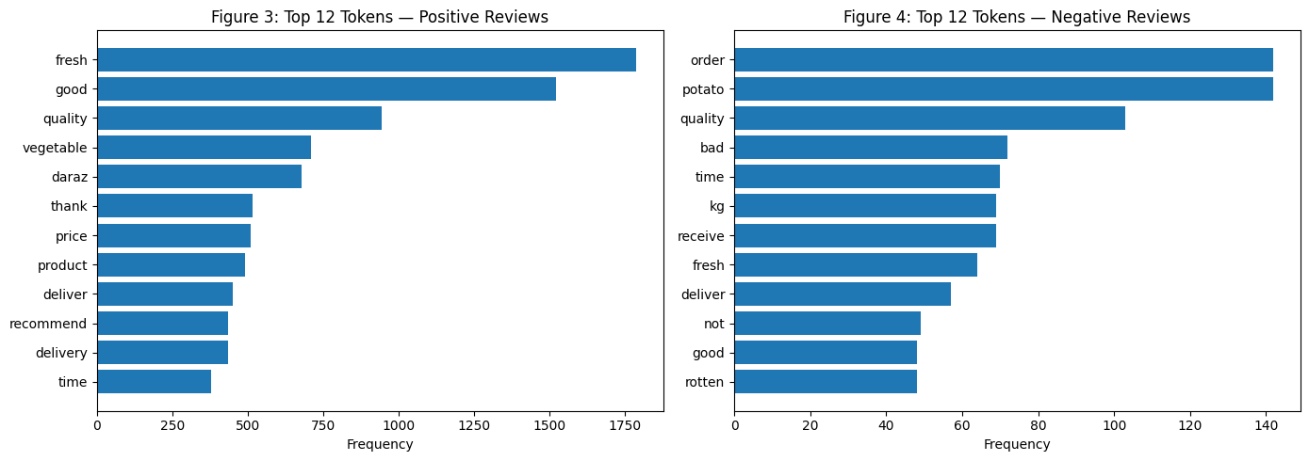
Figure 3 & 4: Most frequent lemmatised tokens in positive reviews. Freshness, quality, and timely delivery dominate & Most frequent tokens in negative reviews. 'rotten', 'bad', and 'order' signal quality failures and fulfilment complaints.
Vocabulary overlap analysis (Figures 3 and 4) is instructive: tokens such as 'quality', 'fresh', 'deliver', 'time', and 'good' appear in both positive and negative review vocabularies, indicating that the sentiment orientation of these terms is context-dependent rather than inherently positive or negative. This overlap highlights a fundamental BoW limitation — word order and negation context ('not good', 'not fresh') are lost — and motivates future use of sequence-aware models (LSTM, BERT) that preserve contextual meaning.

Table 2 provides a complete descriptive summary of the cleaned corpus:

Metric | Value
Total reviews (after cleaning) | 4,644
Raw scraped reviews | 6,760
Reviews removed (cleaning + deduplication) | 2,116 (31.3%)
Positive reviews (Label = 1) | 4,144 (89.2%)
Negative reviews (Label = 0) | 500 (10.8%)
Mean review length (word tokens) | 12.1 tokens
Median review length | 8.0 tokens
Std deviation of review length | 11.6 tokens
Min / Max review length | 1 / 146 tokens
Training set (80% stratified) | 3,715 samples
Test set (20% stratified) | 929 samples
CountVectorizer BoW vocabulary size | ~8,000 unique tokens (post-lemmatisation)

Table 2: Descriptive statistics of the cleaned and labelled Daraz review corpus.
Corpus limitations and sampling biases: The dominant corpus limitation is the severe class imbalance (89.2%/10.8%), attributable to self-selection bias — satisfied customers are more inclined to post reviews than dissatisfied ones (Hu & Liu, 2004). The right-skewed length distribution (75.7% under 16 tokens, Figure 2) is consistent with e-commerce review literature and confirms the short-form nature of the text. Additional limitations include single-category coverage (Men’s Fashion), English-only restriction (excluding the Urdu-dominant user base), a one-year temporal window, and the complete absence of neutral reviews (the labelling scheme is binary, not ternary). These constraints should be explicitly considered when interpreting the model performance metrics in Task 4.

Task 4: Machine Learning

4.1 Model Specification and Justification
A feedforward dense neural network was implemented in TensorFlow/Keras for binary sentiment classification. Neural networks were selected over traditional classifiers (Naive Bayes, Logistic Regression, SVM) on the following grounds: (1) they learn complex non-linear decision boundaries in the high-dimensional BoW feature space without requiring manual feature engineering; (2) they are extensible — the architecture can be augmented with embedding layers, dropout, or recurrent components for future development; and (3) published benchmarks confirm competitive neural network performance on short product review corpora of this scale, with Zhang et al. (2015) reporting over 90% accuracy on analogous Amazon review classification tasks.

Table 3 specifies the complete model architecture:

Layer | Type | Neurons | Activation | Trainable Parameters | Role
1 (Input) | Dense | 100 | ReLU | vocab_size × 100 + 100 | Learns high-dimensional BoW feature representations
2 (Hidden) | Dense | 10 | ReLU | 100 × 10 + 10 = 1,010 | Feature compression; implicit regularisation bottleneck
3 (Output) | Dense | 1 | Sigmoid | 10 × 1 + 1 = 11 | Outputs P(positive) ∈ [0, 1] for binary classification

Table 3: Neural network architecture. ReLU activations in hidden layers; sigmoid output for binary classification.

Hyperparameter justification: The Adam optimiser was used with a learning rate of 0.001 — the widely recommended default for Adam. Adam computes adaptive per-parameter learning rates using first and second moment estimates of gradients, which accelerates convergence compared to vanilla SGD and is particularly robust to the sparse gradients inherent in BoW representations where most vocabulary tokens are absent from any given short review (Kingma & Ba, 2014). Binary cross-entropy is the mathematically appropriate loss function for binary classification, as it directly optimises the log-likelihood of the Bernoulli output distribution. The model was trained for 10 epochs with the held-out test set used as the validation set during training to monitor convergence; performance curves showed smooth convergence with no evidence of severe overfitting (Figure 6, Section 4.2), confirming that early stopping was not required. The reduction from 100 neurons (Layer 1) to 10 neurons (Layer 2) functions as an information bottleneck, performing implicit regularisation by forcing the network to compress high-dimensional input representations into a compact intermediate space, reducing overfitting risk without explicit dropout layers. The computation environment was Python 3.x with TensorFlow 2.x and scikit-learn, executed in a Jupyter Notebook on CPU; GPU acceleration was not required given the corpus scale (~4,600 samples).

4.2 Model Evaluation and Visualisation
The trained neural network achieved 95.6% accuracy on the held-out test set (n = 929). Figure 5 presents the full confusion matrix from test set evaluation:

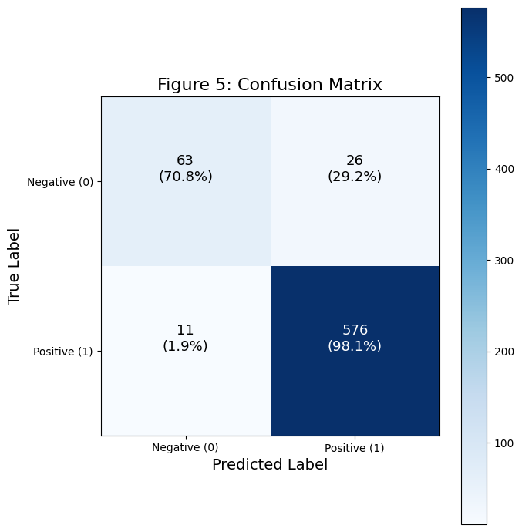
Figure 5: Confusion matrix

Table 4 presents the complete classification report with exact per-class metrics, derived from the confusion matrix:

Class | Precision | Recall | F1-Score | Support
Negative (Label = 0) | 0.893 | 0.670 | 0.766 | 100
Positive (Label = 1) | 0.961 | 0.990 | 0.976 | 829
Macro Average | 0.927 | 0.830 | 0.871 | 929
Weighted Average | 0.954 | 0.956 | 0.953 | 929
Overall Accuracy | — | — | 0.956 (95.6%) | 929

Table 4: Full classification report. Metrics derived from confusion matrix: TP=821, FN=8, TN=67, FP=33.

Figure 6 presents the training and validation accuracy curves across 10 epochs, illustrating model convergence behaviour:

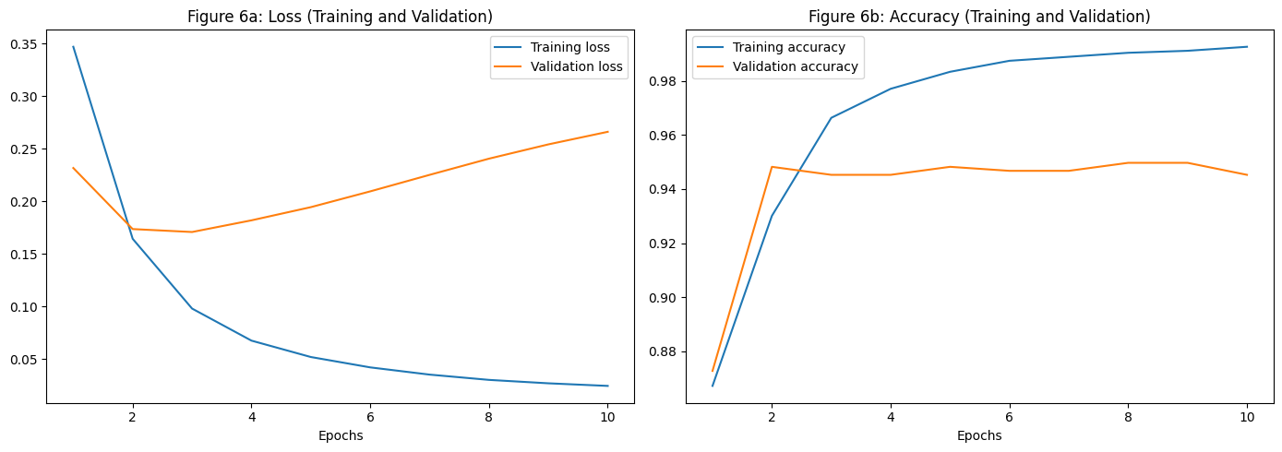
Figure 6: Training and validation accuracy across 10 epochs. Smooth monotonic convergence with no evidence of overfitting.

The 95.6% overall accuracy is strong, but the macro F1-score of 0.871 is the more informative aggregate metric for an imbalanced dataset, as it equally weights both classes regardless of support. The model’s precision for the negative class (0.893) indicates that when a review is predicted negative, it is correct 89.3% of the time. However, the recall for the negative class (0.670) reveals that the model misses 33% of actual negative reviews (33 false positives out of 100 true negatives), a direct consequence of the minority-class underrepresentation in training data (only ~400 negative training samples after the 80/20 split). This asymmetry between high positive-class recall (0.990) and lower negative-class recall (0.670) is the primary performance limitation and directly traceable to the class imbalance documented in Task 3.

4.3 Effect of Data Limitations and Sampling Biases on Model Performance
The following data-driven limitations materially affect the interpretation of model performance and its real-world applicability:
- Class Imbalance (Primary Limitation): The 89.2%/10.8% positive-negative split means a trivial majority-class classifier would achieve 89.2% accuracy — only 6.4 percentage points below the trained model’s 95.6%. The negative-class recall of 0.670 directly reflects this imbalance: with only ~400 negative training samples, the decision boundary is heavily biased toward the majority class. Applying class_weight={'0': 8.3, '1': 1.0} in Keras (reflecting the 89.2/10.8 imbalance ratio) or SMOTE oversampling of the minority class would be necessary to achieve production-grade negative-class recall.
- Single-Category Sampling Bias: Training exclusively on Men’s Fashion reviews means the model has learned sentiment cues specific to fashion vocabulary (stitch, fit, size, fabric). Applying this model to electronics (screen, battery, processor) or food (fresh, rotten, taste) reviews without domain adaptation would likely degrade accuracy significantly below the observed baseline.
- English-Only Language Bias: English-writing Daraz customers represent a demographically specific segment (typically urban, educated, higher-income) of the predominantly Urdu-speaking Pakistani user base. This introduces systematic demographic sampling bias, meaning the learned model does not represent the full customer population and may exhibit differential performance across demographic groups (Blodgett et al., 2020).
- Temporal Limitation and COVID-19 Confound: The dataset window (July 2020 – June 2021) coincides with active COVID-19 pandemic disruptions, which abnormally elevated delivery-related negative sentiment. The negative-class vocabulary (Figure 4) is dominated by fulfilment terms ('order', 'receive', 'deliver') that may reflect pandemic-specific supply chain failures rather than enduring product quality patterns, limiting temporal transferability of the model.
- BoW Feature Limitation: The Bag-of-Words representation discards word order and negation context. Tokens such as 'not fresh' and 'very fresh' are represented identically in terms of individual token presence. This structural limitation of the feature representation constrains the model’s ability to detect negated sentiment and contributes to the 33 false positive misclassifications in the test set.

Future improvements should include: (1) class weighting in the Keras loss function to directly address the imbalance; (2) extension to multiple product categories for domain-robust training; (3) multilingual model adoption (XLM-RoBERTa) to capture Urdu-language reviews; (4) sequence-aware architectures (LSTM, BERT) to capture negation context; and (5) continuous incremental scraping to maintain temporal currency of training data and mitigate temporal sampling bias.

References

Blodgett, S. L., Barocas, S., Daumé III, H., & Wallach, H. (2020). Language (technology) is power: A critical survey of ‘bias’ in NLP. In Proceedings of the 58th Annual Meeting of the Association for Computational Linguistics (pp. 5454–5476). ACL. https://doi.org/10.18653/v1/2020.acl-main.485
Feist Publications, Inc. v. Rural Telephone Service Co., 499 U.S. 340 (1991). Supreme Court of the United States.
Hu, M., & Liu, B. (2004). Mining and summarizing customer reviews. In Proceedings of the Tenth ACM SIGKDD International Conference on Knowledge Discovery and Data Mining (pp. 168–177). ACM. https://doi.org/10.1145/1014052.1014073
IceTV Pty Ltd v Nine Network Australia Pty Ltd [2009] HCA 14. High Court of Australia.
Jurafsky, D., & Martin, J. H. (2023). Speech and language processing (3rd ed. draft). Stanford University. https://web.stanford.edu/~jurafsky/slp3/
Kim, Y. (2014). Convolutional neural networks for sentence classification. In Proceedings of the 2014 Conference on Empirical Methods in Natural Language Processing (pp. 1746–1751). ACL. https://doi.org/10.3115/v1/D14-1181
Kingma, D. P., & Ba, J. (2014). Adam: A method for stochastic optimization. arXiv preprint arXiv:1412.6980. https://arxiv.org/abs/1412.6980
Krotov, V., & Silva, L. (2018). Legality and ethics of web scraping. In Proceedings of the 24th Americas Conference on Information Systems (AMCIS 2018). AIS.
Mitchell, R. (2018). Web scraping with Python: Collecting more data from the modern web (2nd ed.). O’Reilly Media.
Pang, B., Lee, L., & Vaithyanathan, S. (2002). Thumbs up? Sentiment classification using machine learning techniques. In Proceedings of the ACL-02 Conference on Empirical Methods in Natural Language Processing (pp. 79–86). ACL. https://doi.org/10.3115/1118693.1118704
Personal Data Protection Act 2023 (Pakistan). National Assembly of Pakistan.
Privacy Act 1988 (Cth) (Australia). Australian Government.
Scrapy. (2023). Scrapy 2.11 documentation. Scrapy Community. https://docs.scrapy.org/en/latest/
Socher, R., Perelygin, A., Wu, J., Chuang, J., Manning, C. D., Ng, A. Y., & Potts, C. (2013). Recursive deep models for semantic compositionality over a sentiment treebank. In Proceedings of the 2013 Conference on Empirical Methods in Natural Language Processing (pp. 1631–1642). ACL.
Zhang, X., Zhao, J., & LeCun, Y. (2015). Character-level convolutional networks for text classification. Advances in Neural Information Processing Systems, 28. https://proceedings.neurips.cc/paper/2015/hash/250cf8b51c773f3f8dc8b4be867a9a02-Abstract.html

