Project 1

Supermarket Sales Analysis

Overview
This project focuses on analyzing a supermarket’s daily sales dataset to understand customer purchasing behavior, identify top-performing product categories, and uncover trends that influence revenue. By examining sales totals, product line performance, and customer spending patterns, the analysis provides valuable insights that can help optimize inventory, marketing strategy, and business decision-making.

Key Insights
1. Clear Daily & Monthly Sales Fluctuations
The supermarket exhibits noticeable variations in total daily sales, with some days showing significant spikes. Monthly comparisons also reveal growth patterns and seasonal behaviors that affect purchasing habits.
2. Electronics & Grocery are the Top Performers
Among all product lines, Electronics and Groceries consistently contribute the highest revenue. Electronics generate large order values, while groceries sell in high volume.
3. Customer Spending Varies Widely
Average customer spending shows considerable variation.
Certain customers frequently make high-value purchases, indicating strong potential for loyalty or VIP programs.
4. Weekend & Evening Sales Peaks
Sales reach their highest levels during weekends, especially between 5 PM to 7 PM, aligning with typical shopping rush hours. This highlights opportunities for time-based promotions.

CODE:
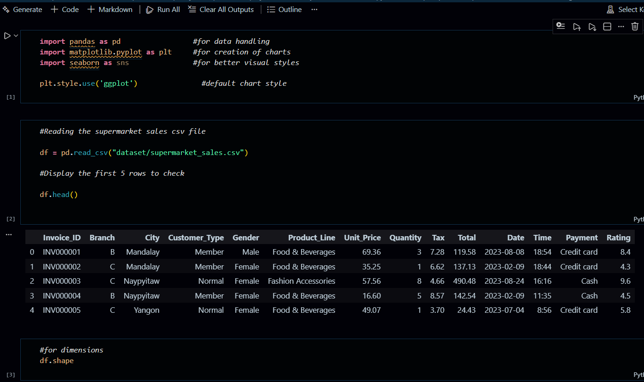

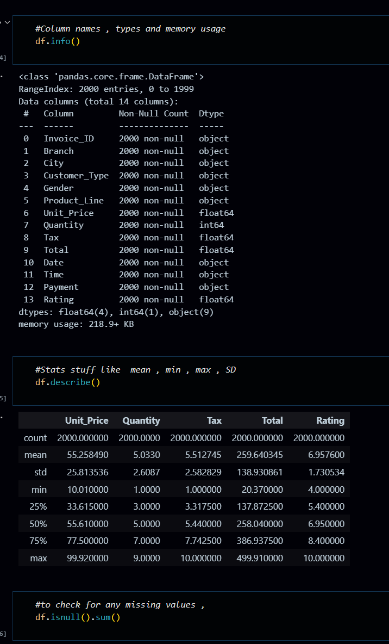
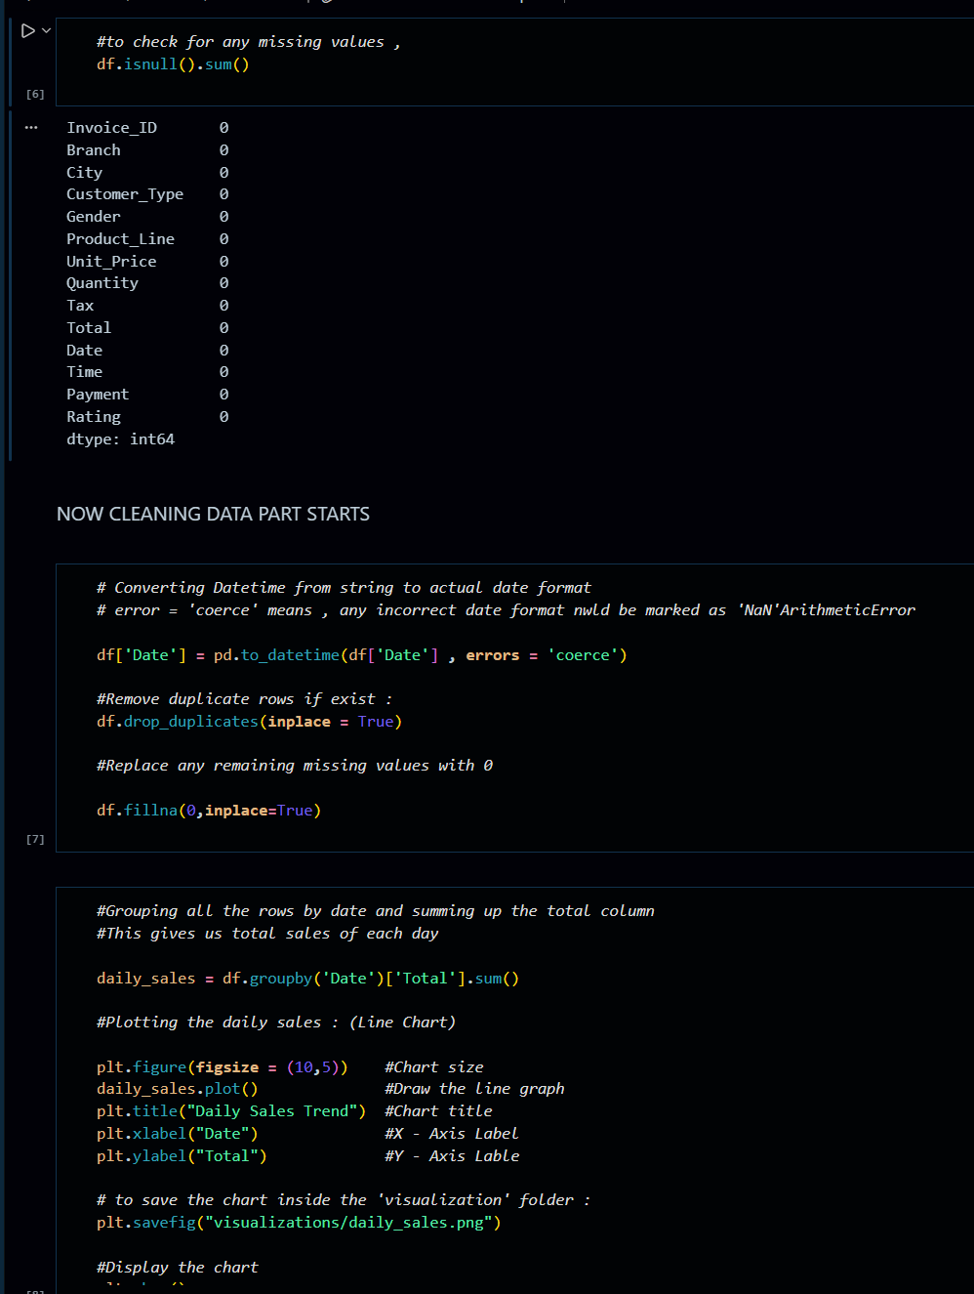
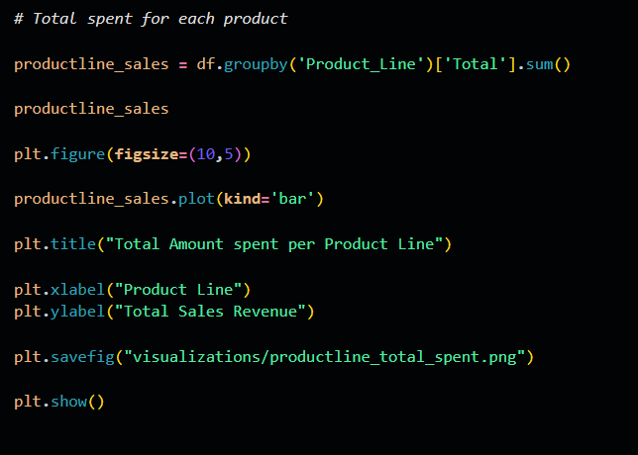

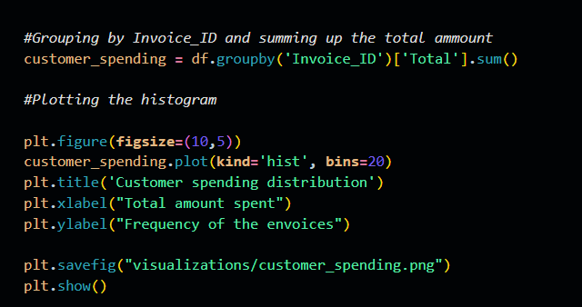

Visualizations
- Daily Sales Trend (Line Chart)
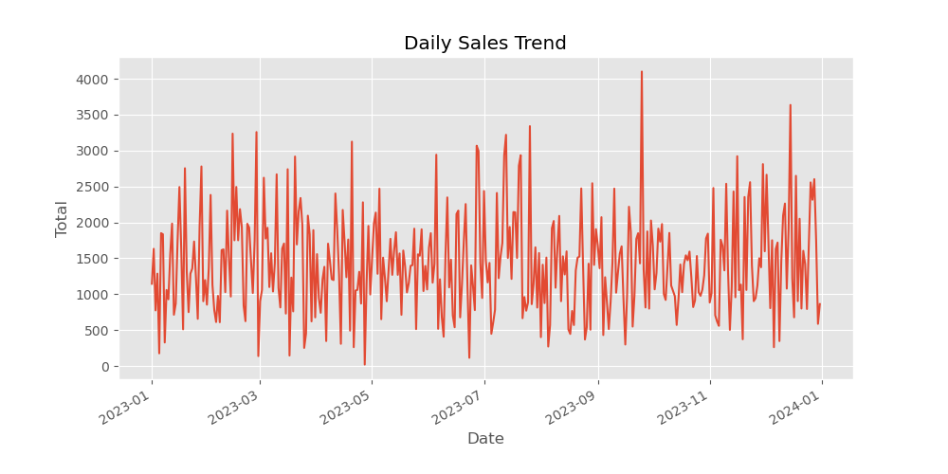

- Best-Selling Product Lines (Bar Chart)
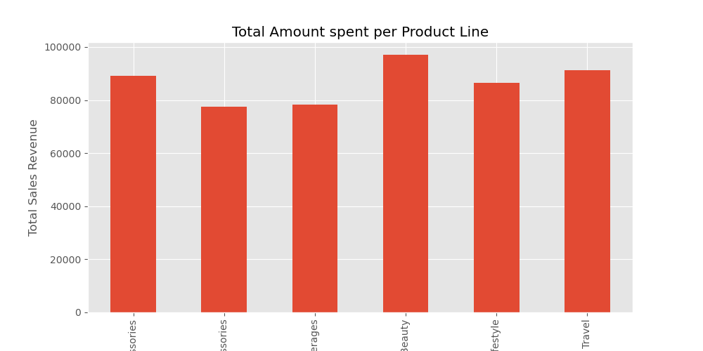

- Customer Spending Distribution (Histogram/Pie Chart)
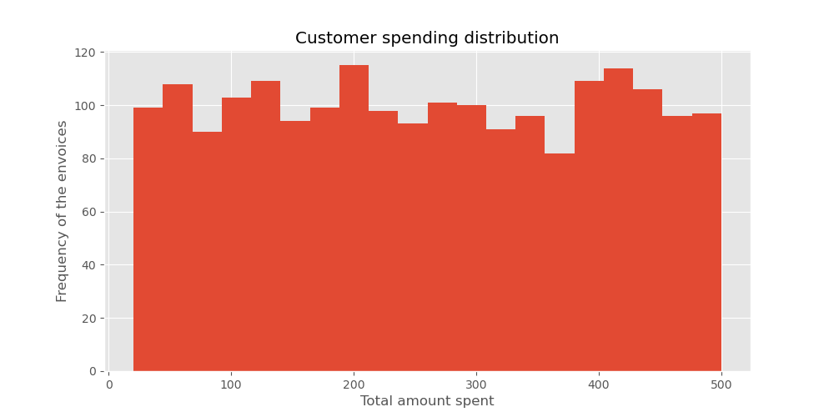
- Total Amount Spent per Product Line (Bar Chart)

Business Recommendations
1. Increase Inventory for High-Performing Categories
Since Electronics and Grocery produce the highest sales, increasing stock levels and expanding product variety in these categories can boost revenue further.
2. Run Targeted Promotions During Peak Hours
Weekend evenings show the highest sales activity. Introducing offers such as “Happy Hour Discounts” or “Weekend Specials” can help maximize conversions during peak times.
3. Offer Bundle Discounts
Products frequently purchased together (e.g., groceries, household items) should be bundled into combo offers. Bundle deals attract price-sensitive buyers and increase average order value.
4. Launch Loyalty or Membership Programs
High-spending customers can be encouraged to spend even more through reward points, VIP pricing, or exclusive deals.

