Project 2

Student Performance Analysis

Overview
This project analyzes student academic performance across three major subjects Maths, Science, and English. The analysis includes pass/fail evaluation, subject-wise score comparison, attendance impact, and overall score distribution. These insights help identify learning gaps and provide data-driven suggestions to improve academic outcomes.

Key Insights
1. Majority of Students Passed the Exam
Using a 40% pass threshold, most students qualified. Only a smaller portion fell below the passing mark, indicating overall good academic standing.
2. Highest Average Performance in English
Among the three subjects, English recorded the highest mean score.
Maths displayed comparatively lower average performance, suggesting that many students may find it more challenging.
3. Attendance Does Not Strongly Correlate in This Dataset
Although attendance typically impacts performance, this dataset shows a uniform spread, meaning students with both high and low attendance achieved varied scores.
(This is due to the dataset being synthetic/random.)
4. Score Distribution Shows Moderate Variation
The histogram indicates that most students score between 50–80, with some high achievers above 90 and a few lower scores below 40.

Visualizations

Pass vs Fail Pie Chart
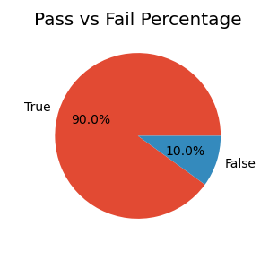

Average Score by Subject

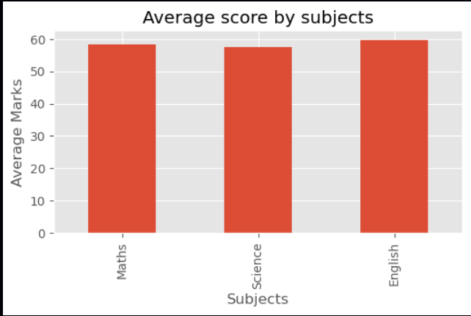

CODE:
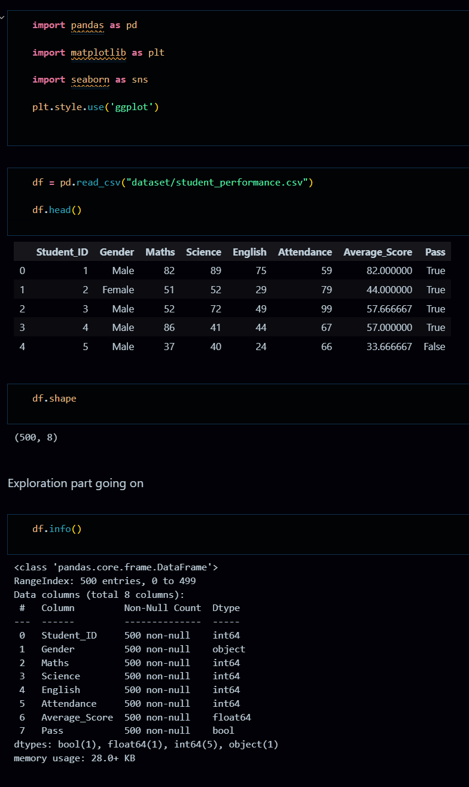
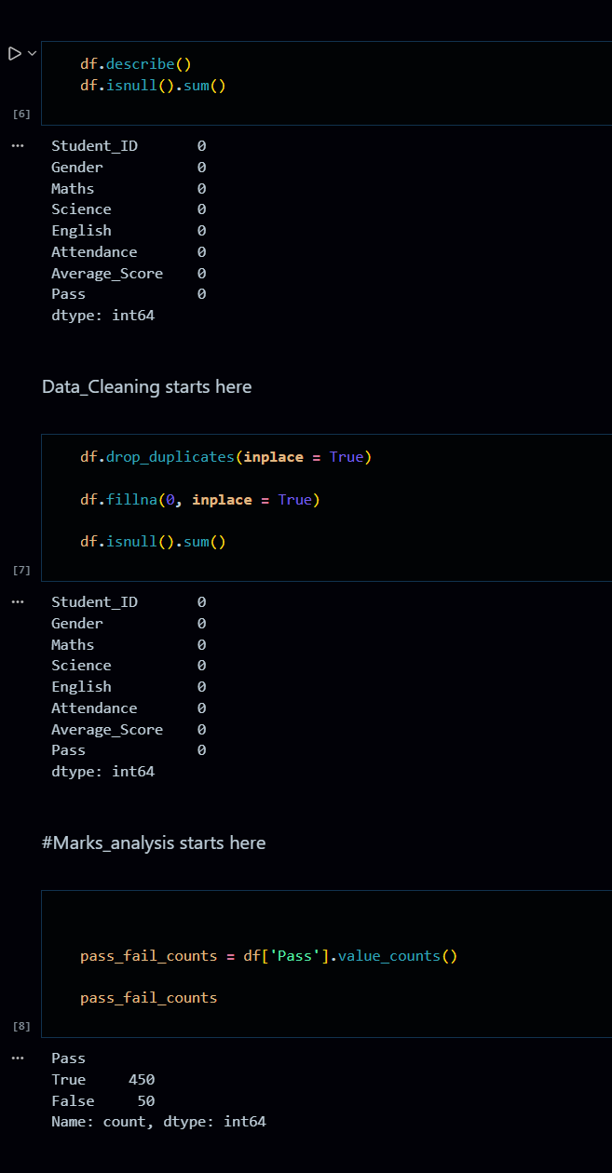
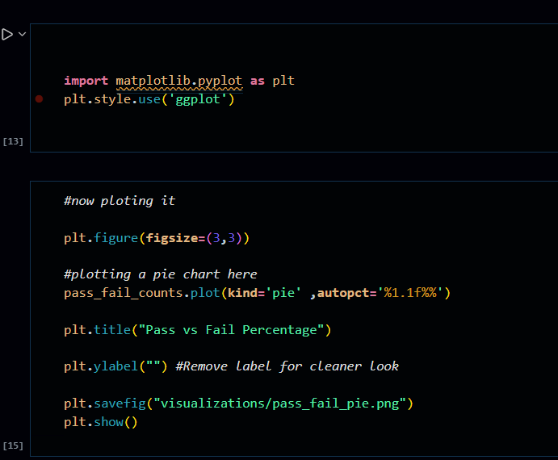
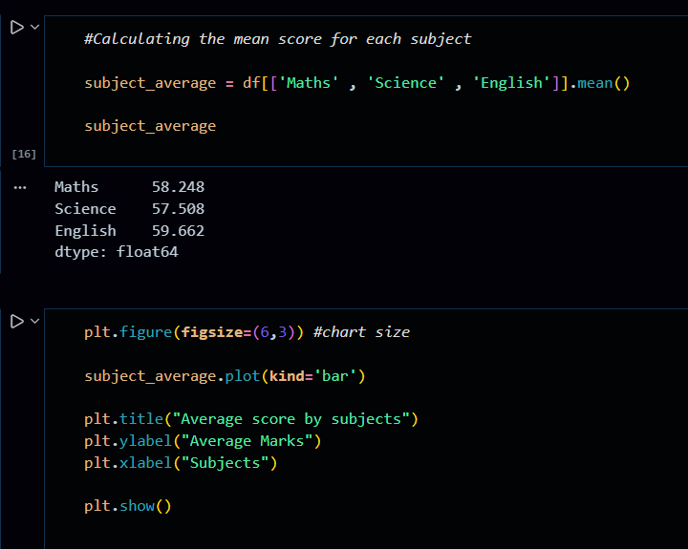
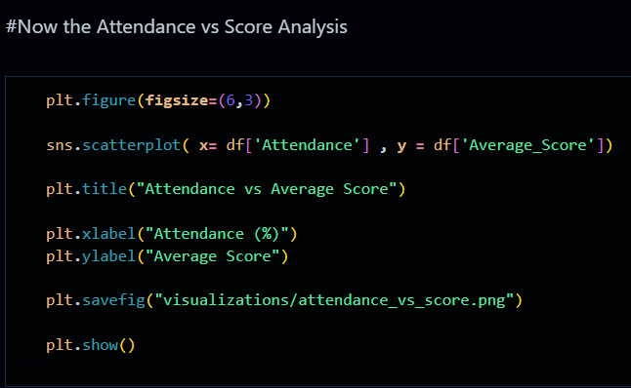
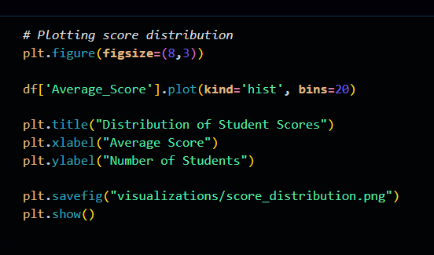

Attendance vs Average Score
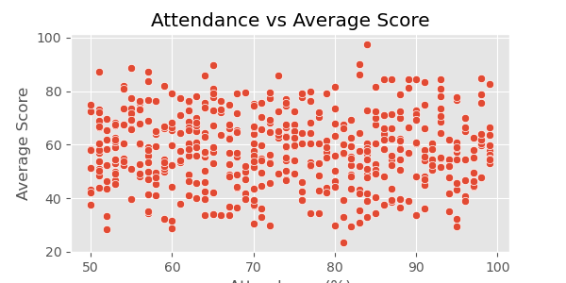

- Score Distribution (Histogram)
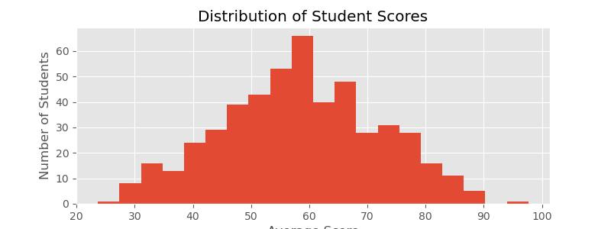

Business Recommendations
1. Strengthen Mathematics Support Programs
Extra coaching sessions, practice worksheets, and regular assessments can help improve Maths performance the weakest subject in this dataset.
2. Encourage Consistent Attendance
Even though the dataset doesn’t show strong correlation, improving attendance generally enhances learning outcomes.
Schools can introduce attendance-based incentives or reminders.
3. Provide Targeted Help for Low-Performing Students
Identify students scoring below 40 early and arrange remedial classes, mentorship, or personalized study plans.
4. Promote Peer Learning and Study Groups
Strong performers in certain subjects can assist weaker students.
Peer–peer learning programs often improve confidence and understanding.
5. Review Teaching Strategies in Lower Scoring Subjects
Courses with lower averages especially Maths may need revised teaching methods, updated materials, or interactive learning tools.

