Project 3

Weather Analysis

Overview
This project analyzes one full year of meteorological data, including temperature, humidity, rainfall, and wind speed.
The goal is to understand environmental patterns, seasonal behavior, rainfall distribution, and extreme weather conditions.
- The dataset contains 365 daily records with the following attributes:
- Date
- Temperature (°C)
- Humidity (%)
- Rainfall (mm)
- Wind Speed (km/h)
This analysis helps identify climate trends and prepares for environmental planning.

Key Insights
1. Temperature Trend
- Temperature fluctuates steadily throughout the year.
- Warmer months show a noticeable rise in average temperature.
- Colder months show significant dips, indicating seasonal transitions.
2. Rainfall Distribution
- Rainfall mostly remains low, with occasional spikes.
- Heavy rainfall days appear sporadically throughout the year.
- The rainfall pattern suggests a semi-tropical environment.
3. Seasonal Temperature Patterns
- Summer months (April–June) show the highest average temperatures.
- Monsoon months exhibit moderate temperatures and increased rainfall.
- Winter months (December–February) show the lowest temperature values.
4. Extreme Weather Detection
- Several days were identified as “extreme temperature days” (above 35°C).
- Occasional high-rainfall days (over 20mm) also contribute to extreme weather.
- Extreme conditions may impact agriculture, travel, and outdoor activities.

CODE:
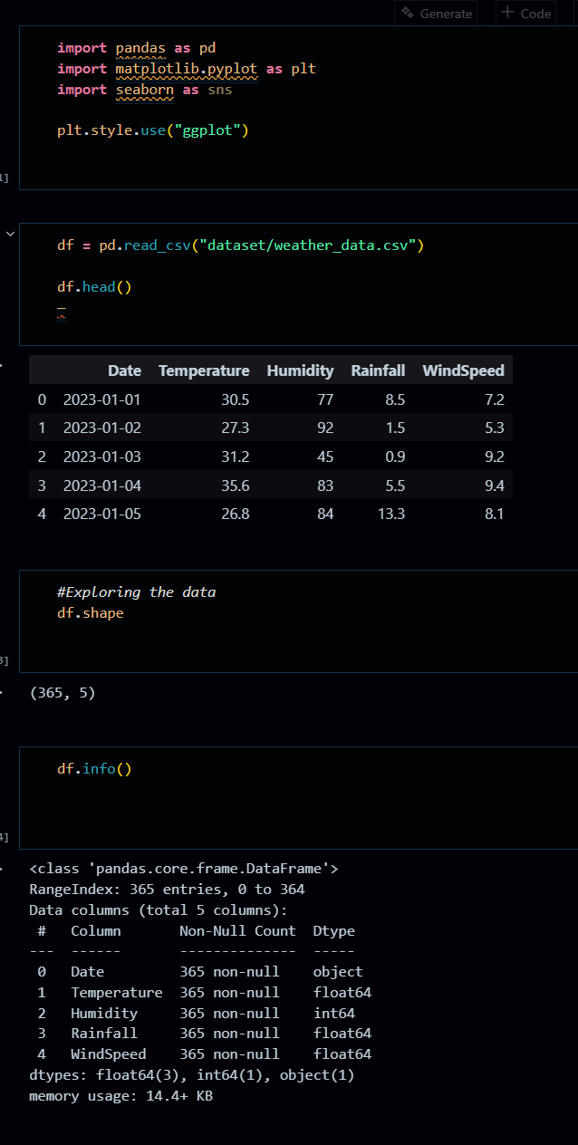
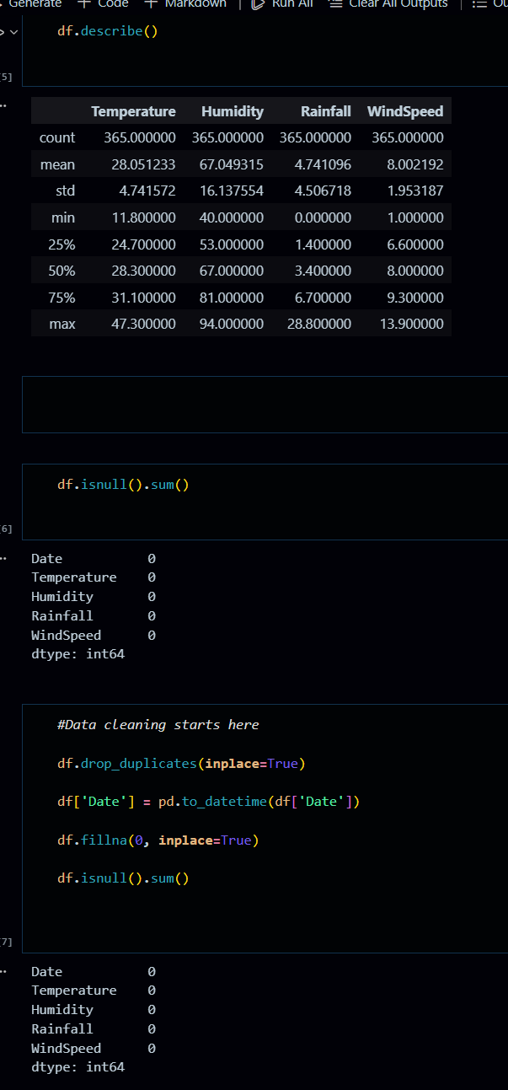
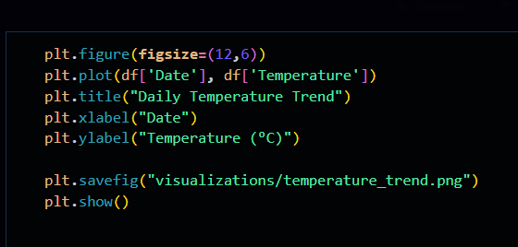

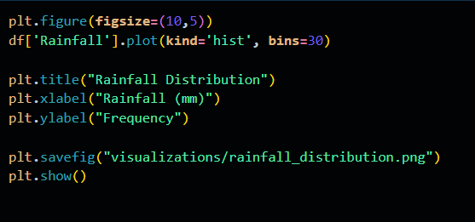

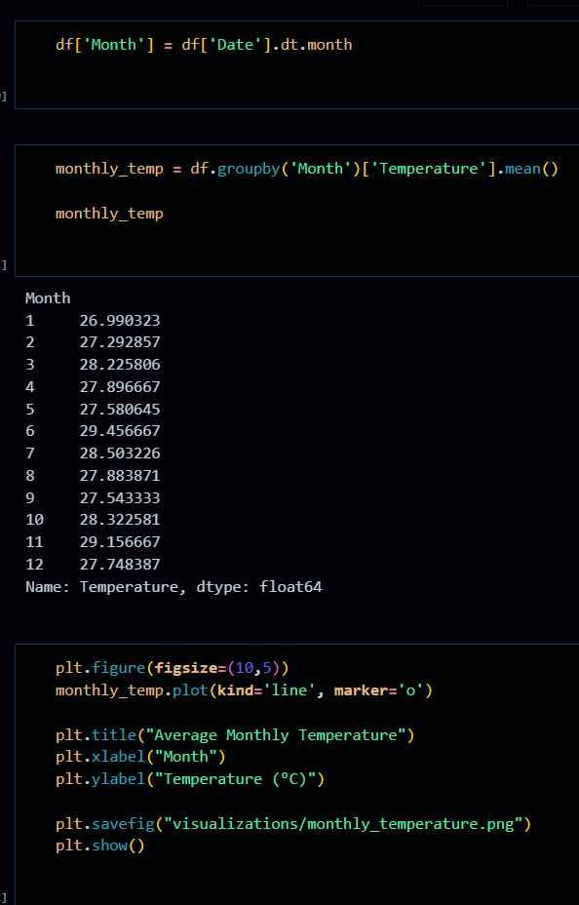
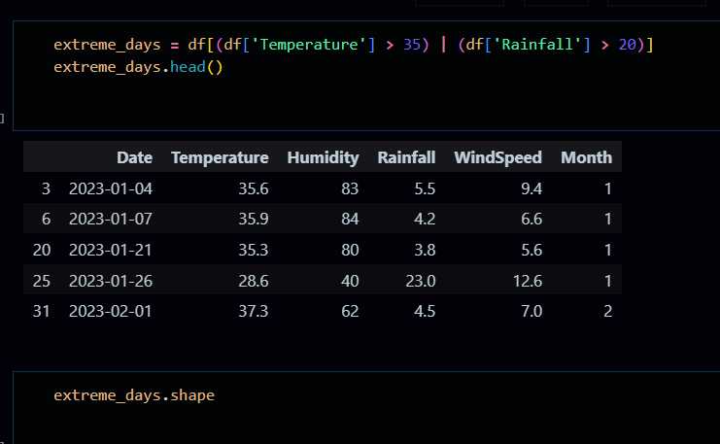

Visualizations

Daily temperature line graph
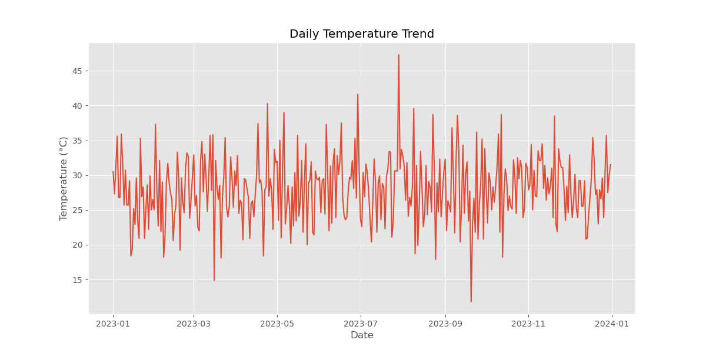

Histogram of rainfall
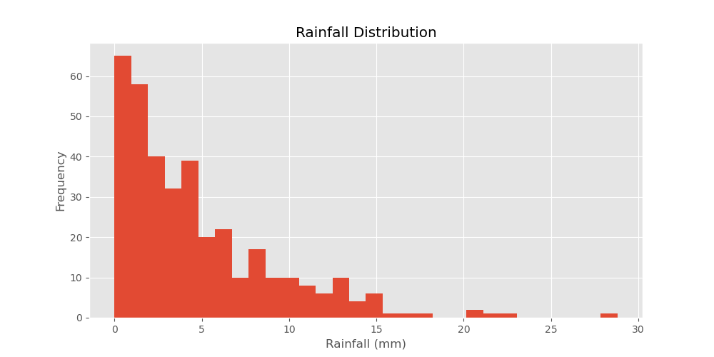
Average temperature by month
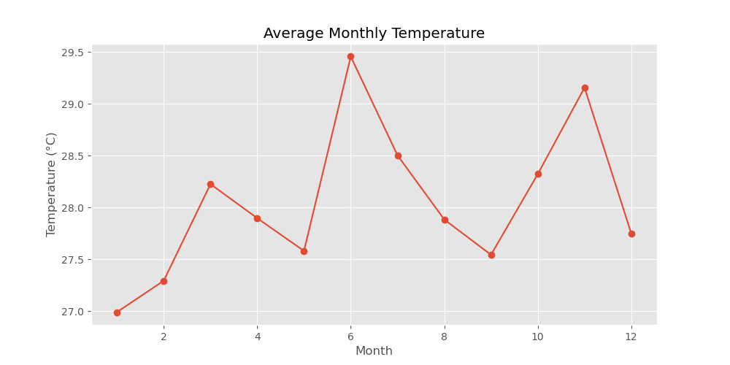

Business Recommendations
- Prepare for High-Temperature Months
Develop heat safety awareness campaigns during summer peaks.
- Strengthen Rainfall Readiness
Improve drainage systems to prepare for occasional heavy rainfall days.
- Use Seasonal Planning
Align agricultural and outdoor activity schedules based on seasonal trends.
- Monitor Extreme Weather
Maintain alert systems for days exceeding temperature and rainfall thresholds.
- Long-Term Climate Observation
Continue collecting weather data annually to detect long-term climate changes.

