Project 4

COVID-19 TRENDS ANALYSIS

Overview
This project analyzes one full year of COVID-19 data, including daily new cases, deaths, recoveries, and active cases.
The objective is to understand how infections rise and fall over time, identify outbreak peaks, evaluate severity, and derive strategic healthcare recommendations.
The dataset contains 365 records with the following fields:
- Date
- New_Cases
- Deaths
- Recoveries
- Active_Cases
This analysis provides valuable insights for healthcare planning, outbreak readiness, and public safety.

Key Insights
1. Daily New Cases Trend
- The daily new case numbers fluctuate significantly over the year.
- Multiple outbreak peaks appear clearly in the data.
- Certain weeks show sudden spikes indicating rapid transmission.
2. 7-Day Moving Average (Trend Smoothing)
- The moving average helps reduce daily noise.
- It reveals a smooth upward trend during outbreak waves.
- Downward slopes indicate periods of recovery and reduced spread.
3. Deaths vs Recoveries
- Recovery numbers are consistently higher than deaths.
- This indicates manageable severity in most cases.
- Death spikes correspond to major infection outbreaks.
4. Active Case Behavior
- Active cases rise when new infections exceed recoveries.
- They fall when recoveries are significantly higher than new cases.
- Prolonged high active-case periods signal healthcare strain.
5. Peak Case Detection
- Peak days were identified using:
    - Mean + Standard Deviation threshold
    - Elevated new case counts
- These peaks align with periods of increased community transmission.

Key Insights:

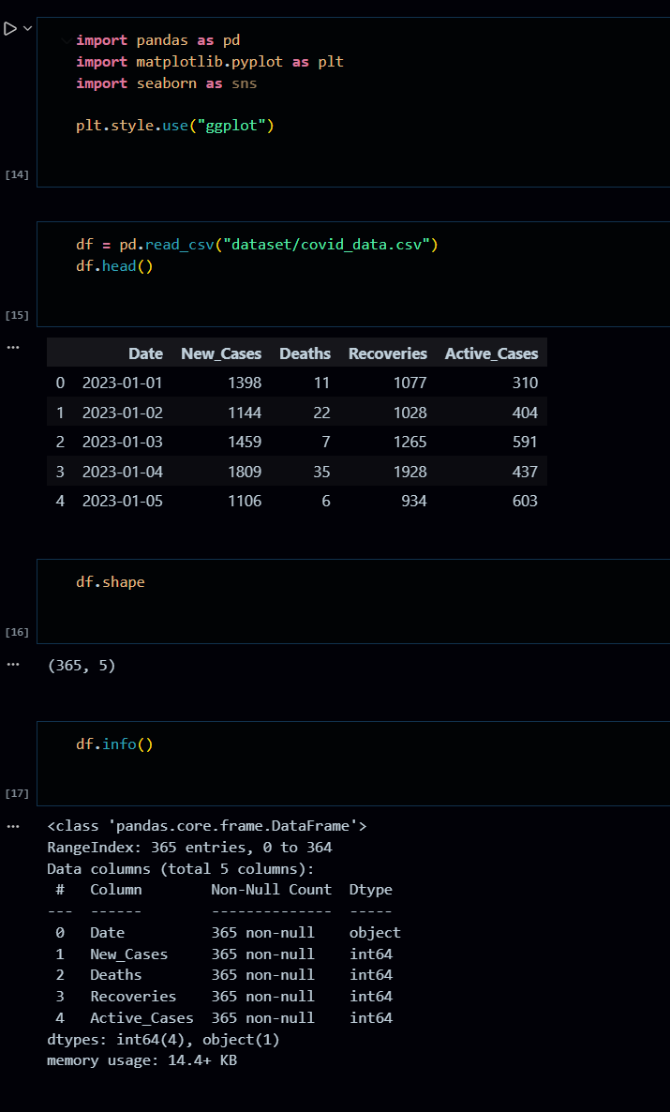
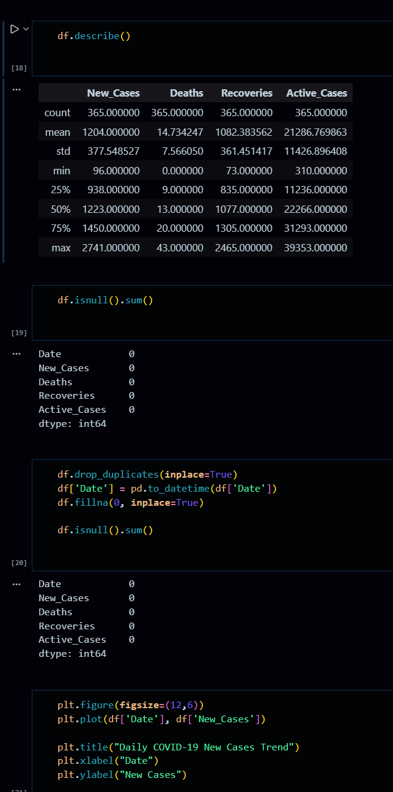
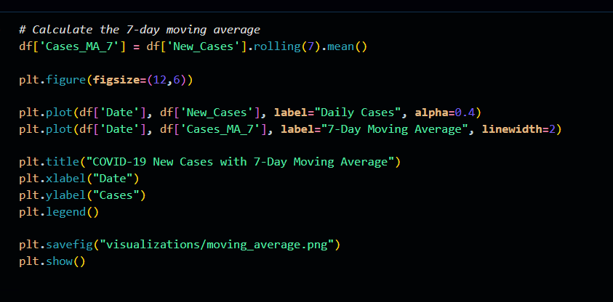
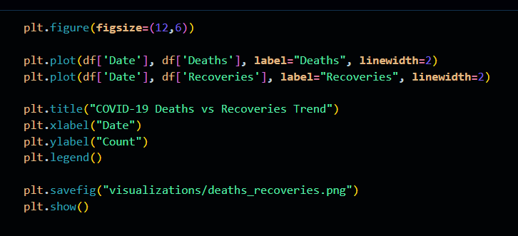

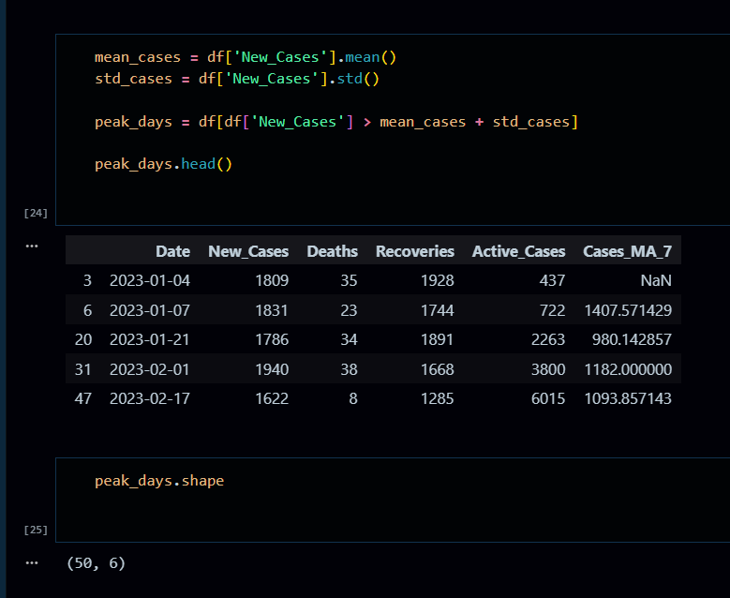

Visualizations
- Daily new case trend
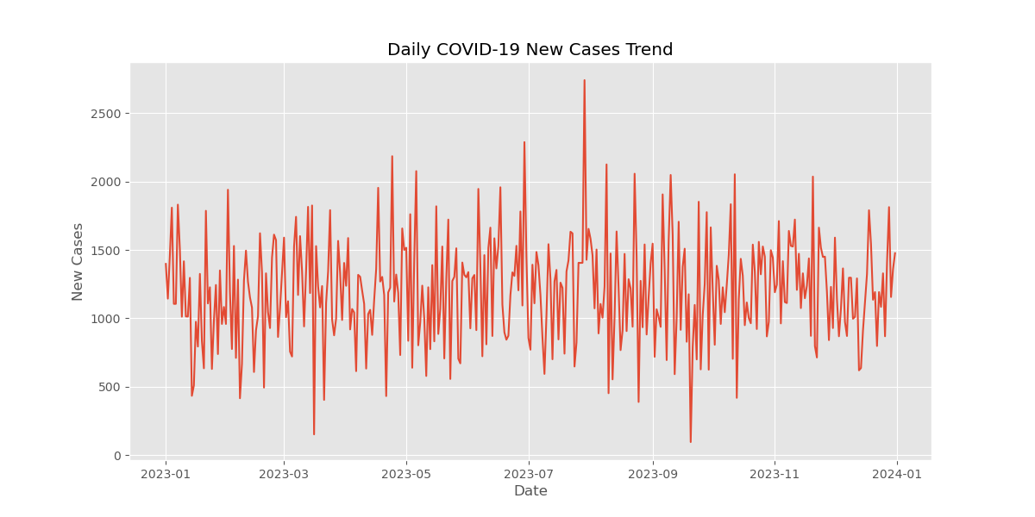

- 7-day moving average vs daily cases
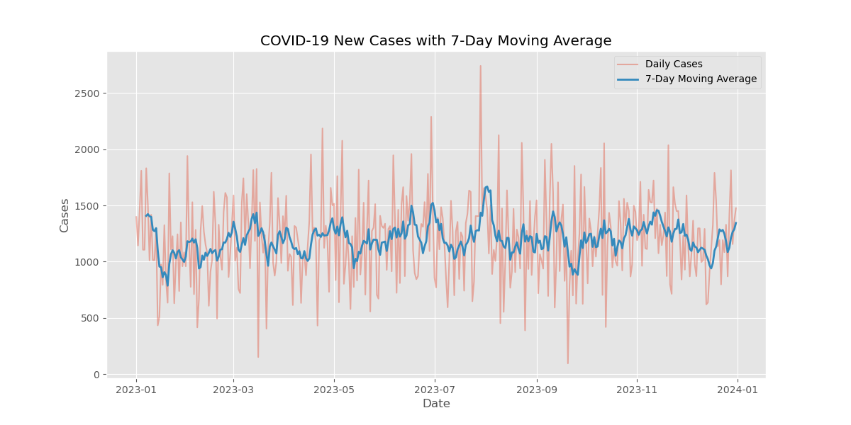
- Deaths vs recoveries comparison
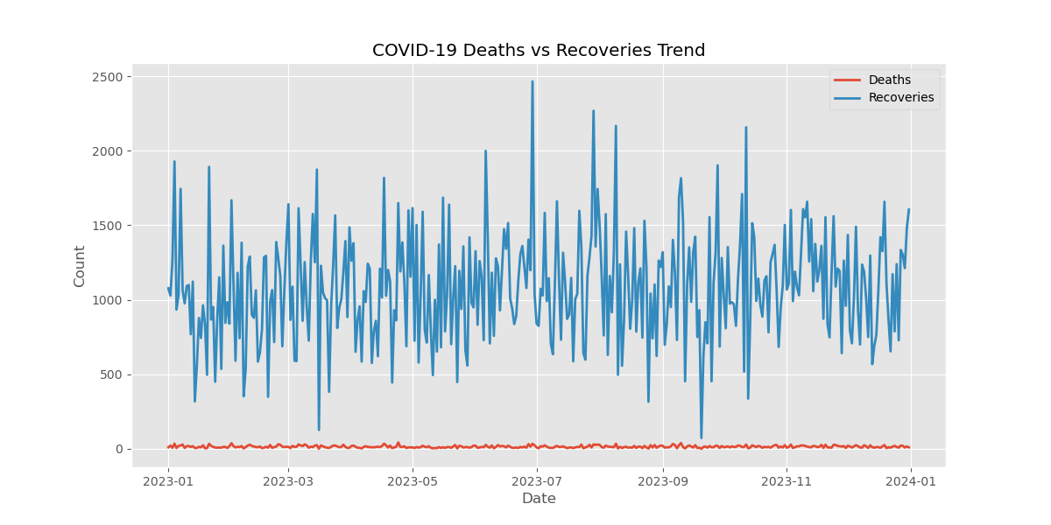

Business Recommendations

- Increase Healthcare Capacity During Peak Periods:
Hospitals should prepare in advance when moving average trends go upward.
- Improve Early Detection and Response:
Rapid test centers and screening can reduce spike severity. Strengthen Public Awareness Campaigns
Use peak predictions to inform the public about safety protocols.
- Monitor Active Cases Closely:
High active-case days must trigger emergency management measures.
- Use Predictive Modeling for Forecasting:
Forecasting methods can help governments and hospitals prepare for upcoming waves.

