Project 5

STOCK MARKET ANALYSIS

Overview
This project analyzes one full year of stock market data, focusing on price trends, trading volume, volatility, and moving averages.
The goal is to uncover market patterns, identify fluctuations, evaluate risk, and generate insights useful for financial decision-making.
The dataset contains 365 entries with these fields:
- Date
- Open Price
- High Price
- Low Price
- Close Price
- Volume (shares traded)
This analysis gives a clear understanding of market behavior over an extended period.

Key Insights
1. Closing Price Trend
- The stock price shows several ups and downs throughout the year.
- Periods of sharp increase or decrease indicate strong market reactions.
- The general movement reflects a realistic market trend influenced by volatility.
2. 30-Day Moving Average
- The 30-day MA smooths noise and reveals the true long-term direction.
- Upward slopes indicate bullish momentum.
- Downward slopes indicate bearish or correction phases.
- Crossing points (price crossing MA) can signal trend reversals.
3. Volume Trend
- Trading volume fluctuates heavily across the year.
- High-volume days may indicate:
  - news events
  - earnings announcements
  - major buy/sell activity
- Low volume often corresponds to market stability or lack of interest.
4. Volatility Analysis
- Daily returns show natural swings, both positive and negative.
- The volatility line (7-day rolling STD) highlights:
  - Market uncertainty periods
  - High-risk trading zones
  - Calm phases with low variance
5. Price Behavior Patterns
- Higher highs and higher lows indicate temporary positive market behavior.
- Sudden dips align with volatility spikes, likely linked to market shocks.

CODE:

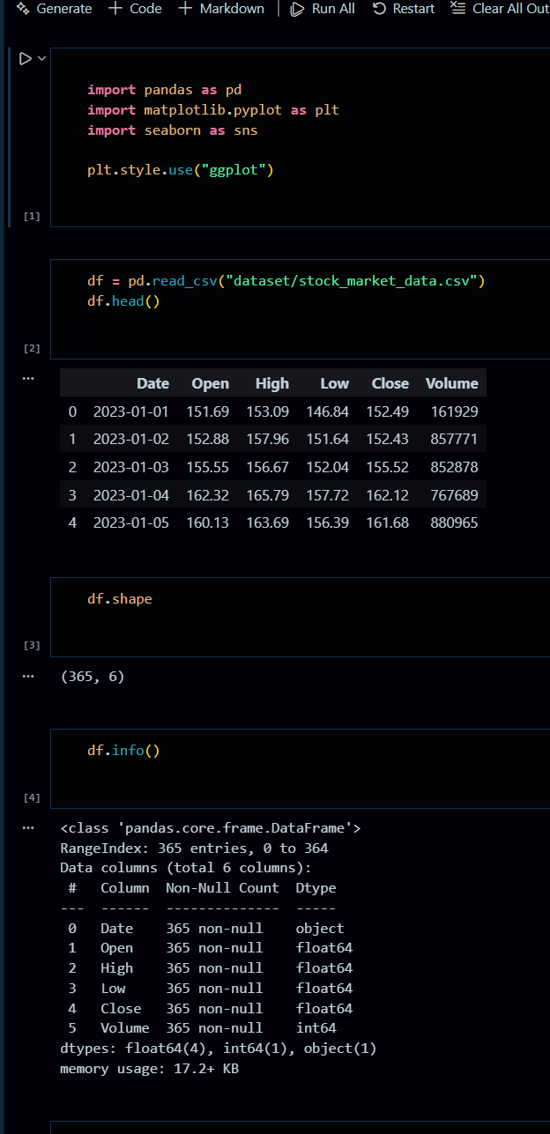
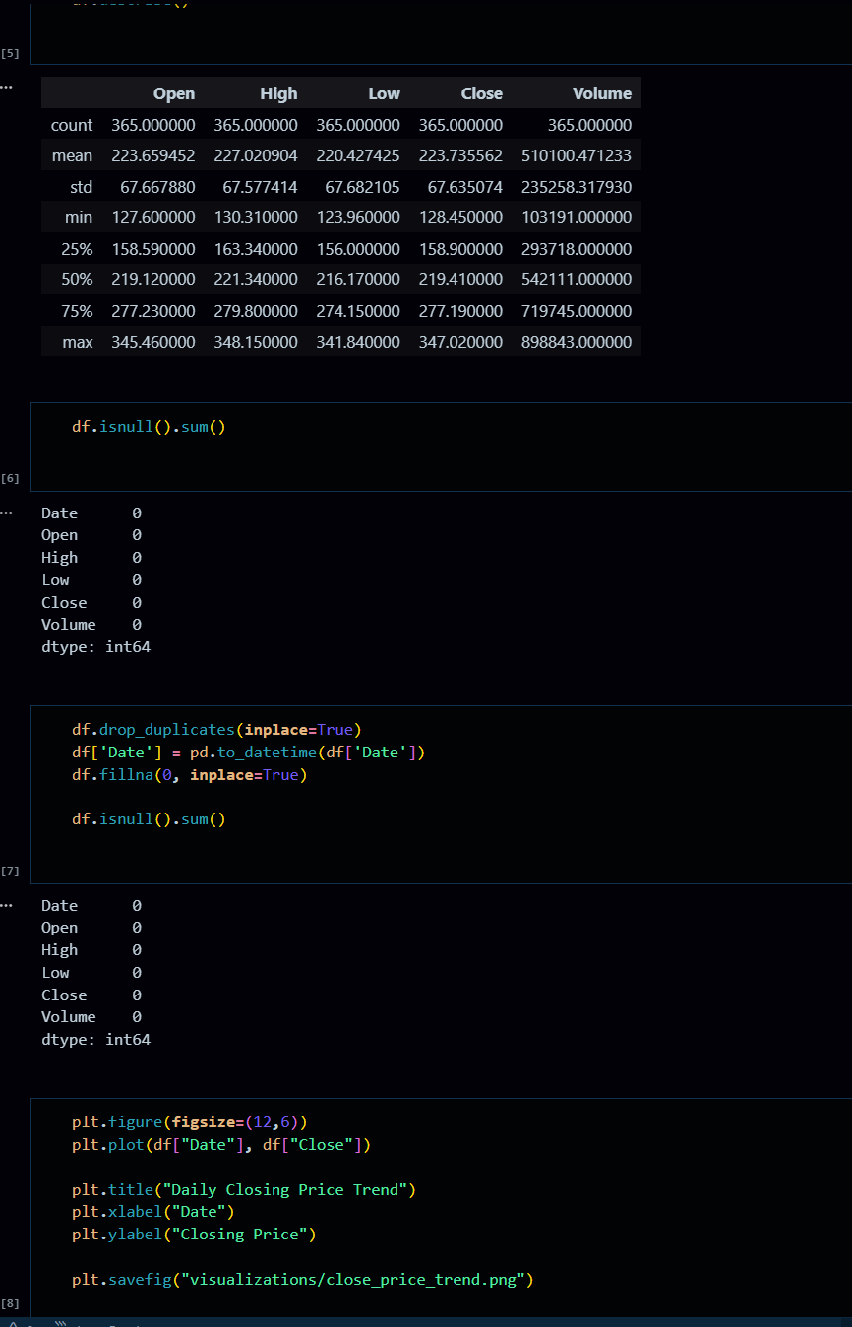
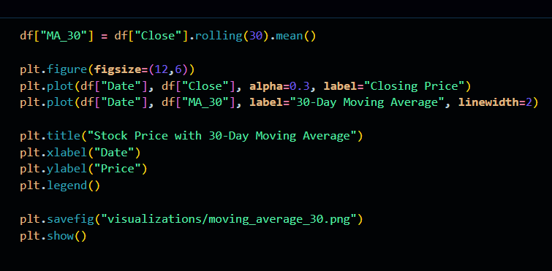

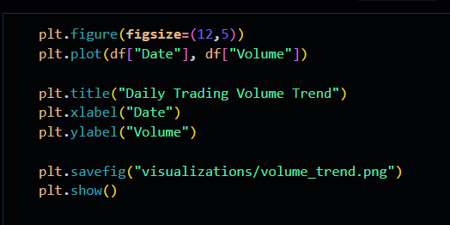

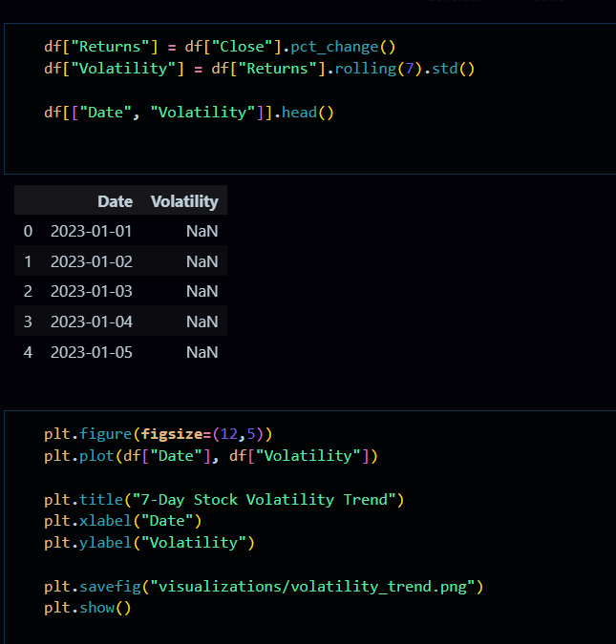

Visualizations
Daily closing price
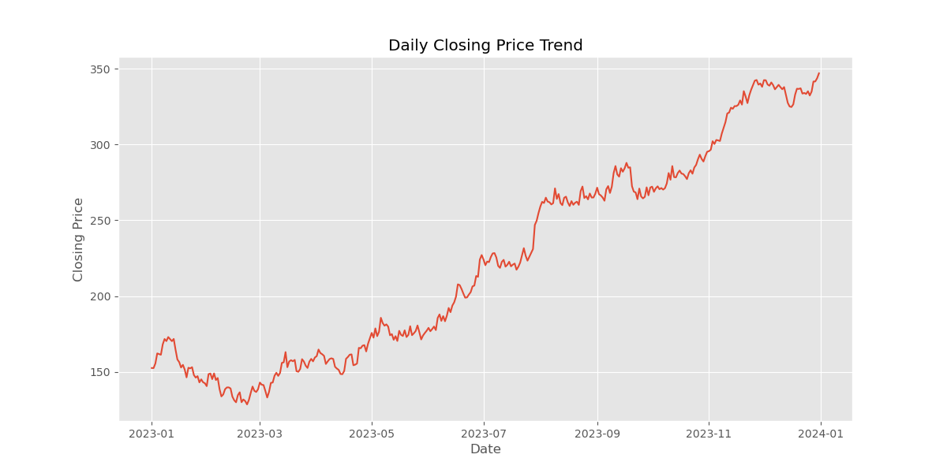
30-day MA trendline
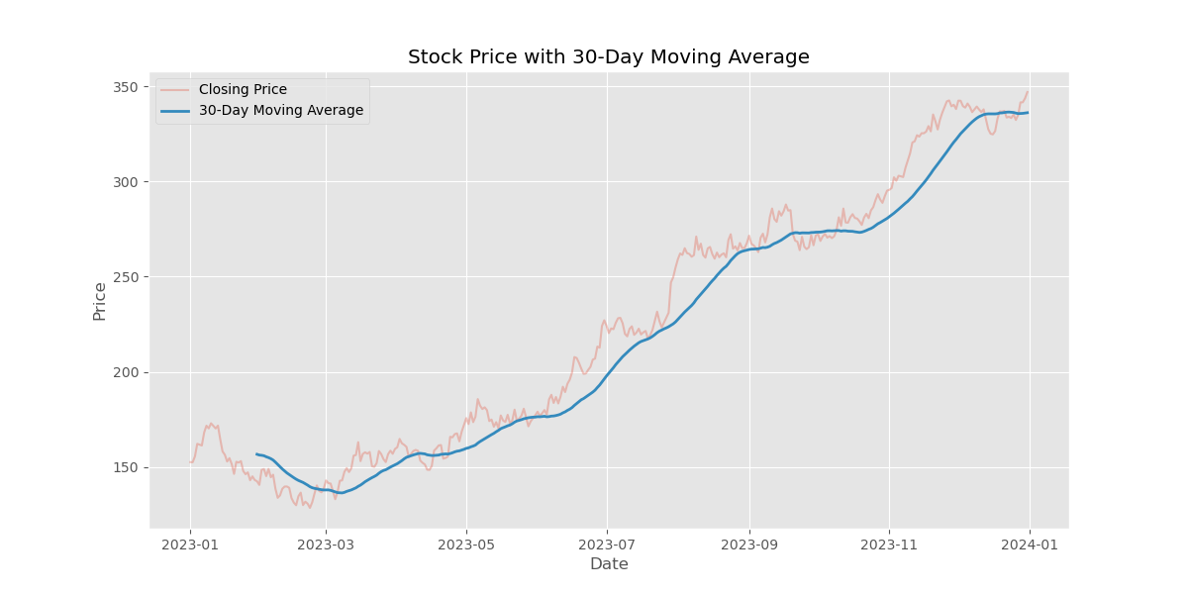
Trading volume trend
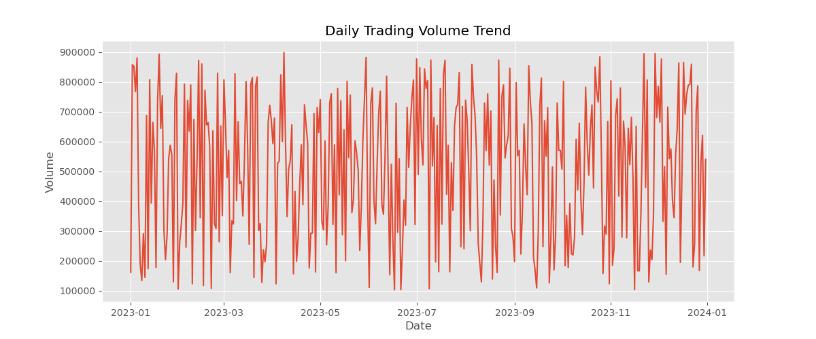
Market volatility pattern
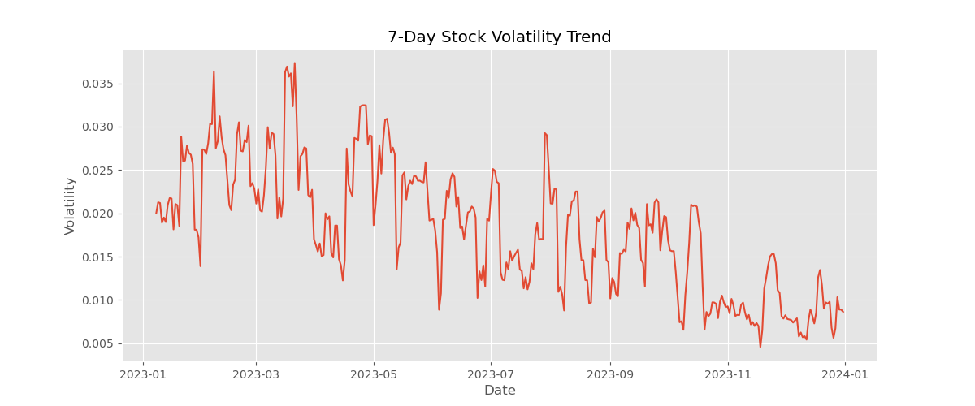

Business Recommendations

- Use Moving Averages Before Making Decisions
Rely on 30 day MA instead of reacting to short-term noise.
- Watch Volume Spikes
They often signal major shifts or upcoming price movement.
- Monitor Volatility for Risk Management
High volatility suggests caution; low volatility suggests stability.
- Diversify Investment Strategy
Using volatility signals can help reduce risk and optimize returns.
- Combine Indicators
MA + Volume + Volatility = Better trading decisions and trend confirmation.

