***North South University***

***Course: CSE327***

***Section:06***

***Groupmates:***

* *Md Siamul Islam - 1511914642*
* *Nasim Ahmed Bulbul - 1711608042*
* *Md Moin Uddin - 1711132042*
* *Dipu Chandra Malo - 1712419642*

**Table of Contents**

|  |  |
| --- | --- |
| Project Proposal | **4** |
| **1. Introduction!** | **5** |
| * 1. Purpose! | 5 |
| 1.2. Scope! | 5 |
| 1.4. References! | 5 |
| 1.5. Overview! | 5 |
| **2.Stakeholders** | 6 |
| **3.Requirements Elicitation Technique** | 6 |
| **4.Overall Description!** | **7** |
| 4.1. Product Perspective! | 7 |
| 4.2. Product Functions! | 7 |
| 4.2.1. Account Registration! | 7 |
| 4.2.2. Account Login! | 7 |
| 4.2.3. Forgot password | 7 |
| 4.2.4. Reserve! | 8 |
| 4.2.5. Contact Us! | 8 |
| 4.2.6. Update Account Information! | 8 |
| 4.2.7. Account Logout! | 8 |
| 4.3. User Characteristics! | 8 |
| 4.4. Constraints! | 8 |
| 4.5. Assumptions and Dependencies! | 8 |
| 4.6. Apportioning of Requirements! | 9 |
| 4.7. Context Diagram | 9 |
| **5. Specific Requirements!** | **9** |
| 5.1. External Interface Requirements! | 9 |
| 5.1.1. User Interfaces | 9 |
| 5.1.2. Hardware Interfaces | 10 |
| 5.1.3. Software Interfaces | 10 |
| 5.1.4. Communication Interfaces | 10 |
| 5.2. Functional Requirements! | 10 |
| 5.2.1. Stimulus: Click "Register" Button: Account Registration! | 10 |
| 5.2.2. Stimulus: Click "Login” Button: Account Login | 10 |
| 5.2.3. Stimulus: Click "Reserve” Button: Reserve | 10 |
| 5.2.4. Stimulus: Click "Contact Us" Button: Contact Us | 10 |
| 5.2.5. Stimulus: Click "Update Account Information” Button: Update Account information | 11 |
| 5.2.6. Stimulus: Click "Logout" Button: Account Logout | 11 |
| 5.3. Non-Functional Requirements | 11 |
| 5.3.1. Performance Requirements | 11 |
| 5.3.2. Reliability! | 11 |
| 5.3.3. Availability! | 11 |
| 5.3.4. Security! | 11 |
| 5.3.5. Maintainability! | 12 |
| 5.3.6. Portability! | 12 |
| 5.4. Logical Structure of Data | 12 |
| 5.4.1. Types of Information used | 12 |
| 5.5. Design Constrains | 12 |

**Software Requirements Specifications (SRS)**

**Project Proposal**

**Project Title: Happy Travel**

**Introduction:** In Bangladesh, there are a number of tourist spots. But there is no web application where tourist will find a simple way to know about the spots, to manage tourist guide or nearby hotels. Also, able to hire a hotel guide bookie. Our aim is to develop a web application by which we shall be able to diminish this kind of issues.

**Our Features with description:**

**Technical Features: -**

* Sign up: There will be sign up window for the user. Those users will be able to see every detail who are signed up. Otherwise, they will be able to see only the Home window.
* Login: People logged in to our website will be served with all our features.
* Admin panel and easy data insertion: There will be an admin panel. All major changes must be done by the Administrator. We shall keep an access through which admin will be able to manage data from website. They will not need to bring changes in the code. So, data will be inserted easily.
* Users Access restriction: Users will not be allowed to book any hotel or tourist guide without proper authentication.
* User feedback: Users have the freedom to send us the feedback.

**User Level Features:**

* Location of spot: Users (Especially, foreigners) will get explicit information about the spots where they can visit through the help of this website.
* Hotel Booking: Tourists will be able to book hotels for the respective spots through our website.
* Tour Guides for respective spots: Tourists will be able to book tour guides for the respective spots through our website.

**Languages and Framework: -**

* HTML
* CSS
* PHP
* jQuery
* SQL

Front-end framework

* Bootstrap

Back-end framework

* Laravel

**Conclusion:** This is a project to develop an idea to ease the difficulties one faces while traveling. This project will not only diminish this tourism related difficulties but also increase the business benefits of tourism sector. Our belief is that one handy web application will make a huge change in this sector. A steady, sustained and ongoing development of this application may achieve more user value in future.

**1. Introduction**

**1.1. Purpose**The purpose of this Software Requirements Specifications (SRS) is to fully document the specifications and requirements for the Travel Guideline. Here is all the specification that we will be implementing in our website. The audience of this SRS will be the clients who want the software to be built and the technical professionals developing the software.

**1.2. Scope**The objective of this project is to create and implement a website for the Tourism. The website will be used primarily by travelers from all over The world. The website will allow users to create and maintain individual secured accounts. People around World can easily reserve hotel and guide at the website, and get all the information about the places.

**1.4. References**The following material was used in creating this document:  
• IEEE Std 830-1998, IEEE Recommended Practice for Software Requirements Specifications.

**1.5. Overview**The rest of the SRS is organized as follows:

* Stakeholders
* Requirement elicitation techniques
* Section 2 is an overall description of the project.
* Section 3 cites the specific requirements

1. **Stakeholders: -**

* Local governments with specific competence in tourism matters;
* Tourism establishments and tourism enterprises, including their associations;
* Tourism employees, tourism professionals and tourism consultants;
* Trade unions of tourism employees;
* Tourism education and training centers;
* Travelers, including business travelers, and visitors to tourism destinations, sites and attractions;
* Local populations and host communities at tourism destinations through their representatives;
* Other juridical and natural persons having stakes in tourism development including non-governmental organizations specializing in tourism and directly involved in tourism projects and the supply of tourism services."

1. **Requirements Elicitation Techniques: -**

**Questionnaires: -**

1. **Do you think a secured admin panel is necessary?**

**Ans:** Yes obviously. Because I do not want to show my personal info in public. Also, I want to show that info which I like. But there is some other information I want to keep it private. So, security reason is necessary, I think.

1. **Do u want to be a registered user of this application?**

**Ans:** Yes. I want to be a registered user of this application because this travel tour registration form clients so they can easily register them.

1. **Do you expect any login panel in this software?**

**Ans:** Yeah i want. I want my every information to be secured in this software also.

* **Brainstorming: -**

We have to think about the policies like national tourism policy cause without maintaining those policy we can't launch our web application in market.

* **Observation: -**

**Analysis of Existing System: -** We have to analysis the functionality of existing web application to build a unique web application.

**4. Overall Description**

**4.1. Product Perspective**This product is an entirely new product. It is not a component of a larger system. The Happy travel, this system will interact with other Hotel Management sites in order to book hotels from the website. The system will also interact with the Hotel’s Inventory database, which records the quantity of rooms available for booking in the inventory. The website will also suggest some places on the account holder’s choice of preference. It will hold a record of each user that books Hotel rooms and tour guides. It will also have a review system by which users will give their feedback.

**4.2. Product Functions**The following list of function descriptions explains the major features of our Happy Travel Web Application.

**4.2.1. Account Registration  
The registration function shall allow users to create secure accounts.** The account will track the user’s name, address, username and password.   
*Rationale:* This provides security to the account member by setting up an account that is password protected. This also offers convenience so the user only has to enter the information listed above once and then it is stored in the account.

**4.2.2. Account Login  
The account login function shall allow account members to enter  
their username and password.** Once verified, users will be able to access account history, and update their account information.  
*Rationale:* This provides a method by which the user can access the restricted operations.

**4.2.3. Forgot Password   
This function will allow to change the password if the user forgets it.** It will ask some question regarding their information and if all the information matches then the user will have access to change the password.

**4.2.4. Reserve  
The reserve function shall hold booking Hotels and tour Guides***Rationale*: This offers convenience to the user by allowing them to make sure a booking is placed for hotel or guides.

**4.2.5. Contact Us  
The contact us function shall give users the office address, telephone number and email address.**  
*Rationale:* This helps the user gain trust in the tour agency by showing how easy it is to have person-to-person contact with agency employee.

**4.2.6. Update Account Information  
The update account information function shall give account members access to edit their stored information.***Rationale:* This offers convenience to the account members by allowing them to make changes to account information immediately.

**4.2.7. Account Logout  
The account logout function shall allow account members to exit their account for security purposes.***Rationale:* This allows account members to exit their accounts, and prevent others from accessing it.

**4.3. User Characteristics**Users of the website must know how to navigate in a website and place an booking of the desired need.

**4.4. Constraints**The constraints on the services and functions of the system are as follows.  
• The software product must confirm to Tourism disclaimer policy.

**4.5. Assumptions and Dependencies**Since the Tourism guideline website is only accessible through the Internet, it is assumed that the end user has a connection to the Internet. It is also assumed that the user has a web browser able to display the website. (I.E. Microsoft Internet Explorer 4+ or compatible browser)

**4.6. Apportioning of Requirements**There are no requirements that may be delayed until future versions of the system.

**4.7. Context Diagram**

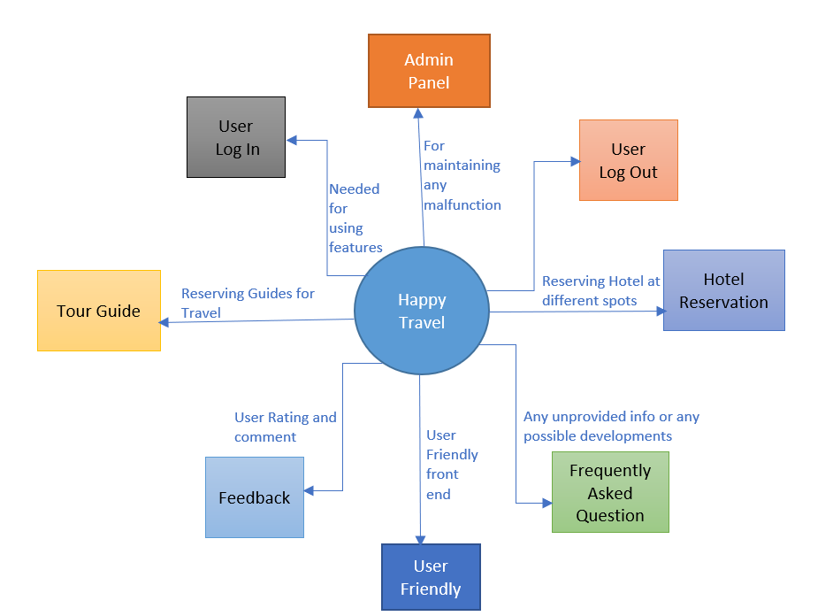

**5. Specification Requirements**

**5.1. External Interface Requirements**

**5.1.1. User Interfaces**The system will provide the ability for people to access the Travel guideline via the Internet. There will be two different user interfaces that will accompany this website: one for the user, and the administrators.  
• User will not be allowed to search database without having to login, however, they must login in order to perform any other queries. These other will include reserving hotel or guide, or viewing their account information.  
• Administrators will be required to login at all times. However, they will have all the access via the web-interface. They can update web application data through the web app.

**5.1.2. Hardware Interfaces**There are no special hardware interface requirements.

**5.1.3. Software Interfaces**The website will be using one of the most popular framework bootstraps and Laravel and. Through these frameworks the website will be designed and other features will be given.

**5.1.4. Communication Interfaces**There are no special communication interfaces requirements.

**5.2. Functional Requirements**

**5.2.1. Stimulus: Click "Register" Button: Account Registration**1. The system shall allow a non-registered user to create a secure account.  
2. The system shall require the following information from the user: Name, Email, Username Password.  
3. The system shall ask the user for a username and password.  
4. The system shall confirm the username and password are acceptable.  
5. The system shall store the information in the database.

**5.2.2. Stimulus: Click "Login" Button: Account Login**1. The system shall allow a registered user to log-in to their account.  
2. The system shall require a username and password from the user.  
3. The system will verify the username and password, and the user will be

considered “logged-in”.

**5.2.3. Stimulus: Click "Reserve" Button: Reserve**1. The system shall allow a registered and logged-in user to reserve a Hotel or guide.  
2. The user must enter a name, mailing address, phone number, and email address.  
3. The user is given a confirmation number.

**5.2.4. Stimulus: Click "Contact Us" Button: Contact Us**1. The system shall allow a user to view various methods of contacting the travel agency.  
2. The system shall display the office address, telephone number, email address, and directions on how to get to the office.  
3. The system should also display a map showing the location of the office.

**5.2.5. Stimulus: Click "Update Account Information" Button: Update Account Information**1. The system shall allow a user to update the information in their account.   
2. The user shall be able to change their password by entering the old one once, and a new one twice.

**5.2.6. Stimulus: Click "Logout" Button: Account Logout**1. The system shall allow the registered and logged-in user to exit his/her account, so that access to operations requiring a user to be logged in are now disabled.

**5.3. Non-Functional Requirements**

**5.3.1. Performance Requirements**The performance requirements are as follows:  
• System login/logout shall take less than 5 seconds.  
• Orders shall be processed within 10 seconds.

• System shall support 10,000 simultaneous users.

**5.3.2. Reliability**The average time to failure shall be 30 days. In the event that a server does crash, a backup server will be up and running within the hour.

**5.3.3. Availability**The Online Travel guideline shall be available to users 24 hours a day, 7 days a week, with the exception of being down for maintenance no more than one hour a week. If the system crashes, it should be back up within one hour.

**5.3.4 Security**Users will be able to access only their own personal information and not that of other users. Reservation will be handled through a secure server to ensure the protection of user’s personal information.

**5.3.5. Maintainability**Any updates or defect fixes shall be able to be made on server-side computers only without any patches required by the user.

**5.3.6. Portability**Nothing required

**5.4. Logical Structure of the Data**The two sections below show the different types of information used by various functions and the overall data model, respectively.

**5.4.1. Types of Information used**The types of information used by various functions of the website:

|  |  |
| --- | --- |
| **Function** | **Types of Information Used** |
| Account Registration | User information (name, email, number, and user name, and password) |
| Account login | User information (user name, and password) |
| Update Account info. | User information (name, email, number, and user name, and password). |
| Hotel Booking | User information (name, email, number, address). |
| Hotel Booking | User information (name, email, number, address). |

**5.5. Design Constraints**The Online Travel guideline shall conform to the following design constraints:  
• Able to support PC, Mac, Mobile platforms.  
• System supports all web browsers (i.e. graphical, non-graphical).