Hello there,

I place an order (Order #111-1218974-4317038), and Then I receive an Email from you,said my account was been locked ,and you want me to fax you a statement which displays the billing name and address for the card.

I don't know why ,then I thought maybe that's because I filled in the wrong billing address.I do not know it would lead to such serious consequences. Please open my account，thank you.If you need any other information,please tell me.That is my billing statement of 01/2019 and my credit card‘s image below.Please check.

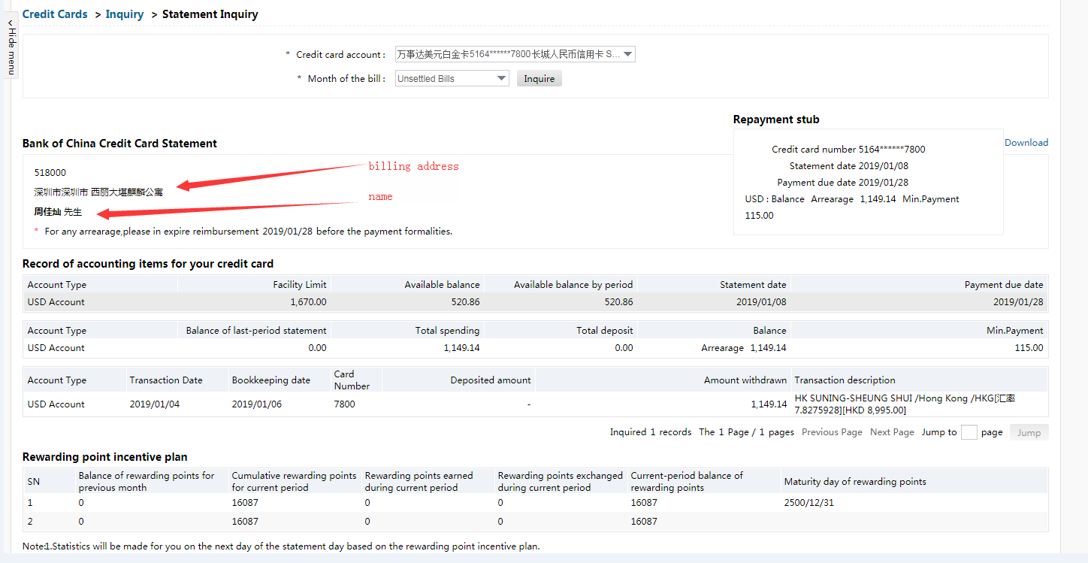

billing statement :

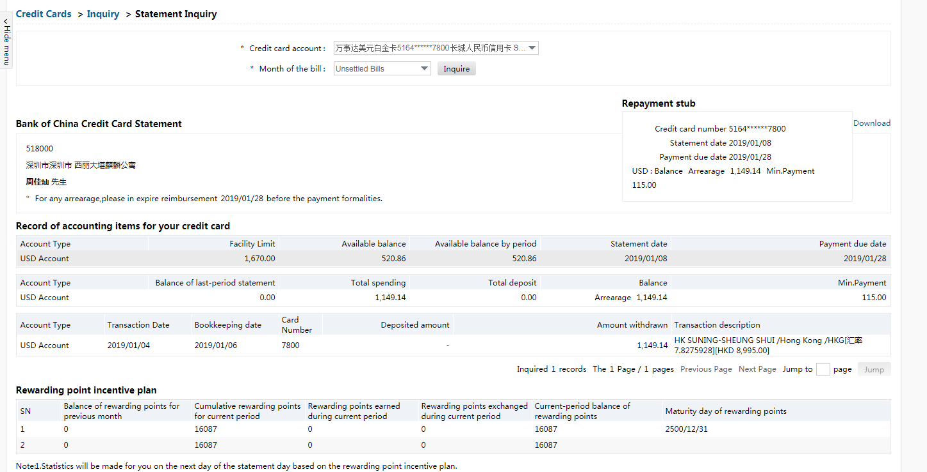

Credit Card Image:

