# **LocationFinder**

Dira GeoSystem's LocationFinder is an extremely fast and user-friendly interactive search for named locations such as place names, addresses, plot numbers, points of interest, etc. The LocationFinder is an “on-premise” solution and can therefore be used for sensitive in-house data.

The LocationFinder allows for interactive searching of named locations through a single text field. Locations can include addresses, place names, postal codes, glaciers, hydrants, and general points of interest.

## Your own data

The LocationFinder operates on your own data (no data is supplied) and provides access to an interactive search, for example, to correctly position a map.

## Examples of Applications

The LocationFinder operates on your own data (no data is supplied) and makes them accessible for an interactive search, for example, to correctly position a map.

|  |  |
| --- | --- |
| **Industry/sector** | **Search for (examples)** |
| Large retailers | Addresses, branches, possibly competitor locations. |
| Emergency services | Places, field names, mountains, hospitals, air bases |
| Police, fire department, emergency medical services | Addresses, streets, neighborhoods |
| Municipalities, offices | Field names, parcels, offices, workshops |
| Telecommunications | Antennas, addresses, administrative regions |

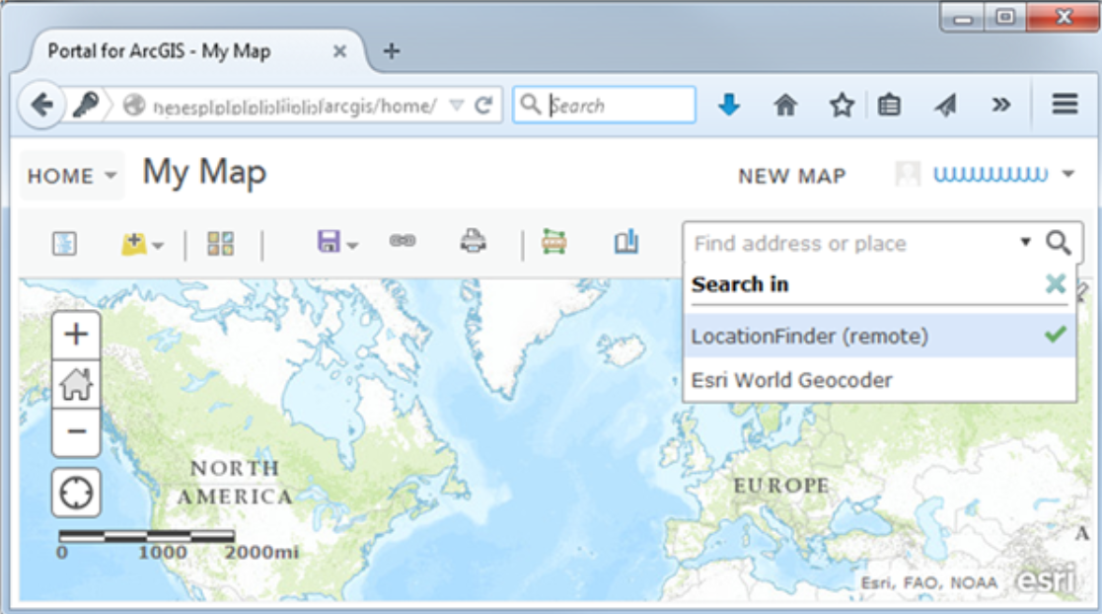

LocationFinder as an integrated search in ArcGIS

## The LocationFinder is optimised for speed, easy administration (no dependencies), and extensive configurability.

## Features

* Interactive geocoding (given name/address, find coordinates)
* Lexicographically sorted result list, even for partial queries
* Reverse geocoding (given point, find nearest address/place name)
* Very high speed, even with a large number of locations
* Simple REST interface for queries
* Queries can narrow down search results using Boolean filters
* Developed in 100% .NET, no additional dependencies
* Operates on-premise, making it suitable for sensitive data
* Easy installation and administration
* Optional integration into the ArcGIS platform (ArcGIS Online, ArcGIS Enterprise, ArcGIS Pro)

## Limitations

* The LocationFinder does not include its own data.
* The LocationFinder does not provide an interface for end-users, as its application is the integration into your application.
* The LocationFinder was developed for interactive search and is not suitable for geocoding lists (batch geocoding).

A simple REST API for integration

## Architecture

The LocationFinder is a server-side solution consisting of two programs: a Builder and a Service. The Builder reads location data and constructs an index structure on disk. The Service uses this index structure to respond to queries directed to it via a simple REST API. (The Service also implements the Esri REST API to allow integration into the ArcGIS platform.) The Builder reads data in a simple XML format. (With the help of plugins, it can also read Esri feature classes and some other formats.) The build configuration determines how the search “feels” (behaves) to the end-user. For example, it is possible to generate keywords for categories to assist the user in searching, shoot in synonyms, and to some extent, determine orthographic tolerance. Furthermore, it is possible to derive aggregates from existing locations, such as streets and postal code areas from address points.

## Integration into your application(s)

The Builder program has a graphical interface for creating the build configuration. However, the Service program only provides a REST API and no interface for end-users. The Service is designed to be integrated into an application (or into the ArcGIS platform). Dira GeoSystems has extensive experience in integrating the LocationFinder into your applications.

## System Requirements

The LocationFinder requires .NET Framework 4.8 and a fast local disk for the index. There are no additional dependencies, making installation and operation very simple.

## Road Ahead

The next major release will further reduce dependencies and only require .NET Core (in the current version at that time), allowing the LocationFinder to be operated on Linux systems or in containers.

## Licensing

The LocationFinder requires a license for each productive instance of the Service program. Test instances do not require a license. An initial license is necessary for the first instance, and a subsequent license is required for each additional instance per customer.

There are two options for acquisition:

Perpetual License: for the current version at the time of acquisition. Support is available separately and is not included in the license fee. An upgrade to the latest version is available at the cost of a subsequent license.

Annual Subscription: covers all available versions, especially the latest version, and includes limited-time remote support for the latest version and its predecessor.

## Contact

For further information or a quote, please contact us: Phone +41 44 2448442 or email at [hello@dirageosystems.ch](mailto:hello@dirageosystems.ch).

Dira GeoSystems AG

c/o Impact Hub Zurich AG

Viaduktstrasse 93-95

CH-8005 Zurich