# 

# **Dira ProSuite**

Dira GeoSystems develops and distributes powerful tools for professional data production, quality assurance, and cartography with Dira ProSuite. Dira ProSuite is implemented as an extension ("Add-In") for Esri's ArcGIS Pro.

## Three complementary functional areas

Dira ProSuite comprises three functional areas that complement each other but can also be used separately:

1. ProSuite QA is the fastest quality assurance for geospatial data available on the market.
2. ProSuite Edit Tools are editing tools for highly efficient (especially topographic) data production and error correction.
3. ProSuite Carto are a set of processes for fully and semi-automated cartographic post-processing to meet the highest aesthetic standards.

## Suitable for small and large organisations

Dira ProSuite is successfully used for the efficient processing and validation of very large datasets in complex organisations but has also proven itself in smaller projects. Dira ProSuite supports both interactive editing and validation by the user in ArcGIS Pro and automated deployment as a batch process.

## A complete and self-consistent solution

### Add-In for ArcGIS Pro

* Tools for error detection and correction in geospatial data
* Editing tools
* Auxiliary tools (e.g., browse assistant)
* Cartographic algorithms

### Administration client

* Configuration of quality checks
* Configuration of map processes
* Other central configurations

### Batch-Processes

* Quality check
* Schema analyses
* Map processes

# **ProSuite QA** Professional quality assurance of geospatial data

Dira ProSuite QA is the comprehensive solution for quality assurance of geospatial data in ArcGIS. It impresses with efficiency, validation logic, stability, scalability, and integration capabilities, convincing organisations responsible for large, complex, or critical datasets. Geospatial data and map producers achieve increased productivity and data quality with ProSuite QA, both in the data editing process and in the reception and delivery of data products.

## The centerpiece: 130 test algorithms

With over 130 available test algorithms, there are nearly unlimited possibilities for quality checking geospatial data. Features of the QA tests include:

* Very fast verification of spatial relationships, even with very large datasets
* Exact identification of error geometry and involved features
* Complex attribute conditions can be combined with spatial conditions
* Individual exceptions can be saved
* Features from different databases can be checked against each other

## Definition and verification of individual quality conditions

Dira ProSuite QA offers comprehensive capabilities for the definition and verification of quality conditions beyond the standard mechanisms of the geodatabase. Currently, there are over 120 test algorithms available in the following categories:

* Attributes and Relationships
* Geometry of Individual Features
* Linear Networks (even without geometric networks)
* Proximity (distances between features)
* Topological Conditions (even without topology datasets)
* M-Values
* Z-Values
* 3D Buildings (Multi Patches)
* Polygon Networks (boundary lines and centroids)
* Cartographic Symbolisation
* Schemas of Tables/Feature Classes
* Complex Combinations of these Categories

# Exact Identification of Errors

Dira ProSuite QA documents identified errors and warnings in error feature classes. A browsing assistant guides the user directly to individual errors, displaying the error geometry, features involved in the error, and information about the affected quality rule.

## 

## Efficient interactive error correction

The user is guided to the geographically nearest error during error inspection. Due to the precise error description and efficient editing tools, the identified error can be corrected immediately.

The editing tools are available not only for error correction but also for regular data entry. They provide an optimised editing workflow and simplify many challenging editing tasks (e.g., topologically correct alignment of features, bulk attribution, editing linear networks).

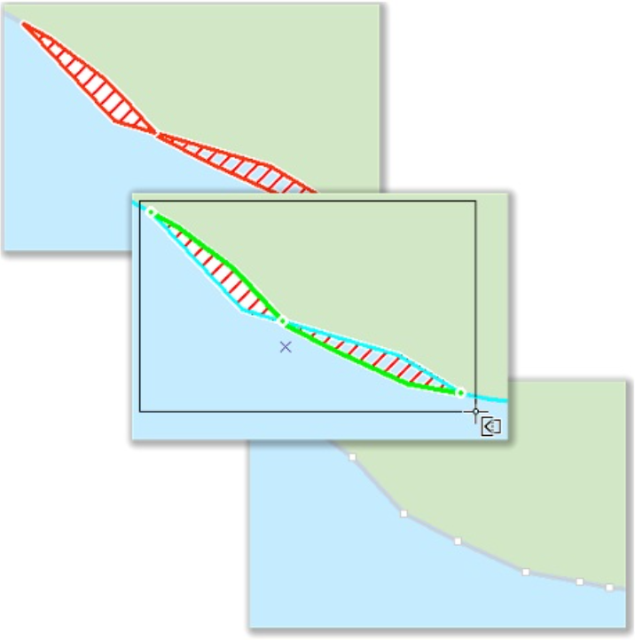

## Highest performance even with very large amounts of data

Thanks to in-memory technology, even very large amounts of data can be quickly checked. In particular, spatial relationships can be checked very efficiently. QA tests are executed in a test container that guarantees both highly efficient data access and very fast processing of features held in memory tile by tile.

## Comfortable configuration and easy exchange

For the configuration of QA tests, a convenient graphical administration environment is available. The configuration is stored in a database (the ProSuite Data Dictionary) and can be exported and exchanged in the form of XML files.

## Optimised data production environment.

Dira ProSuite QA enables checks directly during data capture in ArcGIS Pro. Prior to delivery, a very fast and comprehensive examination of the entire dataset ensures the specified quality.

* Integrated editing tools (ProSuite Edit-Tools) support error-free data capture and efficient error correction
* Significant increase in productivity thanks to short check/correction cycles
* Multi-stage examination: selected objects, entire work packages, or fully integrated data sets.

## Automated examination using geoprocessing tools

Quality checks can also be automated outside of ArcGIS Pro:

* Examination against individual quality conditions
* Ad-hoc examination of basic quality conditions
* Documentation and evaluation of schema differences
* Examination of the result of date transformations
* The examination results are extensively documented.

## Flexible integration into existing environments

Dira ProSuite QA is well applicable within specialized modules and as a complement to existing QA solutions.

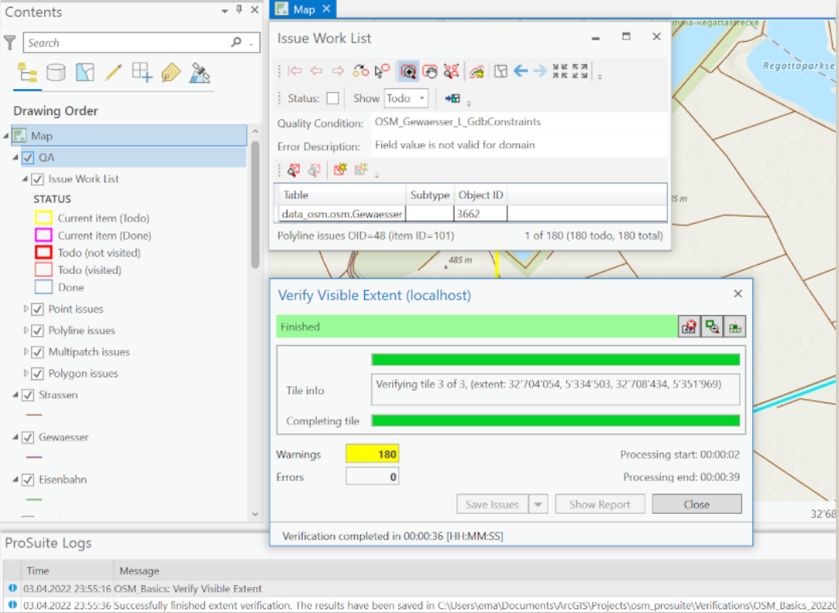

Screenshot showing ProSuite QA running in ArcGIS Pro

# **ProSuite Edit Tools** Highly efficient geodata capture and processing

Dira ProSuite Edit Tools can be used as part of QA for efficient error correction, but also independently of QA for efficient data capture and processing. Over more than 15 years, interactive editing workflows have been optimized and further developed in collaboration with various national mapping authorities and offices at the national or cantonal level.

Thanks to the interactive editing tools, data capture productivity and control over the behaviour of the tools, and consequently, the quality, can be significantly enhanced.

The key tools are already available on ArcGIS Pro, including the classics such as 'Reshape Along,' 'Advanced Reshape,' 'Remove Overlaps,' and others. We are happy to assist you in migrating to the new platform and implementing additional tools as needed or as part of our subscription.

# **ProSuite Carto**

Dira ProSuite Carto comprises approximately 20 “Carto processes” for the cartographic post-processing of topographic data, meeting the highest aesthetic standards. The Carto processes are flexibly configurable, both centrally and individually at the workplace. All processes can be executed interactively as editing tools or in bulk through selections or the entire database.

# **Status & Road Ahead**

Dira ProSuite for ArcGIS Pro is a commercial product of Dira GeoSystems AG, consisting of extensions for Esri ArcGIS Pro as well as server components. Large parts of the Dira ProSuite are open source and are available for free use and critical examination on github.com/prosuite.

Dira ProSuite is currently in development. Essential components of the complete solution are already available (and are also in productive use), while other components are still actively being developed. Employees of Dira publish on technical topics related to Dira ProSuite in the ProSuite Tech Blog.

The ProSuite was formerly developed and distributed by Esri Switzerland as an extension for ArcMap. The source code of this Esri ProSuite for ArcMap is proprietary to Esri Switzerland AG. With the discontinuation of ArcMap, Esri Switzerland also discontinued the ProSuite. Dira GeoSystems is developing this new solution based on ArcGIS Pro with two goals: (1) to offer comparable functionality on the new platform and (2) to achieve extensive reusability of existing customer configurations. Dira GeoSystems aims to provide customers with continuity and a seamless transition into the 'new world' of ArcGIS Pro. At the same time, Dira GeoSystems will revise and improve the functionality, carefully listening to the needs of our customers.

# Contact

For further information or a quote, please contact us:

 (+61) 0494 066 467

Transparent Email Icon Images – Browse 11,966 Stock Photos ... [hello@dirageosystems.com.au](mailto:hello@dirageosystems.com.au).