PRODUCT REQUIREMENTS DOCUMENT (PRD)
EDU360 — K–12 School Management & Student Outcomes Platform
Version: 1.0 | Target Segment: K–12 (Nursery to Class 12) | Platforms: Web App & Mobile App

1. Executive Summary & Product Vision
EDU360 is a next-generation School Management and Student Outcomes Platform designed for K–12 schools. While traditional School ERPs act only as digital registers that store records and send repetitive notifications, EDU360 acts as an Action & Intelligence System that connects Administration, Teachers, Parents, and Students around three core principles:
- 1. Actionable Management Intelligence: Instead of forcing school management to search through dozens of static reports, EDU360 highlights what needs attention today, why it matters, and who needs to take action using a Red / Orange / Green Priority Engine.
- 2. Outcome-Oriented Parent Involvement: Instead of spamming parents with 15 notifications a day, EDU360 uses a moving-slider banner on the home screen for routine updates and a shared Student Focus Table so teachers and parents work together to improve a child's weak subjects.
- 3. Zero Extra Burden for Teachers: Automates routine work like online class attendance (via a 10-minute join rule) and allows teachers to correct and remark on uploaded homework directly inside the browser without downloading or re-uploading files.

2. Platform Strategy (Web vs. Mobile Usage)
Based on how school stakeholders work every day, EDU360 follows a Role-Optimized Platform Strategy:
User Role | Primary Platform | Secondary Platform | Why This Fits Daily Workflow
Administration / Management | Web App (Desktop/Laptop) | Mobile Web / App (Quick Alerts) | Needs a large screen for priority triage, admissions CRM, fee milestones, inventory, staff salaries, and event/vendor tracking.
Teachers | Web App (Desktop/Tablet) | Mobile App (Leave & Quick Chat) | Needs a comfortable screen to host live classes, annotate and correct student homework inline, and manage Student Focus Tables.
Students | Web App (Desktop/Tablet) | Mobile App (Timetable & Alerts) | Needs a larger screen to attend live online classes, watch class recordings, take online exams, and upload homework/achievements.
Parents | Mobile App (Android & iOS) | Web Portal (Optional) | Parents check updates on the go—viewing moving dashboard sliders, tracking the school bus via GPS, paying fees, and checking the Focus Table.

3. User Roles & Permission Matrix
IMPORTANT — Strict Document Security Rule
Official student documents in the Student Information System (SIS) can ONLY be uploaded, edited, or replaced by Administration. Teachers, Parents, and Students have strictly View/Download-Only access.

Module / Capability | Administration | Teacher | Parent | Student
SIS Official Documents | Create / Edit / Delete | View Only | View Only | View Only
Student SIS Profile & Analytics | Full Access | View Assigned Students | View Own Child | View Own Profile
Live Online Classes & Recordings | Monitor / View | Host & Record | View Schedule | Join Class & Watch Recordings
Attendance | Full Access + Override | Auto-Capture + Edit Class | View + Submit Leave | View Own Attendance
Homework & Assignments | View / Audit | Create + Inline Grade/Remark | View Remarks & Status | Upload Work + View Corrected Doc
Student 'Focus Table' | View All | Create / Edit / Track | View / Co-Track with Teacher | View Study Plan
Exams & Marks | Publish + Email Trigger | Enter / Bulk Upload Marks | View + Receive on Email | Attend Exam + View Results
Fees & Receipts | Set Milestones + Raise Alerts | View Status (Context Only) | Pay Online + Email Receipt | View Status
Staff, Salaries & Vendors | Full Access | Own Profile / Apply Leave | No Access | No Access
Inventory & School Assets | Full Access | Request / View Assigned | No Access | No Access
Events (Annual Day, etc.) | Create + Assign Staff/Students/Vendors | View + Manage Assigned Tasks | View Event Banner & Child Role | View Event Banner & Tasks
Entry/Exit & TC Clearance | Full Control + Verify Signatures | No Access | Digital Sign-Off + Physical Sign | View Status

4. Detailed Functional Requirements by Role

4.1 Role 1: Student Portal (Web-First)
- 1. Class Dashboard & Recordings (LMS Layer): Students see their daily live class schedule and join online classes with 1 click (like a video meeting). Past recorded classes are organized by Subject, Chapter, and Date so students can re-watch any lesson anytime alongside digital syllabus notes.
- 2. Student Information System (SIS — Global Profile): Connected across all modules. Displays complete exam results, attendance trends, applied leaves, performance analytics charts, and View-Only official documents.
- 3. Attendance & Leave History: Displays daily and subject-wise attendance status (Present, Absent, Late, Approved Leave) and monthly percentage.
- 4. Homework Module (Upload & Teacher Corrected View): Students view daily homework, upload their completed homework (PDF/images) online, and view the teacher-corrected document with inline remarks.
- 5. Exams & Assignments (Online & Offline): Attend online timed quizzes/exams directly in the portal and view offline exam schedules, seating plans, and published marks.
- 6. Participations & Achievements (Side-by-Side Portfolio): Displayed as two side-by-side sections: Left Section (Participations) lists all school events, sports, and competitions the student joined; Right Section (Achievements) lets the student upload certificates and awards earned.
- 7. Timetable, Holidays & Transport Route: Weekly class timetable, annual holiday calendar, and assigned school bus route showing stop timings and live status.

4.2 Role 2: Teacher Portal (Web-First)
Zero-Burden Design Rule for Teachers
Every teacher workflow must minimize manual data entry. Attendance in online classes is captured automatically, homework is corrected inline without downloading files, and marks can be bulk-uploaded or auto-graded.

- 1. Teacher Profile & Personal Dashboard: Displays today's classes, pending homework submissions to grade, student leave requests, personal attendance/salary details, and assigned event duties.
- 2. Class Dashboard & 10-Minute Auto-Attendance Rule: Teachers initiate live online classes from their dashboard. Students who join within the first 10 minutes of class start time are automatically marked PRESENT. Students joining after 10 minutes are flagged as LATE (for 1-click teacher approval), and non-attendees are marked ABSENT.
- 3. Inline Homework Correction & Remarks Module: Teachers open student-uploaded homework directly inside the browser canvas, draw corrections, write remarks, and save. The corrected file automatically updates/replaces the uploaded homework document for the student and parent to view.
- 4. Per-Student 'Focus Table' (Shared with Teacher & Parent): Based on each student's exam performance and analytics, a personalized Focus Timetable highlights which subjects or concepts the student must focus on. Both the Teacher and the Parent have shared access to track progress.
- 5. My Students List & 360° Drill-Down: View all students in assigned classes and open any student's complete SIS dashboard and performance analytics.
- 6. Parental Connection Hub: Direct communication with parents when a student's performance drops, online Parent-Teacher Meeting (PTM) scheduling, student leave approval, and visibility into student marks and fee status context.
- 7. Leave & Short-Permission Section: Apply for full-day leaves or short permissions (e.g., late arrival, early exit) routed directly to Management for approval.

4.3 Role 3: Parent Application (Mobile-First)
- 1. Anti-Spam 'Moving Slider' Dashboard: To prevent notification fatigue, routine school updates ('Results Are Out', 'Annual Day in 1 Week', 'Holiday Notice') appear as interactive moving slides/banners at the top of the Parent App. Tapping a slide takes the parent directly to that section. Parents are onboarded to open the app once daily.
- 2. High-Signal Push Notifications Only: Phone push notifications are strictly reserved for urgent items: Teacher Remarks, updates to the child's Focus Table, consecutive absence alerts, and fee reminders raised by Admin.
- 3. Automated Email Delivery for Marks & Receipts: Exam report cards/marks and fee payment receipts are automatically sent as formatted PDFs to the parent's registered email.
- 4. 5-Level Parent Involvement Workflow: Supports Level 1 (Visibility of SIS/Attendance/Fees), Level 2 (Leave requests & Teacher chat/PTM), and Levels 3–5 (Active participation and intervention using the shared Student Focus Table).
- 5. Live Bus GPS Tracking: Parents track their child's assigned school bus route and live GPS location on the map during pickup and drop-off hours.

4.4 Role 4: Administration / Management Portal (Web-First — Super Admin)
- 1. Priority Triage Command Center (Red / Orange / Green Action Engine): Instead of forcing management to check records manually, the dashboard highlights top issues by priority, explains why attention is needed, and recommends the next action:
Priority Level | Category | Example Alert Shown on Management Dashboard | Recommended Next Action
RED (Critical) | Attendance | 20 students absent today; 5 students absent for 3+ consecutive days. | Assign Class Teacher to call parents & log reason.
RED (Critical) | Academics | Class 8 Maths average marks dropped suddenly by 18%. | Trigger subject review with Maths Teacher & update Focus Tables.
ORANGE (Follow-Up) | Fees | 30 students have pending Fee Milestone dues. | Send targeted fee notification & assign follow-up call.
ORANGE (Follow-Up) | Operations | 2 school buses (Route 4 & Route 7) are not reporting GPS data. | Alert Transport Supervisor to verify GPS / driver app.
GREEN (Scheduled) | Daily Tasks | Today's urgent and scheduled administrative tasks with deadlines. | Mark complete or reassign before deadline.

- 2. Urgent & Upcoming Tasks Manager: Dedicated sections where Admin can create tasks, assign deadlines, and track completion.
- 3. Admissions & Enquiry CRM (Chatbot + Human + Follow-Up Calls): Combines an AI Chatbot + human handover for admission enquiries, logs interested leads, schedules follow-up calls for the admissions team, and converts confirmed admissions into SIS profiles.
- 4. Fee Milestone Tracking & Automated Email Receipts: Tracks installment milestones per student, allows Admin to raise fee alerts, and automatically emails digital PDF receipts to parents upon payment.
- 5. SIS & Exclusive Document Control: Admin has full access to all student details and is the ONLY role allowed to upload or edit official SIS documents (all other roles have View-Only access).
- 6. Entry/Exit Management & Dual-Signature TC Clearance: Logs gate entry/exit and manages departing students. When a student leaves the school, the system records both the Parent's Digital Approval (confirming all original certificates were received) AND a scanned copy of the Physical Signature to prevent any future legal or documentation disputes.
- 7. Complete Staff & Vendor Management: Full profiles and dashboards for all teaching staff, non-teaching staff, drivers, and vendors—covering salaries/payroll, attendance, leave approvals, and assigned classes/tasks.
- 8. Inventory & Resource Management: Tracks books, lab equipment, sports gear, and school resources (stock counts, issued items, condition).
- 9. Transparent Event & Vendor Command Center (e.g., Annual Day): Displays upcoming events across all 4 role dashboards. Clearly maps which Staff members are assigned to which event tasks, which Students are assigned under each staff member, what equipment is needed, vendor contact details, and exact handover/return timestamps.

5. Key System Workflows & Flow Diagrams

5.1 Online Class Auto-Attendance & Consecutive Absence Triage
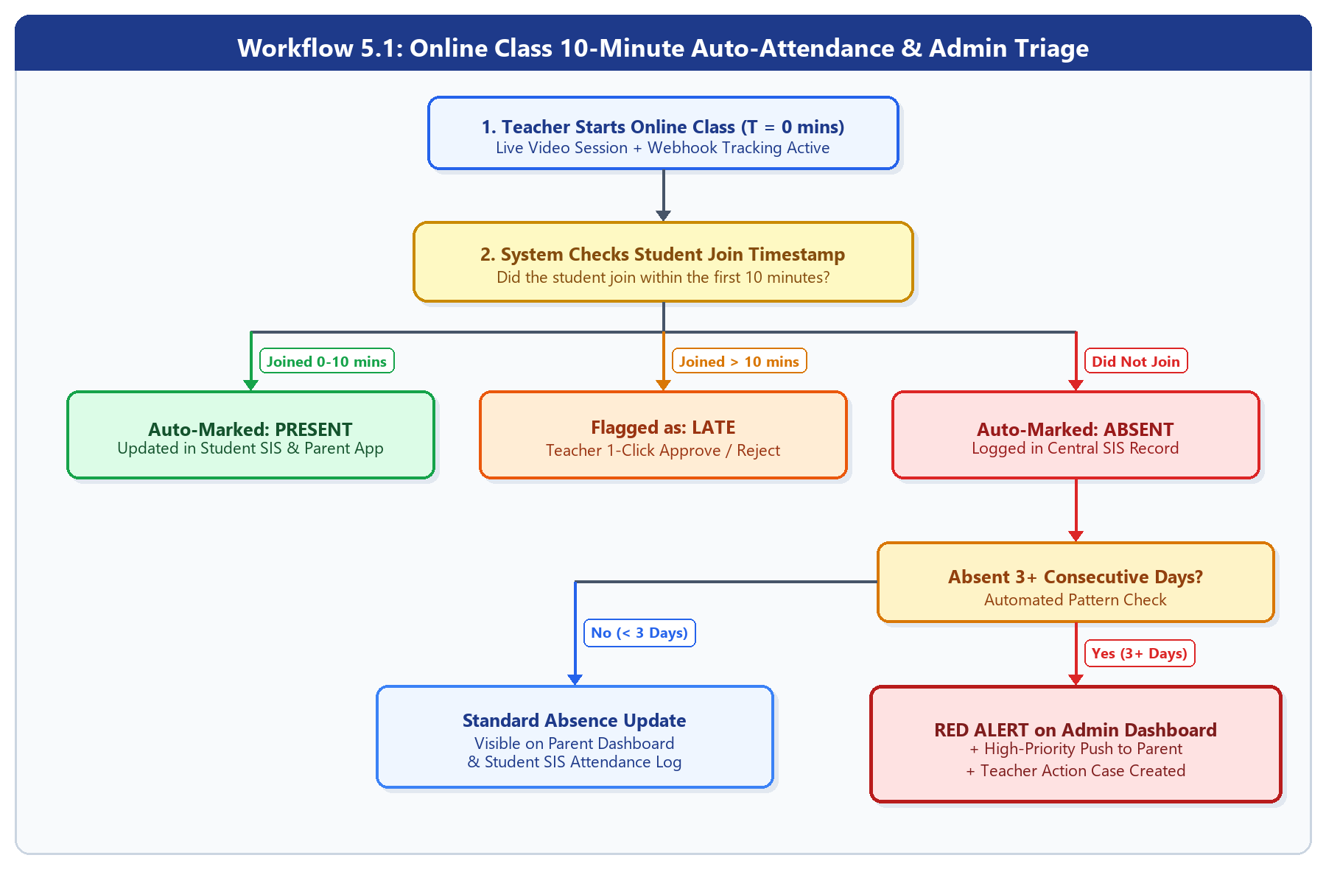
Step | Actor / System | Rule / Action | System Output
Step 1 | Teacher | Starts live online class from Class Dashboard at T = 0. | Video room opens; attendance webhook listener starts.
Step 2 | System (Auto) | Checks student join time against 10-minute rule. | 0–10 mins = PRESENT | >10 mins = LATE | No join = ABSENT.
Step 3 | System (Auto) | Checks if absent student has 3+ consecutive absences. | If Yes: Raises RED Alert on Admin Dashboard + Push Alert to Parent.

5.2 Homework Submission, Inline Correction & Focus Table Workflow
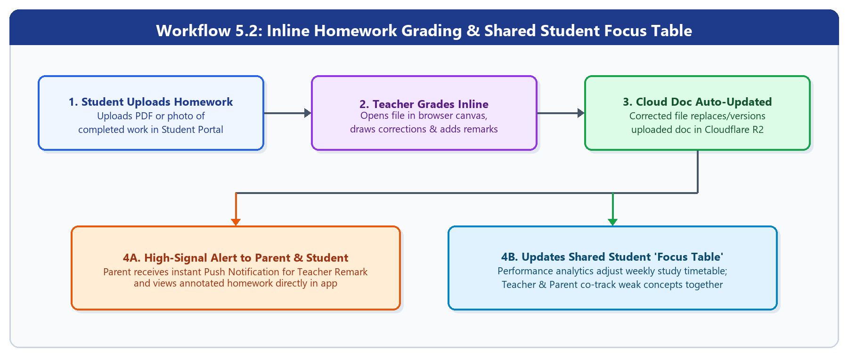
Step | Actor / System | Rule / Action | System Output
Step 1 | Student | Uploads completed homework (PDF/Image) in Student Portal. | File stored in Cloudflare R2 and added to Teacher grading queue.
Step 2 | Teacher | Opens file inline in browser canvas, draws corrections & adds remarks. | Annotated file replaces/versions original homework document.
Step 3 | System + Parent | Sends high-priority notification & updates Student Focus Table. | Parent & Teacher co-track weak concepts on the shared Focus Table.

5.3 Student Exit & Dual-Signature Legal Clearance Workflow
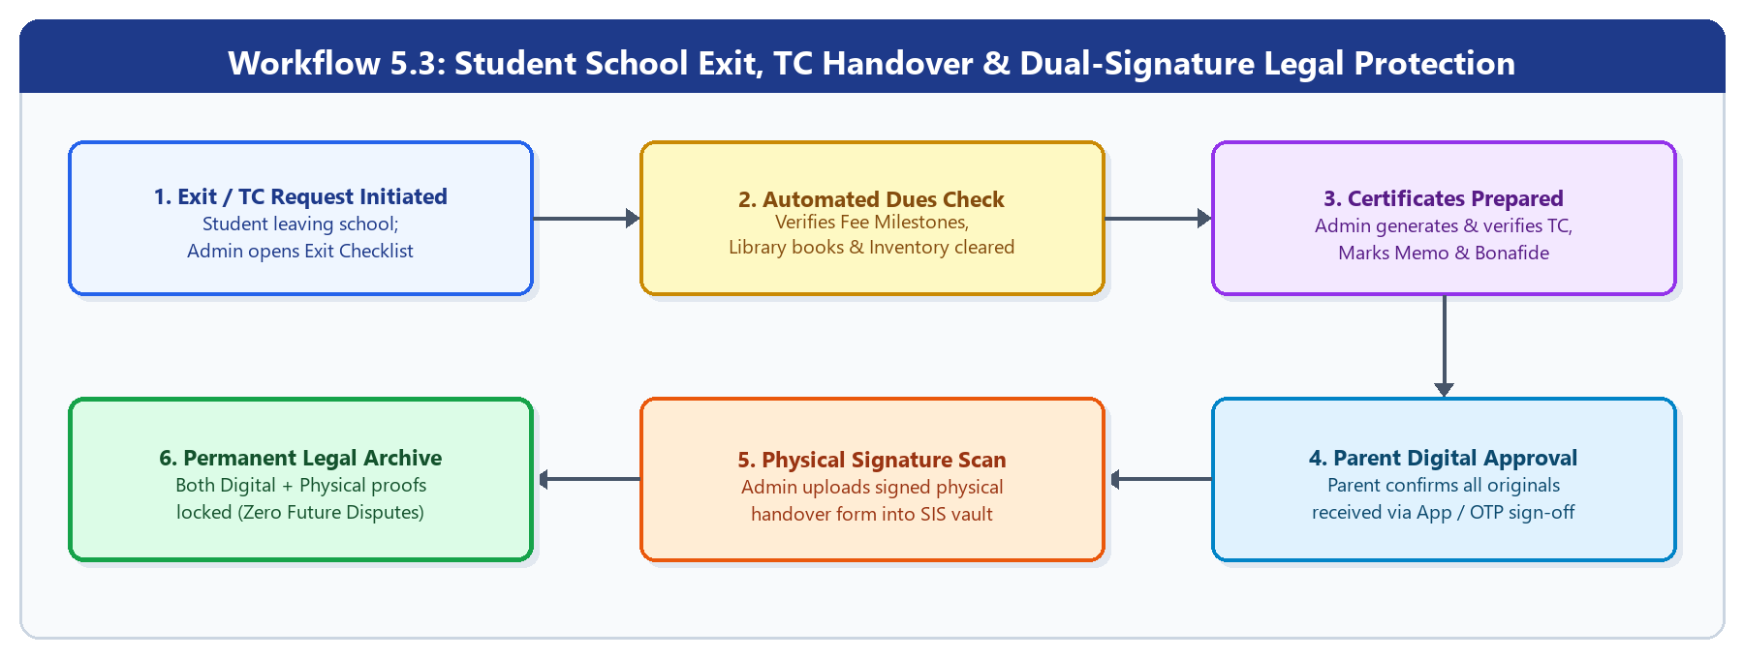
Step | Actor / System | Rule / Action | System Output
Step 1 | Admin + System | Initiates student exit and verifies zero pending fee/library dues. | Clearance checklist unlocked; original TC & certificates prepared.
Step 2 | Parent | Reviews original certificates and provides Digital Approval (App/OTP). | Timestamped digital acknowledgment recorded in SIS.
Step 3 | Admin | Uploads scanned copy of physically signed handover form. | Digital + Physical proofs permanently locked to prevent future disputes.

6. UI/UX Screen Checklist (For Design & Frontend Teams)
Role / Portal | Primary Device | Core Screens Required in Figma
Administration Portal | Web (Desktop) | 1. Priority Command Center (Red/Orange/Green Triage + Urgent/Upcoming Tasks)  2. Admissions CRM (Chatbot Logs, Lead Table, Follow-Up Call Tracker)  3. SIS Directory & Document Vault (Admin-Only Edit Lock)  4. Fee Milestone Manager & Defaulter Notification Trigger  5. Staff, Payroll & Vendor Directory + Leave/Permission Approval Queue  6. Inventory Manager (Books, Lab Equipment, Resources)  7. Event Command Center (Staff-Student Tree + Vendor Equipment Handover Tracker)  8. Entry/Exit Gate Log & Dual-Signature TC Clearance Modal
Teacher Portal | Web (Desktop/Tablet) | 1. Teacher Home Dashboard (Today's Classes, Pending Homework, Leave/Permission Form)  2. Live Class Host Studio + 10-Min Auto-Attendance Roster  3. Split-Screen Inline Homework Grader & Remark Canvas  4. My Students List & 360° Student Analytics Drill-Down  5. Shared Student 'Focus Table' Builder  6. Parental Connection Hub (1-on-1 Chat, Online PTM, Student Leave Approval)
Student Portal | Web (Desktop/Tablet) | 1. Student Home Dashboard (Moving Event Banner, Today's Classes, Attendance Summary)  2. Live Class Join Screen & Recorded Classes Video Library (LMS)  3. Homework Upload & Teacher-Corrected Document Viewer  4. Online Exam / Assignment Interface & Results Analytics  5. Side-by-Side Participations & Achievements Portfolio Upload  6. View-Only Document Vault, Timetable, Holidays & Bus Route Viewer
Parent Application | Mobile App (Android & iOS) | 1. Parent Home with Top Moving Banner Carousel (Sliders) & Child Summary  2. Shared Student 'Focus Table' & Teacher Remarks Viewer  3. Live School Bus GPS Map Tracker  4. Fee Milestones Online Payment (UPI/Cards) & Receipt History  5. Leave Request Form, Online PTM Booking & Digital TC Receipt Sign-Off

7. Recommended Technology Stack & Architecture
Architecture Layer | Recommended Technology | Why It Fits EDU360
Web Frontend | Next.js (React) + TypeScript + Tailwind CSS | Fast, responsive desktop dashboards for Admin, Teachers, and Students.
Mobile Application | React Native (Expo) + TypeScript | Single codebase for Android & iOS; shares API schemas and business logic with the web app.
Unified Single Backend | Python (FastAPI) | Unified Core + AI Engine. High-performance async Python backend handling all SIS, Attendance, and Fees endpoints while executing AI/analytics (Priority Triage, Focus Tables, Chatbot) in-process without microservice overhead.
Primary Database | PostgreSQL (Async SQLAlchemy 2.0) | ACID-compliant relational storage for linked student, fee, staff, and permission records with strict role security.
Real-Time & Background Jobs | Redis + ARQ (or Celery) | Handles live Bus GPS coordinates and scheduled background jobs (consecutive absence checks, Focus Table generation, auto-emails).
File & Video Storage | Cloudflare R2 (or AWS S3) | Stores homework uploads, corrected PDFs, certificates, and class recordings with zero egress fees.
Inline Doc Annotation | PDF.js + Fabric.js (HTML5 Canvas) | Enables teachers to draw corrections and remarks directly on uploaded homework in the browser.
Live Video & Attendance | 100ms SDK or LiveKit | Embedded live classes, auto-recording, and join/leave webhooks for the 10-minute attendance rule.
Notifications & Email | Firebase (FCM) + Resend / AWS SES | Free high-signal push alerts to Parent App; automated PDF fee receipts & marks via email.
Maps & Bus Tracking | Google Maps SDK | Displays live school bus routes and stops for Parents and Admin.

8. Phased Implementation Roadmap
Phase / Milestone | Timeline | Core Deliverables
Milestone 1: Core SIS & Admin Control | Weeks 1–5 | Role-Based Auth (Admin, Teacher, Parent, Student), Central SIS Profile, Admin-Only Document Vault lock, Admissions Enquiry CRM + Follow-Up Call Tracker, Fee Milestones with Automated Email Receipts, Staff/Salary/Inventory, and Dual-Signature Exit/TC Clearance.
Milestone 2: Classroom, Grading & Parent App | Weeks 6–10 | Live Online Classes + Recordings Library, 10-Minute Auto-Attendance Engine, Student Homework Upload + Teacher Inline Homework Correction Canvas, Side-by-Side Participations & Achievements, Parent App with Moving Banner Sliders, and Event + Vendor Handover Command Center.
Milestone 3: Intelligence Layer & Live GPS | Weeks 11–14 | Admin Red/Orange/Green Priority Triage Engine, Urgent/Upcoming Tasks Manager, Shared Student 'Focus Table' Generator, Admissions AI Chatbot, Live Bus GPS Tracking, QA & Pilot Deployment.

