Name: Ngala Dirane Ngiri

Lesson: SQL Server Development tools

Date: 20/07/2018

Question:

Take a screenshot of both tables, place them in ONE Word File and submit them via the CRM.

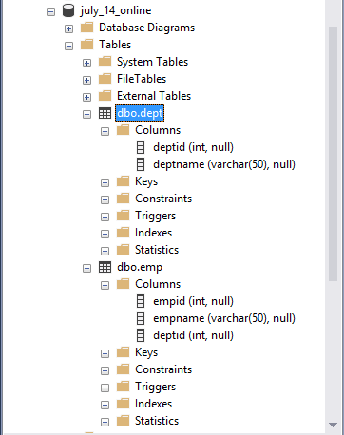

**Figure 1: Screenshot of Employee and Department tables created in SQL Server management studio**

Question:

Find an online article related to Business Intelligence, read it and send a short paragraph to the Discussion Group summarizing the article. **Attach a screenshot of your post to the group and paste it on the same Word doc created for the above homework assignment.**

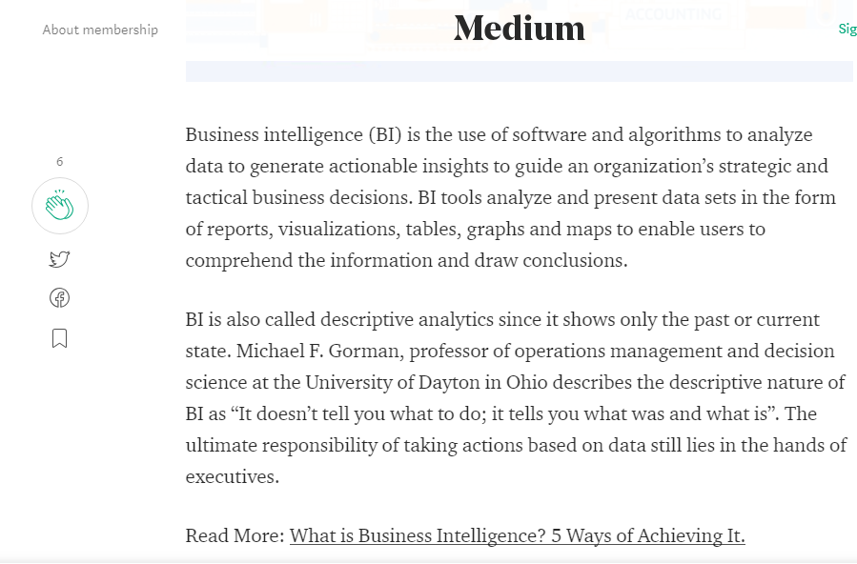

**Figure 2:Screenshot of blog post on BI taken from medium.com**