Name: Ngala Dirane

Section: Auditing and Error Handling

Date: 16/20/2018

1. Create dictionary tables in Prospects database for Title, Department, Company and Location – (Project document)

Figure : Creating Tables

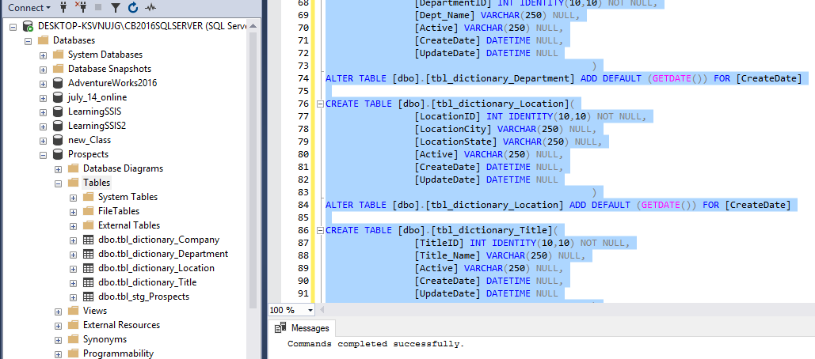

1. 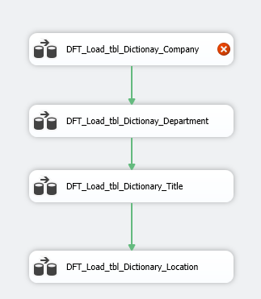Create a SSIS package ***Load_Prospects_Dictionaries.dtsx*** to load the dictionary table (make sure to lookup for records and insert/update accordingly the dictionary table)

Figure : Package created with four Data flow tasks

Figure 3: Populating Company table by configuring source and destination

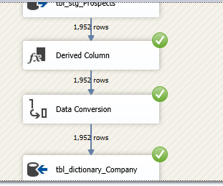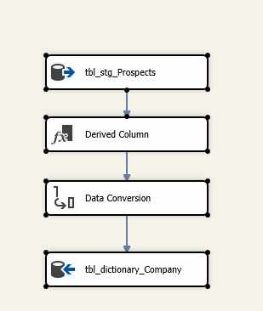

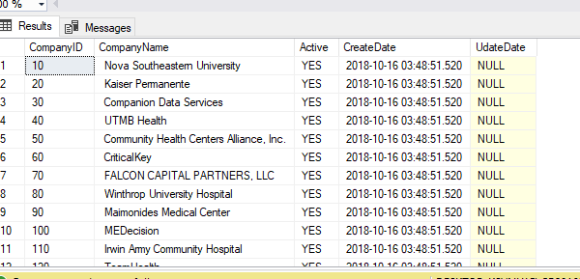

Figure : Company table populated on Insert

Figure : Configuration Of Lookup for dictionary_Company table

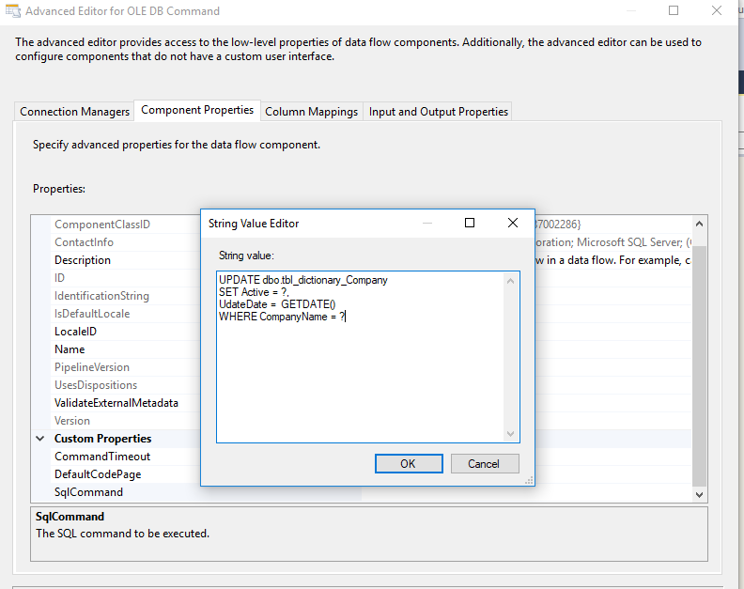

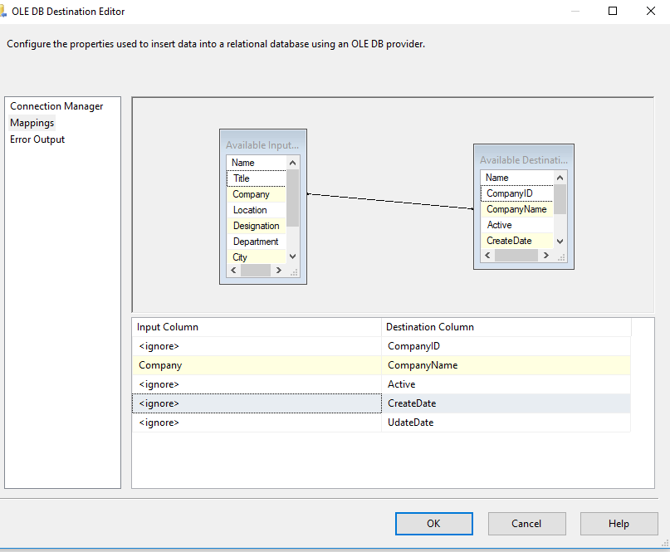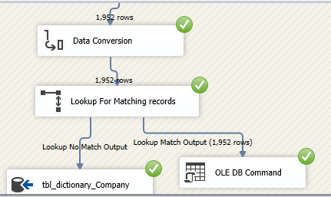

Figure : Mapping Input to output columns for dictionary_company

Figure : Images showeing data for all the four tables with Active column set, On Insert and Update Date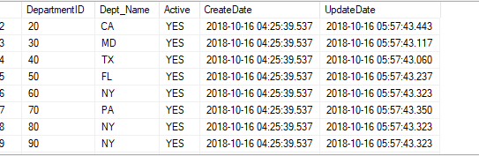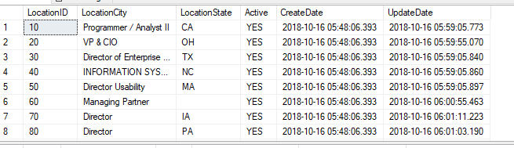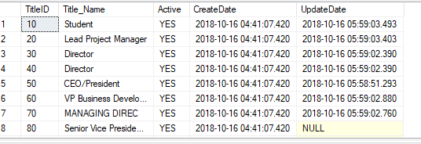

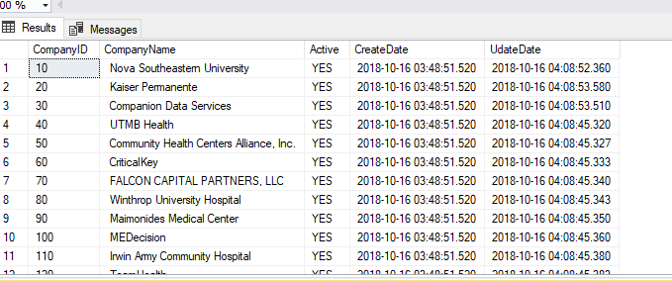

1. 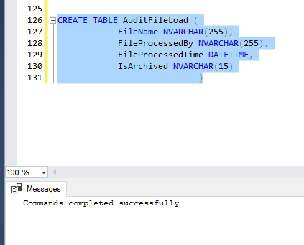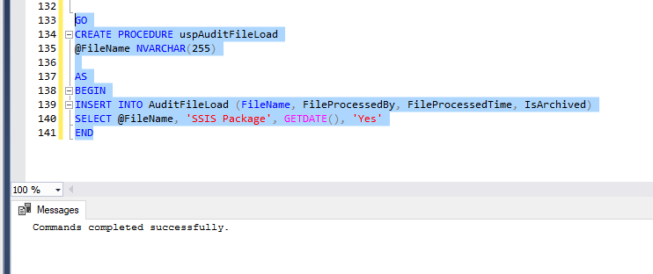Create the audit table to log file load process – (Project document)

Figure : Store Procedure

Figure : Creating the audit file load table

Figure : Configuration of the execution of Stored procedure

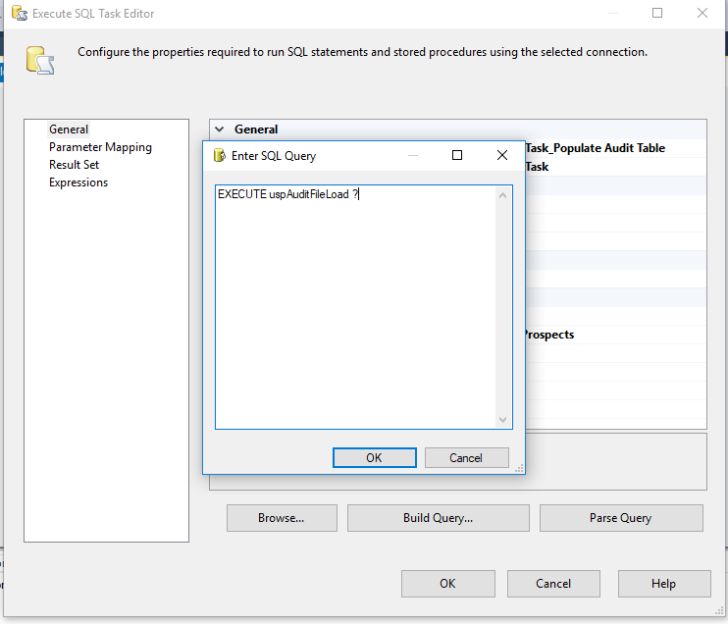

Figure : Result after audit file load

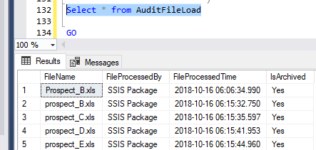

1. Modify ***Load_Prospects_Staging.dtsx*** to include the following
   1. Move the rejected files to the error folder

Figure : Configuring table for bad files

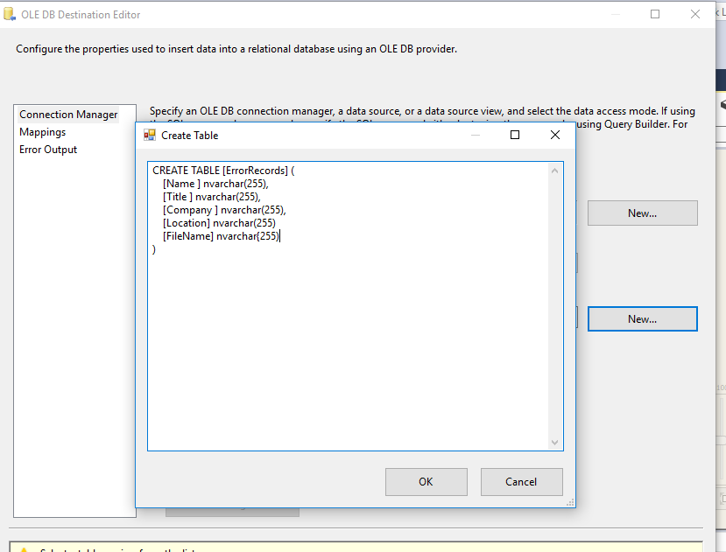

Figure : Successful run of file separation into good and bad files using multicast to different destinations

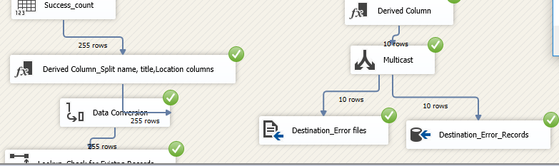

Figure : Content of error folder

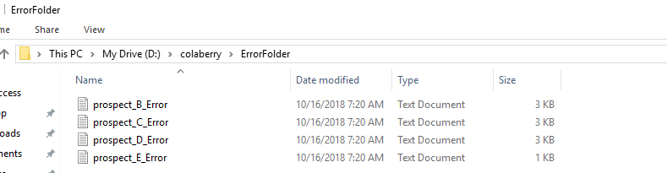

Figure : List showing the variables used for this lab

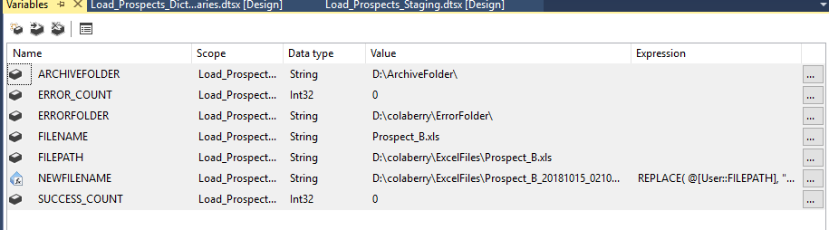

Figure : Configuring Script Task to implement count of good and bad files

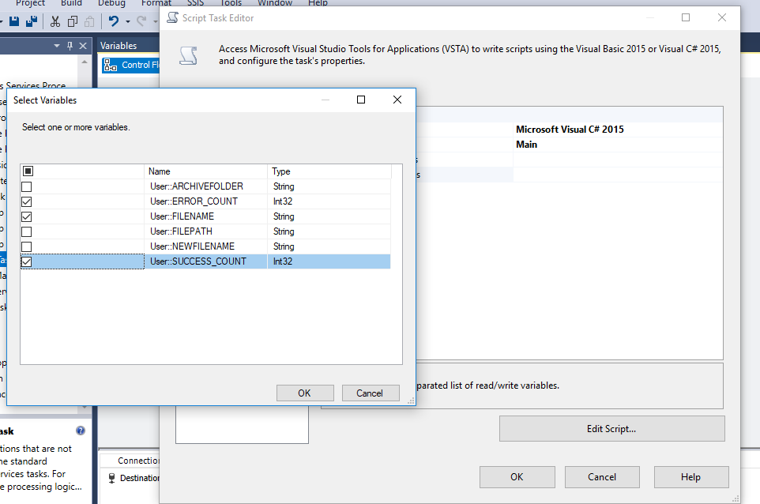

Figure : Code to display count figures for good and bad files

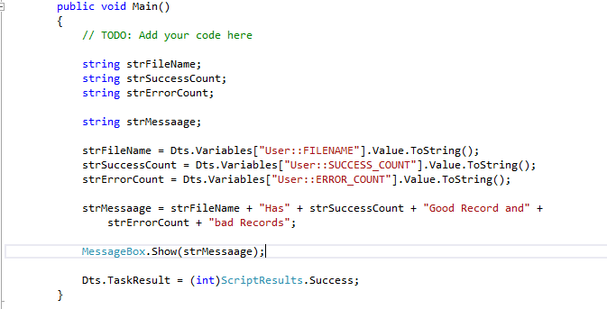

Figure : Display message for count files

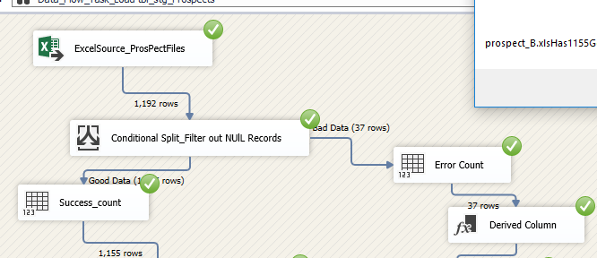

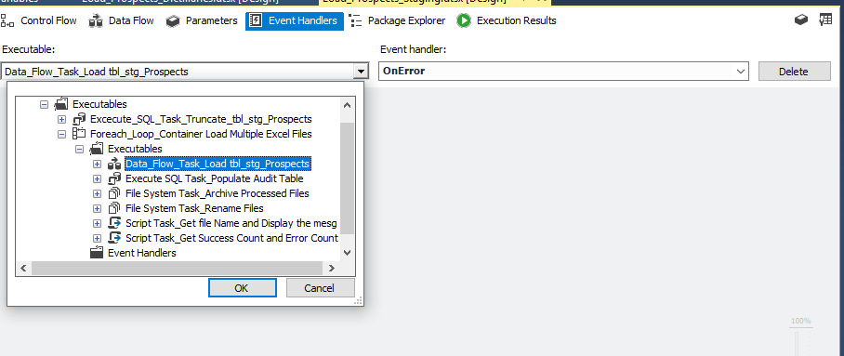

Figure : Implementing Event Handling

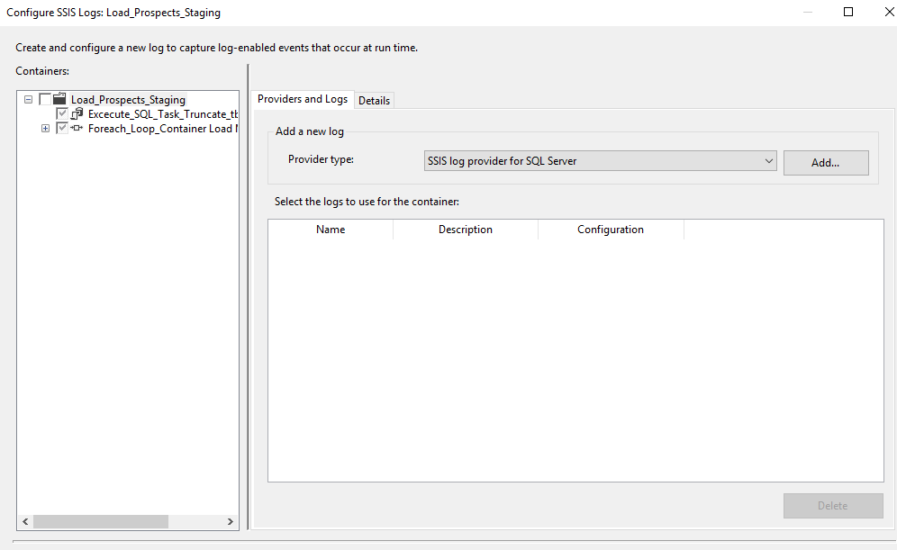

Figure : Logging

Figure : Log file

