Name: Ngala Dirane

Lesson: Charts and Graphs

Date: 15/09/2018

Create the following 6 Charts and Graphs in the SSRS Project found in the ***Introduction to the SSRS Architecture Lab***

1. Sales by Year Chart

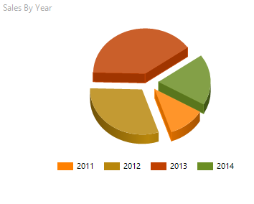

1. Sales Trend by Year / Month Chart

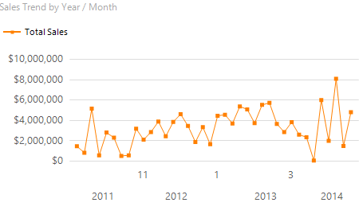

1. Sales by Territory Group Chart

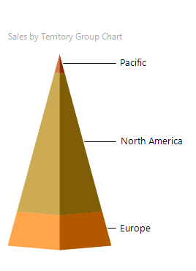

1. Sales by Territory Chart

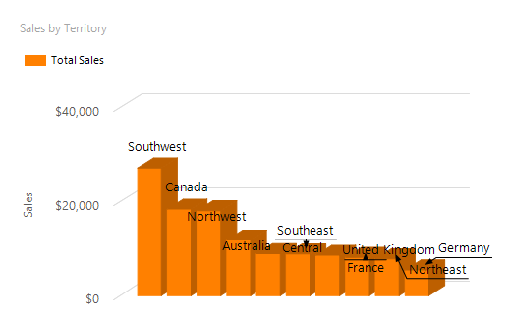

1. US Sales by State Chart

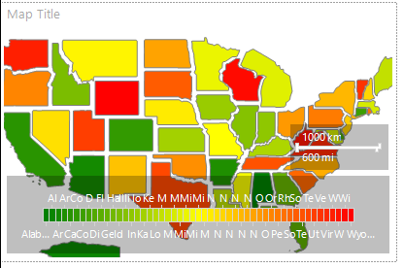

1. Top 10 Sales Reps Chart

