Name: Ngala Dirane Ngiri

Lesson: Constraints

Date: 01/08/2018

Create the following tables…

1. 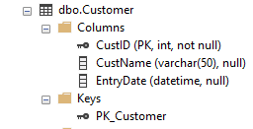Create Primary Keys on all 3 tables

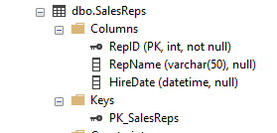

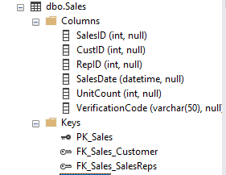

1. All 3 tables should have IDENTITY columns as the PRIMARY KEY’s. They must start at 100 and increment by 2.

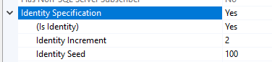

1. Create a Unique Key on dbo.Sales.VerficationCode

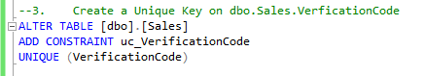

5. The following tables.columns will default to GetDate() if no Date is given.

* 1. Dbo.Customer.EntryDate
  2. Dbo.SalesRep.HireDate
  3. Dbo.Sales.SalesDate

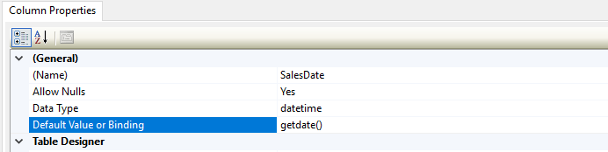

1. Run the following script to ensure the Constraints have been added correctly

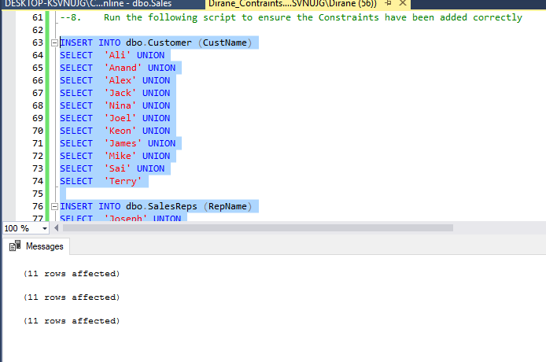

**Group Exercise:**

In a Word Doc, specify who will be the leader of your group for this quarter. Then take a screenshot of your whole team on a Zoom call. List out the name and last completed section for everyone on your team.

The last time we had group meeting we elected Tare Kragha as our group leader.

From the last meeting we had, details of completed sections for each group member is as follows

Group Leader: Tare Kragha

|  |  |
| --- | --- |
| Name | Section |
| Dirane Ngala | 4 |
| Rajasekha Kolusu | 6 |
| Efe Kragha | 6 |
| Nardos Mengistu |  |
| Tare Kragha | 6 |